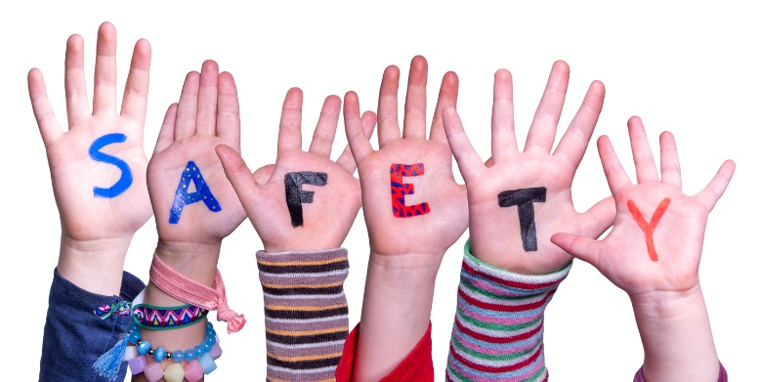

**Questions to ask providers before allowing your child / young person to attend:**

What are your emergency procedures?

Can I see your safeguarding children policy?

Who is your Designated Safeguarding Lead? And when did they last do DSL training?

Do all staff/volunteers have a DBS check? How often do you renew them?

Who do I speak to if I have any concerns?

Do you have a health and safety policy?

When did your staff/volunteers last do Safeguarding and first aid training?

**You wouldn’t leave your credit card with a stranger…. Please don’t leave your child with someone you know nothing about**

**Clubs and Activities for children and young people**

**Choosing safe provision – myth busting**

We know that schools, early years and childminders are inspected by Ofsted – did you know that lots of out of school activities are not?

**What we’re doing to help**