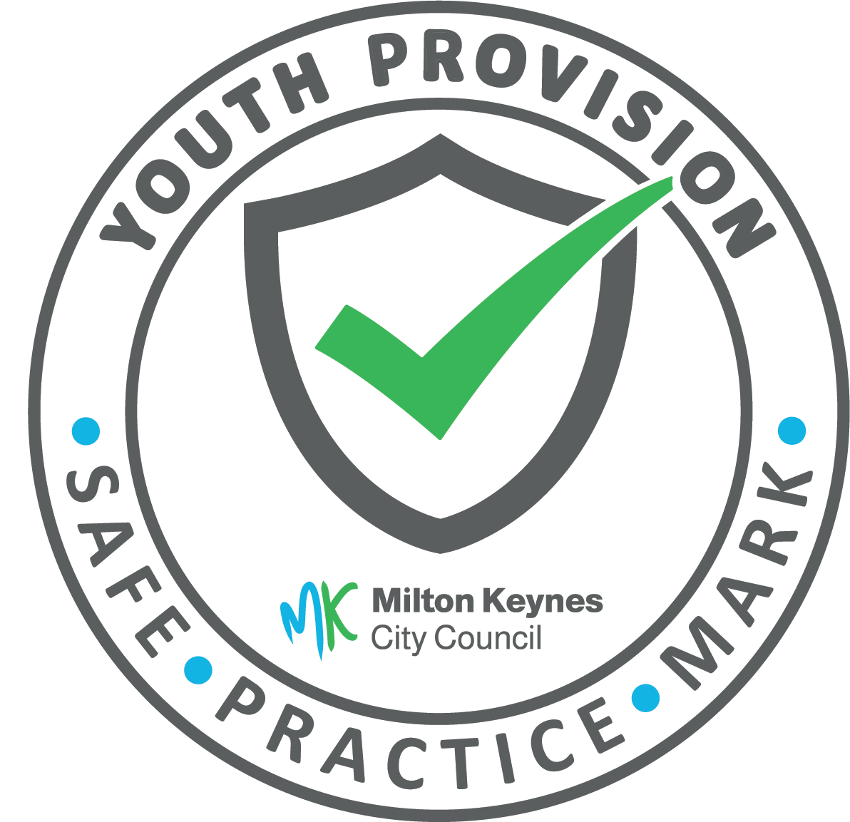
Application guidance
Youth Provision Safe Practice Mark

Introduction to the mark

Thank you for considering making an application by your organisation to the Youth Provision Safe Practice Mark. For background information on the mark please see annex 1 at the end of the document or visit Milton Keynes Youth Provision Safe Practice Mark | Milton Keynes City Council (milton-keynes.gov.uk)

The purpose of this document is to provide guidance on making an application and what the panel that assess the applications will be looking for in each of the documents you are asked to submit as part of your application. Please note that an application will not be taken to the panel until all the documentation asked for is provided. We understand that not all organisations will name or divide their policies in the same way, but all the topics that are identified in the list of documents needs to be covered in the paperwork submitted.

We require you to send us the following documentation alongside completing and submitting the Microsoft (MS) forms:

Policies covering:

- Safeguarding and child protection
- Managing allegations
- Social media usage
- Equality, diversity, and inclusion
- Health and safety
- Data protection and confidentiality
- Behaviour management
- Complaints

Other documentation:

- In date and valid Designated Safeguarding Lead (DSL) training certificate for your identified DSL
- Organisations constitution, terms of reference or other governing document

For questions or guidance relating to the Safe Practice Mark please email ypsafepractice@milton-keynes.gov.uk

What to include in each document

For all documents they need to be the most recent versions, be in date and have a review date. Where applicable ensured there are correct phone numbers for external organisations and contact details for named individuals eg data protection officer. We have listed below the minimum criteria for each document/topic that needs to be included, but to achieve the mark the policies need to demonstrate an understanding beyond this and information on roles and responsibilities for all levels of staff and volunteers within the organisation. All policies should be clear and accessible to staff and volunteers as well as service users.
Good practice on writing policies indicates that each policy should include the following:

- Purpose and aim: identify the organisation, its purpose and function including keeping children safe
- Scope of the policy: Be clear about who and what the policy applies to
- Context: state any relevant legislation and guidance and how this links to the function of the organisation
- Policy statement: include the organisations beliefs/ values in the context of the policy topic
- Contact details of who is responsible for the policy, and any named responsibility within, eg DSL

Safeguarding and child protection
- Your named Designated Safeguarding Lead and their contact details as well as Deputy Designated Safeguarding Lead
- Recognising the signs and symptoms of abuse including the 4 categories of abuse
- Becoming aware of a safeguarding issue – how to respond
- What to do if you’re concerned about a child
- MASH and ESWT contact details
- Process / flowchart for staff and volunteers to follow
- Definitions of Child Sexual Exploitation / Child Criminal Exploitation / Female Genital Mutilation / County lines
- How to interact with a child / young person who is making a disclosure
- Safer Recruitment
- Management and supervision of staff/volunteers
- Recording and managing information relating to safeguarding matters

Managing allegations
- Contact details of the Local Authority Designated Officer (LADO)
- DSL and Deputy DSL contact details
- Process / flowchart for children, young people and parents/carers to follow
- Whistleblowing information for staff and volunteers
- What to do if you are concerned about the conduct of another staff member or volunteer within the organisation
- When and how to report

Social Media Usage
- Personal account guidelines including not being ‘friends’ or ‘connected’ with service users or their families and ensure appropriate security and privacy settings are in place
- Association with the organisation and potential reputational damage for the individual or organisation
- Organisation account guidelines include etiquette, confidentiality and anonymity of service users
- Photo and video consent

Equality, diversity and inclusion
- Protected characteristics
- Oppose and avoiding all forms of unlawful discrimination
- Commitments by the organisation to promote and actively demonstrate equality, diversity and inclusion
- Agreement or call to action for staff and volunteers to adhere to the policy

Health and Safety
- Who is responsible for health and safety across the organisation
- What risk assessments will be in place
- Training for staff and volunteers
- Fire evacuation procedures
- First aid procedures
- RIDDOR
- COSHH
- Understanding individuals medical and behavioural needs

Data protection and confidentiality
- legal principles and responsibilities of the organisation
- Commitment to understanding and following the rights of those whose data you hold
- Intention to minimise data collection
- Staff training on data protection, confidentiality and GDPR
- Data retention and deletion
- Where data can be stored, by whom and on what systems
- Data processing procedures
- Procedure for data access request
- Procedure for data breach

Behaviour management
- How the organisation will support children and young people with positive behaviour
- Procedure for handling and addressing negative behaviour

Complaints
- What is a complaint and therefore what is or isn’t covered by the policy
- Reference to whistleblowing policy
- How to complain
- What the complainant can expect from the organisation when handling a complaint including standards and timeframes
- Stage one complaint
- Stage two complaint
- How to escalate to external complaints process

Annex 1 - Background information about the mark

Purpose
- Provide assurance to Milton Keynes of youth provision that has correct safeguards in place
- Offer community and voluntary sector organisations support from MKCC Safeguarding services
- Standardise practice of setting up and running youth provision in MK
What is it
- Organisations can gain the Safe Practice Mark overseen by Milton Keynes City Council on behalf of the MK Youth Provision forum
- Annual process of completing the form and submitting the associated evidence to MKCC for review and approval
Requirements of the mark
- All paid and unpaid staff and volunteers who come into contact with children and young people to have a valid DBS check recorded correctly by the organisation that is refreshed and reviewed every three years.
- All paid and unpaid staff and volunteers to have up to date Safeguarding training. This should be a minimum of a 3-hour course each year.
- The organisation has a dedicated and appropriately trained Designated Safeguarding Lead
- The organisation’s safeguarding, allegations and social media use policies approved by Milton Keynes Council Safeguarding Team
- The organisation has other required policies in place:
1) Equality and diversity policy
2) Health and Safety policy
3) Data protection and confidentiality policy
4) Behaviour management policy
5) Complaints policy
Benefits of having the mark:
- Free access to Safeguarding and DSL training through MKCC training programme
- Your organisation to be confirmed as having the mark on MKCC webpage that will be circulated and advertised across MK
- Having the Mark will make an organisation eligible for specific MKCC funding streams including homework club fund. Some Parish/Town Councils may choose to only give grants for youth activities to organisations who have achieved this mark
- Ability to display Safe Practice mark on marketing and publicity material
Oversight
- The MK Youth Provision Forum will maintain oversight of the award in partnership with the Head of Safeguarding and Quality Assurance for MKCC
Process
1. Submit completed and signed form and appropriate evidence to YPSafePractice@milton-keynes.gov.uk
2. MKCC will process the form and evidence submitted. Where necessary going back to the organisation for additional information and/or clarifications
3. MKCC representative sends recommendation of either approve or decline to nominated forum members and Head of Safeguarding and Quality Assurance
4. 100% agreement required for approval, further questions can be directed to the applying organisation
5. If successful the safe practice mark will be awarded. If unsuccessful MKC representative will offer to meet with the organisation to explain the reason behind the decision and offer support and opportunity to re-apply once concerns have been rectified.

