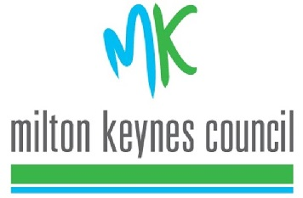
Please return to:
The Licensing Team
Milton Keynes Council
Civic Offices
1 Saxon Gate East
Milton Keynes
MK9 3EJ
Email: licensing@milton-keynes.gov.uk

Notification of Representation

Licensing Act 2003
Licensed Premise Name and Address:
(only 1 can be specified)

Your Name and Address:

Tel: email address:

Do you want someone to represent your views? Yes 􀀀 No 􀀀
If yes please give their name and address below:

Do you consider yourself to live in the vicinity of the premise? Yes 􀀀 No 􀀀

What is the approximate distance between your property and the premise? ………..…metres

Tel: email address:

Please indicate the grounds under which the objection is made, outline details and any evidence you have:

Crime and Disorder: Yes 􀀀 No 􀀀

Public Safety: Yes 􀀀 No 􀀀

Public Nuisance: Yes 􀀀 No 􀀀

Protection of children from harm: Yes 􀀀 No 􀀀

Date:
Print Name:
Signature:
IMPORTANT NOTICE:
This information will become a public document and will be sent to the applicant. Representations that request personal details be withheld from the applicant will only be considered in exceptional circumstances
Anonymous representations will not be accepted.
It is an offence to knowingly or recklessly make a false statement in connection with an application and the maximum fine of £5000 is liable on summary conviction for the offence.

