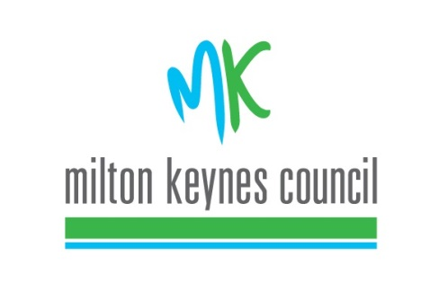
Milton Keynes Council Development Review Forum

4 March 2019 Civic Offices 6pm

Meeting Notes

Attendees:

Neil Sainsbury | Milton Keynes Council (Chair)
Tracey Darke | Milton Keynes Council
Stuart Proffitt | Milton Keynes Council
David Buckley | Milton Keynes Council
Nikolaos Grigoropoulos | Milton Keynes Council
Tim Roxburgh | Milton Keynes Development Partnership
Phil Winsor | Newport Pagnell Parish Council
 | North Crawley Parish Council
Tim Skelton | MK Forum
Kevin Twigger | Kevin Twigger Associates

Apologies

Cllr Jenni Ferrans
Cllr Sam Crooks
Cllr Angela Kennedy – Stantonbury Parish Council

The chair explained the purpose of this new initiative that being:

- Streamline the planning application process by addressing stakeholder comments on design at the pre-application stage
- Improve quality of design elements within schemes
- Raise profile of design across MK
- Allow for greater input by local stakeholders on design issues with aim of reducing local objections

Concerns were raised by DCC Committee Members that it was not appropriate for them to attend so they left before the first item. The chair of DCC also indicated that this Forum should be added to the DCC Agenda so that a formal decision is made regarding DCC members attendance at such forums in the future.

The issue of who was invited was raised and it was agreed that the Forum should be advertised on the Council website so that any residents could potentially attend.

Agenda Item: Tickford Fields Farm Proposal

Description- Allocated Housing Site within Newport Pagnell Neighbourhood Plan, 930 homes and ancillary functions.

Tim Roxburgh outlined the key layout and design elements of the scheme.

In response the following discussion took place:

Tim Skelton raised four points on behalf of MK Forum:
1. Wider Context - Highlighted the context of the building setting and how the site relates to the wider context, in particular the council-owned site to the north of the site. Suggested that a masterplan could exist for the wider area including a walking route between the development site and the site to the north as well as on the northern side of the river.

2. Grid Square – The scheme is the size of an MK grid square which give the council an opportunity to be more prescriptive in its approach in terms of housing mixtures, sizes, self-build etc., which is part of the MK character. Great Holm was raised as an example.

3. Layout of the Site - Sustainable Drainage System (SuDS), could be better positioned to provide focal points and features of the scheme. Also the road layout and associated housing location is such that there are not views of the park/park edge in the northern part of the site as you drive in from North Crawley Road which could be improved. The location of a signature building should be reconsidered as it could impact on a significant tree. It was also questioned whether a bridge could be included to connect to land to the north. It was explained that the illustrative masterplan doesn’t prohibit this (if it’s technically possible).

4. Low Carbon - The scheme could provide a lower level of carbon for development as an example to private developers. In this regard it was suggested that discussions with the National Energy Foundation take place. Spoil created as part of construction works should be retained on site.

There was a wide ranging discussion on the points above and MKC stated that they will take these in to consideration, although it is acknowledged that there are limitations as the scheme is fairly advanced in pre-application and there are also commercial pressures to be considered and the scheme should viable to deliver.

Other points raised by North Crawley PC were regarding how school drop off parking would be accommodated as this could have a significant impact on highways. It was explained that a ‘kiss and drop’ facility will be in place. North Crawley Parish Council also expressed a concern about the need for a Construction Environment Management Plan to protect neighbouring villages. It was confirmed by Tracy Darke that this is consideration/requirement as the application advances.

In conclusion, all parties recognised there is great value in this approach and MKC will work on the initial ‘teething’ issues, to create a useful forum to engage on development projects at an early stage.

