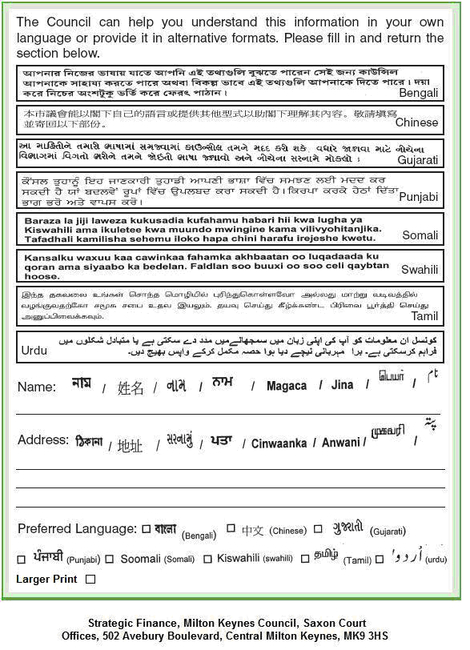
Telephone: 01908 254709 Fax: 01908 254420
E-Mail: Ray.watkins@milton-keynes.gov.uk

