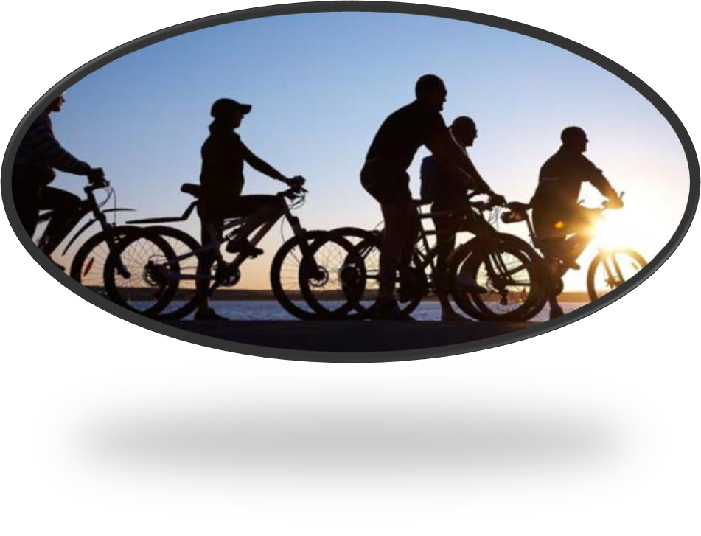
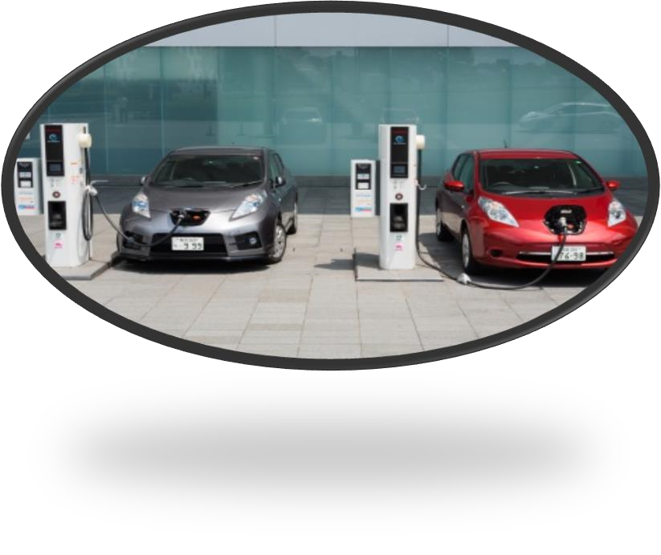
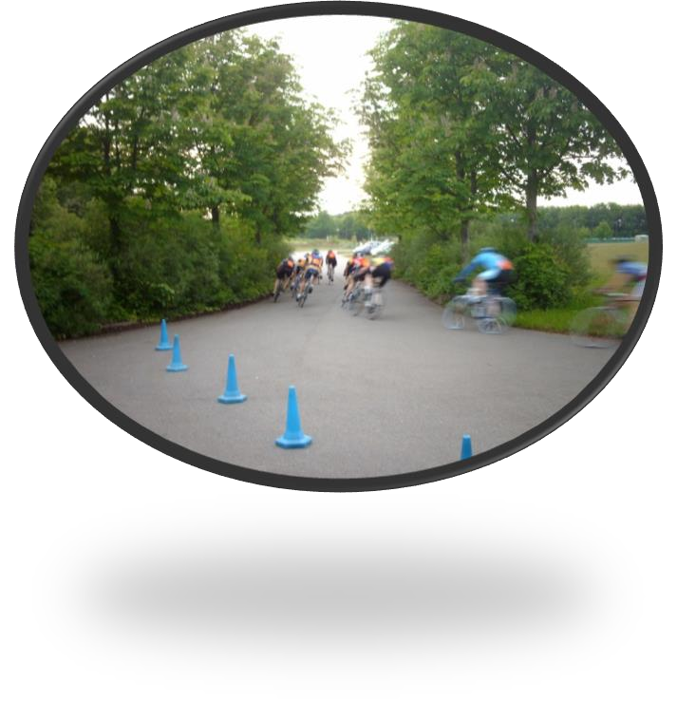

October

202
1

Mobility Strategy (LTP4):
Road Safety, Walking
&

Cycling and Smarter Travel
Strategy

ANNEX A

Contents page

1)

Introduction…………………………………………………………………………
.
………………
.
………
.
3

2)

Problems
,
Issues

and Opportunitie
s
……………………………………………
.
…………………
4

3)

Objectives…………………………………………………………………………………
.
…
.
………
.
………
6

4)

Transport
Policies………………………………
.
…………………………………………………
..
……..
8

5)

Priority
Initiatives……………………………………
…
…………………………………………………
.
1
3

6)

Monitoring and Targets……………………………………………
.
………………………………
.
…
1
9

1) Introduction

The Local Transport Plan (LTP4) for Milton Keynes comprises the Mobility Strategy adopted in 2018 and a suite of supporting strategies which provide further detail and direction to support the delivery of the Mobility Strategy objectives. The first of these supporting strategies, the Transport Infrastructure Delivery Plan, was adopted in 2019. This strategy covers the related topics of road safety, walking and cycling and smarter travel. Smarter Travel is the umbrella term for various activities undertaken to encourage travel behaviour change by encouraging reductions in single occupancy car use, and encouraging travel by more efficient, safe and accessible modes of travel with an overall low impact on the environment.
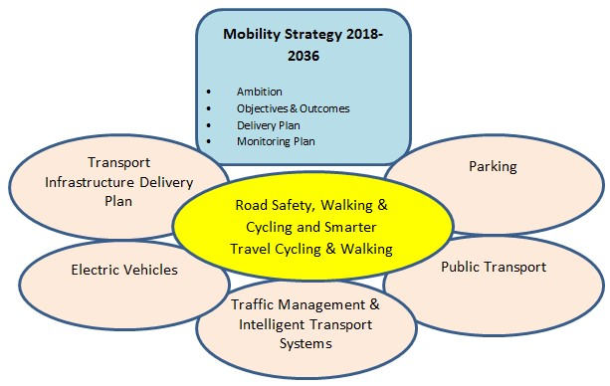

Local Transport Plan suite of documents
By covering these topics in a combined strategy, we have produced a more integrated approach to delivering the Mobility Strategy objectives which represents better value and should result in better outcomes. Delivery of the Mobility Strategy objectives will not only improve the quality of life of residents but will also support the continued growth of the borough to 2050. It will also support the council’s carbon reduction agenda, outlined in its declared ‘Climate Emergency’ and Sustainability Strategy 2019-2050. Reducing emissions from transport, industry and agriculture is one of the three principles of this strategy. The promotion of zero emission vehicles and public transport will play a key role. However if Milton Keynes is to achieve the strategic aim to be carbon neutral by 2030 and carbon negative by 2050, as set out in the sustainability strategy 2019-2050, technological solutions are unlikely to be sufficient and more fundamental transport behaviour change in the short and long term will be required.
The walking and cycling section of this strategy includes reference to key changes in the new Redway Design Manual, which will be adopted soon after this strategy. As well as the design manual the strategy is supported by technical reports on each of the topics covered which forms the evidence base. The paper has also been subject to a Strategic Environmental Assessment screening and an Equalities Impact Assessment.

2) Problems, Issues and Opportunities
Below is a summary of the problems and issues relevant to road safety, walking and cycling and smarter travel in Milton Keynes, which have guided the development of this strategy:
- Whilst there have been significant improvements locally and nationally to accident reductions, we are now seeing a slowing of progress in reducing rates of killed and seriously injured casualties on the transport network in recent years.
- High speed interurban roads and urban grid roads can encourage inappropriate speed increasing the severity of injury when accidents occur.
- Reduced road safety partnership activity and joint working with other local authorities in recent years.
- Limited funding dedicated to road safety and lack of national targets driving casualty reduction.
- Approaches to addressing accidents tend to focus on localised engineering solutions to the detriment of a more holistic approach. to benefit non-car modes and reduce danger on the network, rather than engineering solutions seeking to maintain traffic flow and speeds above all other considerations.
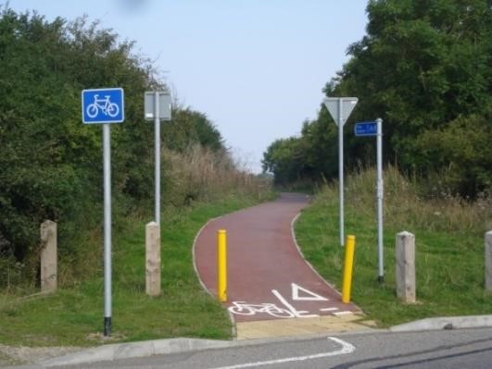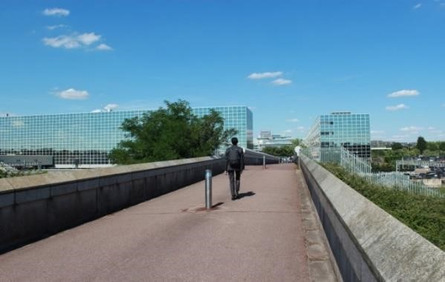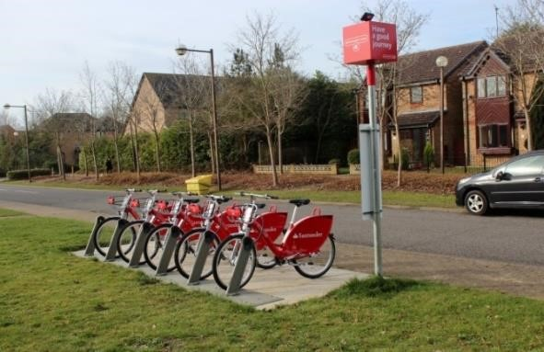
- The Department for Transport’s Road Safety Statement (2019) identifies ‘Four Priority Road User Groups’ which should be a focus: young users, rural road users, motorcyclists and older vulnerable road users. There is a need to embed the ‘Safe System Approach’ as per national

recommendations to ensure that people’s lives and health in Milton Keynes are not compromised by the need to travel.
- Partnership working and engaging local communities has a key role to improve safety, entailing better enforcement, education and campaigns, encouraging behaviour change and improvements to emergency responses.
- Growth and investment provide opportunities to reengineer public realm and the highway network to support active travel, the quality of place and improve safety on the network.
- The design of large parts of Milton Keynes where high speed grid roads and Redways segregate traffic from active modes provides some road safety benefit. However, the car dominated environment can deter active travel where this segregation does not exist, or cyclists wish to use the carriageway for faster or more direct journeys.
- Low commuting mode share for cycling and walking despite existing infrastructure provision, high self-containment of residents who both live and work in the borough, reasonable cycling distance between employment sites and residential areas of the city, and favourable topography.
- Routes provided are indirect, lack sufficient pedestrian and cycle priority where they interact with highway carriageway, and suffer from poor wayfinding.
- Poor personal safety perception of walking and cycling on Redways.
- Poor ride comfort for cyclists reported in many locations due to poorly maintained or designed routes.
- Lack of secure cycle parking provision around the city.
- Missing links in the Redway network, and not all areas are well served by Redways (such as in the older towns) where the urban form makes it more challenging to implement.
- Safety risk and conflict which could arise from new forms of mobility sharing space on the Redways.
- Increasingly inactive population reducing willingness to travel by walking and by cycling
- Ample and affordable car parking in Milton Keynes making car use the default transport option for car owners.
- Poor perception of public transport reliability and speeds.
- Dispersed employment and residential sites make sustainable travel a challenging option to promote.
- Limited car club availability and provision of alternatives to car ownership.
- Rural areas are a challenge to serve by public transport and broadband.
- Lack of demand management for car use to encourage behaviour change.
- Risk that land use policies and new technology such as electric vehicles could further encourage car use to the detriment of other transport modes.

3) Objectives

The Mobility Strategy has four objectives: 1 - Support growth and provide mobility for all. 2 - Provide an effective network. 3 – Maximise travel choices. 4 – Protect transport users and the environment.
To inform the amended policies and priority initiatives outlined in this paper, the following sub objectives have been identified to support delivery of the Mobility Strategy.
Road Safety
- To reduce the number of people killed or seriously injured on the Milton Keynes transport network;
- To reduce the number of pedestrians and cyclists killed or seriously injured on the Milton Keynes transport network;
- To adopt a ‘Safe System Approach’ to travel safety delivery in Milton Keynes;
- To encourage people to use the transport network in a more considerate manner, through targeted behavioural interventions with network users most likely to be involved in collisions;
- To deliver network safety infrastructure improvements prioritised at high collision sites, prioritising the needs of vulnerable users;
- To work with our partners on education and promotional programmes to improve the education and skills of drivers, particularly younger drivers;
- Leverage our smart city capability to make Milton Keynes the leading city in the UK for the deployment of technologically enabled solutions that will improve network safety in Milton
Keynes

Walking and Cycling
- To make walking and cycling the default choice for Milton Keynes residents for the majority of trips less than 3 miles;
- To make the cycling infrastructure of Milton Keynes the best cycling infrastructure of any UK city, which is accessible to all residents regardless of their cycling proficiency;
- To deliver improvements to our streets that are accessible, and can be easily used by anyone, regardless of mental or physical impairment;
- To provide walking and cycling links between key services that are safe, convenient, direct, and prioritise the movement of pedestrians and cyclists;
- To increase the amount of cycling undertaken by vulnerable groups;
- Reduce the number of pedestrians and cyclists killed or seriously injured in Milton Keynes;
- Leverage our smart city capability to make Milton Keynes the leading city in the UK for the deployment of technologically enabled walking and cycling solutions;
- To create a mode shift from private car to walking, cycling, and scooting to school.

Smarter Travel
- To achieve a modal shift for all journeys from single occupancy car user to walking, cycling, and public transport.
- To minimise the overall increase in vehicle traffic in Central Milton Keynes every year until 2030 through encouraging sustainable travel;
- To reduce the carbon footprint of local transport in Milton Keynes through targeted behaviour change initiatives;
- To contribute to a healthy, happy city by raising awareness of active travel modes, particularly in schools;
- To support investment in physical infrastructure – particularly for sustainable transport – with targeted promotional campaigns that achieve modal shift;
- Leverage Milton Keynes’ smart city capability to make the city a testbed for innovative travel behaviour change solutions and new technologies that encourage regular use of sustainable modes of travel.

4) Transport Policies

Following a review of the existing Local Transport Plan (LTP3, 2011) policies relevant to road safety, walking and cycling and smarter travel, this section presents an updated policy set to strengthen delivery of the Mobility Strategy objectives.
How new development is allocated, designed and delivered will significantly impact on the objectives. The policies presented align with and support the delivery of Plan:MK (March 2019). This strategy does not seek to replicate policies already agreed as part of Plan:MK, and there are numerous policies which support the objectives of this strategy (see policies within chapters 5 on Strategic Site Allocations, 8 on Transport and Connectivity, and 15 on Design).
With the exception of policy TUH1 below, the following policies align to the activity area they are most relevant to, denoted by their prefix (RS = Road Safety) and are either retained or adapted versions of the Local Transport Plan 3 policy set they now supersede. TUH1 is a cross cutting policy which contributes to all three activity areas covered by this strategy, as well as future strategies on topics such as Public Transport.
TUH1 Transport User Hierarchy: To support the creation of built environments that encourage greater and safer use of sustainable transport modes, development and new transport scheme proposals should meet the needs of transport users in the following order of priority:
- Pedestrians
- Cyclists (including e-bikes and e-scooters) and horse riders
- Passenger transport and shared modes users (including taxis)
- Powered two-wheeler (mopeds and motorbikes) users
- Other motor vehicle users

RS1 Vision Zero and Safe System Approach: The council will seek to continually improve road safety, working towards an ultimate vision of zero fatalities and serious injuries. This will include the application of a Safe Systems Approach to network safety activity with a particular focus on managing speeds to reduce collision severity and developing a comprehensive multi-party road safety management framework.

RS2 |  | Road Safety Audit Policy and Procedures: The Road Safety Audit Policy will apply to any highway scheme from the preliminary design through to implementation of the scheme.
RS3 |  | Engineering measures to reduce the number of fatalities and serious injuries: Engineering measures will be considered where there are clusters of collisions, and after analysis of these collisions, the speed of vehicles, the local environment and other traffic conditions. This should be informed by proactive road safety survey methodologies (such as iRAP) and would consider engineering tools such as signage, road markings, re-engineering junctions, speed limits and detection, traffic regulation orders, and banning turning movements where appropriate and justified. The Transport User Hierarchy will apply to any scheme designed.
RS4 |  | Ongoing funding for safety education, training and promotion: Well informed and targeted, proactive interventions will be delivered for travel safety education, training and promotion. Ongoing funding is required to keep providing the service to a changing population and to keep travel safety promotional messages ‘fresh’. The impact of these measures should be carefully monitored to inform future activity. Initiatives should be delivered in partnership with national and local agencies, including neighbouring local authorities, to enhance the impact.
RS5 |  | Maintain a Highway Design Guide: The Highway Design Guide will be retained and periodically updated to set out the general principles and minimum standards for the layout and dimensions of highways and paved areas in all new developments and for major maintenance works. The guide will not be seen as a prescriptive solution to all highway layouts. The aim will be to provide a broad framework within which development of a high standard of travel safety and environmental quality can take place to the benefit of all members of the community.
RS6 |  | 20mph Speeds: 20mph should be the maximum vehicle speed in all residential areas in Milton Keynes. Where there are opportunities to encourage greater adherence to a 20mph speed as part of any transport improvement scheme implementation, these should be applied where feasible.
 | CW01 |  | Increase promotion, education and training for cycling and walking - The council will continue to support the delivery of ‘Bikeability’ training. As part of school travel  planning work, the council will continue to encourage schools to incorporate Sustainable Travel and Road Safety (STARS) into their school curriculum and adapt to relevant national government policy and the direction of the curriculum. All promotional and educational activities will be delivered through an integrated works programme. Through ongoing travel planning, and promotional and education campaigns with workplaces, cycling and walking will be further encouraged.
 | CW02 |  | Continue to develop, improve and promote our online journey planner - Get Around Travel MK, which allows bespoke identification of cycling and walking routes across the borough, integrated with other modes of transport. The existing tool will be further developed to include Real Time Passenger Information, cycle parking provision and link to smart ticketing.
 | CW03 |  | Redway Super Routes – The Redway Super Routes Project will deliver significant improvements to 13 identified routes (priority routes parallel to the grid road network) including widening of the routes, re-surfacing, wayfinding, lighting improvement,
vegetation cutting, review and improvement of junction and crossing provisions for active travel. The project aims to make these routes attractive, quick, safe and direct.
CW04 | Expansion of the walking and cycling network into Central Milton Keynes, new developments, and existing urban areas with limited existing provision - The walking and cycling network will be expanded to help realise its full potential as a choice network for short and medium length trips in Milton Keynes, and for leisure and active travel purposes. Walking and cycling schemes and priorities will be determined by a Local Cycling and Walking Improvement Plan which is being developed in 2021.  The council seeks to maximise the use of the walking and cycling network, and so will be open to new forms of mobility using the network, providing it does not compromise safety and deter active mobility.
CW05 | Improve walking and cycling links and connectivity in rural areas – Subject to funding and likely demand, walking and cycling links between the city and surrounding villages will be improved as well as links in rural areas to employment centres and local services.
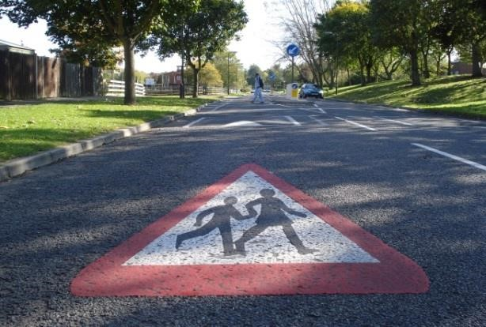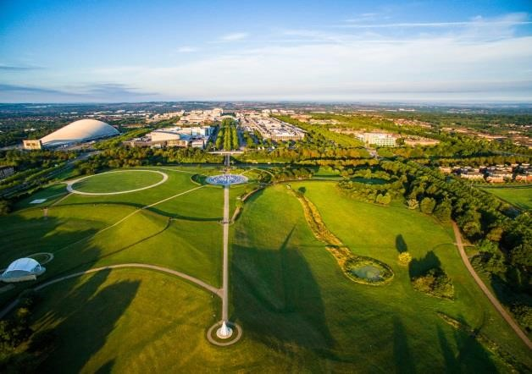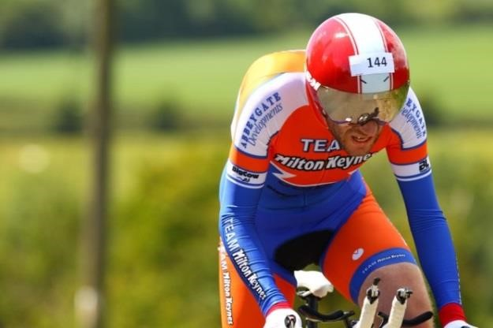

CW06 Bedford and Milton Keynes Waterway Park and development and promotion of cycling and walking corridors - The council recognises that waterways, including the Grand Union Canal, the River Great Ouse, the River Ouzel, and the Bedford and Milton Keynes Waterway are important assets. Navigable waterways provide opportunities for leisure trips, with potential for freight movement. In addition, waterways often provide cycleways, pathways and occasionally bridleways along their banks and towpaths. The council supports the development of the reserved routes for the proposed Milton Keynes Waterway Park – part of the Bedford and Milton Keynes Waterway Trust’s proposed improvements.

CW07 | Redway Design – Where new Redways are built or existing Redways are improved these works will be in accordance with the latest Redway Design Manual. A design manual principle will be for Redway users to have priority where the Redway crosses minor roads, and these crossing points will be designed to indicate this. New crossings will be retrofitted on existing Redways where it is safe to do so, taking into account traffic speeds and visibility.
CW08 | Improve pedestrian and cycling access to the public transport network - Walking and cycling will be fully integrated with the public transport network. Cycle links from city estates and villages to interchanges and bus stops will be improved, including provision of new links, removal of obstructive vegetation and improved sight lines, and improved maintenance of existing and new links.
CW09 | Cycle Parking - Increased levels of secure cycle parking will be provided at interchanges and increasingly at bus stops in the borough to facilitate access to public transport by bicycle. The Council will support improved cycle parking provision at key destinations including workplaces and in local centres providing high capacity, safe and secure cycle storage facilities.
CW10 | Maintenance of the Redway network (and footway and backways network) - Maintenance of the Redway network will be a priority: damaged surfacing will be repaired or replaced, and paths kept clear of broken glass and debris. Lighting will be enhanced where appropriate and prioritised where it is considered inadequate. Vegetation will be cut back and removed where necessary to open up the paths and so enhance feelings of safety and security for users. The Redway Design Manual sets out maintenance expectations to inform the council’s maintenance plans. Redway maintenance including winter maintenance activity will be regularly reviewed to ensure it meets the needs of Redway users as far as reasonably possible based on budget availability and feasibility. There will be a clearly identifiable Redway maintenance budget, covering all Redway assets.
CW11 | Cycle and electric scooter hire expansion - In the long term, council and local funded cycle hire will cover the city and then the borough. The trial of electric scooters will last into 2022 and the results of the trial will determine its long-term viability. Cycle and electric scooter hire will enable residents, workers and visitors to travel by bicycle or scooter for multiple journey purposes. The council will work with partners to expand and develop existing schemes to meet demand and user needs.
ST01 | Workplace Travel Plan for Milton Keynes Council - Milton Keynes Council will lead by example and maintain and monitor a travel plan covering the authority’s own premises with the purpose of reducing single occupancy car use by staff.
ST02 | More effective management and enforcement of development-related travel plans - All significant new developments across all land uses will be required to develop travel plans to ensure that the design of the development facilitates sustainable travel and also to ensure that residents have the information they require to travel by non-car modes, fully supported by promotional activities. Interventions will include working with developers and estate agents for the provision of welcome packs containing public transport, cycling and walking information; free or subsidised travel; provision of car / bike / scooter and other vehicle pools; and a visit from a travel planning officer within one week of moving in.
Travel plans are required for all significant new development in Milton Keynes, including expansion of existing sites. The council will ensure that local policy is strengthened to support development-related travel planning, and officers will work with developers to ensure that travel plan considerations are incorporated from the earliest stage of the planning process. Travel plans will be monitored and enforced through legal and financial mechanisms (such as bonds) to ensure that new developments meet their sustainable travel targets. Effective car park management will be a key travel plan measure required for all new developments.
ST03 | Increased promotion of car sharing – The council encourages and will seek to facilitate car sharing by residents and employees through supporting car share matching services and, in its parking, and development management policies.
ST04 | Increased support for car clubs – The council recognises the role car clubs can play in reducing car ownership and encouraging people to use alternative modes of travel to the car for some purposes. The council will support the development of car club provision as an additional transport choice for residents, workers and visitors. Priority will be given to zero emission car clubs.
ST05 | Agile working - Initiatives to reduce the need to travel (e.g. tele-working, teleconferencing, homeworking and home shopping) will be encouraged.
ST06 | Continued promotion and support for the Safer Journeys to School programme and School Travel Planning - The council will continue to work with schools to help them effectively implement and monitor their travel plans. A school travel plan sets out a package of practical measures aimed at improving safety on the journey to school and encouraging use of more healthy and sustainable modes of travel. We will also continue to encourage schools to incorporate Sustainable Travel and Road Safety into their school curriculum and we will adapt to relevant national government policy and the direction of the curriculum.
ST07 | Increased delivery of travel awareness campaigns and promotions - Focussed awareness raising campaigns will be undertaken to increase the public’s understanding of the problems caused by traffic growth, promote the benefits of sustainable travel and encourage people to think about their own travel behaviour. A wide range of media will be used, and targeted materials will be used to raise awareness of infrastructure  improvements once completed, to maximise the benefit realised. Partnership working with  local bus and rail operators will also ensure effective marketing of public transport improvements and information, and the council will also continue to support national travel awareness projects in order to raise the profile of sustainable travel.
ST08 | Increased partnership working - The council will proactively engage with all appropriate stakeholders, including local business, public transport operators, and National Highways (formally known as Highways England) to deliver many elements of the Road Safety, Walking & Cycling and Smarter Travel Strategy and to secure wide-ranging commitment and buy-in to achieving the objectives of the Local Transport Plan.
ST09 | Development of effective travel plans for all stations in Milton Keynes and other key trip generators - The council will work with key stakeholders to ensure the effective development, delivery, monitoring and maintenance of rail station travel plans to promote alternatives to single occupancy car use. Other key trip generators such as Milton Keynes General Hospital, Stadium MK and the Central Milton Keynes shopping centres will be encouraged to also develop, deliver, monitor and maintain their own travel plans.

5) Priority Initiatives

Following a review of current activity and good practice from elsewhere, a number of initiatives have been appraised for their contribution to the delivery of the objectives, and their feasibility. The following outlines those initiatives that should be prioritised for implementation subject to funding availability and, where applicable, community support. Many of the initiatives can be delivered within existing council budgets and utilising existing officer resources and teams. Where other initiatives cannot be delivered within council budgets, they will be dependent on other funding sources such as developer contributions and capital grants from government.

Road Safety
- Data collection and analysis - To inform interventions and campaigns, determine relevant causation factors and areas of behaviour that lead to crashes, and to monitor and evaluate performance to gauge effectiveness of interventions.
- Investigation - Carry out in-depth investigation into fatal network user crashes
- Campaigns - Lead and coordinate promotional activities and campaigns.
- Safety Audits – Undertake Safety Audit and Safety Checks
- Junior Road Safety Officers - Provide additional support for Junior Road Safety Officers (junior school children who help their local Road Safety Officer to promote travel safety issues within the school and the local community).
- Safer School Zones - Support community led ‘safer traffic around school zones. This could include temporary restrictions around the school limiting vehicles access, speeds or dropping offs/pick-ups at busy times. Bobby Zones in Liverpool are an example of this type of initiative.
- Area wide safety improvements - Future wider public realm, land use planning or local transport improvement projects in Central Milton Keynes and Denbigh/Bletchley should include initiatives that improve network safety through an application of a Safe System Approach that reduces the severity of collisions by enhanced management of vehicle speeds. In Central Milton Keynes this could be integrated with work associated with the Futures 2050 project on Renaissance CMK and improved public realm.

Walking and Cycling and Smarter Travel
- Expand the Walking and Cycling Network - Identify gaps in the existing network and develop a set of schemes to enhance the existing network and link to strategic development sites. Scheme options and priorities will be determined by a Local Cycling and Walking Improvement Plan for the borough.
- Redway Network Upgrades/Super Routes - Upgrade the Redway network including improved wayfinding; widening; cycle priority at junctions / side roads; surface quality enhancements; improving lighting (Council’s city-wide LED street lighting programme); providing CCTV and taking opportunities to improve junction safety, reduce the number of crossings and remove street furniture obstructions.
- Cycling Network Expansion within CMK - Expansion of the existing cycling network into CMK. The extensions would provide direct, high-quality segregated cycle routes. Work will be progressed to identify a preferred option informed by its feasibility and deliverability.
- Cycling and walking infrastructure improvements around schools - Create a programme to focus on infrastructure/design improvements around schools, which will include measures to reduce car dominance and improve pedestrian and bike accessibility.
- School Travel Planning – STARS programme encourages cycling and walking to schools through school’s accreditation. The council will continue working with schools and DfT to encourage modal shift. It is essential to secure further funding to continue providing support to schools.
- Junction and Crossing improvements - Physical improvements to walking and cycling road crossings in accordance with the Transport User Hierarchy to improve safety and accessibility for all users.
- MK Cycling Network - Working in partnership with the council Rights of Way team, the Parks Trust, Canals and Rivers Trust and Sustrans to foster a coherent walking and cycling network.'

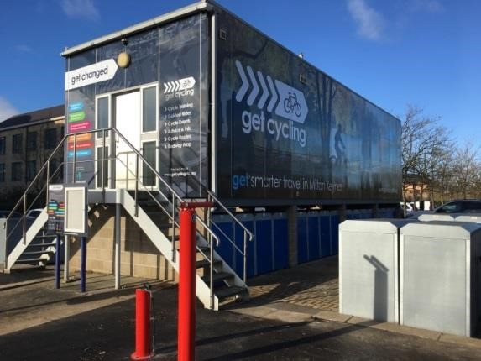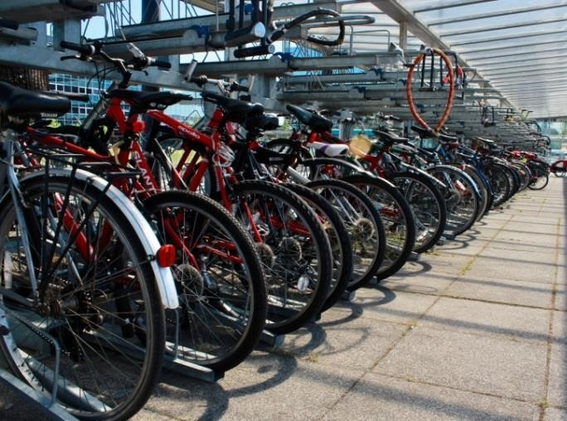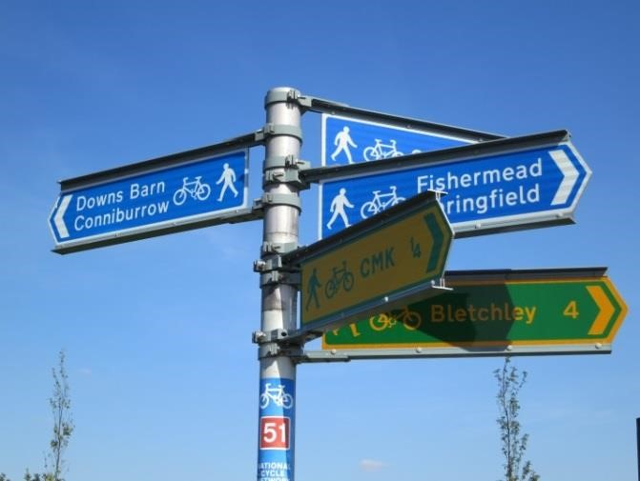

- High Quality Destination Cycle Parking - Implementation of secure, covered, high-quality cycle parking at key destinations including district centres such as Westcroft and Kingston; CMK; schools; nurseries and employment sites. Also include public transport interchanges such as at train stations and bus interchanges. The council will monitor reports of cycle theft and work with TVP to tackle this.
- Wayfinding - Implementation of a comprehensive wayfinding scheme for Milton Keynes. The wayfinding scheme would provide a consistent set of information totems with local maps, walking and cycling times and directions to key local destinations. The wayfinding markers would be situated in key strategic locations on the main pedestrian and cycle routes, transport hubs and destinations.
- Bikeability - Fund cycle training for businesses, schools and local communities through the Bikeability programme. The programme provides trainees with an understanding of how to cycle on the network safely, whilst learning the practical skills to gain confidence in cycling on the road. The programme has a variety of levels which take trainees from the basics of balance and control, to planning and undertaking an independent journey.

- Cycle and electric scooter hire schemes - Expand and promote cycle hire schemes to cover a larger area. New hire stations should be incorporated into existing and new developments, local centres and transport hubs. Subject to any learning from the electric hire scooter trials and any changes in legislation, we will support the expansion of such hire schemes.
- District Centre Public Realm Improvement - Improve connectivity in district centres such as Westcroft and Kingston including to public transport interchanges through improvements to the public realm. Reducing the car dominance and improving connectivity will bring social, environmental and economic benefits along with the opportunity for new community and commercial land-uses.
Local Community Pedestrian Connectivity Improvement - Package of local walking connections to enable improved local community connectivity. Implementation of a permeable network of direct, open and overlooked pedestrian routes that embrace the principles of urban design good practice guides, such as the Manual for Streets. The pedestrian routes would be attractive to users by providing local connectivity to schools, shops, bus stops and adjacent residential areas and communities.
- Get Smarter Travel Initiatives - Continue to develop and promote Smarter Travel Campaigns through Get Smarter MK project. Include new campaigns that target different user groups.
- Travel Planning in new developments - Provide direct support to developers through a standardised package of sustainable transport promotions. Includes local information, discounted fares, bike share subscriptions, and targeted rewards.
- Workplace Travel Planning - Continue to support transport planning for businesses. Encourage travel champions amongst businesses by providing support, tools and information for sustainable travel. Promote home and agile working to reduce the need to travel.
- Smart ticketing and development of Mobility as a Service - Work with the smart ticketing provider to enable users to access multiple modes of transport such as bike share and car share in future. Build on smart ticketing to develop a Mobility as a Service (MaaS) tool covering the borough providing a single journey planning and payment platform for all legs of a multi modal journey.
- Car club development – Support deployment of car clubs across Milton Keynes.
- Get Around MK website review - Upgrade the tool to allow interactive Personal Travel Planning which allows access to real time information on public transport and other innovative features
- Liftshare -To continue promoting the Liftshare car sharing application to Milton Keynes Council and other business employees
- Car Share parking permit scheme - Undertake a review of the existing car parking scheme that offers discounted parking permits for members that share cars and recommend improvements that are needed.
- Multi Modal Travel Hubs – Urban Travel Hubs with co-located access to public transport, Redway routes, cycle facilities, information, car clubs and other transport services.

6) Monitoring and Targets

The following performance indicators will be used to monitor the contribution of the activities covered by this paper to the delivery of the Mobility Strategy. Specific targets will be agreed once reliable baseline data is obtained, and the strategy detailed in this paper is agreed. Where a baseline is still to be considered, additional work will be carried out to identify these figures with an aim to obtain these by September 2022.
Indicator title | Description | Baseline | Target (5 years)
Number killed or seriously injured on all roads | Number of killed and seriously injured casualties from collisions on all roads within the borough of  Milton Keynes. AccsMap Accident Analysis System (MKC) | 74 (2018) | Reduce
Number killed or seriously injured on all roads (excluding the  Strategic Road  Network) | Number of killed and seriously injured casualties from collisions on all roads within the borough of Milton Keynes, excluding those on the Highways England managed network (A5 and M1).  AccsMap Accident Analysis System (MKC) | 64 (2018) | Reduce
Number of children killed or seriously injured on all roads (3 year rolling average) | Number of killed and seriously injured child casualties from collisions on all roads within the borough of Milton Keynes. AccsMap Accident  Analysis System (MKC) | 7.7  (2016-  18) | Reduce
Number of pedestrians killed or seriously injured | Number of killed and seriously injured pedestrian casualties from collisions on all roads within the borough of Milton Keynes. Department for Transport | 14 (2018) | Reduce
Number of cyclists killed or seriously injured | Number of killed and seriously injured cyclist casualties from collisions on all roads within the borough of Milton Keynes. Department for Transport | 15 (2018) | Reduce
Number killed or seriously injured on the  Milton Keynes Grid  Road Network | New indicator to be developed. | TBD | Reduce

Cycling and Walking mode share | The proportion of all types of trips within Milton Keynes that are undertaken by walking or cycling  New Indicator requiring primary data collection to overcome existing reliance on census journey to work data. | TBD | Increase
Number of cyclists recorded on the Redways per annum | MKC Redway counters. Currently have 10 installed that have collected data since late 2018. Further counters to be installed as part of the Super Routes project. | 835,375,00 | Increase
Number of pedestrians recorded on the Redways per annum | MKC Redway counters. Currently have 10 installed that have collected data since late 2018. Further counters to be installed as part of the Super Routes project. | 1,258,863,00 | Increase
Public satisfaction with footways and cycle routes | Overall satisfaction of residents with the provision and access to Redways and other footways and cycle links across Milton Keynes.  (National Highways and Transport Network, KBI 13 and KBI 11) | 63% (cycle paths)  58%  (footways)  (2019) | Increase
Percentage of physically active adults | Public Health England, (C17a) | 67.1%  (2017-18) | Increase
Condition of the current walking and cycling infrastructure | TBD - The proportion of the Redway asset, as assessed by asset management teams, as being in a poor condition. This includes surfaces, lighting, and street furniture. | TBD | Reduce
Bikeability cycle training delivery | Number of children undertaking Bikeability training in MK schools at Levels 1, 2 and 3, as well as Bikeability Balance, Bikeability Fix and Bikeability Transition courses. | 1366 (2019) | Increase
Percentage of all trips undertaken by walk, cycle, public transport, and car sharing | The proportion of all types of trips within Milton Keynes that are undertaken by sustainable modes of transport  New Indicator requiring primary data collection to overcome existing reliance on census journey to work data. | TBD | Increase
Number of vehicle trips into and out of Central Milton Keynes per annum | The number of trips entering and leaving Central Milton Keynes per annum, as counted by roadside traffic counters | TBD | TBD
Local transport carbon emissions per capita (tonnes) | The estimated per capita CO2 emissions for Milton Keynes for local transport only. UK local and regional CO2 emissions data tables (2017) | 1.48 | Decrease
Percentage of primary school children who walk and cycle to school | The percentage of primary school children as recorded on Modeshift STARS who regularly cycle or walk to school. (Academic year 2017-  18)* | 42% | Increase
*Data from the 29 primary schools in Milton Keynes using Modeshift Stars in 2017-18 to record this data. The total number of primary schools in Milton Keynes that same year was 90.

Heading

Milton Keynes Council
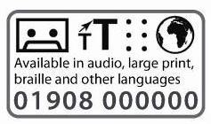
Transport Policy & Programme
01908 252510

Civic Offices
1 Saxon Gate East
Central Milton Keynes
MK9 3EJ

Tel: 01908 252546
Fax: 01908 254212
Email: transport.policy@milton-keynes.gov.uk
Web: www.milton-keynes.gov.uk/transport-policy

Safe System Approach encourages a multi-disciplinary approach to improving road safety and includes a change in focus from seeking to prevent all collisions, to preventing the severity of these when they inevitably occur. See evidence report for more detail.
Vulnerable groups include children, older adults and disabled people.
Vision Zero is a strategy to eliminate all traffic fatalities and severe injuries, while increasing safe, healthy, equitable mobility for all.

