Before you start

Please read the CIF Guidance Notes before you complete your application. This can be viewed online on the Highways & Transport Hub page

You must complete all sections, providing as much information as possible and any supporting documents, quotes or images. Further information may be requested at the next stage of the process.

Send your completed application to highways.liaison@milton-keynes.gov.uk by Friday 26 August 2022.

If you are experiencing difficulties meeting this deadline or have any questions about the process, please get in touch with the Highways Liaison Team using the above email address.

Application form

Name of Parish, Community or Town Council:
Address of Parish, Community or Town Council:

Parish contact details:
Name
Job title/position
Email
Contact number/s

What are the objectives of your proposal? tick all that apply

Safety, wellbeing or health

Improve the local environment Improve local facilities Building stronger communities
Encouraging wildlife and biodiversity
Encouraging sustainable transport Tackling climate change

Other (please specify)

Provide opportunities for local people

Financial contributions

Ensure that your project estimate includes all additional implementation costs including design, installation, traffic management, relevant licences etc. If using an external contractor, get 3 independent quotes for the works.

You must contribute at least 50% of the total cost of your proposal (25% for very small parishes with a tax base of less than 200). The MK Council contribution is up to a maximum of £20,000.

These contributions can be revised at the next stage of the process, where officers will work with you to refine your application as part of the feasibility checks.

MK Council Contribution Parish Contribution Proposal Total

Up to maximum £20,000
Minimum of 50% of total project cost. Smaller parishes will contribute 25%

Project plan and timeframes
Outline your expected timeframe and project plan for your proposal here.
For example, consider any preliminary works, supply and manufacture of materials, landscaping requirements such as seasonal nesting times. Add in contingency time for unforeseen circumstances or poor weather conditions. If you are unsure, contact the Highways Liaison Team who can assist you.

Community Infrastructure Fund 2023-2024

Location of your proposal

Please state exactly where your proposal will be and provide details of land ownership. If the location is on MK Council-owned land, you must liaise with MK Council officers first before submitting any proposals.
Locations must be owned by either: MK Council
Parish/Town Council owned (or available for parish acquisition)
Long term lease (If the building is occupied on a long term lease, the terms of the lease will need to be reviewed prior to award of grant funding).

Expected outcomes

Who will benefit from your project and how? Are there any wider benefits to Milton Keynes or the local area? How will the success of the proposal be measured e.g. increased footfall, feedback from residents etc.

What are the consequences of not doing this proposal? Will there be an impact on the community? Will it make an existing issue worse? (Give brief details)

Engagement

Explain here how the proposal came about - was it the result of a resident's suggestion, was there any local engagement done to find out what they wanted or do you have any information about a consultation?

Have you spoken with any MK Council officers about all or parts of your proposal? If so please provide details here including which officer/s you spoke to, their involvement and the outcome
e.g. advice on planting or location of a bench.

Highways Data Protection Privacy Statement
We collect and use information about you so that we can provide you with Highway services under the relevant legislation. Full details about how we use this data and the rights you have around this can be found at www.milton-keynes.gov.uk/highways-and-transport-hub/highways-privacy-notice.

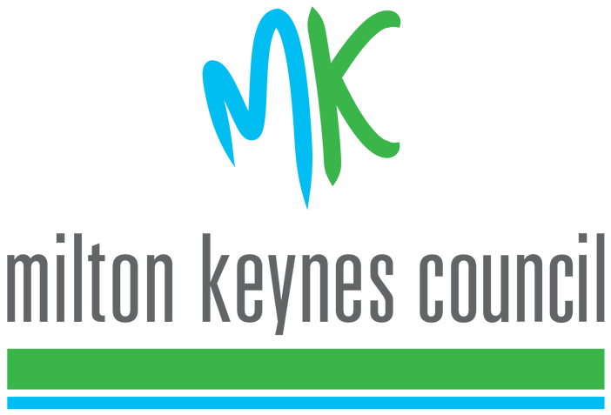
If you have any data protection queries, please contact the Council's Data Protection Officer at data.protection@milton-keynes.gov.uk

Thank you for your application to the 2023-24 Community Infrastructure Fund.

