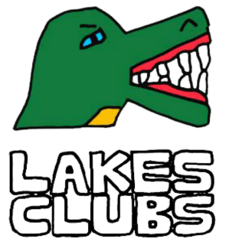

Lakes Clubs Expression of Interest form for existing providers

Please complete this form if you want to apply for funding to help boost clubs you are already offering on the Lakes Estate.

Section 1 Organisation Information:
Name and address of organisation

Lead contact name

Email

Phone

Section 2 Existing Club:
2.1 Please provide a summary of the club that you run at present
2.2 Where does the club take place?
2.3 When does the club take place (days of the week and times)
2.4 Who is the club for?
2.5 What is the minimum and maximum number of places available at your club?
2.6 Are all the available places full? | Yes ☐ No ☐  If yes, do you have a waiting list?
2.7 How much does it cost to attend your club?

Section 3 Boosting your club:
3.1 How would you use funding to boost your club?
3.2 Will further sessions be added to your club? | Yes ☐ No ☐  If yes, please provide details i.e., number of weeks, months boosts will be available for days of the week and times ?
3.3 Will there be any changes to who can attend the club? | Yes ☐ No ☐  If yes, please provide details?
3.4 To run your club what will be the minimum and maximum attendance number.
3.5 Will there be any change to the cost to attend your club? | Yes ☐ No ☐  If so what will the cost be?
3.6 How much funding are you requesting?

Section 4 Policies and Procedures:
4.1 Policies and Procedures
Organisation must be able to demonstrate and explain their safeguarding arrangements and have relevant and appropriate policies and procedures such as:
  - Safeguarding (including appropriate DBS checks for staff and volunteers).
  - Health and Safety.
  - Insurance.
  - Evidence of up to date accounts, and a separate bank account in the organisation’s own name.
  - Where clubs are Ofsted registered, clubs must also be compliant with the Ofsted requirements for working with children.
Please confirm that you have these in place
Yes ☐ No ☐

Section 5 Data and Intelligence:
5.1 Organisations will be expected to provide information on attendance at each activity. A specific template will be provided for this.
Please confirm that you agree to comply with this.
Yes ☐ No ☐

Name (Print Name) Job Title

Signature Date

Please email a single PDF version of your completed application form with the subject header, Lakes Club to LakesClubs@milton-keynes.gov.uk

