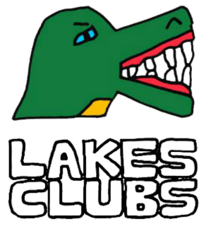

Ideas Form for Local Residents
Are you a local resident of the Lakes Estate and would like to organise a club, perhaps this could be a lunch club, book club, walking group or gardening club as part of the Lakes Clubs.

Section 1 Contact Information:
Name and address of organiser

Email

Phone

Section 2 Club Idea:
2.1 Please tell us what club you would like to start in the Lakes Estate.
2.2 Where will it take place?
2.3 When will the club take place (days of the week and times)
2.4 Who will the club be available to?
2.5 What is the minimum and maximum number of places will be available at each club?
2.6 Will there be a cost to attend the activity? | Yes ☐ No ☐  If yes, how much?
2.7 What do you need from us to get your club started?
We will need to know who took part in your club | Please confirm that you agree to tell us.  Yes ☐ No ☐

Name Signature Date

Please email a single version of your completed application form with the subject header, Lakes Clubs to LakesClubs@milton-keynes.gov.uk

