\\\\\\\\\\\\\\\\\\\\\\\

Dr Suzanne Bailey

Dr Rob Beadel

Dr Jennifer McLoughlin

*April 2020*

**Helping Children and Young People cope when someone has died**

**Children’s Services**

Educational Psychology Service

**Normal Responses**

**This leaflet is intended to remind you of the possible range of feelings and reactions children may experience following bereavement.**

Because children often do not have the same understanding as adults they may have more difficulty talking about their feelings. However, the following responses are normal:

* **Shock:** A child may be very quiet or they may cry uncontrollably
* **Denial:** Even though they know the person has died, they may think that the person will return
* **Searching:** They may worry about losing other people
* **Anger:** They may be angry towards the people around them or the person who has died
* **Anxiety:** They may feel anxious about the things they may or may not have done, or said, to the person who has died.
* **Guilt:** They may feel that in some way they caused the death or let the person down
* **Confusion:** They may feel confused about what has happened to the dead person.

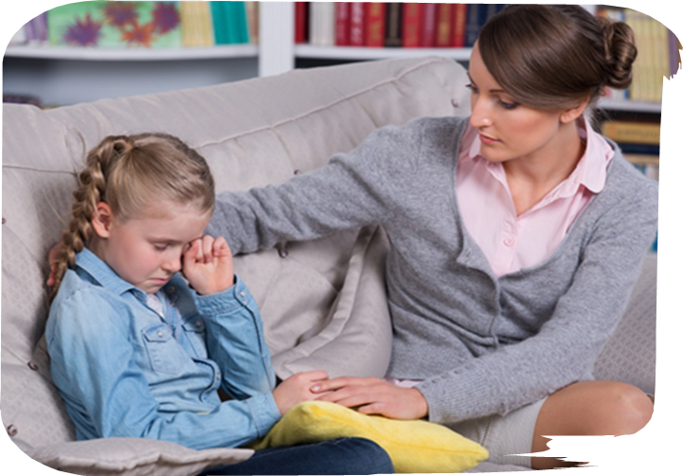

**Behaviours you might expect to see**

In such tragic situations children and young people experience similar feelings to adults. They have a need for support in coming to terms with traumatic events but they may not be able to express feelings when they cannot find the words. Children, particularly young children, often show their feelings through behaviour.

**These behaviours might include:**

* Behaving as a younger child
* Becoming very withdrawn
* Sleep disturbance: bad dreams, fear of being alone, fear of the dark
* Increased ‘pretend’ play, including a desire to act out details of what took place in the original incident
* Wanting to be with their parents, or a trusted adult, at all times
* Difficulty concentrating, especially at school
* Children may forget things or have toileting accidents
* Changes in appetite
* Fears of their own safety, or for the safety of family or friends
* Reluctance to talk
* Becoming easily upset

**These are all normal reactions to a distressing event and may last for some time.**

**How you can help**

**Most children need immediate support and reassurance from people they know, trust and feel safe with.**

* Try to answer questions as honestly and openly as you can
* Maintain familiar routines and structures, these provide a sense of security
* Be patient and calm, if possible
* Give children opportunities to talk about their feelings and let them know it’s okay to cry
* Try to treat children in the usual way. You may wish to be especially protective. This is a natural reaction, but in the longer term being too protective can make a child feel insecure
* Seek support for yourself if you need it