**Supporting Children and Young People's Emotional Wellbeing: Information for Schools**

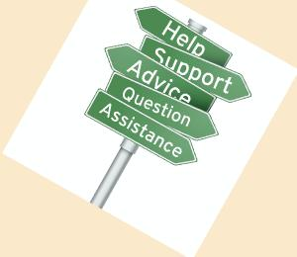

This resource is intended to be considered alongside the Milton Keynes Joint Emotional Wellbeing and Mental Health Pathway: 

This document draws together information about local support and resources, including those updated from last year's Wellbeing for Education Return project. A range of useful national resources are also provided.

A key priority of this year's Wellbeing for Education Recovery project is helping education settings to navigate useful support and resources.

**Local Support and Resources**

**Whole School Approaches**

Last year, the Educational Psychology service delivered a webinar entitled **‘Whole school resiliency during the pandemic: a psychological approach’**. This information is still relevant for schools and may be useful to revisit. The keynotes can be found here: <https://www.milton-keynes.gov.uk/sites/default/files/2022-03/Webinar%20One%20Key%20Notes%20Resource%20%281%29.pdf>

For those who were unable to attend last year's training, a short recorded webinar entitled ‘Every Interaction Matters’ which covers some of the key points can be found here: <https://www.minded.org.uk/Component/Details/685525>

Keynotes from a second webinar entitled **‘An individual approach focussing on bereavement and loss’** can also be found here: <https://www.milton-keynes.gov.uk/sites/default/files/2022-03/Webinar%20Two%20Key%20Notes%20Resource.pdf>

**Supporting Children and Young People with Anxiety**

Schools tell us that anxiety continues to be highly prevalent in their settings and is an area that additional signposting and support is welcomed.

The Milton Keynes Educational Psychology Service are providing **a limited offer of one-to-one and small group anxiety intervention work** for children and young people. The intervention aims to support students who are showing signs of increased anxiety about attending school. Further information can be found here: <https://www.milton-keynes.gov.uk/sites/default/files/2022-03/Anxiety%20Intervention%20Offer%20%281%29.pdf>

An **8 session anxiety programme** has been created by the Educational Psychology Team drawing from the work of experts Dr Karen Triesman and Paul Stallard. The programme is made up of a practical step-by-step guide and has been designed for school staff to easily follow and implement. To request a copy of the intervention programme manual, please contact our Educational Psychology team: [education.psychology@milton-keynes.gov.uk](mailto:education.psychology@milton-keynes.gov.uk)

Service Six offer **6 week programmes** (1 hour a week) looking at what anxiety is, signs and symptoms, understanding how we can identify when we are anxious and strategies to reduce and cope with anxiety. For more information email [katie.byrne@servicesix.co.uk](mailto:katie.byrne@servicesix.co.uk)

**School Staff Wellbeing**

**Coaching Conversations for School Staff:**

We know that the pandemic is impacting on the mental health and wellbeing of children and young people, and for some will have a longer-term impact. School staff are at the forefront of recognising and supporting the wellbeing of the children and young people in their school. In this context we recognise the need to support education staff and leaders to look after their own and each other’s wellbeing.

Coaching is one way to do this. Coaching is the opportunity to talk about aspects of work with a view to supporting development and wellbeing. Topics that coaching can support with could include:

* Impact of COVID-19 and lockdown on you, the school, etc
* Setting and maintaining boundaries
* Motivation
* The demands of your role
* Professional goals and how to achieve them
* Work/life balance
* Off-loading about frustrations or challenges

**Other Resources:**

The Milton Keynes Educational Psychology service are **providing a limited offer of coaching sessions for staff in Milton Keynes schools**. Further information can be found here: <https://www.milton-keynes.gov.uk/sites/default/files/2022-03/Coaching%20Conversations%20Offer.pdf>

A condensed version of the successful **webinar entitled 'Education Staff Wellbeing'** produced by the Educational Psychology Service remains available for schools and can be accessed here: <https://www.youtube.com/watch?v=kA3izQfPT50>

Please use the link below to download a helpful **information sheet** that has been developed in collaboration with colleagues across education, SEND, health and the charity sector in Milton Keynes: <https://www.milton-keynes.gov.uk/sites/default/files/2022-03/Staff%20Wellbeing%20Extra%20Resources.pdf>

**Emotionally Based School Avoidance (EBSA):**

**Guidance for Schools and Parents**

Feedback from last year’s Wellbeing for Education Return project identified EBSA as an area that schools would value further information and support. As a result, updated guidance has been produced as part of a wider EBSA project. The guidance has been developed in two parts: the ‘Information’ document - which is intended to provide information about prevalence, contributing factors, and good practice approaches to identification and support; and the ‘Practice’ document- which includes practical frameworks and resources. Both these documents will be available shortly in the resource section of the project webpages: <https://www.milton-keynes.gov.uk/schools-and-lifelong-learning/SEND/send-resources/educational-psychology-service-resources>

A workshop session for parents on the topic of EBSA will also be delivered as part of the MK SEND Information Festival: 4th and 5th February 2022. More information can be found here: <https://www.mksendinfoday.co.uk/>

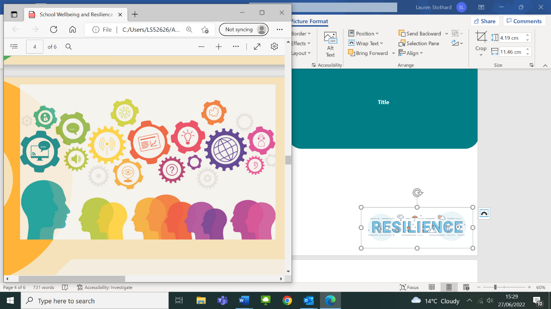

**SEND Team Training, Resources and Support**

The **SEND Support Line** can provide advice and signposting for concerns relating to Social Emotional and Mental Health needs in schools. Please call 01908 657 825 or email [inclusionandinterventionteam@milton-keynes.gov.uk](mailto:inclusionandinterventionteam@milton-keynes.gov.uk)

A variety of training and events are available for both education staff and parents. A list of upcoming training including 'Applying Positive Behaviour Support (PBS) in schools to support with Anxiety' can be found in the **centralised training booklet**. You can download the most up to date version here: <https://www.milton-keynes.gov.uk/sites/default/files/2022-03/Centralised%20training%20booklet%202021-22_NB_Amended.pdf>

For further information about the range of support available please visit the **SEND Local Offer page** here: <https://www.milton-keynes.gov.uk/schools-and-lifelong-learning/send-local-offer>

Many resources are also available within the sections 'Social and Emotional Wellbeing' and 'Staff Wellbeing' on the **MK Educational Psychology Resources webpage**: <https://www.milton-keynes.gov.uk/schools-and-lifelong-learning/SEND/send-resources/educational-psychology-service-resources>

**Psychological Consultation Service**

Staff in education settings can use this service to discuss a range of issues and concerns including pupil's emotional wellbeing. Further information and directions for how to book a consultation can be found here: <https://www.milton-keynes.gov.uk/sites/default/files/2022-02/4.%20Psychological%20Consultation%20Service%20Factsheet-%20final%20version.pdf>

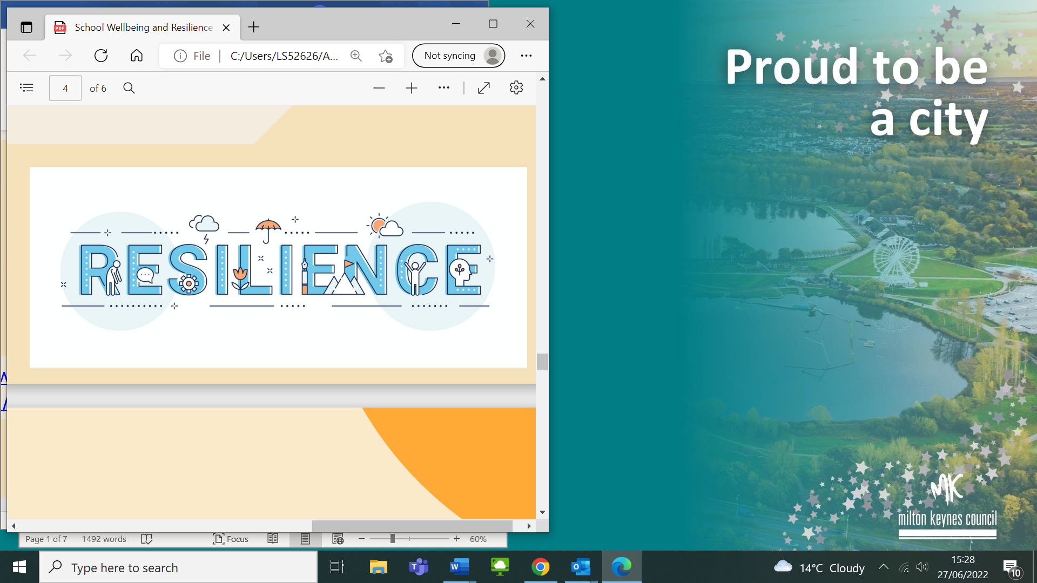

**School Mental Health Initiatives: The Local Picture**

**Senior Mental Health Lead Training**

The Department for Education is currently offering a grant for a senior member of school or college staff to access quality assured training to implement an effective whole school or college approach to mental health and wellbeing. This is available for schools in Milton Keynes and more information can be found here: <https://www.gov.uk/>

**Mental Health Leads in Schools**

Mental Health Leads (MHL) are an initial point of contact for support in this area. Many schools in Milton Keynes have already established a MHL.

If you are a MHL, there is a network in MK that meets every half term. This is an opportunity to meet with other leads, discuss cases and issues and access the latest information about what is happening both locally and nationally with mental health initiatives and resources. If you would like further information about the network or would like to join please email [liz.nightingale@greenparksch.org.uk](mailto:liz.nightingale@greenparksch.org.uk)

**Mental Health Support Team (MHST) in Milton Keynes**

In line with the national initiative, schools in some areas of Milton Keynes have access to the valuable support of a MHST. If this is service is currently available for your school, a MHST will have made contact directly with the school's Mental Health Lead.

This is a service that supports children and young people, aged 5 to 18, and their families, with mild to moderate mental health difficulties. This includes anxiety and/or depression needs MHSTs work with CYP, parents/carers, school staff, and external specialist services. They provide support through:

* Training and workshops for both schools and parents
* Group programmes
* 1:1 interventions where indicated by need

The MHST work with levels 1 and 2 (Get Advice and Get Help) on the Emotional Wellbeing and Mental Health pathway (see two links below). This means that interventions are targeted and short term with an aim of promoting the development of a young person's resilience when approaching their own mental health and wellbeing.



Check with your Mental Health Lead to find out if your school is working in collaboration with the MHST. If in doubt, call 01908 725692 for clarification or signposting.

**COVID, Stress and Anxiety**

Dr Karen Treisman, MBE, is a Highly Specialist Clinical Psychologist who works across the National Health System and children’s services. Her website features a wide range of resources and podcasts. The webpage on Covid, anxiety and stress is particularly valuable and can be found here: [http://www.safehandsthinkingminds.co.uk/cov id-anxiety-stress-resources-links/](http://www.safehandsthinkingminds.co.uk/cov%20id-anxiety-stress-resources-links/)

Learning to look after ourselves and our emotions is crucial to our wellbeing. Self-care is a useful skill that we can learn and develop throughout our lives, and something that schools and colleges can teach their students. Below is a link to self-care toolkits for both students and staff: <https://mentallyhealthyschools.org.uk/resources/self-care-toolkit/?searchTerm=self+care+toolkit>

Online training entitled ‘Psychological First Aid’ is provided by Public Health England. This is a course for those supporting children and young people affected by COVID-19. Those completing the training will be equipped to better identify those children that are in distress and provide support to help them feel safe connected and able to take steps to help themselves during the pandemic or other crisis situations: <https://www.futurelearn.com/courses/psychological-first-aid-for-children-and-young-people>

**National Resources**

**A Whole School Approach**

Recent Government guidance about promoting children and young people’s mental health and wellbeing can be found here: <https://www.gov.uk/government/publications/promoting-children-and-young-peoples-emotional-health-and-wellbeing>

**School Staff Wellbeing**

Public Health England have complied a helpful list of support services, guidance and resources for school staff which can be found here: <https://www.milton-keynes.gov.uk/sites/default/files/2022-03/Public%20Health%20England%20Schools%20Staff%20Wellbeing%20.pdf>

Further staff wellbeing resources for can be found on the Anna Freud website, <https://www.annafreud.org>, some of these include:

*Ten Ways to Support Staff Wellbeing*

<https://www.annafreud.org/schools-and-colleges/resources/ten-ways-to-support-school-staff-wellbeing/>

*An Every Mind Matters self-care tool*: <https://mentallyhealthyschools.org.uk/resources/self-care-toolkit/?searchTerm=self+care+toolkit>