

**Milton Keynes Council**

Dr Sima McGuigan (Senior Educational Psychologist)

Dr Yvonne Bancroft (Senior Specialist Educational Psychologist)

Andrea Piggott (Children and Young People Integration and Transformation Commissioner)

**Webinar One: Developing Whole School Resiliency – Key Notes**

**Wellbeing for Education Return**

**Wellbeing for Education Return**

Wellbeing for Education Return is a government initiative intended to support education staff promote children and young people, teachers and parents and carers’ mental wellbeing and resilience and aid mental health recovery, in light of the impact of Covid-19 and lockdown. The government has invested £8 million nationally to support this initiative and they have developed it as a two part package of support:

* ‘Train the Trainer’ training package which has been developed by a range of education and mental health professionals in collaboration with MindEd. This training has been delivered to Local Authorities by the Anna Freud Centre
* Follow up support to schools until March 2021

The MindEd materials within the national training package were adapted by local experts from the education and health sectors in Milton Keynes to include local services and referral routes. The original full version is published on the MindEd website. The Department for Education’s vision is that those receiving the locally adapted training will embed it into their schools/settings as part of a whole school response to re-opening following lockdown.

Wellbeing for Education Return is not about starting from scratch but building on what local areas already have in place. Some of the recent achievements in our local area are outlined below: 

**Resiliency**

Wellbeing in broad terms is about ‘feeling good and functioning well’ (DHSC, 2014). Wellbeing at its’ best is where students **learn** best, education staff **teach** and relate best and parents and carers **parent** best.

The more resilient we are the more improved our wellbeing becomes.

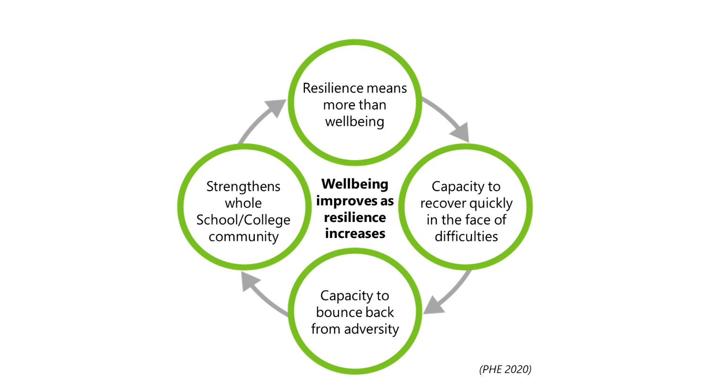

However, resilience means more than wellbeing:

* Capacity to recover quickly in the face of difficulties; a feeling of being insulated from stress; feeling that although there are stressful factors, you are okay.
* The capacity to bounce back from adversity (PHE, 2020).
* Strengthens a whole school/college community; provides the person, child, adult and whole community with a sense that they are emotionally strong when faced by stresses.

In context of the pandemic, it is important to consider the children and young people who may be more vulnerable to low resilience and therefore low wellbeing. The latest guidance from Public Health England (2020) outline two categories of higher risk:

1. Those who already have a statutory entitlement for care and support, e.g. those who have a social worker; those with an EHC plan; fostered and adopted children; those with learning difficulties, autism etc.
2. Children not known to services but may have health/other factors leading to poor outcomes, e.g. those living in poverty; those where parents have mental health problems; are drug alcohol dependent etc.

Whilst schools have little influence over what children and young people are born with and grow up with, they can influence some of the events that happen to them and their families. For some children and young people, school provides an important protective role when other aspects of their lives such as their home/family circumstances might be difficult or challenging. Research shows that one solid, trusting relationship with a teacher or similar figure can be important in developing positive long-term outcomes of children and young people from such additionally vulnerable family backgrounds.

**The Learning Zone Model**

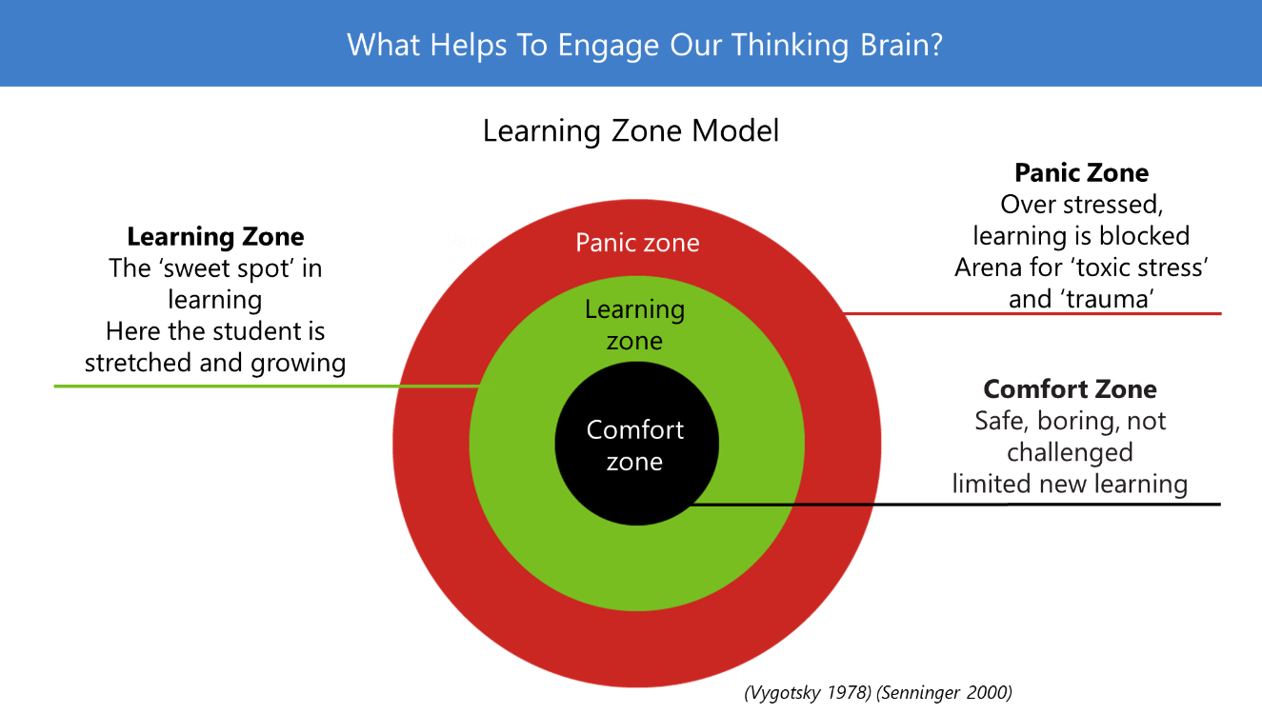The learning zone is where a child or young person feels emotionally regulated and safe and therefore is able to engage in learning. This also applies to adults who have their optimum zone and will not function at their best unless their wellbeing is supported.

**The 5 Rs: An Aide Memoire for Interactions**

The key to this framework is relationships. For any interaction taking place inside your school/college, the 5Rs provides a framework to remember the types of actions that help promote wellbeing.

Help the **relationships; recognise** and look out for needs and cues; listen and **reflect** carefully; support **regulation** of emotions so that things are manageable; and in so doing support new habits of **resilience.** This model can be used in any order.

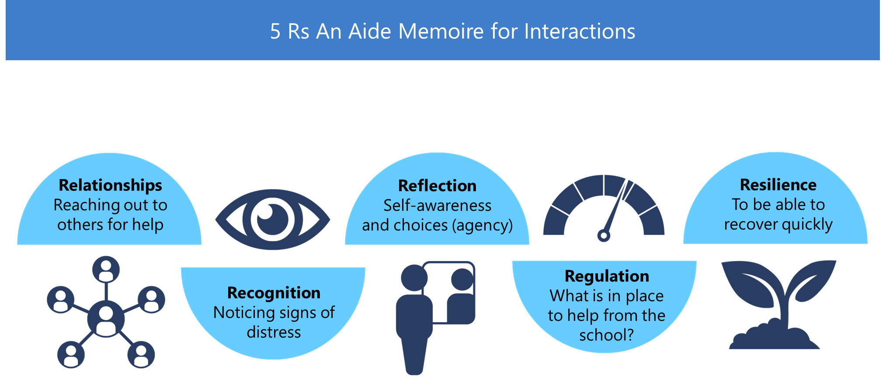This is a recommended reference for your whole school to adopt.

**Psychologically Informed First Aid (PFA)**

This framework consists of a three-step plan: Look, Listen and Link.

Similarly with the 5Rs, it builds on ways of remembering how to deliver support to each other at all ages. It builds from the same ethos of recovery and support as soon as possible, to pathways towards return of wellbeing.

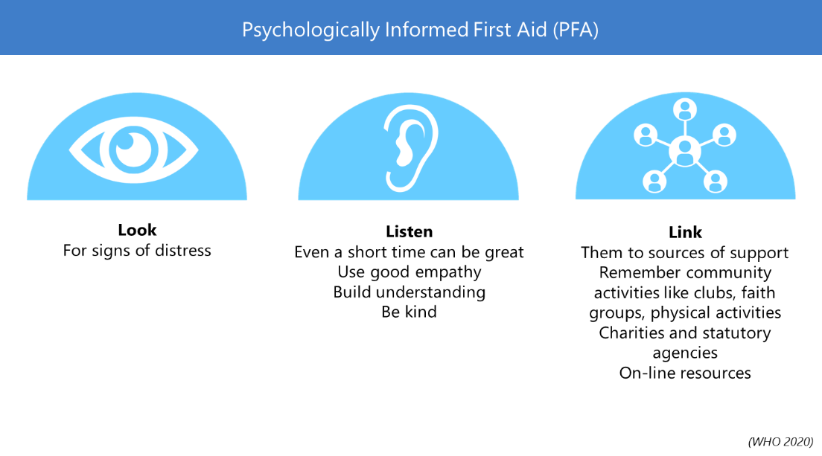Consider the PFA as an additional level of support for any individual, built on the 5 Rs but then reaching outwards (as required) to further supports and **links.**

**Look** for signs of distress such as alcohol and other substances, gambling and other addictions, self-sabotage, relationship breakdowns, insufficient sleep and isolation.

**Listen** carefully and well. Some top tips for listening are: listen with empathy skills, give time and be kind; remember confidentiality “if I think you or others are at harm I may seek support”; plan support if possible, setting a time to meet and discuss is supportive.

**Link** to sources of support. If appropriate, this can include ordinary community activities such as clubs, religious groups, sports, charities, on-line resources etc. Schools may also link with other agencies such as teams within the Local Authority. Research shows that even one solid good relationship with a teacher or similar figure can be important in developing positive long-term outcomes of children or young people from such additionally vulnerable family backgrounds.

**5 Key Principles of Whole School Approach to Recovery**

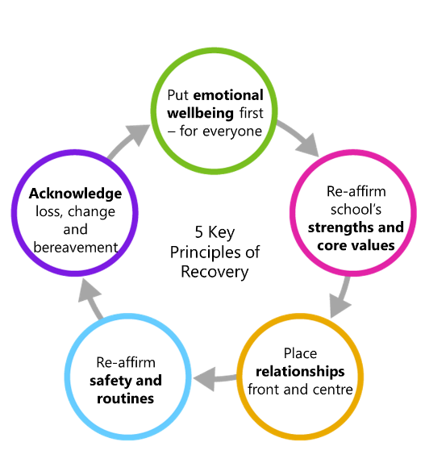The 5 Rs sit inside of the 5 Key Principles of Recovery and PFA. PFA is like the glue linking interactions and support to communities of support.

These 5 key principles support the 3 pillars of recovery:

1. Build relationships
2. Learn habits of resilience and strategies of coping
3. Give sense of support and make change happen

These 3 pillars will enable post trauma leaning, growth and recovery, supporting new resilience and more wellbeing.

An example of applying this on a whole school basis:

* Behaviour policies which recognise and take close account of underlying covid-19 related stresses
* Highlighting how these stresses might be impacting behaviour such as attendance or presenting behaviours
* Thereby avoiding what might be counterproductive sanctions

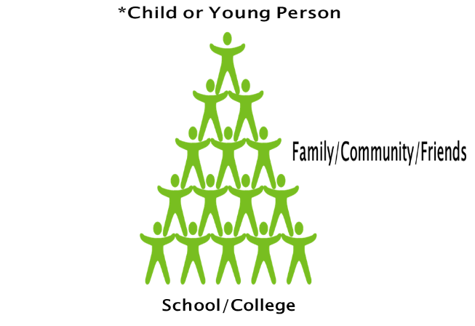Overall, these models can be applied within three levels of interactions:

1. The individual person to person interactions supported by 5 Rs as an aide-memoire for positive interactions
2. Linking to wider supports available and recovery support for the individual using the PFA
3. How these two levels of support sit within the whole school/college ethos based on the 5 Key Principles of Recovery.

**6**

Educational Psychology Team: [education.psychology@milton-keynes.gov.uk](mailto:education.psychology@milton-keynes.gov.uk)

Andrea Piggott: [andrea.piggot1@nhs.net](mailto:andrea.piggot1@nhs.net)

Educational Psychology Service website: <https://www.milton-keynes.gov.uk/schools-and-lifelong-learning/send-local-offer/education/send-services/new-educational-psychologists-service>