

**Milton Keynes Council**

Dr Sima McGuigan (Senior Educational Psychologist)

Dr Yvonne Bancroft (Senior Specialist Educational Psychologist)

Andrea Piggott (Children and Young People Integration and Transformation Commissioner)

**Webinar Two: Bereavement and Loss – Key Notes**

**Wellbeing for Education Return**

**Wellbeing for Education Return**

Wellbeing for Education Return is a government initiative intended to support education staff promote children and young people, teachers and parents and carers’ mental wellbeing and resilience and aid mental health recovery, in light of the impact of Covid-19 and lockdown. The government has invested £8 million nationally to support this initiative and they have developed it as a two part package of support:

* ‘Train the Trainer’ training package which has been developed by a range of education and mental health professionals in collaboration with MindEd. This training has been delivered to Local Authorities by the Anna Freud Centre
* Follow up support to schools until March 2021

The MindEd materials within the national training package were adapted by local experts from the education and health sectors in Milton Keynes to include local services and referral routes. The original full version is published on the MindEd website. The Department for Education’s vision is that those receiving the locally adapted training will embed it into their schools/settings as part of a whole school response to re-opening following lockdown.

Wellbeing for Education Return is not about starting from scratch but building on what local areas already have in place. Some of the recent achievements in our local area are outlined below:ents in our local area are outlined in this diagram:

**Definitions**

**Bereavement** = the death of someone important

**Grief** = emotions that we experience due to death

Grief is a normal response to death, although it may look different from person to person.

**Understanding Bereavement**

**7 Stages of Grief** (Modified Kubler-Ross Model)

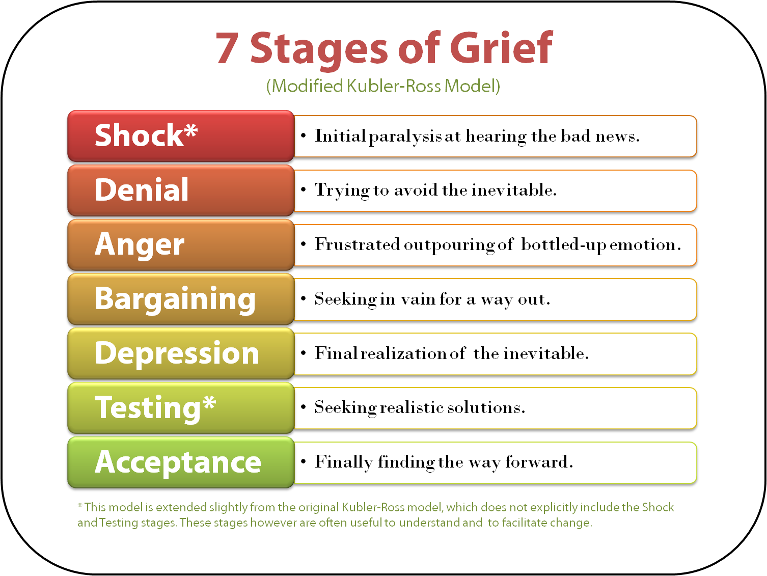This model explains the stages that people may experience when dealing with a bereavement. However, it is important to note that grief is an individual experience and therefore, experiences of grief can vary from person to person.

The stages mentioned are not a fixed sequence and it is normal to have good or bad days.

The symptoms of grief can last for weeks, months or years. How we respond to bereavement and loss varies widely.

It is important to remember that whatever you experience is okay, and this is also something that you could communicate to someone you are supporting.

This model can be applied to any form of loss, but we focus on bereavement from death.

**Shock and Disbelief:** For many people, this is often the first stage after learning about a death, especially if it was sudden or unexpected. Shock is often a way of protecting ourselves from feeling overwhelmed.

**Denial:** This doesn’t mean denying the event but refers to how you express your emotions and feelings. Some people deny their feelings. For some, this is a coping mechanism, perhaps for example to get through a day of the rituals of religious services.

**Anger:** With a death, feelings of disbelief can turn into frustration and anger. Thoughts of ‘why is this happening to me’ are common. It is also normal to feel anger towards the situation or the person who died, or someone who has nothing to do with the situation. Whilst anger is a normal part of the grieving process, a role that schools can play in helping children and young people is to support them through releasing their emotions in a healthy way.

**Bargaining:** Often a way to prevent permanent loss by ‘making a deal’ with someone, for example, a person trying to make a deal with their God. If the bargaining does not get the hoped for result, it can lead back to shock and denial.

**Depression:** At this stage, the grieving person might feel more able to accept the death but unable to cope with it. Unfortunately, loneliness can accompany feelings of depression, especially as the death or loss in the wider sense starts to sink in. Feelings of guilt may also emerge here and can lead to people thinking it is their fault. In this stage the mind won’t necessarily determine between feelings that are logical and those that are not.

**Testing:** During this stage a bereaved person begins to realise the effect that grief is having on their personal life and so they begin to look for realistic ways to learn to cope with grief. They may try new things to improve their mood and help improve their emotional outlook.

**Acceptance:** This is the stage where a grieving person will be able to accept and cope with their loss. This doesn’t mean they will ever ‘be over it’ but can start to feel okay again. This is the stage where the person can acknowledge how the death or loss has affected them and reflect upon what the person or thing they lost meant to them.

**Growing Around Grief** (Tonkin, 1996)

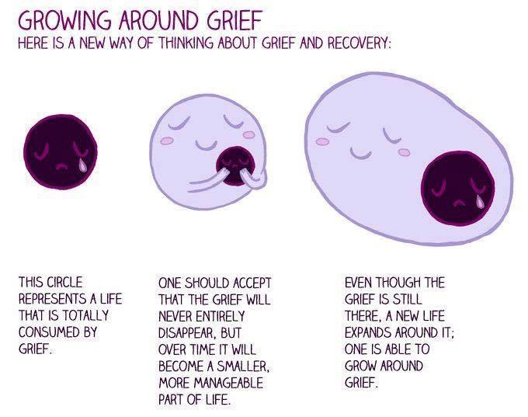

Traditional thinking around grief suggests that over time the grief somehow becomes smaller, diminishing as time passes.

Dr Tonkin suggests that we do not move on from grief and that grief does not become smaller, but instead we grow around it. Life experiences can expand to accommodate the bereavement whilst making space for new things.

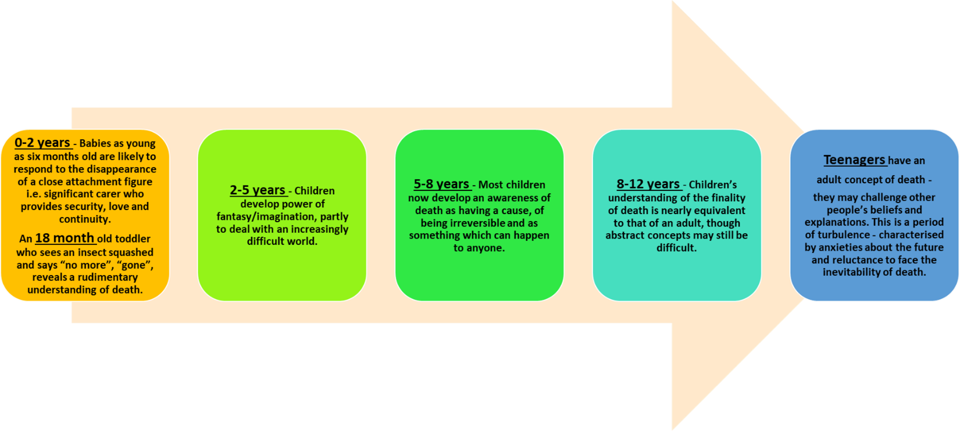**Meaning Making for Different Ages**

The concept of disappearance, loss and death is experienced from as young as new born and toddler age. It is why they cry sometimes when their significant caregiver leaves the room and are fascinated with games such as peek-a-boo.

Conversations with children about death can happen in some everyday situations such as looking at insects, and children’s fairy tales often incorporate death including the latest hit Frozen. They may not have the ability to understand what is going on entirely, but will experience feelings around grief and loss, and we should be very careful in underestimating that.

By the time children are 5-8 years old, they understand death as being irreversible.

By 8-12, children’s understanding of death can be similar to adults, especially as they become aware of their own mortality.

Teenager’s experiences of bereavement can leave them feeling confused and anxious. In the context of Covid19, it is possible that these feelings may be intensified.

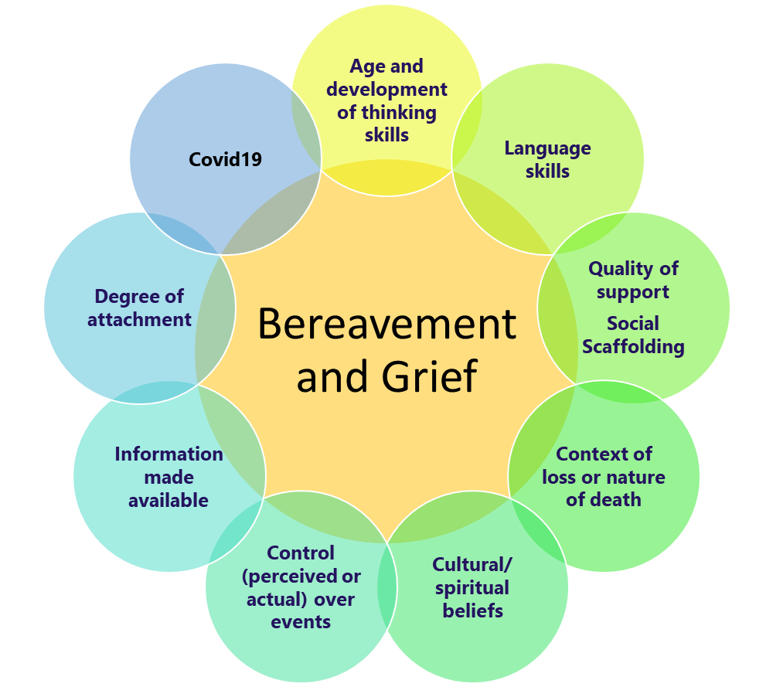

**Factors Affecting Bereavement and Grief**

A person’s ability to cope with grief can be heavily impacted upon by their cultural and religious beliefs, the support structures available to them and the circumstances surrounding the loss and death (e.g. whether it was sudden and unexpected, or loss in lockdown restrictions).

School cannot change what happened with the death or what the circumstances were (e.g. lockdown restrictions), but they can influence the environment in a positive way by ensuring adequate support is provided. Most grieving children and young people do not need a ‘bereavement expert’; they just need people who care.

For young children, views of death can often be distorted. They can be influenced by the information made available to them, their control over events and their developing cultural or spiritual beliefs. Their understanding can be distorted by cognitive development which in turn is strongly influenced by language skills. Limitations here can influence understanding of the situation and also the expression of thoughts and feelings.

**Grief in the Context of Covid19**

Covid 19 can lead to people experiencing different types of grief, including anticipatory grief or grief after a sudden and unexpected death of a loved one. Under normal circumstances, we turn to others in our lives for support. We might spend a loved one’s last moments with them then gather with friends and family to cry, share happy memories, and offer care and support to one another. The coronavirus pandemic however has made it almost impossible to carry on ‘as normal’. Restrictions have had to be put in place, which have negatively impacted on our ability to engage in the familiar and comforting traditions that support the grieving process. This has made it that much more difficult for many to cope.

All behaviour is communication. Therefore, if you are seeing challenging or unusual behaviours in children and young people, it is very likely that this is their way of communicating their distress at something. In many instances, they will not be aware that this is what they are doing and will often struggle to communicate why they are behaving the way they are. A key role that adults can play is to try to recognise and understand the behaviour as a form of communication.

**Watchful Waiting**

Watchful waiting is the concept of carefully watching and monitoring children and young people (in this case, those you may view as vulnerable). If you notice any changes in their behaviour, this can be the time to intervene and offer support.

**Puddle Jumping**

Puddle jumping is the process of naturally dipping in and out of grief. Children and young people can experience grief in waves; they may be sad one minute and happy the next. This is a type of safety mechanism and prevents overwhelming feelings.

**Knowing What to Say**

It is important to know what to do or say to a grieving person, which can often feel uncomfortable. The most important think you can do is to simply be there.

**There is no right or wrong way to grieve.**  Grief does not always unfold in orderly, expected stages. It can be an emotional rollercoaster, with unpredictable highs, lows and setbacks. Everyone grieves differently, so it is important to avoid telling the grieving person what they ‘should’ be feeling or doing.

**Grief may involve extreme emotions and behaviours**.  Feelings of guilt, anger, despair, and fear are common. A grieving person may yell to the heavens, obsess about the death, lash out at loved ones or cry for hours on end. The grieving person needs reassurance that what they feel is normal. Don’t judge them or take their grief reactions personally.

**There is no set timetable for grieving**. For many people, growing around grief after bereavement takes 18 to 24 months but for others it may be longer or shorter. Don’t pressure the grieving person to move on or make them feel like they’ve been grieving too long. This can actually slow the healing process.

As children and young people are aware of death at some level, it is important to talk about it. It is always better to say something rather than nothing, and important to use straight language rather than misleading language. Using concrete words such as ‘death’; ‘dying’ and ‘funeral’ IS BETTER THAN ‘went to sleep’ or ‘we lost them’, which may be confusing for younger children or those with difficulties with the nuances of abstract concepts and multiple meanings.

When someone is ill, Kubler-Ross reminds us to offer hope in our language, using terms such as ‘seriously ill’.

**The ‘PIES’ Model**

This model is helpful when thinking about how to support others with trauma and loss.

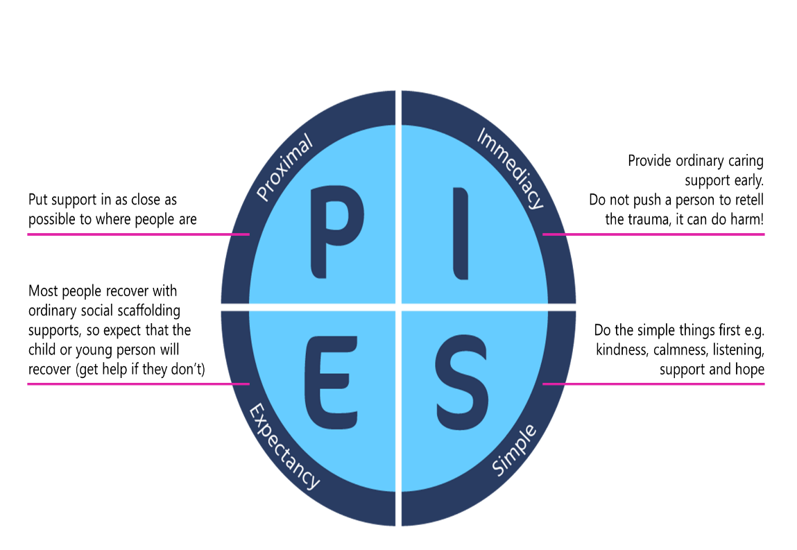

**P**roximal: Put support in as close as possible to people. If you become concerned, ask for help.

**I**mmediacy: Don’t wait to watch it get worse; provide ordinary caring support early.

**E**xpectancy: Expect that the child or young person will recover: use all methods described in these two webinars.

**S**imple: Use simple interventions first.

**Next Steps for Schools**

Steps for schools to plan ahead and introduce this into whole school approaches to supporting with bereavement and loss:

1. Read the ‘Planning for a Sad Event Guidance’ found here: <https://www.milton-keynes.gov.uk/schools-and-lifelong-learning/special-educational-needs/critical-incidents-schools-and-settings>
2. Review and reflect upon school policies
3. Keep on top of training
4. Ensure you know where and how to access up-to-date and relevant local and national support
5. Ask families to alert your school as to whether they have had a bereavement and the circumstances*
6. Be open and alert to hearing and responding flexibly to different circumstances
7. Implement the 5 Key Principles for Whole School recovery
8. Build on the 5 Rs and PFA

**8**

Educational Psychology Team: [education.psychology@milton-keynes.gov.uk](mailto:education.psychology@milton-keynes.gov.uk)

Andrea Piggott: [andrea.piggot1@nhs.net](mailto:andrea.piggot1@nhs.net)

Educational Psychology Service website: <https://www.milton-keynes.gov.uk/schools-and-lifelong-learning/send-local-offer/education/send-services/new-educational-psychologists-service>