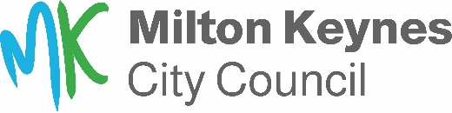
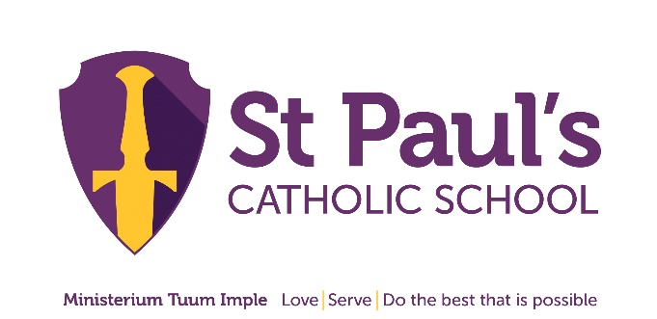

Statutory Consultation: Development of Communication and Interaction Resourced Provision at St Paul’s Catholic School

Department: Special Educational Needs and Disability (SEND)
Contact: SEND Team
Email: highneeds@milton-keynes.gov.uk
Period: 7 October 2022 to 4 November 2022

Summary
Local Authorities have a statutory responsibility under the Children and Families Act 2014 to keep its special educational needs provision under review, to ensure sufficiency in placements to meet the needs of children and young people with special educational needs and/or disabilities (SEND) working with parents/carers, young people and providers.

The council has a legal duty to ensure there are sufficient places for all children and young people, including those with Education, Health and Care Plans (EHC) and to support this the Governing Body at St. Paul’s Catholic School have published a statutory notice for the expansion of the Communication and Interaction Resourced Provision.

Purpose
The consultation is seeking views on the following proposals:

- Development of Resourced Provision at St. Paul’s Catholic School through 24 additional places at the school. These additional places will be supported by a dedicated 3 classroom block development, to provide a unit model of delivery.

This consultation seeks views from those directly involved as to whether they agree with the proposal.

To respond please email highneedsplanning@milton-keynes.gov.uk
or write to the City Council address

