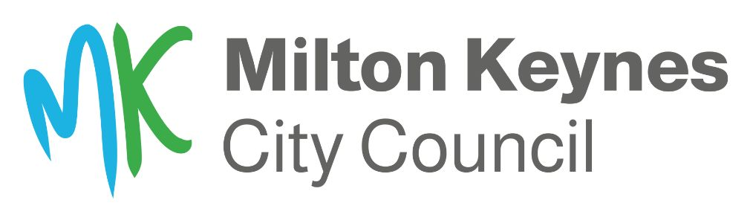

Tickford Bridge Update – 24 October 2022

Tickford Bridge is a Scheduled Ancient Monument of significant national importance therefore any works, however minor, must go through a rigorous approvals process and have regular inspections as the works take place by Historic England.

We factor in for these checks in the planning stage and allow plenty of time for any adjustments however if unforeseen issues come up, there can be longer delays pushing the completion date back.

In August, the Historic England inspector visited the bridge and raised concerns over the painting works resulting in a change to hand preparation only to retain the historic layers of paint as much as possible. We were also required to provide detailed documents on our plans and processes for this stage of the works. This additional work and various other tests delayed the painting stage as we were unable to begin without the official approval from Historic England.

In September, a pigeon nest was discovered while the scaffolding was being erected on the underside of the bridge. As all active bird nests are protected under the Wildlife & Countryside Act 1981, we had to consult an ecologist who visited the site in early September and found two active nests, one with eggs and one with recently hatched chicks.
For this reason, a temporary halt to the works had to be called so that a specially designed protective barrier could be installed around the nests. Once the ecologist had confirmed the birds had left the nests in early October, works could restart.

With many schemes like this, once the refurbishment works start, unforeseen issues can appear. In this instance, once the defective paint layers were removed, serious structural defects became visible including cracks in the cast iron. This work must be carried out with additional safety measures due to the high lead content in the paint.

Due to these high levels of lead-based paint that were used on the bridge in the past, it must be shrouded in protective screens to retain contaminants and prevent pollution. The protective screens will remain in place during the repainting work. This means the workforce are not always visibly working unless taking a rest break.

Additional plans for repair work had to be devised and set to Historic England for approval. Whilst this process is ongoing, the contractor is working on the underside of the bridge, subject to water levels.

The permit for the bridge works is due to expire on 14 November. Due to the reasons listed above this date is no longer realistic and we will need to extend the permit until 25 November, which has been requested.

We are confident that this date can be met in time for the Christmas Light switch on scheduled for the 26 November and understand the importance of this event for the local community and businesses.

