

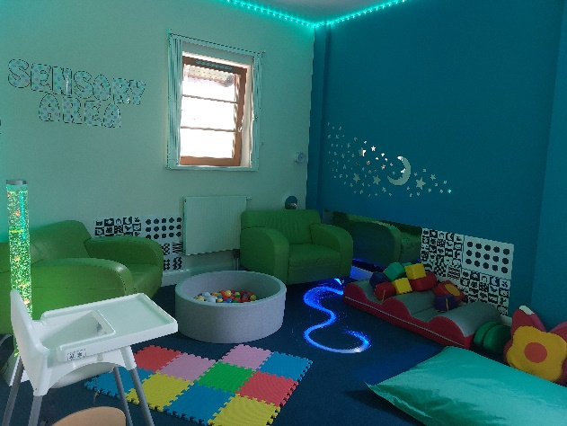

The Family Time Service is part of Milton Keynes City Council and is made up of a team of Social Workers, Senior Family Time Workers, Family Time Workers, and our Family Time Co-Ordinator. We are based at Coffee Hall, but also supervise sessions over at our Greenleys venue to, and if appropriate in the local and wider community. We arrange and support family time between child/ren and their parents, with direction given by the Local Authority and Court.

Our Family Time Workers will work closely with parent/s, carers and child/ren to assist in the family time session being a good quality positive time for all. They may provide support and suggestions to help with this and will offer feedback after each session if the parent wishes. The Family Time Workers will write a factual based observational report which is shared with the child’s allocated Social Worker and with court, where applicable.

**www.milton-keynes.gov.uk**



September 2022



Contact Details:

**Who are we?**

Monday to Friday (9am – 5pm)

Saturday (9:30am – 4:30pm)

Tel: 01908 253232

Email: [FASTContactservice@milton-keynes.gov.uk](mailto:FASTContactservice@milton-keynes.gov.uk)

Family Time Service,

135 Jonathans,

Coffee Hall,

Milton Keynes.

MK6 5DR.

Out-of-hours Contact details

Emergency Social Work Team (ESWT)- Tel: 01908 265545

***Milton Keynes City Council***

***Family Time Service***

(Carer’s Information)



Children and Families| Family Time Service

**Who requests the Family Time Service to be involved?**

The Family Time Service supports and supervises family time sessions between adults and children in a child friendly appropriate setting. Usually, we become involved with a family if a child or children have been removed from the care of their parent / guardian, and the court have directed that family time needs to be supervised or supported.

The child/ren will have a named Social Worker to whom we will send all updates and reports to. We hold review meetings with the parent/s, the Social Worker, and a Senior Family Time worker to discuss how the sessions are going, changes to the family time arrangements, any issues that may have occurred and any move on plans if applicable. The Social Worker will share feedback provided by the Child’s carer.

**How does the Family Time service work?**

1. Referral request received from the child/ren’s Social Worker.
2. Request will be risk assessed by a senior member of the Family Time service.
3. If accepted, a planning meeting will be arranged; referred parent/s will be invited along with the child’s Social Worker.
4. A written agreement between the parent and the Family Time Service is signed by all parties present at the meeting (this clearly outlines the expectations of using our service).
5. This will include an early arrival protocol being put in place e.g., minimum fifteen minutes for all parents to be at the centre. If they are late for any reason, the session will be cancelled (*this allows us to remain consistent and fair to all, as it is very difficult to track a pattern of persistent late attenders, who may have historically been given leeway).*
6. The Social Worker will liaise with the children’s carer to ensure the dates and times scheduled can be met, and if support is needed with this, then this should be explored with the carer at the time.

**Carer’s role in supporting Family Time**

* Prepare the child/ren for family time: please book a pre visit directly with us, where we will obtain your views and any information related to the child/ren e.g., daily routine, school / nursery hours and clubs; this will contribute to the planning meeting discussions*).*
* Please arrive a few minutes before the start time and park around the front of the building *(parents come in via the back gate at Coffee Hall).*
* On arrival bring the child/ren inside the reception area of the centre. You will be greeted by the Family Time worker.
* Handover- please share marks/bruises present with the worker, so an explanation can be given to the parent if needed. Please share other information that will be useful to know e.g., last bottle feed and nappy change, health, wellbeing, and mood of the child and how their day has been so far.
* If you wish to have a chat with a senior member of our team, please wait for the child/ren to be taken to their room by the worker first.
* Give factual updates in the communication book in respect of the child/ren and clear instructions e.g., bottle feeds.
* Please be understanding that there could be a range of reasons for a session being cancelled last minute. Any queries, please liaise with the Social Worker about this.
* Please do not bring a child with a contagious illness to the centre (call us in advance). All medication to be handed to the worker on arrival with instruction (if applicable).
* Any concerns in respect of Family Time, please liaise with child/ren’s Social Worker in the first instance, along with your Supervising Social Worker.