

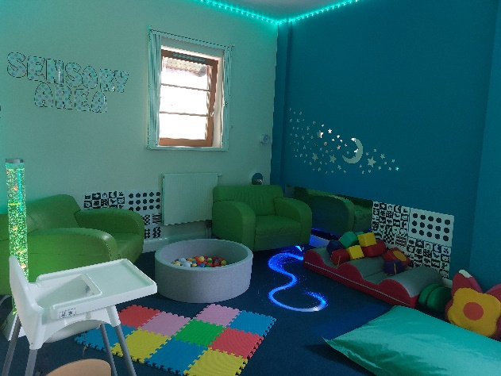

The Family Time Service is part of Milton Keynes City Council and is made up of a team of Social Workers, Senior Family Time Workers, Family Time Workers and our Family Time Co-Ordinator. We are based at Coffee Hall, but also supervise sessions over at our Greenleys venue to, and if appropriate in the local and wider community. We arrange and support family time between child/ren and their parents.

**www.milton-keynes.gov.uk**



September 2022

MKCC logo jpg

Contact Details:

**Who are we?**

Monday to Friday (9am – 5pm)

Saturday (9:30am – 4:30pm)

Tel: 01908 253232

Email: [FASTContactservice@milton-keynes.gov.uk](mailto:FASTContactservice@milton-keynes.gov.uk)

Family Time Service

135 Jonathans,

Coffee Hall,

Milton Keynes.

MK6 5DR.

Out-of-hours Contact details

Emergency Social Work Team (ESWT)- Tel: 01908 265545

***Milton Keynes City Council***

***Family Time Service***



Children and Families| Family Time Service

**How does the Family Time service work?**

The Family Time Service supports and supervises family time sessions between adults and children in a child friendly appropriate setting.

The service receives a request from the child/ren’s Social Worker for family time to be arranged. This request will be looked at by a senior member of the Family Time service and discussed with the social worker.

Following this discussion, a planning meeting will be arranged to which the referred adult / parent will be invited and expected to attend. This is in order that their views are part of the meeting and recorded, but also to explore the current situation, how best the Family Time Workers can support the family and give clear advice on the Centre’s expectations are. A written agreement between the parent (adult) and the Family Time Service is signed by all parties present at the meeting as this also clearly outlines what you should expect from us as a service. Our Family Time Workers will work closely with both parent and child/ren to assist in the family time session being a good quality positive time for all. They may provide support and suggestions to help with this and will offer feedback after each session if the parent wishes.

Support can be given if required in initiating play for example, and guidance around meeting the basic care needs of the child/ren. We aim for both parent and child/ren to enjoy their time spent together. The Family Time Workers will write a factual based observational report which is shared with the child’s allocated social worker and with court, where applicable.

**Who requests the Family Time Service to be involved?**

Usually, we become involved with a family if a child or children has been removed from the care of their parent / guardian, and the court have directed that family time needs to be supervised or supported.

The child/ren will have a named social worker to whom we will send all updates and reports to. We also hold review meetings with the parent/s, the Social Worker and a senior member of the Family Time service to discuss how the sessions are going, changes to the family time arrangements, any issues that may have occurred and any move on plans if applicable.