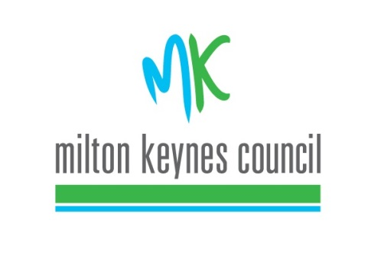
Home to School Travel Exceptions and Appeals (TEA) Panel Terms of Reference
People Directorate
Education Sufficiency and Access

Call 01908 252526
E-mail HTST@milton-keynes.gov.uk

Purpose

The council has a clear policy about which children are eligible for support with home to school travel. If policy determines that a particular request for support with home to school travel cannot be granted under the policy, then parents/carers may make an application to ask for the case to be heard by the Travel Exceptions & Appeals Panel, (hereafter ‘the Panel’). There are three reasons why this might happen:

- The parent/carer believes that the policy has been incorrectly applied
- The parent/carer believes that the policy has been correctly applied, but their child’s needs are exceptional and merit consideration outside of normal policy
- Home to school travel has been agreed under policy, but the parent/carer believes that the manner in which it is being provided is inappropriate for their child’s needs
Membership and Meeting Schedule

The Panel is chaired by the Head of Delivery, Sufficiency and Access and attended by senior officers from Education Access, Finance and Special Educational Needs.

Meetings are held on a fortnightly basis.

Criteria applied by the Panel

All decisions of the Panel will be made on the basis of evidence produced by the parent/carer or local authority representative acting on behalf of the parent/carer. A parent/carer can provide input from an external third party but this must be submitted in writing along with the application. For example, if health issues are cited as a factor, then the parent/carer should submit written medical evidence from health practitioners with their application.

At the Panel the following questions will be asked:

- Has the policy been correctly applied?
- If the policy has been correctly applied is the support being offered, or the fact that no support is being offered, appropriate for the child and family’s needs?

- If not, what is the cheapest way in which the child and family’s needs can be appropriately met?

All relevant information and evidence relating to each case must be submitted at the time a TEA application is made. If insufficient information is provided, the case will be postponed until a future Panel meeting.

Notification of panel decisions

Decisions reached by the Panel will be notified to parents/carers by email within 5 working days (may take longer to arrive if no email address is provided) of the Panel meeting and a clear reason will be given about the rationale for the decision, alternatively applicants can call 01908 252526 to be updated of the panel outcome.

If support for travel is agreed or altered, it can then take the Client Transport Team approximately 15 working days from the date of the Panel’s decision to put the operational arrangement into place.

Key dates – Subject to change if required

Application deadline | TEA Panel date | Outcome emailed by
02 December 2022 | 12 December 2022 | 16 December 2022
16 December 2022 | 09 January 2023 | 13 January 2023
13 January 2023 | 23 January 2023 | 27 January 2023
27 January 2023 | 06 February 2023 | 10 February 2023
10 February 2023 | 20 February 2023 | 24 February 2023
24 February 2023 | 06 March 2023 | 10 March 2023
10 March 2023 | 20 March 2023 | 24 March 2023
24 March 2023 | 03 April 2023 | 06 April 2023
07 April 2023 | 17 April 2023 | 21 April 2023
21 April 2023 | 02 May 2023 | 05 May 2023
05 May 2023 | 15 May 2023 | 19 May 2023
19 May 2023 | 30 May 2023 | 02 June 2023
02 June 2023 | 12 June 2023 | 16 June 2023
16 June 2023 | 26 June 2023 | 30 June 2023

Emergency Arrangements

In exceptional circumstances there may be situations where cases need to be reviewed outside of the above TEA panel timeframes for safeguarding purposes. In such situations a request will need to be made by the Head of Service in writing via email to the Chair of the panel. It is at the Chairs discretion whether it is appropriate to deviate from the deadlines stated above and for the case to be seen at the next TEA panel regardless of the date of the application made.

Dissatisfaction with panel decision

The outcome of the panel is final.

A new application will only be accepted if key information was omitted from the original application; any further application will need to provide new and detailed information regarding family’s circumstances/needs.

Only is the case where you believe that policy or procedure outlined in this document have not been followed can you consider making a complaint. This option is available out the council’s website.

If you feel that the support offered does not meet need or is unsuitable then you can appeal this decision within 20 working days by submitting a written request for the decision to be reviewed. Once this is received an Independent panel will have up to 40 days to review and reach a decision.

How to Submit a TEA Application

Full information about how to make an application can be found at:
www.milton-keynes.gov.uk/schools-and-lifelong-learning/information-for-parents/home-to-school-transport

