Woughton Community Neighbourhood Plan 2017-2031
Consultation Statement

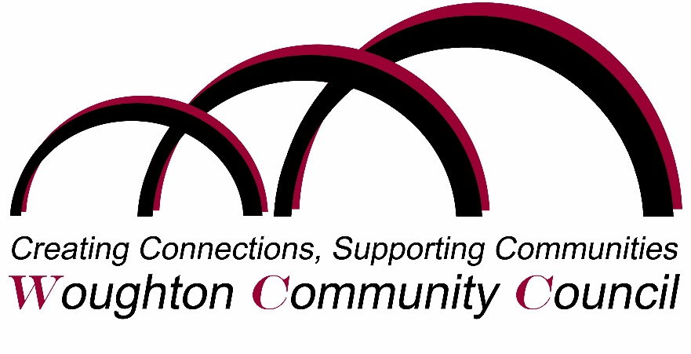

Published by Woughton Community Council
under the Neighbourhood Planning (General) Regulations 2012
Part 5, Section 15(2)
Table of Contents

Introduction 3
Background 3
The Consultation Process 4
Establishing the Neighbourhood Area 4
Preparing the Plan 5
The Key Issues raised and how they were addressed in the Plan in Rounds 1 and 2 6
Changes made as a result of the representations to the Pre-Submission Consultation (Round 3) 8

Appendices (available in separate documents):
Annex A: Timeline of meetings and decisions about the Neighbourhood Plan
Annex B: Summary of consultation activities in creating the WCNP
Annex C: Summary of Round 1 Consultation (with publicity materials)
Annex D: Summary of Round 2 Consultation (with publicity materials)
Annex E: Report on the Regulation 14 Consultation Period
Annex F: List of Stakeholders consulted during the Regulation 14 Consultation Period
Annex G: Summary of All Comments made during the Regulation 14 Consultation Period (with publicity materials)

Introduction
This Consultation Statement has been prepared to fulfil the legal obligations of the Neighbourhood Planning Regulations 2012 Section 15(2) in respect of the Woughton Community Neighbourhood Plan (WCNP). Part 5 of the Regulations sets out what a Consultation Statement should contain:
(a) contains details of the persons and bodies who were consulted about the proposed neighbourhood development plan;
(b) explains how they were consulted;
(c) summarises the main issues and concerns raised by the persons consulted;
(d) describes how these issues and concerns have been considered and, where relevant, addressed in the proposed neighbourhood development plan.

Background
The Woughton Parish is a unique area set inside the setting of the UK’s most successful New Town. However, it faces many challenges including high deprivation levels and the lowest quality of health in Milton Keynes with the life expectancy some 10 years shorter than any other ward in the city.
Four of the seven residential estates in Woughton have been identified by Milton Keynes Council as part of a major 15 year Regeneration Programme. While the intentions of this programme are aimed at improving the overall quality of life in the identified areas, it has also led to many residents feeling concerned over the potential consequences on their homes and everyday lives. As such, the community at large has expressed concerns over how the Regeneration Programme may impact them, their homes, and their community and the Community Council decided to embark on creating a Neighbourhood Plan in November 2013 (see Annex A).
Prepared by Woughton Community Council and a Steering Group made up of local representatives, the purpose of the Woughton Community Neighbourhood Plan (WCNP) is to set a 15 year planning policy framework for all communities that make up Woughton that will guide its future development, regeneration and improvement. The Plan covers a variety of topics including Spatial Principles, Green Infrastructure, Housing, Accessibility, Business & Retail, Social Infrastructure, and the Regeneration Programme. Therefore the aim is not to not stop development altogether, but it is to encourage the right types of development to occur based on the priorities of the current population, not just those included in the Regeneration Programme, by influencing how future decisions are made about how, where and when change happens in the area.

The Consultation Process

Establishing the Neighbourhood Area
The consultation and publicity period to establish the Neighbourhood Area occurred between 5 November and 17 December 2014. The area was designated as the Parish Area on 13 January 2015 (see Figure 1). From here, WCC commissioned the consultancy firm rCOH Ltd. to assist in the development plan as of March 2015, and a Steering Group was appointed in June 2015 with representatives of the Parish Council, one residential representative for each estate, a planning officer from Milton Keynes Council, and a representative from Milton Keynes University Hospital. The Steering Group has worked very hard to reach out to different stakeholders in the community (residential and business) for their involvement in creating the Plan.

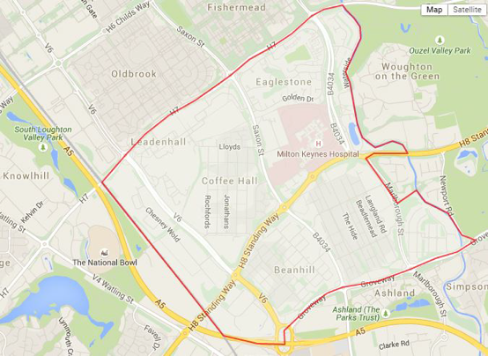
Figure 1: Woughton Designated Neighbourhood Plan Area

Preparing the Plan
In creating the Plan, three rounds of consultation were utilised to gather baseline information, community opinion on local problems and potential solutions, and to gather views on potential policies. Each round built of the previous one as well as other evidence and research gathered throughout the process so that policies would be as reflective of the general community opinions as possible.
Throughout this process, the Community Council and the Steering Group had difficulty increasing the numbers of stakeholders submitting feedback given the population of the Parish area, an issue which MKC has raised previously. This was not due to a lack of trying as the Steering Group went to great lengths to have a variety of consultation methods that built on the lessons learned from previous rounds and attempted to engage with the largest cross section of residents possible to ensure policies that are truly reflective of the area. See Annex B for a summary of consultation and engagement methods by consultation round.
This has been determined to be largely due to the transient nature of residents and the content of more well-established residents to either have their views passed to residential representatives on the Steering Group or to wait until the details of the Regeneration Programme were established. However community opinion has been consistent throughout this process, and these have also been supplemented with insights of local councillors and other representatives that are reflective of other stakeholders in the Parish.
The Community Council has been very mindful from the start of the project that for the Plan to be made, it must pass a referendum, and that this cannot be taken for granted. It has therefore had to use its judgement of community opinion to give it the confidence to proceed, firstly to the Pre Submission stage and then to the final Submission stage. Had there not been consistent feedback from residents on their preferences for how the area may change, then the Community Council may have tried again to disentangle the project from the regeneration programme, in the way the two are perceived by the majority of local people. However, the projects are considered to be ‘two sides of the same coin’, with the Plan setting out with the intent of shaping how regeneration should happen.
The legitimacy of the Plan should therefore not be considered to be hindered by what MKC may perceive to be a low turnout at the referendum. The Regulations do not define, nor make provision for, a low turnout. Success at the referendum leading to the making of the Plan in due course, must require MKC as the planning authority to consider all planning applications against this part of the new development plan as it would any other part of the development plan.
For its part, once the Plan is made, the Community Council will switch its focus to representing and engaging the affected local communities in the regeneration programme, using the proposed Community Regeneration Plan mechanism. Again, it will use all its community contact points to ensure as best it can that as wide a cross section of the community gets involved and in as high a volume as possible.
A Question & Answer Event was held in July 2015 to introduce residents to the Neighbourhood Plan. The first consultation period lasted from 27 July to 30 November 2015 & was very successful as it allowed the Steering Group to gather baseline information about how the local community wants to see Woughton grow & develop (Annex C). The base of this consultation was the Household and Online Surveys which asked open-ended questions about what people like, don’t like, and wanted to see changed in their community. In total, 812 unique comments were gathered from 309 individual responses. During this time other evidence bases were constructed including a Housing Advice & Assessment and the Tinkers Bridge Residents Association also completed a Community Action Plan, the results of which have been incorporated into the Plan where appropriate.
The second consultation period lasted from 9 March to 10 June 2016 and allowed the Steering Group to expand more into how to potentially solve the issues identified in the first round of consultation (Annex D). The base of this consultation was an Issues & Futures Document which asked the community to comment on the many possible ways the Plan could potentially address the issues established in the first round. This enabled the Plan to move beyond just identifying issues but also tried to establish community opinion on preferred solutions. During this comment period 324 unique comments were submitted. Other evidence bases that were used during this time period included a data search from the Buckinghamshire & Milton Keynes Environmental Records Centre, a residential survey about the Regeneration Programme by Beanhill Action Group 2 and a Woughton Parish Play Area Study conducted by MKC – the results of all have been incorporated into the Plan, where appropriate.
The third consultation period for the WCNP lasted from 19 September – 31 October 2016, and was the statutory period of consultation and publicity required by the Neighbourhood Planning (General) Regulations (2012) (Annex E). See Annex F for a list of stakeholders consulted during this period. The base of this consultation was proposed land use planning policies within the Draft Plan, and consisted of a Response Form and Policy Map. This enabled the Steering Group to gather community opinions on how residents felt about the actual consequences of the proposed policies and how this would impact their lives in the future. This comment period was the most successful in gathering quality comments, and in total 126 representations were made, totalling 2169 individual comments. The results of the Coffee Hall Residents Association’s Household Survey completed in February 2016 (passed on to the Steering Group in October 2016) were also considered in Plan, where appropriate – the results of which were consistent with other residential estate surveys.

The Key Issues raised and how they were addressed in the Plan in Rounds 1 and 2
Many interesting trends emerged from all consultation rounds that fed into each other when developing the WCNP. From the first round, the following trends were identified:
- The importance of select existing play areas and green & open spaces – led to the creation of Policies WN4 – WN8;
- Concerns over the current management of waste & landscaping;
- Concerns over the maintenance of Redways, underpasses & general road conditions – established the basis and importance for Policy WN12;
- The need to increase residential & commercial parking Parish wide – this led to the importance of parking requirements included in Policies WN8, WN9, WN11 and WN15 – WN18;
- The importance of community spirit in each estate and Woughton as a whole and the need to improve or add community hubs in select estates –led to the creation of Policy WN18;
- The importance of a social & affordable housing stock that is well maintained and serves the current and future needs of local residents – this helped to establish the importance for Policies WN9 – WN11 as well as the policies relating to the Regeneration Programme (WN20 – WN22);
- The role that Woughton plays in the overall feel of Milton Keynes – which led to the creation of Policy WN1; and
- The need for a larger variety of local shops – which led to the principles for Policies WN3 and WN14 – WN16.
It was very clear from this consultation that local residents had strong opinions as to how they would like Woughton to change in the future. Even though some residents did recognise the need of the Regeneration Programme, the majority of them were very concerned what impacts this would have on them (mainly the threat of compulsory purchase, moving home, and the potential breakup of the community). It became clear that this Plan would become essential in informing the Regeneration Programme of the community baselines and what impacts they want to see from these programmes. It also become clear that some issues presented could not be covered by the Neighbourhood Plan, however these were noted by the Community Council for any future works or projects.
As a result of the first round, the Steering Group had a much clearer picture of the issues that could be addressed through the Plan. The next part of the process was then how to come up with solutions to these issues. As such, the second round of consultation was more focused on having the community identify potential solutions to these issues that will better inform the creation of policies. The following trends emerged:
a) Environmental management on a whole was the most popular theme, with the importance of select green/open/play areas a key concern – reiterating the importance of Policies WN4 – WN8.
b) Access & Movement was a main concern, mainly for the need to:
- Increase parking Parish wide (residential & shops) – reiterating the importance of Policies WN8, WN9, WN11, WN15 – WN19;
- Have public transport routes run through the residential estates and to the industrial estates or terminals, and changes to road layouts or walking routes/maintenance – led to the establishment of Policy WN13 (Bus routes and facilities) and reiterate Policy WN12.
c) Ensuring an appropriate housing mix that meets the needs of the current population before thinking externally was an important theme, with managing HMOs a top individual priority - reiterating the importance of Policies WN9 – WN11, and WN20 – WN22;
d) The Regeneration Programme remained a hot topic with residents – most people expressed concerns for the programme, while others identified areas of land that could be better used if redeveloped for the purpose of appropriate housing for the current population – reiterating the importance of Policies WN20 – WN22;
e) Local Businesses was also an important issue: overall increasing the variety/expansion/additional business & retail facilities (within residential & industrial estates) – reiterating the importance of Policies WN3, WN14 – WN16;
f) Increasing local services was also a top priority, with emphasis on additional services in community centres (i.e. babysitting, activities etc.), GP Practices/places, and local schools/places as well as the potential to create a health hub – led to the establishment to Policy WN2 (Medical Facilities);
g) The importance of community remained high on residents minds, with an emphasis on maintaining cohesion & the creation/expansion of community centres or meeting points – reiterating the importance of Policy WN18; and
h) Out of all the other / miscellaneous comments, controlling the maximum building heights was a top individual priority – led to the details established in WN9.
Once the Steering Group had a clearer picture as to the direction the community wished to address these items, work could commence on creating land use planning policies.

Changes made as a result of the representations to the Pre-Submission Consultation (Round 3)
This round saw the highest quantity and quality of individual comments out of all rounds of consultation. The vast majority of comments supported the proposed policies, with minor amendments being suggested (see Annexes E – G). From this consultation, the following amendments were made:
- WN1 Distinctive Grid Squares: a Character Study was created to strengthen the position that grid squares would like to remain different and separate from one another; the protection of heritage assets (and the correction of their names) were highlighted by referencing their inclusion in Policy WN6.
- WN3 Self-Contained Grid Squares: originally named Sustainable Grid Squares, this policy was renamed so that it better reflects its intention.
- WN4 Green Grid Squares: terms relating to the Green Infrastructure System were defined; clarification was added explaining that the amount of land protected should not constrain the deliverability of the Regeneration Programme; Annex D was reformatted into a table.
- WN6 Local Green Spaces: clarification was added explaining that the amount of land protected should not constrain the deliverability of the Regeneration Programme.
- WN7 Trees in the Public Realm: clarification was added so that trees could be relocated in case they are causing damage or undue maintenance burden on local residents or the local authority.
- WN9 Housing Design: emphasis was placed on housing design that would enhance the distinctiveness of grid squares by referencing the Character Study; building heights of up to four stories were specified at local centres; the supporting text was clarified that design should enhance energy efficiency as well as include Lifetime Standard Homes.
- WN10 Housing Mix in the Regeneration Grid Squares: the requirement for elderly accommodation was added. This was originally included in a separate policy (WN11 Retirement Village), however that was deleted and instead the provision for a broader range of elderly living schemes was added to WN10.
- WN11 Houses in Multiple Occupation (HMOs): HMO levels were reduced from 35% to 20% in the estates were the problem was felt most acutely (Peartree Bridge, Netherfield, and Tinkers Bridge).
- WN15 Grid Square Local Centres: this policy was originally called Grid Square Precincts but was renamed to better reflect its intentions.
- WN18 Community Facilities: Clarification was added to the supporting text about how the land adjoining Tinkers Bridge Meeting Place could be developed.
- WN20 Regeneration – Refurbishment: clarification was added that those areas protected under Policies WN4 and WN6 should not constrain the deliverability of the Regeneration Programme. It was also added that refurbishment will also enable improvements in energy efficiency and adaptation to Lifetime Homes Standards.
- WN21 Regeneration – Redevelopment: the wording of this policy was strengthened and existing requirements for minimum space standards were reiterated.
- Infrastructure: clarification on MKC’s current CIL position was added.

