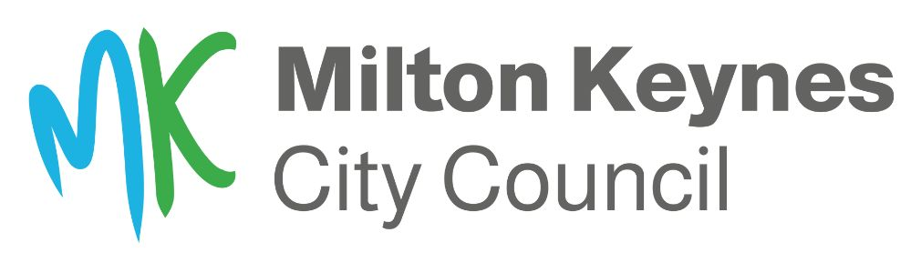

Community Infrastructure Fund (CIF) 2024-2025
Application Form
Before you apply
Each year parish, town and community councils may apply for up to £20,000 from the CIF to match fund a local community public realm project.
Since it started in 2019/20, the CIF has helped local parishes to deliver a wide range of projects to benefit their local area.
There are conditions for applying to the fund which can be viewed on our website under the ‘Working with Parish Councils’ section on www.milton-keynes.gov.uk/highways
Every application received by the deadline, 5pm on Thursday 31 August 2023, will be checked and scored out of four against our four criteria to show how your scheme will:

- Solve a persistent problem
- Address a safety issue
- The local community support or requested it
- It will provide added value to the local community and MK

Your application should include evidence to support how it fulfils all these criteria. For example, to show local community support you may provide evidence of a petition or local survey or letters of support.
We will use all the information provided with your application form when we score it against the matrix of criteria so it’s important to complete all sections as fully as possible.
Applications with the highest scores, out of a maximum 16, will go onto the final list to be approved for funding through a Delegated Decision in March 2024.

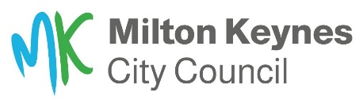

Apply to the Community Infrastructure Fund 2024-2025
1. Name of parish, town, or community council

2. Address of parish, town, or community council

3. Contact details
Name
Job title
Email
Telephone/mobile

4. What are the main objectives for your project? Tick all that apply
- Safety, wellbeing, or health
- Improve the local environment Improve local facilities
- Building stronger communities
- Encouraging wildlife and biodiversity
- Encouraging sustainable transport
- Tackling climate change
- Provide opportunities for local people
- Other (please specify)

5. Financial contributions

Ensure that your project estimate includes all additional implementation costs including design, installation, traffic management, relevant licences etc.
If using an external contractor, you must include 3 independent quotes for the works to show value for money. If this is not possible, for example, bespoke equipment or specialist services, you should explain this clearly in your application.

You must contribute at least 50% of the total cost* of your proposal (25% for very small parishes with a tax base of less than 200). The MK City Council contribution is up to a maximum of £20,000. You may submit more than one CIF application up to this value.

These contributions can be revised at the next stage of the process, where officers will work with you to refine your application as part of the feasibility checks.

*The parish financial contribution must not be made up of another MKCC funding stream.
MKCC contribution requested | £
Parish contribution | £
Total cost of CIF project | £

6. Project plan and timeframe
Outline your expected timeframe and project plan for your proposal here.
For example, consider any preliminary works, supply and manufacture of materials, landscaping requirements such as seasonal nesting times.

Add in contingency time for unforeseen circumstances or poor weather conditions. If you are unsure, contact your Highways Liaison Officer who can assist you. If you are unsure who this is, email the Highways Liaison inbox,
highways.liaison@milton-keynes.gov.uk

7. Location of your proposal
Please state exactly where your proposal will be and provide details of land ownership. If the location is on MK City Council-owned land, you must liaise with MK Council officers first before submitting any proposals. You should also consider if you will need any permissions such as access to complete your project.

If your project involves making changes to an MKCC leased property, you must request permission from the Estates team before submitting your application as this can take time to complete.

Locations must be owned by either:
- MK City Council
- Parish/Town Council owned (or available for parish acquisition)
- Long term lease (If the building is occupied on a long-term lease, the terms of the lease will need to be reviewed prior to award of grant funding)

8. Expected outcomes
Use the space below to tell us who will benefit from your project and how? Try and be specific rather than ‘the public’.
Are there any wider benefits to Milton Keynes or the local area? How will the success of the proposal be measured e.g., increased footfall, feedback from residents etc. You may continue on a separate sheet if needed.

What are the consequences of not doing this proposal? Will there be an impact on the community? Will it make an existing issue worse? (Give brief details).

9. Community engagement
Explain here how the proposal came about - was it the result of a resident's suggestion, was there any local engagement done to find out what they wanted, or do you have any information about a consultation?

10. MKCC engagement
Have you spoken with any MK City Council officers about all or parts of your proposal? If so, please provide details here including which officer/s you spoke to, their involvement and the outcome e.g., planning advice, guidance on equipment or land ownership

11. Is there anything else you would like to tell us that is relevant to your application?

Thank you for your application.
________________________________________________________________
Highways Data Protection Privacy Statement
We collect and use information about you so that we can provide you with Highway services under the relevant legislation. Full details about how we use this data and the rights you have around this can be found at www.milton-keynes.gov.uk/highways-and-transport-hub/highways-privacy-notice.

If you have any data protection queries, please contact the Council's Data Protection Officer at data.protection@milton-keynes.gov.uk

