Guidance Notes
Furzton Resident Permit Scheme

Guidance Notes

November 2023

MK Parking Service

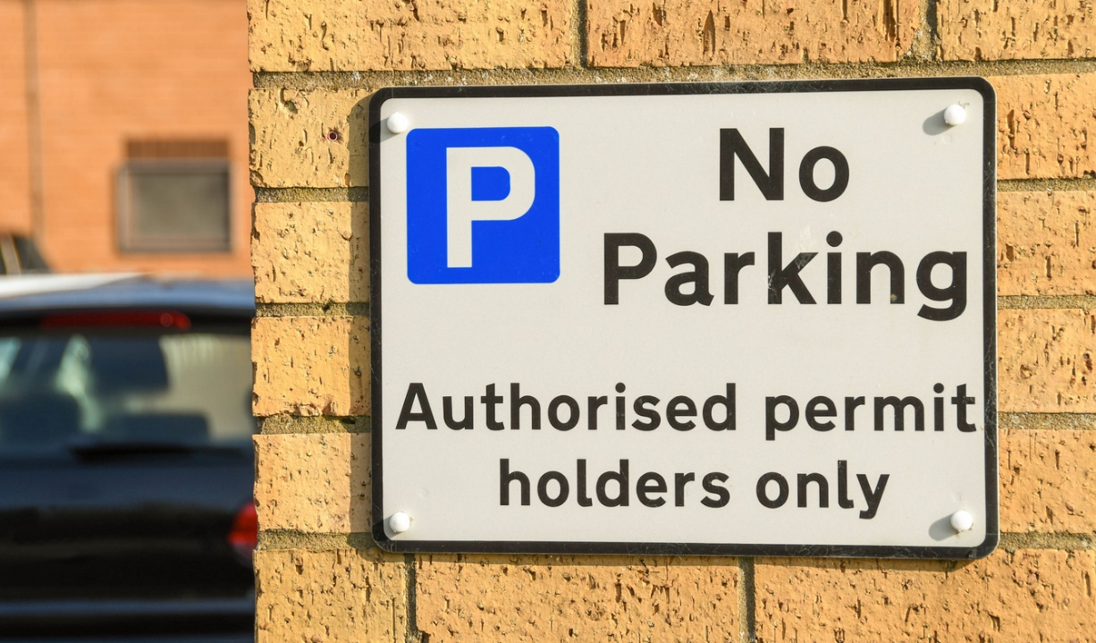

GUIDANCE NOTES
For Furzton Resident Permit Scheme
Eligibility
Any resident over the age of 17 years residing at the following properties may purchase a Resident Permit, Visitor Permit, and permit day vouchers:
ROAD NAME: |  | PROPERTIES:
Bilbrook Lane, Furzton |  | All residential properties
Each resident will be entitled to:
- One resident permit per vehicle
- One visitor permit per person.
- 50 free visitor day vouchers per year, per person provided at least one resident or visitor permit has been purchased.
- Additional visitor's day vouchers may also be purchased.
A virtual permit shall only be valid for the duration of a single day commencing 00:001 finishing at 24 hours.
You will be required to provide evidence of residency, specific to the permit scheme in Furzton.
Proof of Residency
Applicants are required to provide a copy of your vehicle registration (V5C) registered for the address for which you are applying for a permit and two documents verifying the application address e.g. Driving licence/lease agreement, Formal Tenancy Agreement (accepted on initial application only), Utility Bill, Bank Statement (please note that these must be dated within 3 months).
Proof of residence must be provided before your application can be approved. The Council reserves the right to request further proof of residence if necessary.

Where the permit is valid
Resident permit holders are authorised to park where the permit symbol below is displayed on posted signs within Furzton. The permit is not valid in any other parking restriction.
R37
The resident permit does not allow you to park on yellow lines, footways, and verges. If you do, you may be at risk of being issued with a Penalty Charge Notice.
It is an offence for a person to knowingly make a false statement for the purposes of obtaining a Parking Permit. A Permit may be withdrawn if obtained by fraudulent means. The Council will not hesitate to prosecute, and a conviction may result in a substantial penalty.
Vehicle Eligibility
A parking permit may be used with the following class of vehicles:
- A passenger vehicle, which carries no more than 12 passengers (this includes motor vehicles, electric vehicles, and hybrids)
- A goods vehicle weighing less than 3.5T gross laden weight.
Permits are not valid for trailers. It is prohibited for any street trader vendor’s vehicle to be parked or operate from any parking place.
Change of Vehicle
If you change your vehicle during the validity of your parking permit, you must log into your account and change the vehicle details to update your permit.
Renewal
It is your responsibility to renew your permit. Applications for renewals should be made at least 5 days prior to the expiry of your permit to allow the application to be processed.
To apply, visit www.milton-keynes.gov.uk and go to the Parking Permit section.
General Data Protection Regulations
Under the General Data Protection Regulation Act Milton Keynes Council has a legal duty to protect any information we collect from you.
For more information about how we use your personal data please visit www.milton-keynes.gov.uk

