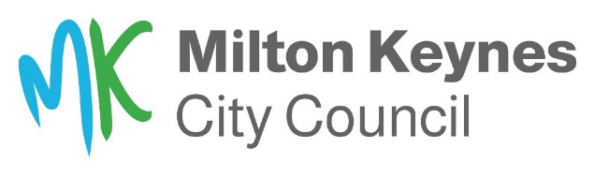
Highways and Transportation Service

Sandbags

The highways team keep a small stock of sandbags at their Bleak Hall depot that they may use if there is a severe an imminent risk to public safety.

For this reason, we will only issue sandbags during flooding events after a highways officer has attended a flood site and assessed the level of severity.

If there is a risk to life due to flooding, call 999 and ask for the Fire and Rescue Service.
The emergency services do not issue sandbags, so do not contact them.

Residents should take all steps to protect their property if a flood alert is raised. The Flooding Team can help residents and parish councils to prepare a flooding plan. Their contact details are on our website, www.milton-keynes.gov.uk

We recommend aqua sacs or hydro snakes as they are easy to store, can be deployed quickly and are versatile. They are also reusable, unlike sandbags.

Sandbags are not as effective in preventing flood water from entering properties and do not store well over lengthy periods. They are heavy and are not easy to move from one place to another.

Sandbags will help to keep water out for a brief period but will not prevent flooding if the water levels rise further. If a property is already flooded, then sandbags will not help as the water will be coming through the floor.

What we will not do
- Provide sandbags to any property where there is no imminent risk of severe flooding.
- Clear blocked culverts or watercourse during or after flooding that is not MKCC owned.
- Provide sandbags to protect gardens, sheds, or other outbuildings.
- Distribute sandbags at the request of anyone other than the property owner or current resident/s.
- Move vehicles trapped in flooded areas.
- Pump excess water from the streets.
- Close roads unnecessarily

