Guidance Notes

Central Milton Keynes - employees

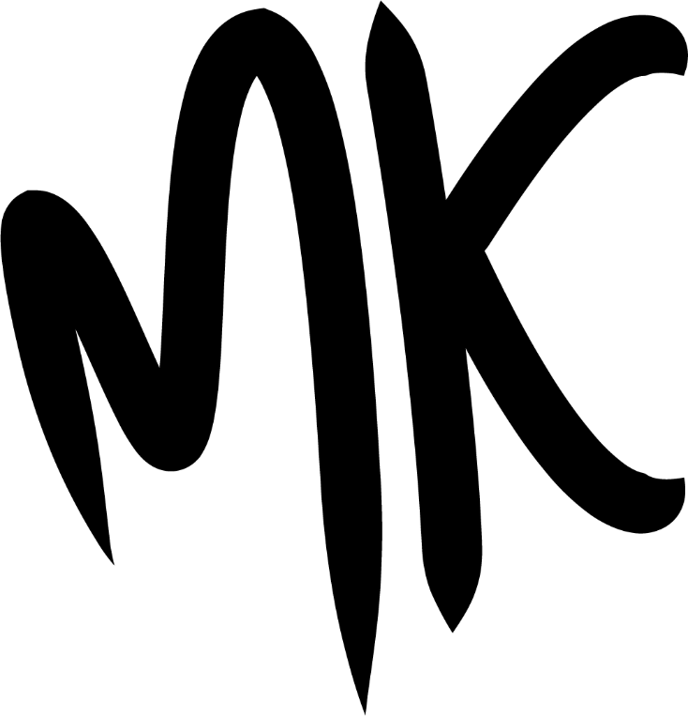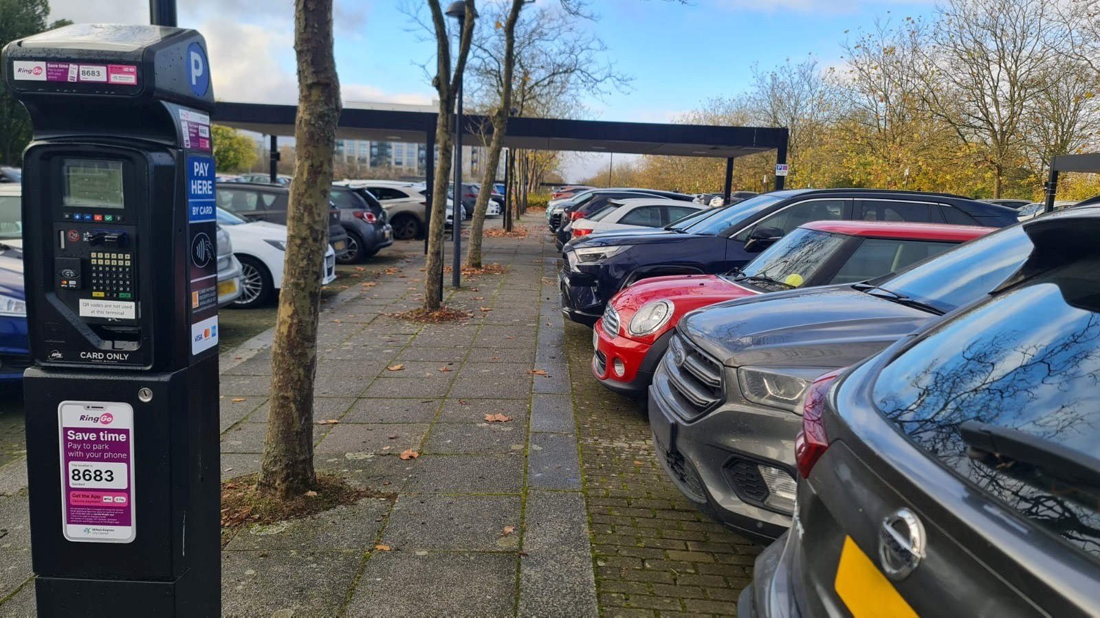

Entitlement

Any employee or a business or organisation located in Central Milton Keynes may apply for the following permits:

* 5-hour employee permit
* 24-hour employee permit
* 1-month, 3-month, 6-month or 12-month employee permit

The Council reserves the right to request proof of employment or vehicle ownership if necessary.

Any resident who resides in a property located in Central Milton Keynes, who is over the age of 17 years, may apply for the following permits:

* 1-month, 3-month, 6-month or 12-month employee permit

Proof of employment residence and vehicle ownership must be provided before your application can be approved. The Council reserves the right to request further proof of residence or vehicle ownership if necessary.

Permits are not required for motorcycles.

Apply here: <https://permits.paysmarti.co.uk/acct/miltonkeynes>.

For any permit queries please email [miltonkeynespermits@imperial.co.uk](mailto:miltonkeynespermits@imperial.co.uk).

Proof of Employment

One of the following documents in your name will be accepted:

* A letter for your employer on headed paper

The Council reserves the right to check with your employer at any time during the year to ensure that the permit holder is currently employed.

Proof of Residency

One of the following documents in your name will be accepted:

* Council Tax Bill ‐ must be the current year’s bill.
* Tenancy Agreement ‐ must be current & signed by all the relevant parties.
* Utility Bill ‐ Water/Electric/Telephone or Gas bill ‐ must be less than three months old.
* Driving Licence.
* Bank Statement (within last three months).

Proof of residence must be provided before your application can be approved. The Council reserves the right to request further proof of residence if necessary.

Proof of Vehicle Ownership

One of the following documents in your name will be accepted:

* V5 Log Book

Proof of ownership may be provided before your application can be approved. The Council reserves the right to request further proof of vehicle ownership if necessary.

Conditions

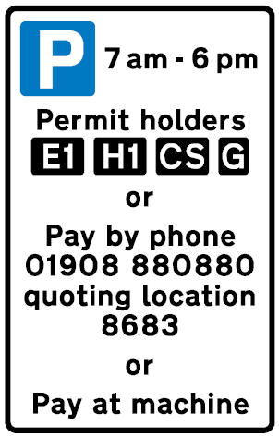All permits issued by Milton Keynes City Council are virtual. The permit allows you to park your vehicle within any parking space identified by the **E1** symbol on the signs adjacent to the bays, free of time limits and parking charges.

When parking in Central Milton Keynes, other than the parking areas where the **E1** symbol is shown, you may need to pay the parking charge. The time limits and charges may vary so please follow the signs for guidance.

When parking, please ensure that you check the time limits for the chosen bay, which are always displayed on the signs adjacent to the bays.

The permit does not allow you to park on yellow lines, footways and verges, taxi ranks, disabled bays or loading bays. If you do, you risk being issued with a Penalty Charge Notice.

The employee permit is not transferable between vehicles, but a permanent change of vehicle can be made. If you need to change your vehicle during the validity of your parking permit, you must log into your account and change the vehicle details to update your permit.

If you change your vehicle during the validity of your parking permit, you must log into your account and change the vehicle details to update your permit.

If you no longer require your Employee parking permit you can obtain a pro-rata refund. The refund applies to full calendar month unused before the expiry of the permit calculated from the date of receipt by the Council.

Refunds will either be paid to the debit/credit card used to pay for the permit or by BACS. There are cheque or cash refunds.

Any refund will start from the date that the application refund was received and may take up to 4-weeks to be processed.

The Council reserves the right to revoke any permit if the Council has reason to believe that it is not being used in accordance with the regulations.

It is your responsibility to renew your permit. Applications for renewals should be made at least 5 days prior to the expiry of your permit to allow the application to be processed.

Where can you park?

There are many different parking restrictions within Central Milton Keynes and it is important to ensure you are aware of the areas where you are permitted to park with a valid employee parking permit.

The employee permit allows you to park your vehicle in any standard tariff parking space where the **E1** symbol is shown on the signs adjacent to the parking place.

Standard tariff parking spaces are identified by a purple road marking at the front of the parking spaces.

The CMK Parking Guide provides a map showing the location of all standard tariff parking spaces in Central Milton Keynes [Add link to parking map]

When parking, please ensure that you check the time limits for the chosen bay, which are always displayed on the signs adjacent to the bays.

Permit Period

The Council offers a variety of periods for the employee permit:

* 5-hour
* 24-hour
* 1-month
* 3-month
* 6-month
* 12-month

The 5-hour and 24-hour permits are only available to employees – not residents.

Permit Charges

The following charges will apply:

|  |  |  |
| --- | --- | --- |
| **Permit Type** | **Period** | **Charge** |
| E1 Employee Permit | 5-hours | **£2.00** |
| E1 Employee Permit | 24-hours | **£3.00** |
| E1 Employee Permit | 1-month | **£56.25** |
| E1 Employee Permit | 3-months | **£168.75** |
| E1 Employee Permit | 6-months | **£337.50** |
| E1 Employee Permit | 12-months | **£675.00** |

Data Protection

Under the General Data Protection Regulation Act Milton Keynes Council has a legal duty to protect any information we collect from you.

Full details about how we use this data and the rights you have around this can be found at [www.milton-keynes.gov.uk/privacy](http://www.milton-keynes.gov.uk/privacy). If you have any data protection queries, please contact the Data Protection Officer at [data.protection@milton-keynes.gov.uk](mailto:data.protection@milton-keynes.gov.uk)

You can view the Privacy Notice for Milton Keynes Council at [Milton Keynes City Council corporate privacy notice | Milton Keynes City Council](https://www.milton-keynes.gov.uk/milton-keynes-council/privacy-notices/milton-keynes-city-council-corporate-privacy-notice)