

**Multi-agency guidance: Action to take**

**in response to a suspected suicide of a**

**child or young person in Milton Keynes**

**(June 2024 v2)**

**Context & Purpose:**

1. Suicide is a leading cause of death for young people in the UK. In young people especially, exposure to a suicide may lead to increased risk of their own suicidal thoughts.
2. A suicide cluster may result from ‘contagion’, whereby one or more than one person’s suicide influences another person to engage in suicidal behaviour or increases their risk of suicidal thoughts and attempts.
3. A cluster of suicides is a rare event, but when it happens it can affect more than families and friendship groups. The impact can be widespread. A suicide cluster can cause distress in whole communities.
4. Definition of a suicide cluster in a school, college or setting is extremely difficult, due to the generally low rate of suicide in children and young people. More than one death, even over a protracted period of time, should raise concerns of possible contagion or a cluster.
5. This response aims to reduce the potential for contagion by co-ordinating support for a school, college or community setting in the event of a suspected pupil suicide.
6. The response is aligned to the statutory Child Death Board (CDB) procedures. A supporting multi-agency pathway that outlines the response to a child death (including a suspected suicide) can be found [here](https://miltonkeynesscp.trixonline.co.uk/resources/local-resources)

**Scope and activation:**

1. This response will be activated by the Milton Keynes Public Health team **in the event of a suspected suicide of any school-aged young person (up to the age of 19 years) living in Milton Keynes, attending a school, college or setting in Milton Keynes.**
2. **The response is not intended to be activated:**

* **For other forms of traumatic death, such as accidental death**
* **Where a child or young person has previously left a Milton Keynes school/college or setting**
* **For young people who were in education and over the age of 19 years at the time of death**

However, it is recognised that elements of the plan may be helpful in responding to the needs of the school/college community. The response in these instances will therefore be considered on a case-by-case basis by the Public Health team, in collaboration with the head teacher or leader of the school, college or setting.

**The response process:**

The Milton Keynes public health team will mobilise the response process as outlined in the flowchart below:

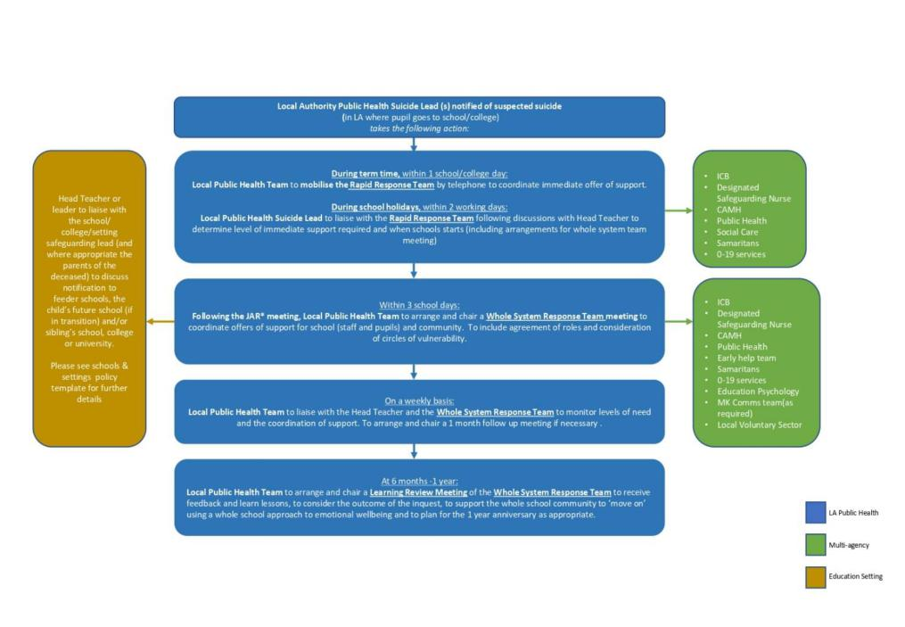

Please note each of these key elements of the response:

- During term time, within 1 school/college day, the Milton Keynes Public Health team will also work with the Head Teacher/Principal or nominated representative in order to mobilise a **Rapid Response** (by call or virtual meeting). The immediate offer of support is collectively determined by CAMHS and/or other provider services, in agreement with the Head Teacher/Principal or nominated representative. As a minimum, this would include increased presence in the school/college on the same day of mobilisation, continuing until the whole system response meeting is held.

- Within 3 school days: The Milton Keynes Public Health Suicide Lead(s) will liaise with the Head Teacher/Principal or nominated representative to arrange and chair a **whole system response team meeting** with the school/college to co-ordinate offers of support for staff, pupils and the community. The meeting will include consideration of circles of vulnerability (Please see Appendix A)

**Supporting the response:**

I. All services commissioned and/or provided by the Beds, Luton and Milton Keynes Integrated Care Board (ICB), the local authority and public health team will support the response by

providing immediate support to the school/college community in the event of a suspected suicide of a child or young person.

1. The level of support required from each agency will vary depending on the specific circumstances of the suspected suicide. If there are any barriers to offering ongoing support as part of the response, these should be raised with the public health team.
2. The public health team may also engage other agencies in the response process where specialist input or support will help minimise the potential for contagion.

**‘Standing down’ the response:**

1. The school/college or setting leader, or nominated representative, in discussion with the Milton Keynes Public Health team will decide when support is no longer required.
2. The whole system response team will stand down following the learning review meeting, as agreed with the school/college or setting leader, or nominated representative, or at the latest, following the 1-year anniversary.

**Appendices:**

* **Appendix A – Identifying Vulnerability**
* **Appendix B – Schools, colleges and settings policy template – Responding to a suspected suicide of a child or young person**
* **Appendix C – Useful Resources**

**Reference Material:**

|  |
| --- |
| **Key Supporting information** |
| PHE (2015) Identifying and responding to suicide clusters and contagion A practice resource [https://www.gov.uk/government/publications/suicide-prevention-identifying-and-responding-](https://www.gov.uk/government/publications/suicide-prevention-identifying-and-responding-to-suicide-clusters) |
| [to-suicide-clusters](https://www.gov.uk/government/publications/suicide-prevention-identifying-and-responding-to-suicide-clusters) |
| Papyrus; Prevention of Young Suicide<https://www.papyrus-uk.org/> |
| Building Suicide-Safer Schools and Colleges A guide for teachers and staff [https://www.papyrus-](https://www.papyrus-uk.org/wp-content/uploads/2018/08/toolkitfinal.pdf) |
| [uk.org/wp-content/uploads/2018/08/toolkitfinal.pdf](https://www.papyrus-uk.org/wp-content/uploads/2018/08/toolkitfinal.pdf) |
|  |
| Samaritans Media Guide [https://www.samaritans.org/media-centre/media-guidelines-reporting-](https://www.samaritans.org/media-centre/media-guidelines-reporting-suicide) |
| [suicide](https://www.samaritans.org/media-centre/media-guidelines-reporting-suicide) |
|  |
| Samaritans (2017) – Step by Step: How to prepare for and respond to a suspected suicide in schools and colleges.  <https://www.samaritans.org/sites/default/files/kcfinder/files/HWWNIM_Feb17_Final_web.pdf> |
|  |

**Key Contacts:**

|  |  |
| --- | --- |
|  |  |
| **1.** | **Debra Richardson: Head of Public Health Programmes** [Debra.Richardson@milton-keynes.gov.uk](mailto:Debra.Richardson@milton-keynes.gov.uk) |
|  |
| **2.** | **James Dove: Public Health Principal, Children & Young People** [James.Dove@Milton-Keynes.gov.uk](mailto:James.Dove@Milton-Keynes.gov.uk) |
|  |
| **3.** | **Marimba Carr: Deputy Director for Public Health** [Marimba.carr@milton-keynes.gov.uk](mailto:Marimba.carr@milton-keynes.gov.uk) |
|  |

There is also a multi-agency key contacts list (including email and phone numbers) that will be shared with key stakeholders alongside this guidance.

**Revision Process**

This guidance will be reviewed as appropriate in response to feedback following an incident or legislative/best practice change. A record of these amendments will be documented below:

|  |  |  |  |
| --- | --- | --- | --- |
| **Version** | **Amendment(s) made** | **By whom** | **Date** |
| V2 | Clarification on early communication in schools policy template (Appendix B) | James Dove | 3rd June 24 |

**Appendix A – Identifying Vulnerability**

**The Circles of Vulnerability Model can help to identify people who are most at risk of suicide contagion:**

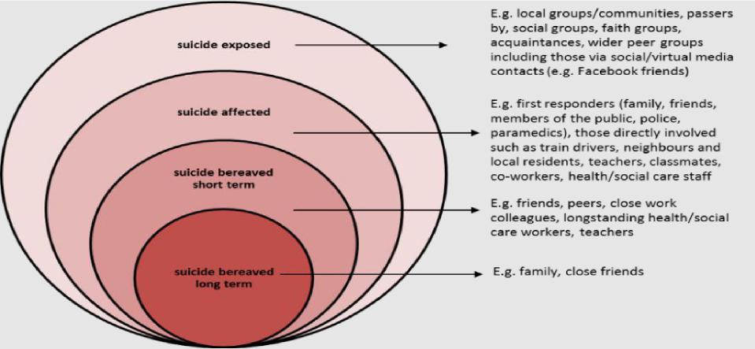

**Please also consider the following factors when considering vulnerability:**

|  |  |
| --- | --- |
| **Geographic proximity** | **The physical distance between a person and the incident.** For example, people discovering the body of someone who has died by suicide or been exposed to the immediate aftermath may be more at risk. Extensive or sensationalised news or social media coverage may extend the geographic boundaries of people who may be vulnerable. |
| **Social proximity** | **The social closeness to the person who has died by suicide.** Family members and close friends, including boyfriends and girlfriends, are likely to be particularly vulnerable. It is also important to consider individuals in communities such as schools, clubs, faith groups and wider friendship groups (including those in contact via social media). |
| **Psychological proximity** | **The psychological closeness a person feels to the individual who has died by suicide.** Some people may identify with the deceased more than others – for example, individuals of a similar age or sexual orientation, or those who have cultural or religious connections. There is often a larger risk of contagion in people who were not the closest friends of the deceased, but who knew them socially. |

Taking a matrix approach to vulnerability can therefore be used to identify and prioritise at-risk individuals and groups and identify appropriate interventions and support. A matrix can be

populated to help map and record interventions. This can help to avoid missing people or duplicating responses and also to identify gaps and ongoing need.

**Supporting tools:**

**Vulnerability matrix – By group:**

|  |  |  |  |  |
| --- | --- | --- | --- | --- |
| **Circle grouping** | **Who *(Please  amend as  necessary)*** | **Proximity** | **What is being done to help this group?** | **What else needs to happen?** |
| **Suicide Bereaved – Long term** | Parents/Carers, Family |  |  |  |
| Close Friends |  |  |  |
| **Suicide bereaved – Short term** | Pupils within the school and their peer group (including social clubs) |  |  |  |
| Teaching and other professional staff |  |  |  |
| **Suicide affected** | First responders – including ambulance and Police |  |  |  |
| **Suicide exposed** | Wider school and local community |  |  |  |
| Social media  contacts |  |  |  |

**Vulnerability Matrix – by Individual:**

A vulnerability matrix can also be used as a tool for Milton Keynes schools or relevant settings to identify individual children and young people (CYP) they are most concerned about. The matrix in this way may be shared with key services (CAMHS, MASH, Children’s Social Care, A&E) to cross reference risk and identify any actions needed to help reduce risk for that individual CYP. It can be used to identify what support/actions may be needed and who is best placed to provide this.

The matrix could be used as an ongoing tool for the school to hold and aid discussions and meetings to support their vulnerable pupils. A template is available on request. The school is best placed to decide how they use the matrix and what is most useful. Please note, the vulnerability matrix does not replace multi-agency safeguarding procedures and these should be followed at all times where there is concern for the welfare of a child or young person.

**Appendix B – Schools, colleges and settings policy template – responding to a suspected suicide of a child or young person**

**Definition of suicide**

**Suicide** refers to a death caused by self-directed injurious behaviour with any intent to die as a result of the behaviour1.

A pupil who is defined as **high risk for suicide** is one who has made a suicide attempt, has the intent to die by suicide, or has displayed a significant change in behaviour suggesting the onset or deterioration of a mental health condition. The pupil may have thought about suicide, including potential means of death and may have a plan. In addition, the pupil may exhibit feelings of isolation, hopelessness, helplessness, and the inability to tolerate any more pain.

Contagion suicide is the risk associated with the knowledge of another person’s suicidal behaviour, either first-hand or through the media. Suicides that may be at least partially caused by contagion are sometimes called “copycat suicides.”2

National guidance from The Samaritans3 recommends that schools/colleges should aim to respond to a suspected suicide within 48 hours. This is necessary to maintain the structure and order of the school/college or setting routine, while facilitating the expression of grief.

**Note: The coroner’s or medical examiner’s office must first confirm that the death was a suicide before any partner may state this as the cause of death. It is therefore recommended that in specific circumstances, the **term ‘suspected suicide’** is always used, until the verdict has been made public.

Further guidance on communication in response to a suspected suicide can be found in Schedules 1 to 3.

**Responding in the Event of a Suspected Pupil Suicide
  
A. School, College or setting statement of purpose:**

* We are aware that suicide is one of the leading causes of death in young people
* As a school we can play a vital role in helping to prevent young suicide

1 Crosby, A.E., Ortega, L., and Melanson, C. (2011). Self-directed violence surveillance: Uniform definitions and recommended data elements. Version 1.0. Atlanta, GA: Centers for Disease Control and Prevention, National Center for Injury Prevention and Control.]

2 Crosby, A.E., Ortega, L., and Melanson, C. (2011). Self-directed violence surveillance: Uniform definitions and recommended data elements. Version 1.0. Atlanta, GA: Centers for Disease Control and Prevention, National Center for Injury Prevention and Control.]

3 Samaritans (2021) Step by Step Guide <https://media.samaritans.org/documents/samaritans-help-when-we-needed-it-most.pdf>

* We want to ensure that children and young people at our school/college are as safe as possible and that our governors, parents and carers, teaching staff, support staff, pupils and other key stakeholders share our commitment to this policy
* We are committed to tackling suicide stigma. In our language, and in our working relationships, we will promote open, sensitive talk that does not stigmatise and perpetuate taboos
* Our governors and leadership team are clear about how we will respond in the event of a suicide. Each member of our named response team has a defined responsibility

**B. School, College or Setting – A notification received**

As part of multi-agency Milton Keynes Child Death Board (CDB) procedures:

- Notification of a suspected suicide will be made to *(Head Teacher name or nominated emergency contact)* by Milton Keynes Children’s Social Care using the emergency contact list for all schools/colleges held by Social Care.

- The *(Head Teacher name or nominated emergency contact)* will be invited to a Joint Agency Response Meeting (JARM). This will usually take place within 48 hours. The JARM will be led by a health professional and the need would normally be decided between lead health professional, police and social care

- Where appropriate, a strategy meeting led by Milton Keynes Childrens Social Care

The full CDB procedures can be found [here](https://www.mktogether.co.uk/)  [.](https://www.mktogether.co.uk/) Please note, the statutory CDB process is not activated for students aged 18+.

In parallel, the Milton Keynes public health team will also mobilise their response. The full response is outlined in the diagram below:

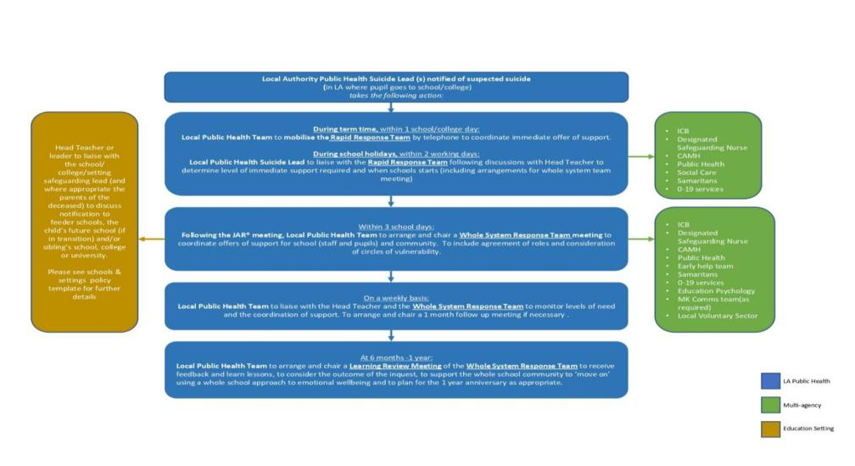

Please note each of these key elements of the response:

- During term time, within 1 school/college day, the Milton Keynes Public Health team will also work with the Head Teacher/Principal or nominated representative in order to mobilise a **Rapid Response** (by call or virtual meeting). The immediate offer of support is collectively determined by CAMHS and/or other provider services, in agreement with the Head Teacher/Principal or nominated representative. As a minimum, this would include increased presence in the school/college on the same day of mobilisation, continuing until the whole system response meeting is held.

- Within 3 school days: The Milton Keynes Public Health Suicide Lead(s) will liaise with the Head Teacher/Principal or nominated representative to arrange and chair a **whole system response team meeting** with the school/college to co-ordinate offers of support for staff, pupils and the community. The meeting will include consideration of circles of vulnerability (See Figure 1).

**Figure 1:**

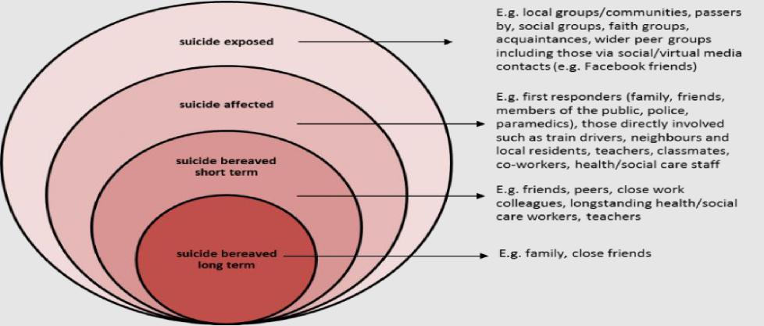

**C. School, College or Setting – Immediate steps**

**Step 1. Contact the family**

As soon as formal notification has been received as detailed in local guidance, *Head Teacher name/ Person nominated by Head Teacher name*) will contact the parents to offer condolences and discuss their wishes. This will include consideration of how the school can communicate the news within the school community.

**Step 2. School, College or Setting co-ordination - Group notification**

*Head Teacher name/ Person nominated by Head Teacher name*) will notify the school/college co-ordination group, consisting of the following school/college staff:

* (Contact name and emergency contact details) e.g. Welfare Lead
* (Contact name and emergency contact details) e.g. Safeguarding Lead
* (Contact name and emergency contact details) e.g. Head of Year

**Step 3. School, college or setting - Staff notification**

In line with the wishes of the family, *(Name of staff member/ Head Teacher*) will notify other staff members and governors using guidance below. This will include an understanding that details shared will be sensitive and may need to be kept confidential at this stage. Where the family do not want to use the term suspected suicide, the term ‘unexpected death’ may be used.

Notification will initially be made directly to those involved with the deceased, followed by other staff members.

The *(Name of staff member/ Head Teacher*) will notify the school/college administration team to ensure standard pupil correspondence to the family is stopped.

**Step 4. Pupil notification**

After liaising with the pupil’s family, pupils close to the deceased will be informed by a familiar member of staff - ideally face to face.

Other pupils will be informed concurrently (in class groups/tutor groups/other), information will be restricted to the facts and in line with the family’s wishes.

**D. Guidance for notifying pupils and staff**

* Acknowledge that there are rumours about suicide but only use the term suspected suicide when given permission to disclose this by the family
* Only include the pertinent facts about the death without the details of the method of death as agreed with the family
* Normalise the emotions experienced in response to the death
* Encourage caring for each other and letting staff know if anyone has concerns about other pupils
* Encourage positive ways of managing distress
* Let staff/pupils know that support is available and how to access – i.e School Nurse ‘Drop-In’ days; the school’s CAMHS worker contact days; school’s counsellor contact details
* Share useful resources with staff/pupils via printed cards, the school/college website or on notice boards

1. **Identifying those pupils most at risk of suicide, following a suspected pupil suicide in the community**

As part of the whole systems response, the *(Pastoral Lead/Safeguarding Lead name)* will liaise with CAMHS and other specialists to identify those most at risk of suicide for specific support. This process can be informed by completion of a vulnerability matrix. Further details of the vulnerability matrix can be found in ‘multi-agency guidance – Action to take in the suspected suicide of a child or young person in Milton Keynes’.

1. **Recommended actions to support pupils and staff**

* Avoid talking about the specific case but discuss the topic of death in more general terms. This will include a discussion on suicide in line with the wishes of the family
* Liaise with the Milton Keynes public health team and engage in the Whole System Response meetings
* Attend the (JARM) meeting within 48 hours of the death
* Provide facilities for students/colleagues who require a quiet area and offer opportunities for further support
* Ensure that relevant support resources are communicated to all staff and to the school/college community
* Reassure pupils that grief is a normal response to death, and there is no wrong or right way to grieve. Take everyone’s expression of grief seriously and offer support
* Recognise that it is natural for pupils and staff to discuss the event but encourage all pupils and staff to be mindful that any communication on social media must be respectful as it is in the public domain and that any messages they read may not be factual
* Recognise that pupil distress might manifest in their behaviour and/or performance
* Continue the conversation about the death in a reassuring and safe way to reduce stigma and encourage openness. Use helpful language when talking about suicide (Please see Schedule 1 and 2)
* Liaise with local support agencies including Samaritans, CAMHS and the School Nursing Service to develop a plan to support colleagues and pupils
* Debrief colleagues and ‘check in’ with pupils and encourage an ethos of care and support throughout the school/college
* Strike a balance between sensitivity to those who are grieving and in shock with the need to maintain the school/college routine
* Be sensitive to the impact of the death within different faiths
* Consult with the family about disseminating the funeral arrangements
* Consult with the family about a short-term memorial site but avoid romanticising suicide with a prolonged memorial site. A whole school/college assembly may not be appropriate
* Be aware that longer term issues may arise, particularly for those at risk and at the anniversary of the young person’s death and facilitate appropriate discussion and appropriate support
* Support for staff may be required. The Samaritans will be able to provide this support
* Provide resources to support emotional awareness and listening as well as other mental health and wellbeing

**G. Communicating with parents/carers, and community groups**

*(Head Teacher name/ Person nominated by Head Teacher name*) will notify pupils parents by letter, or by alternative appropriate means, following agreement with the family of the deceased. The family will agree the content of the letter with an understanding that any information contained within it may be used by the press.

The school/college will liaise with the Whole System Response Team to identify and inform relevant community groups.

*(Name of staff member/ Head Teacher*) will liaise with the parents of the deceased to agree notification of the following to enable increased vigilance and awareness:

* feeder school/college(s)
* school/college/university attended by deceased’s siblings or close relatives
* any other relevant school/college within the local community, whether in the local authority or over the border.

Please also refer to Samaritans guidance in this instance:

<https://www.samaritans.org/media-centre/media-guidelines-reporting-suicide>

**H. Communicating with the wider media and social media coverage**

*(Head Teacher name/ Person nominated by Head Teacher name*) will initially discuss the need to respond to the press with the parents of the deceased and subsequently at the Whole System Response Team meeting.

All media enquiries will be directed to *(named person appointed by Head Teacher)* and all other staff and students will be asked not to respond to journalists.

Please also refer to Samaritans guidance in this instance:

<https://www.samaritans.org/media-centre/media-guidelines-reporting-suicide>

**I. Sharing and updating the school/college policy**

Once the school, college and setting policy has been drafted, consulted upon by staff, pupils, parents and Governors and finalised, the policy will be **updated annually, or when contact information changes**, by the nominated mental health lead in collaboration with:

* Safeguarding Lead
* Pastoral Care Lead(s)
* Vulnerable Learners Lead (Designated Teacher)
* Members of our senior leadership team
* (Other staff members as appropriate)
* School Nurse
* CAMHS school/college worker
* Students/pupils
* parents and carers.
* Emotional wellbeing Lead Governor

The school, college or setting should will:

* Staff are familiar with this policy and receive relevant training, including what to do if there is a concern about a colleague or pupil
* Staff know what risk factors and signs to look out for in colleagues and pupils, including self-harm

**J. Links to our other school policies**

* Safeguarding
* Emotional wellbeing and mental health
* Supporting pupils with medical conditions
* SEND
* PSHE
* Behaviour and attendance (disruptive, withdrawn, anxious behaviour may be related to unmet emotional or mental health need)
* (Others)

**K. Revision**

This policy will be reviewed as appropriate in response to feedback following an incident or legislative/best practice change. A record of these amendments will be documented below:

|  |  |  |  |
| --- | --- | --- | --- |
| **Version** | **Amendment(s) made** | **By whom** | **Date** |
|  |  |  |  |

**Schedule 1:**

**Guidance for parents/carers when talking to their children about a suspected suicide or death**

* Children can react very differently to news of a death, some may appear to carry on almost without reacting, while others may cry and be completely overcome by their feelings. It is good to remember that there is no right or wrong way to grieve and no rule book to follow.
* Be honest when talking about the death and use sensitive but honest language.
* Try not to overwhelm your child with information or give more information than asked for. When receiving news of a death children may ask a few questions at a time in order to process the information. Children may need to ask the same questions repeatedly.
* It is ok to acknowledge the rumours that the young person took their life but try to avoid speculating on things that may have been said, especially on social media.
* Reassure your children that you are available to listen and talk about the death.
* If your child is concerned and upset by how they are feeling it can help to know that other people often feel shocked, numb, angry, sad and overwhelmed by the death.
* Encourage your child to ask for support in school/college if needed.
* If you are concerned about the emotional and mental health of a child or adult contact a professional. If not school/college, contact your GP.
* If they or you are worried about them harming themselves, ask them direct questions, such as “sometimes when people feel like you do, they think about suicide and harming themselves, is that what you are thinking about”?

**Schedule 2:**

**Examples of Appropriate Language**

Whist the right language is helpful, the most important response is one which is non-judgmental, caring and calm.

Examples of things **you could** say to pupils

How are you feeling?

Examples of what **NOT TO** say to pupils

Avoid cliches such as: “Life goes on”, “Time heals everything” or “They are at peace now”.

We are all so sad and shocked. Would you like to tell me about how you’re feeling?

Avoid assuming the faith and beliefs of the pupil and their family: “They are in a better place”, or “It was God’s will” or “They are looking down on you”.

This is so sad and awful. It is ok to be so upset/confused/angry.

It is hard to know what to say isn’t it? I am here if you want to talk.

Avoid assuming you understand how they are feeling, they may not understand how they feel: “I know how you feel...”

Avoid using judgmental statements such as: “They were selfish to do that” or “They took the easy way out”.

I can’t imagine what you’re going through but I wanted to let you know that I’m here if you’d like to talk.

I’m not sure what to say but I’m here to listen

Is there anything I can do to help you?

Would you like to go for a walk together?

I miss (name of the pupils who died)...how are you?

**Schedule 3:**

**Responding to the media – Guidance:**

A young person’s suspected suicide may attract attention from the media – this could be from either local or national news organisations.

Social media platforms mean that news of such incidents can travel quickly, and you may find yourself being contacted by a journalist seeking a comment within a short period of time.

Whether you are contacted by email, telephone or face to face, it is important that you don’t feel under any obligation to make any statement without having a chance to properly consider your position.

Two key issues need to be thought about before issuing any communications:

a. Whether information about the death is in the public domain and the wishes of the family

b. Whether the death could be subject to any police investigation, in which case you may be restricted in making any comment.

Assuming that these key issues have been considered, it would be prudent to prepare a statement in consultation with the family as soon as possible.

If you have not had an opportunity to do so when approached for a comment, it is entirely appropriate for you to say that you are not yet able to share a statement but will confirm the facts as soon as possible. committing to get back to them directly.

In drafting a statement, you may wish to consider:

* Acknowledging the tragic loss of the young person’s life and explaining that the thoughts of the teaching staff and governing body are with their family at this very difficult time;
* Reflecting on the unique qualities of the young person, perhaps referencing any particular characteristics or contributions they have made to school/college life;
* Explaining the support that you will be giving to the pupils of the school/college (particularly relevant for direct communications with parents/carers).
* Avoid details of the method used or the location;
* Avoid speculation about the ‘trigger’ for the death;
* Avoid making the deceased appear heroic or brave or that his/her death was a solution to a problem;
* Avoid endorsement of myths around suicide;
* Bear in mind the language used;
* Do not over emphasise the school/college and emphasise the Community’s expression of grief;
* Be sensitive to the beliefs and feelings of family and friends;
* Encourage sharing helplines and support organisation details;

Bear in mind that interest is sometimes generated by campaigning groups/bereaved

families, with the aim of raising awareness of the issues.

Please also refer to Samaritans guidance:

<https://www.samaritans.org/media-centre/media-guidelines-reporting-suicide>

**Appendix C – Useful Resources:**

There is a range of **local support** and services available to support children, young people and adults. These can be found [here](https://www.mksendlocaloffer.co.uk/health-conditions-and-disabilities/mental-health-and-wellbeing-hub/how-you-feel-matters-milton)  [.](https://www.mksendlocaloffer.co.uk/health-conditions-and-disabilities/mental-health-and-wellbeing-hub/how-you-feel-matters-milton) This includes:

- How you feel matters (for Children and Young People)

- Local adult services directory (including bereavement support)

Support from the local education psychology service when managing critical incidents is also available [here](https://www.mksendlocaloffer.co.uk/health-conditions-and-disabilities/mental-health-and-wellbeing/bereavement)  [.](https://www.mksendlocaloffer.co.uk/health-conditions-and-disabilities/mental-health-and-wellbeing/bereavement) This includes guidance on responding to critical incidents and resources for children and parents/carers.

There is also a range of general information and resources for schools and settings that can be found [here](https://www.mksendlocaloffer.co.uk/health-conditions-and-disabilities/mental-health-and-wellbeing-hub/information-school)

***Useful national sources of support:***

* **Children Bereavement UK** -[https://www.childbereavementuk.org/](https://or) or **0800 0288840**

Child Bereavement UK supports families and educates professionals when a baby or child of any age dies or is dying, or when a child is facing bereavement

* **Winston’s Wish** - [www.winstonswish.org.uk](http://www.winstonswish.org.uk/)

Offering practical support and guidance to bereaved children, their families and professionals

Freephone Helpline: 08088 020 021 (Mon - Fri 09:00 – 17:00) or [ask@winstonswish.org.uk](mailto:ask@winstonswish.org.uk)

* **Samaritans** - [www.samaritans.org](http://www.samaritans.org/)

Helps people of all ages in distress, through telephone or email support:

**Tel: 116 123** / **Email:** [jo@samaritans.org](mailto:jo@samaritans.org) (response in 24hrs)

* **Childline** - [www.childline.org.uk](https://www.childline.org.uk/) or **0800 1111**

Offers online advice through an app or desktop site, with coping strategies, message boards, “ask Sam” feature, 24/7 online 1-2-1 Counsellor and Freephone helpline for young people up to the age of 19

* **Young Minds** - [www.youngminds.org.uk](http://www.youngminds.org.uk/)**Parents helpline: 0808 802 5544** or visit [www.youngminds.org.uk/find-help/for-parents/](http://www.youngminds.org.uk/find-help/for-parents/)

· **The Mix** - [www.themix.org.uk/](http://www.themix.org.uk/)**Tel: 0808 808 4994 or Text THE MIX to 85258**

For any issue affecting young people under 25.

* **Support after Suicide Partnership -** [help-is-at-hand](https://supportaftersuicide.org.uk/resource/help-is-at-hand/)

***Support for parents & carers:***

* [Young Minds has lots of support for parents](https://youngminds.org.uk/find-help/for-parents/) including a helpline and guidance around [parenting with a mental illness](https://youngminds.org.uk/find-help/for-parents/parents-guide-to-support-a-z/parents-guide-to-support-parental-mental-illness/)
* [Mind Ed](https://mindedforfamilies.org.uk/young-people/) has safe and reliable advice about young people’s mental health, created by experts and parents together and has advice for parents on what to do if you are concerned.
* [Better Health, Every Mind Matters](https://www.nhs.uk/every-mind-matters/supporting-others/childrens-mental-health/) has tips for supporting children and young people with their mental health
* [Milton Keynes Bereavement by Suicide Support Service](https://www.mind-blmk.org.uk/how-we-can-help/milton-keynes/milton-keynes-bereavement-by-suicide-support-service/) – support service for families who have lost a loved one to suicide

***Useful national resources – Suicide & Suicide Prevention:***

* **Papyrus -** [Papyrus-uk.org](https://www.papyrus-uk.org/)

Building Suicide-Safer Schools and Colleges A guide for teachers and staff <https://www.papyrus-uk.org/wp-content/uploads/2018/08/toolkitfinal.pdf>

* **Samaritans -** [Samaritans](https://www.samaritans.org/)

Samaritans (2017) – Step by Step: How to prepare for and respond to a suspected suicide in schools and colleges. [https://www.samaritans.org/sites/default/files/kcfinder/files/HWWNIM_Feb17_Final_web.](https://www.samaritans.org/sites/default/files/kcfinder/files/HWWNIM_Feb17_Final_web.pdf)  [pdf](https://www.samaritans.org/sites/default/files/kcfinder/files/HWWNIM_Feb17_Final_web.pdf)

Samaritans Media Guide<https://www.samaritans.org/media-centre/media-guidelines-reporting-suicide>

* **Grassroots Suicide Prevention**

[Grassroots Suicide Prevention | Educating, Connecting, Campaigning (prevent-](https://prevent-suicide.org.uk/)

[suicide.org.uk)](https://prevent-suicide.org.uk/)

* **Survivors of Bereavement by Suicide (SOBS)**

[Survivors of Bereavement by Suicide – Overcoming the isolation of people bereaved by](https://uksobs.org/)

[suicide (uksobs.org)](https://uksobs.org/)

***Support for staff wellbeing:***

* **Education Support -** [Education Support, supporting teachers and education staff](https://www.educationsupport.org.uk/)
* **Supporting staff wellbeing in schools** - [Supporting staff wellbeing in schools | Anna Freud](https://www.annafreud.org/resources/schools-and-colleges/supporting-staff-wellbeing-in-schools/)



You can call Milton Keynes City Council on 01908

691691

Our customer service team is available 9.00am to

5.15pm Monday, Tuesday, Thursday and Friday and

10.00am to 5.15pm on Wednesday

Our website is always available

[www.milton-keynes.gov.uk](http://www.milton-keynes.gov.uk)