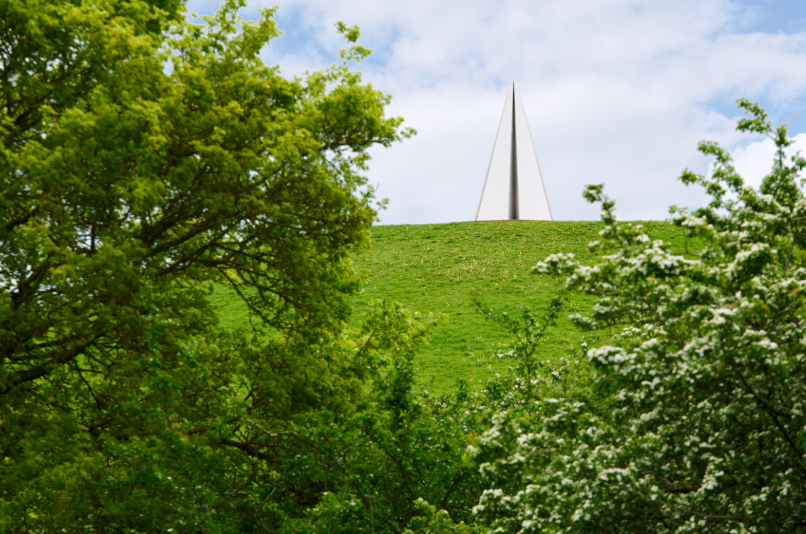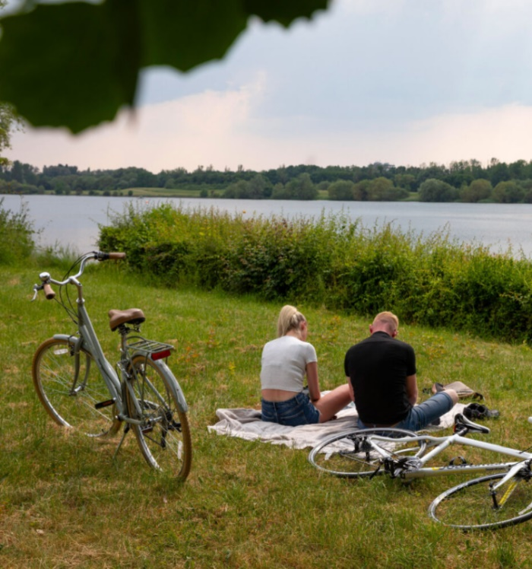

**Milton Keynes**

**Sustainability Action Plan   
(Council)**

2025-2050

**Milton Keynes Sustainability Action Plan - Council**

Milton Keynes adopted its first Sustainability Action plan in 2019.

Since then significant progress has been made on the climate agenda in the city, both on the City Council’s own activity and the wide work the authority does within the city.

This is the second iteration of a Milton Keynes Sustainability Action Plan. This document updates and condenses our previous action plan, outlining the major Council focussed projects that will be undertaken on each theme.

It should be read in conjunction with the Five Year Plan - Pathway to Net Zero 2030 as well as, Milton Keynes Sustainability Action Plan (City) which details the work and actions on the city wide emissions.

Quarterly monitoring of this Action Plan will take place, and an annual report to Cabinet on progress will be provided each January. The Sustainability Strategy and both Action Plans will be reviewed in 2028.

**City of Milton Keynes Sustainability Action Plan**

|  |  |  |
| --- | --- | --- |
| **Economy** | | |
| **Action ref** | **Action wording** | **Responsible service** |
| CC1.1 | Delivery of Net Zero playbook and Scope 3 Procured goods and services plan with MKCC procurement | Procurement |
| CC1.2 | For new build properties, explore and use more sustainable methods of construction, (e.g. MMC's and volumetric procurement.) | Procurement / Planning |
| CC1.3 | Embed carbon reporting and accounting into investment grade business cases for capital programmes. | Corporate Finance |
| CC1.4 | Adopt Government Buying Standards for Food and Food For Life Served Here Standards when applicable | Public Health / Procurement |

|  |  |  |
| --- | --- | --- |
| **Energy** | | |
| **Action ref** | **Action wording** | **Responsible service** |
| CC2.1 | Identify potential sites and deliver investment grade business case for Renewable Energy preferably within the Wolverton Ecopark | Environmental Services |
| CC2.2 | Support the delivery and supply of a District Heating Network | Environmental Services / Property |
| CC2.3 | Deliver investment grade business case and procure an Energy Centre to use heat from MKWRP | Environmental Services |
| CC2.4 | Review and deliver battery storage across the city | Property |
| CC2.5 | That the Council assesses the energy efficiency of its buildings with a view retrofit to EPC Grade C+, delivering through funding programmes including PSDS | Property |
| CC2.6 | Install photovoltaics on council owned assets where economically viable | Environmental Services |
| CC2.7 | Undertake a Local Area Energy Planning overview | Sustainability |

|  |  |  |
| --- | --- | --- |
| **Emissions** | | |
| **Action ref** | **Action wording** | **Responsible service** |
| CC3.1 | Implement low emission fleet for Authority. Transition to electrified vehicles using renewable / private wire. | Environmental Services |
| CC3.2 | Implement low emission fleet across our major service providers in waste, highways and leisure | Environmental Services |
| CC3.3 | Support our bus services provider by supporting access to our private wire to support electrification of buses | Environmental Services / Transport |
| CC3.4 | Expand the charging offer at our Bleak Hall depot | Highways |
| CC3.5 | New Energy and Fuel Plan for security of supply for our services | Sustainability |
| CC3.6 | Understand how staff commute to work and how we might measure impact on travel to work patterns over time. | Sustainability / Transport / HR |

|  |  |  |
| --- | --- | --- |
| **Environment** | | |
| **Action ref** | **Action wording** | **Responsible service** |
| CC4.1 | Drive and deliver the outcomes of the Urban Tree Action Plan to increase biomass, urban cooling and biodiversity in the street | Arboriculture |
| CC4.2 | Locate and plant to MK Carbon Sink Forest in Old Wolverton with The Parks Trust | Environmental Services |
| CC4.3 | Drive creation of Marshland, Bogs and Peatland with The Parks Trust | Environmental Services |
| CC4.4 | Biosecurity Action Plan | Environmental Services |
| CC4.5 | Reviewing and deliver offset options for deployment within Milton Keynes | Sustainability |

|  |  |  |
| --- | --- | --- |
| **Engagement** | | |
| **Action ref** | **Action wording** | **Responsible service** |
| CC5.1 | Our internal reporting policies will look to match the Climate Emergency UK Scorecard. | All departments |
| CC5.2 | We will demonstrate progress on this plan through GHG emissions reporting and annual updates to cabinet | Sustainability |
| CC5.3 | Developing service level risk registers and adaptation action  plans to prepare services for the impacts of climate change | All departments |
| CC5.4 | Training on Carbon literacy and accounting including development of Green Skills | Sustainability |
| CC5.5 | Engaging with Council services to influence the delivery of Net Zero Plans including but not limited to Transport, Housing, Environment and Waste dedicated Action Plans | Sustainability |
| CC5.6 | Engaging with Parishes on delivery on the Pathway to Net  Zero 2030 and sharing opportunities and knowledge | Sustainability |