Resident **Permit Scheme**

July 2024

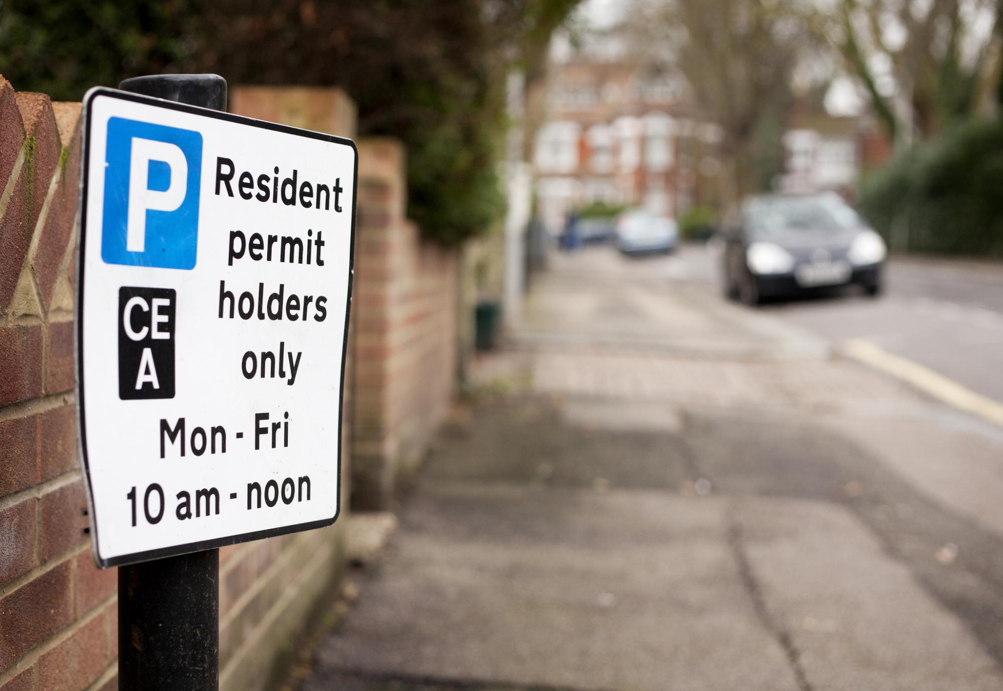



www.milton-keynes.gov.uk

Income

**What is a Resident Permit Scheme?**

A Resident Permit Scheme can help to protect parking spaces for residents use only. This scheme can help in a specific area where there are significant issues with non-residents using the parking spaces.

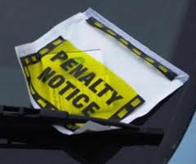The scheme limits parking on the highway to residents-only and their visitors by using a virtual permit. Any vehicle that is parked with the restricted area/parking place without a permit will be in contravention of the parking restriction and will be issued a penalty charge notice when enforced.

Whilst a permit scheme does not guarantee a parking space, the Council aims for all residents to park at least one vehicle near to their home.

**Why is it needed?**

Many areas were built when car ownership was much lower when most households only had one vehicle. In many older parts of the borough, the street layout was not built to accommodate cars at all and there are many challenges around this. A resident permit scheme will not resolve existing road space issues as no new bays are being created, but it will mean that any parking spaces are there for residents only.

**The most common reasons for introducing a resident parking permit scheme**

**What does it cost?**

The permit charges cover the cost of administration and enforcement of the permit scheme. All permit charges are reviewed annually and are subject to change.

**Current Permit Charges** (July 2024):

* The resident permit cost £25 for 12 months.
* The visitor Permit cost £25 for 12 months.
* The pay-as-you-go (PAYG) voucher cost £1 for 24 hours.

Residents will only need to purchase a permit if they park on the highway. If the resident has private parking (driveway/garage) then they may not necessarily need to purchase a permit. However, any visitors that may need to park on the highway, will need to be issued with a permit.

**Which areas could benefit from a permit scheme?**

A resident permit scheme may be suitable if any of the following conditions apply in your local area:

* Located close to businesses, shops, schools, and town centres;
* Located close to railway station;
* Issues with non-residents parking for long and short term on residential streets;
* Willingness to pay for the scheme (£25 per resident and visitor permit per year).

**It may be the case that some areas simply do not have sufficient parking for the level of modern vehicle ownership and parking may always be an issue in these areas.**

If you are experiencing difficulties parking due to non-residents from another street parking in your street, the resident permit scheme will probably not address this issue as the residents from neighbouring streets may then also request a scheme. This will cause a domino effect and impact on neighbouring streets, the end result being the same number of vehicles parked, just all with permits.

**How to set up a resident parking scheme**

We will require evidence that a resident permit parking only scheme is desired by at least 70% of affected residents before we will consider implementing a scheme. A lead resident will be asked to mobilise their neighbours to demonstrate that they have the required level of support from other residents.

This can be in the form of all residents individually writing to the council, or the lead resident may submit a petition which requests the introduction of a scheme and is signed by at least 50% of residents. This document needs to show the names and addresses of all supporting residents, and their signature.

MK Council will review the issues before consulting with the local councillors and the relevant town, community, or parish council to decide whether a resident permit scheme is appropriate. If they do not object, we will hold an informal (non-legal) consultation with residents of the street.

This involves sending a standard document package (letter and sometimes plans) to the residents explaining the advantages and disadvantages of a resident permit parking only scheme.

The charge of £25 per permit will cover the cost of administering and enforcing the permit scheme. When responding to the questionnaire, residents should consider how bad the parking problems are and whether they are willing to pay for a permit to park. An online option for responses is provided. Usually, four- six weeks are allowed for responses.

The Council will only consider introducing a resident permit scheme if 70% of affected residents are in support of the scheme. The threshold is set at this level as any less (e.g. 60/40%) would risk displeasing as many residents as it pleased.

|  |  |
| --- | --- |
| **Successful application** | **Unsuccessful application** |
| Response | Response |
|  |  |
| In Favour | In Favour |
|  |  |

The Council requires a minimum response rate of 50% of properties consulted (i.e. if letters are sent to 100 properties), we need at least 50 letters returned and at least 35 of these must be in favour of a permit scheme.

**40%**

**60%**

*Example shown in Figure 1.0*

If less than 50% of properties respond, we cannot proceed with the scheme and legally we are only required to review a scheme once every five years, although in some circumstances we will consider reviewing a scheme after two years. However, the lead resident can do much to encourage their neighbours to respond, for example, door knocking upon receipt of the document package to explain the issues to residents and the importance of responding.

**80%**

**60%**

If the parking team do not believe a resident permit scheme is appropriate in the circumstances, they will offer to meet with the lead resident to discuss alternative solutions.

**Can People Object to the Scheme?**

Formal/statutory consultation is in line with statutory guidelines but involves laminate notices in the affected area and an advertisement in the local newspaper, as well as writing to the standard list of statutory consultees (Police, fire, councillors etc.).

Objections can be received during the formal consultation period which may affect whether the scheme goes ahead, depending on the nature and number of the objections.

Subject to the outcome of the formal consultation process, a resident permit parking only scheme can be implemented by the creation of a Traffic Regulation Order (TRO).

**What happens next?**

Residents who will require a parking permit to park in the new resident permit parking only area will be contacted one month prior to the implementation date and invited to apply for parking permits.

The area will be signed in accordance with legal requirements and ‘soft’ enforcement will commence from the implementation date, with regular enforcement as required thereafter.

**Creation of Additional Dedicated Resident Permit Parking Only Spaces – Central Milton Keynes (CMK) Only**

Previous residential developments in CMK were built at a time when public parking was plentiful and free, and as a result there is some dedicated parking for ‘residents only’ provided on the public highway near these developments. However, due to the pressure on availability of parking spaces for employees and other users, as well as the adoption of parking standards for employees and other users, as well as the adoption of parking standards requiring at least one allocated (private) parking space per dwelling for new developments, no further public parking spaces in CMK will be changed to dedicated ‘resident only’ parking spaces.

This policy is subject to the Councils discretion and where a resident permit scheme is considered necessary in the interest of the highway network safety the Council reserves the right to refuse to consult on removing the scheme.

**Further information**

If you have any questions about resident permit schemes you can contact the Council:

Tel: 01908 691691

Our phone lines are open 9:00am-5:15pm Monday, Tuesday, Thursday, Friday and 10:00am-5:15pm on Wednesdays.

Email: [customerservices@milton-keynes.gov.uk](mailto:customerservices@milton-keynes.gov.uk)