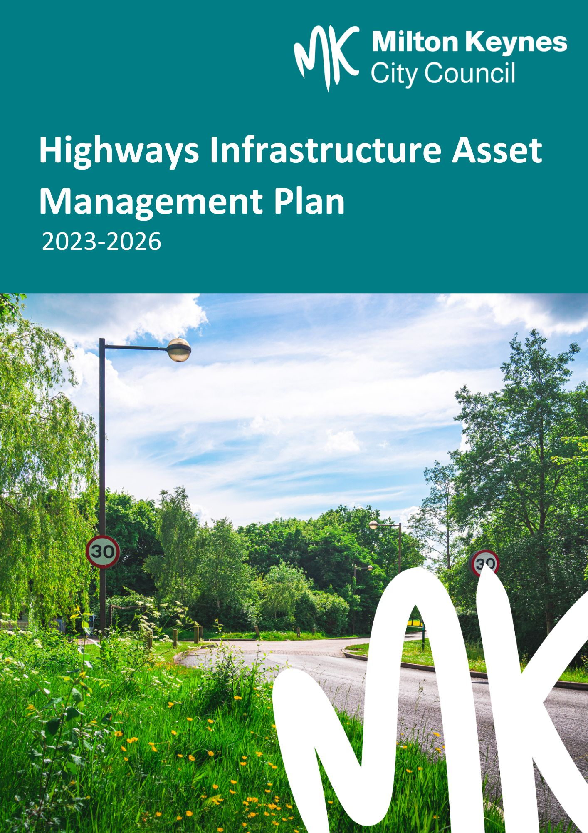

|  |  |
| --- | --- |
| Title | Highways Infrastructure Asset Management Plan 2023 - 26 |
| Author | A.Dickinson – Strategic Asset Manager |
| Review | G.Cox – Head Highways and Transport |
| Status | Final V 2.0.1 |
| Issue Date | March 2023 |

**Document Control**

**Issue Record**

|  |  |  |  |  |
| --- | --- | --- | --- | --- |
| **Version** | **Approval Date** | **Details** | **Status** | **Action By** |
| 1.0.0 | August 2018 | Created Highways Asset Management Plan | Draft | SA |
| 2.0.0 | January 2023 | Review and update Highways Asset Management Plan / change to Highways Infrastructure Asset Management Plan | Draft | AD |
| 2.0.1 | March 2023 | Issued Highways Infrastructure Asset Management Plan | Final | AD |
| 2.1 | October 2025 | Minor revisions | Draft | RM |
| 2.1.1 | October 2025 | Issued revised Highways Infrastructure Asset Management Plan | Final | AD |

**1 Introduction 3**

**1.1 Scope and Purpose 3**

**1.2 Relationship with other Asset Management Documents 3**

**1.3 Outline Contents of HAMP 4**

**2 Highway Asset Management in Milton Keynes 5**

**2.1 Background and Context 5**

**2.2 Overview of Asset Management Process 5**

**2.3 How we are organised. 6**

**2.4 Network Hierarchy 6**

**2.5 Policies and Procedures 7**

**2.6 Service Levels and Performance Targets 7**

**2.7 Benchmarking and Efficiency Monitoring 8**

**2.8 Risk Management 8**

**2.9 Training and Skills 9**

**2.10 Communication 9**

**3 Lifecycle Management Planning 10**

# **Introduction**

## Scope and Purpose

The purpose of this document is to describe how Milton Keynes City Council (MKCC) will manage the highway asset to deliver the current Highway Infrastructure Asset Management Strategy (HIAMS).

The Highway Infrastructure Asset Management Plan (HIAM Plan) covers the most significant highway asset types that are the responsibility of MKCC, namely:

* Carriageways
* Bridges and Highway Structures
* Footways and Redways
* Highway Electrical Assets
* Drainage
* Traffic Signals

## Relationship with other Asset Management Documents

The HIAMPlan covers the three year period 2023-2026. It is part of a suite of documents that collectively provide a framework for the management of the highway asset as shown below.

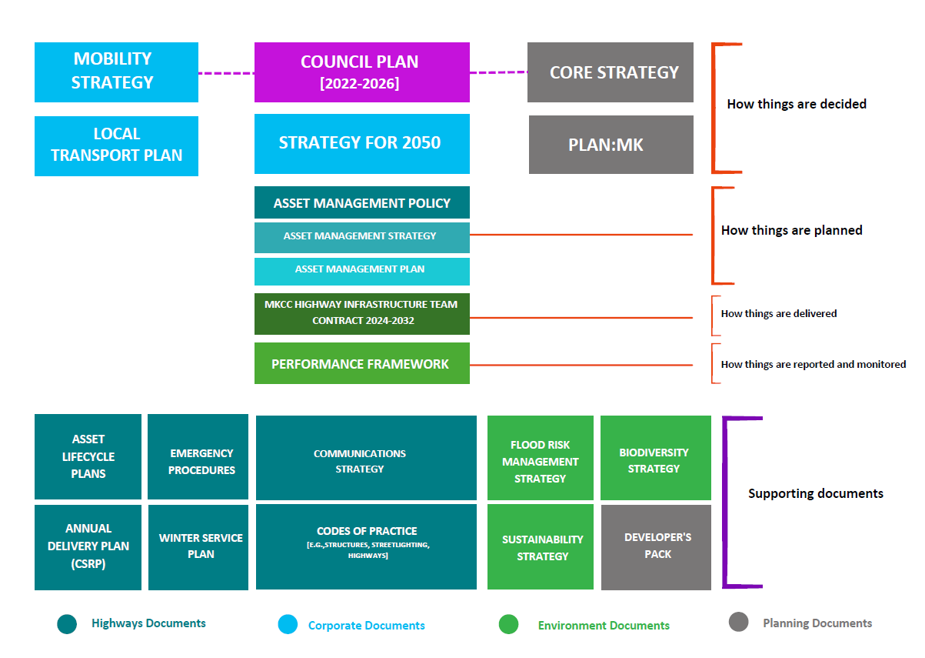**Figure 1 - Highways Asset Management Documentation**

As mentioned above, the HIAM Plan describes how we will manage our assets. The planned maintenance interventions that we need to carry out over the asset lifecycles are be described in separate Asset Lifecycle Plans within the relevant Codes of Practice for each asset type, which will be refreshed on an annual rolling basis, while the specific maintenance activities for the current year will be described in our annual Work Programme(s). Effectively, the Asset Lifecycle Plans and annual Work Programme(s) are outputs from the HIAM Plan.

## **Outline Contents of HIAM Plan**

The HIAM Plan comprises the following sections:

|  |  |
| --- | --- |
| Covered in HIAM Plan | |
| Introduction | Defines the purpose and scope of the HIAM Plan, and how its relationship with other asset management documentation. |
| Highway Asset Management in MK | Describes the overall context and approach to highway asset management in MK. |
| Covered in Code of Practice for Asset Group | |
| Lifecycle Management Planning | Describes the approach taken for the management of each asset type. |
| Budget Prioritisation and Allocation | Describes the process for developing overall programmes of work and allocating budgets to individual asset types. |
| Programme Management and Delivery | Describes how programme delivery is monitored and managed. |
| Improvement Actions | A list of improvements to be made to our asset management processes during the period covered by the HIAMP |
| Inspections / Monitoring | Any cyclic Inspections and/or monitoring of asset condition to allow for investment decision making / prioritised maintenance |
| Operational Considerations | Key activities required to support the maintenance of the particular asset |

# **Highway Asset Management in Milton Keynes**

## Background and Context

Milton Keynes City Council's highway infrastructure is its most valuable asset, valued at £7.1 billion. It provides a transportation network for both businesses and individuals. It supports the Council Plan and Mobility Strategy. We maintain our network in line with good highway asset management practice. We continue to aspire to maintain a position in the top quartile of the 153 authorities in the country and maintain this position as measured by nationally recognised benchmarking methods and organisations.

Due to the generally narrow age profile of Highway assets in Milton Keynes a significant number of assets are or were approaching their end of life at the same time. In 2012 a successful case was made for Prudential Borrowing that allowed MKCC to address the carriageway and lighting maintenance backlog and these assets on the network are now more or less in a steady state. The original Prudential Borrowing case proposed the following approximate split:

* Street Lighting - 8%
* Highways – 54%
* Bridges and highway structures – 38%

This percentage split of capital budget has been reviewed on an annual basis together with the senior finance team. It has been adjusted in accordance with identified pressures on any one or several of the asset groups, based on factual investigative survey and condition data, to ensure that flexibility is built in to the available budgets to address deterioration and intervention at the right time. Additional funding has been re-allocated if, for example, a bid is made through grant funding requiring match funding to address a particular asset improvement project that is beyond the scope of existing budgets (e.g. 2017 DfT Challenge Fund project – A509 asset upgrade).

Other sources of funding associated with growth of Milton Keynes have also contributed to the overall capital budget in the form of ‘Tariff’ funding that is levied on new developments. With the current growth forecast for Milton Keynes, additional tariff is being made available for street lighting LED upgrades and structures asset improvement projects.

Since the implementation of the new maintenance contract in 2024, MK Highways has been able to reprofile revenue budgets to support the expected routine maintenance requirement. Using historical defect numbers and a “lump sum” contract model we are now able to specify maintenance in support of a preventative asset management approach, while continuing to address safety defects as they arise.

## **Overview of Asset Management Process**

This document describes the processes we will follow to manage the highway asset over the period 2023 to 2026 to deliver the Highway Infrastructure Asset Management Strategy. For each individual asset type this typically includes:

1. Knowing what assets we own, including their location, age, and construction.
2. Defining the desired performance or service levels.
3. Identifying asset specific maintenance risks.
4. Assess current performance of the assets against the desired performance targets or maintenance standards.
5. Identifying and analysing maintenance options over the whole life of the asset, in line with asset specific maintenance strategies.
6. Developing a short-term and long-term maintenance and renewal programme(s).
7. Managing delivery of the maintenance programme.

Once programmes of work are developed for individual or groups of assets, they are evaluated and prioritised and budgets are allocated accordingly.

**How we are organised**

The structure of our highway asset management team is illustrated in the following figure.

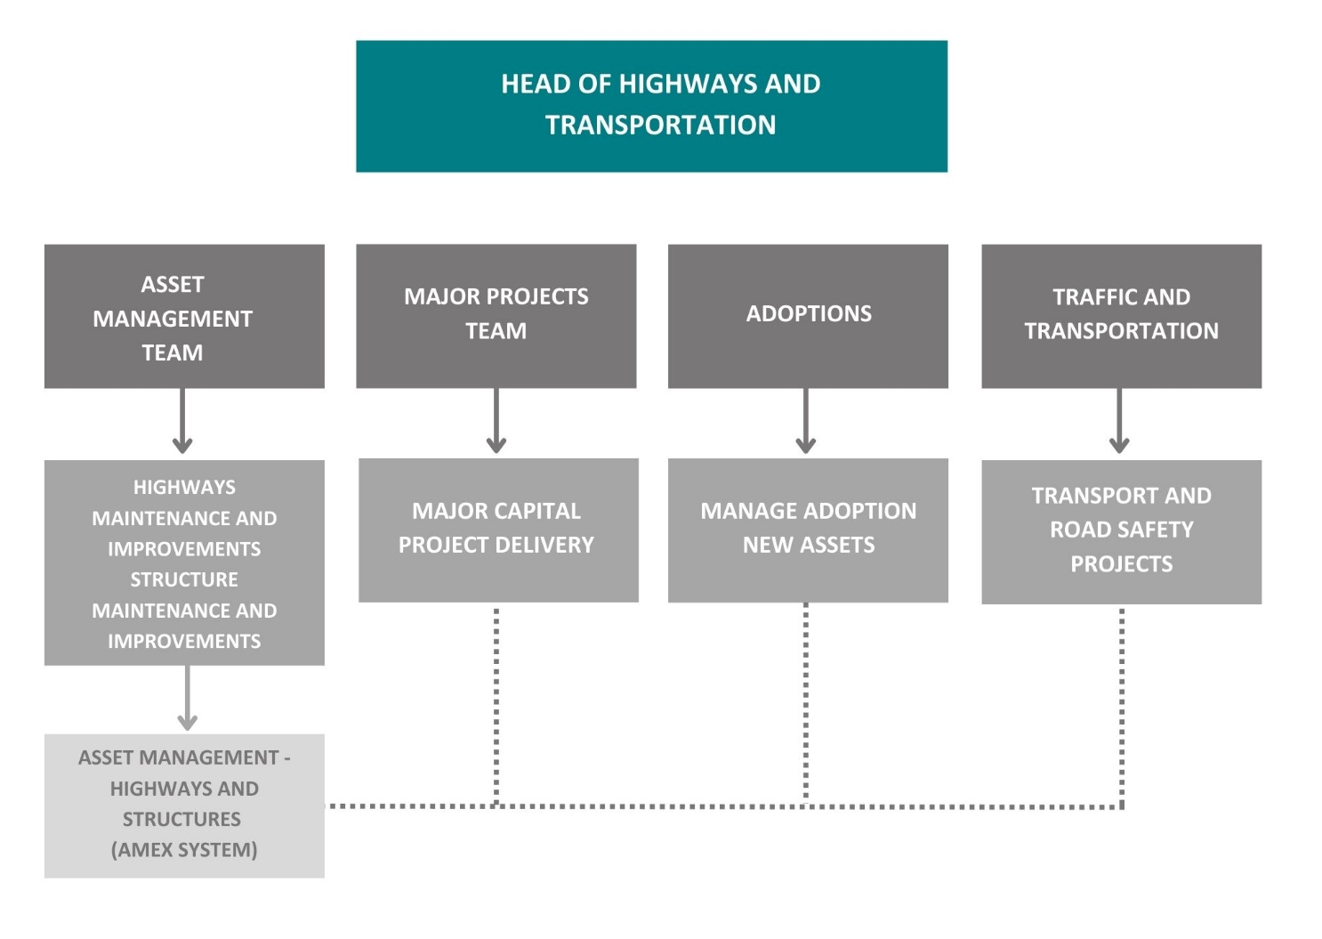

Figure 2 - MK Highway Asset Management Team Structure

## 

## **Network Hierarchy**

Our network is organised into the following hierarchy:

|  |  |
| --- | --- |
| Grid Roads | * Principal * Non-principal * Unclassified |
| Non-Grid Roads | * Principal * Non-principal * Unclassified |

Other hierarchies are used for specific asset types (e.g., footways and redways, estate roads, etc.) and these are expanded upon in the individual Codes of Practice relating to the specific asset group.

**Policies and Procedures**

MKCC Highways have a number of Policies and Procedures that are used to support the asset management processes described below. These include:

* Codes of Practice
  + Highway Inspections
  + Carriageways, Footways and Redways
  + Highways Electrical
  + Drainage
  + Structures
  + Traffic Signals
* Communication Strategy
* Developers’ Pack
* Highways Emergency Procedures
* Flood Risk Management Strategy
* Skid Resistance Policy
* Term Maintenance Contract Documentation incl. Specification
* Winter Service Plan
* Client Services Requirements Plan (CSRP)

## **Service Levels and Performance Targets**

As an authority, we have a range of measures and targets that we use to measure our performance and the quality of service we provided. These include:

|  |  |
| --- | --- |
| National Measures | * Asset Value (as measured by CIPFA WGA Valuation of Assets methodology) * DfT Single Data List: * 130-01 Condition of Principal Roads * 130-02 Condition of Non-Principal Classified Roads * 130-03 Skidding Resistance Data * BVPI 224b Condition of Unclassified Roads * 130-05 Carriageway Work Done * APSE Performance Networks Road Asset Management data collection |
| User Satisfaction | * NHT Survey – standard public survey plus targeted stakeholder survey * Local Stakeholder Surveys by MKCC and Contractor |
| Contractual Measures | * Various measures we use to monitor the performance of Contractor in delivering the highway maintenance contract. The requirements and measures are contained within the contract documents (Scope), and have been fully revised and updated in preparation for the new contract in 2024. |

In addition, we will develop and publish an annual *Highways Infrastructure Asset Management Assessment Report*, which compares our performance to the targets for the condition and performance of our network, and whether we are on track to deliver the improvement actions described in Appendix A. This will be delivered in time to inform the Budget setting process.

## **Benchmarking and Efficiency Monitoring**

The Midland Highways Alliance (MHA), which comprises 21 local highway authorities, provides data on the performance of its members. We actively compare our performance and identify where we are performing well and where we need to target improvements.

The Local Council Roads Innovation Group has instituted regional forums for the purposes of benchmarking and sharing best practice, and we are an inaugural member of the South Central group.

We will continue to institute a process to assess efficiency in how we deliver the service and compare our performance with those of comparable local authorities and to track improvements over time. We will establish measures of efficiency that will take into account expenditure, service quality and public satisfaction.

The Highways Infrastructure Asset Management Assessment Report described above will also set out our efficiency performance and will identify where we will be targeting efficiency gains in the coming year.

## **Risk Management**

Over the period of the HIAM Plan we will continue to adopt a risk-based approach to asset management in line with *Well Managed Highway Infrastructure: A Code of Practice*. This will mean continually reviewing how and why we do things from a risk point of view (i.e., what risks are we mitigating) and providing evidence to justify those decisions. Fundamentally, this will mean that we understand what the risks are. Our approach to managing some of our assets (e.g., structures and street lighting) already includes an element of risk management but we will extend this to other asset types and other parts of the service.

General risks that we are aware of include:

* Narrow general age profile of assets in MK means that they are reaching their ‘end of life’ at the same time, which has been partially mitigated through Prudential Borrowing in 2012
* Population growth is increasing size of and demand on the network. Population growth is also adding pressure to other service areas, which in turn leads to reductions in Highway budgets
* Cuts in Government revenue funding is reducing budgets for reactive highway maintenance
* Capital funding is tailing off as Prudential Borrowing profile reduces extra funding over time.
* Climate change is increasing flood risks and winter service leading to accelerated deterioration of highway assets
* Increasing demand on highway assets to support SMART City Technology
* Inadequate construction information
* Increase in number of claims against the Highway Authority
* General increase in traffic flows

## 

## **Training and Skills**

Training is identified via 1 to 1s, during formal annual assessments and is discussed at Highway management meetings. Training requirements are entered onto individual training plans with the individual expected to ensure the training occurs. Training identified as being needed for a number of staff is organised by one of the management team with individuals that would benefit being identified and targeted or informed of required attendance.

Most Highways staff have undertaken the Highway Maintenance Efficiency Programme Asset management e –training, which provided a basic knowledge and understanding of the area, allowing Asset Management to be considered as part of everyday decision making. This training is now defunct and MKCC is moving to self-delivery of Asset Management awareness, through new starter induction and refresher training.

## **Communication**

## 

Our approach to communication is set out in our *Highway Communication Strategy*. The Communication strategy will need amending to ensure communications are used to inform the public about Highways Infrastructure Asset Management, the changes they may witness and what they can expect.

# **Lifecycle Management Planning**

This section describes the process to be followed to manage each of the main asset types through their lifecycle. Given the maturity of the network, this focusses primarily on maintenance and renewal rather than asset creation or disposal.

Each asset group lifecycle plan is detailed in the respective Code of Practice included for:

* Carriageways, Footways and Redways
* Bridges and Highway Structures
* Highways Electrical Assets
* Drainage
* Traffic Signals

Each Code of Practice uses the following structure for the asset group:

|  |  |
| --- | --- |
| Context | Overview  Asset Stock and Usage  Asset Groupings and Hierarchy  Asset History (Historic Funding, etc.)  Asset Value and Risk Profile |
| Asset Performance | Levels of Service  Surveys and Inspections |
| Scenario Evaluation | Maintenance Strategy  Lifecycle Options  Option Appraisal |
| Improvement Actions | Asset Specific Improvements |
| Operational Considerations | Service operations to maintain assets |

Contact details

Email

Phone

Website

Postal address