
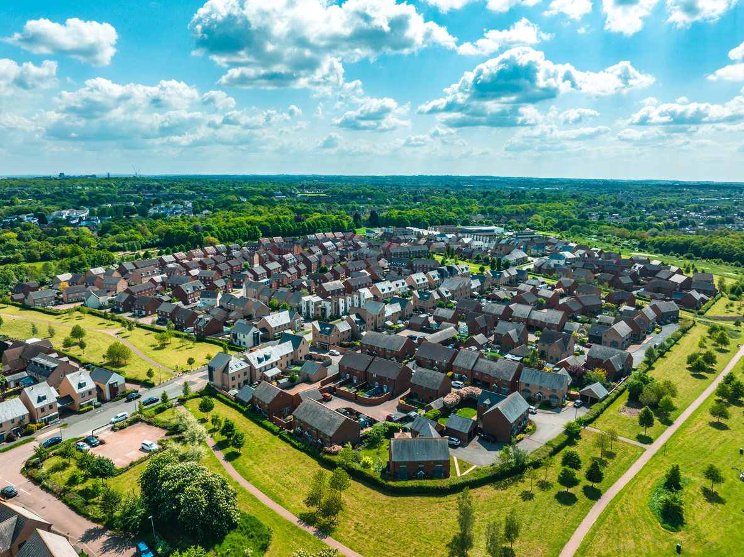

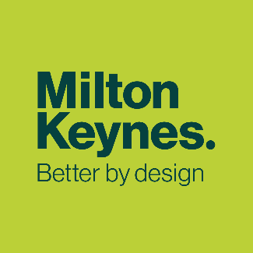


Our Growth Strategy

MK City Plan 2050
Topic Paper

November 2025
Regulation 19 Version

Contents
Purpose of this Topic Paper 1
Our Approach 1
Shaping The Plan 2
Ambition and Objectives 2
Technical Evidence 4
Amount of Growth we are Planning for 5
Identifying our Growth Options 5
Call for Sites 6
The Strategic Housing Land Availability Assessment 9
Sustainability Appraisal and Reasonable Alternatives 11
Our Proposed Growth Strategy 15
Housing and Infrastructure 15
Our Infrastructure First Approach 17
Conclusions and Next Steps 19

Purpose of this Topic Paper
  - This topic paper has been prepared to explain the growth and infrastructure approach we have taken in the Proposed Submission MK City Plan 2050 and why. Whilst each of the individual topic papers we have prepared can be read in isolation, there are many linkages between them and the issues and opportunities they cover.

  - These topic papers have evolved through the plan-making process as we gather further evidence and receive feedback through engagement and consultation. The topic papers set out the more detailed justification for policies in the MK City Plan 2050, allowing the Plan itself to be a shorter, user-friendly document.

  - In this paper, our focus is upon explaining our proposed growth strategy and infrastructure planning approach why we think this helps us achieve our Ambition and Objectives.

Our approach
  - The MK City Plan 2050 will take forward our Strategy for 2050 which sets out a bold and ambitious vision for Milton Keynes that will bring transformational change, whilst protecting that which is unique to Milton Keynes and will play an important role in our future success. Taking an integrated approach allows a range of difficult, and at times competing, things to be considered and balanced in a way that helps growth to be virtuous and beneficial to the communities living in Milton Keynes today and tomorrow.

  - The range of things the MK City Plan 2050 responds to typically includes our need for homes, need to support jobs and business, how we move around the city and effects this has, our changing climate, our natural and built environment, the design of buildings, streets and the places which support our everyday lives, and how we ensure the necessary infrastructure, such as schools, shops and surgeries, is delivered to support new communities. This is reflected in our overarching Ambition for the MK City Plan 2050 set out below.

  - A driving force of the plan is helping to make Milton Keynes a more people-friendly and healthy place to live, work and enjoy. A focus on health is not at the cost of other issues that the plan responds to. Providing more good quality and affordable homes helps people find a suitable home and gives them security, which we know has a positive impact on people’s mental and physical health. We know that creating opportunities for more jobs and an affordable and accessible way of getting to work supports people’s wellbeing and ability to lead healthier lifestyles. Providing quality open and green space, schools and services in the right places creates a sense of community and belonging and encourages physical activity, which we know improves physical and mental health, as well as supporting our aims around biodiversity and climate change. With a focus on health, the MK City Plan 2050 can address the wide range of matters we need and want it to in a virtuous and integrated way.

Shaping The Plan
  - We are currently at the final stage of preparing the plan, referred to as the Proposed Submission or Regulation 19 stage according to legislation that guides the preparation of local plans. This has been built upon a wide range of engagement, both statutory and non-statutory, that has occurred since early 2023. The previous draft stage of the MK City Plan 2050 (Regulation 18) during late 2024 was somewhat unusual compared to most local plans at that stage, as it articulated a full and comprehensive growth strategy, including proposed allocations and a suite of supporting policies that would ordinarily not be seen in most draft plans.

  - Notwithstanding the considerable and wide-ranging feedback that was received, no significant issues were raised at the Regulation 18 stage which gave pause for serious reflection and to consider pursuing a markedly different strategy. As such, the feedback from the Regulation 18 consultation alongside our continued work on the evidence base and targeted stakeholder engagement since late 2024, has resulted in non-fundamental changes to the overall strategy, proposed allocations and supporting policies.

  - Having now reached the Regulation 19 stage, we are asking for feedback on whether this revised plan is sound and legally compliant. We are confident it is, and that the MK City Plan 2050 delivers on the vision set out within the Strategy for 2050 as well as its own Ambition and Objectives, set out below.

Ambition and Objectives

  - Building upon the long-term vision of the Strategy for 2050, we consulted with our communities and stakeholders in early 2023 on how far our Ambition should reach and what the Objectives that guide us should be. We have continued a conversation about this with community groups and stakeholders since then, through online surveys and face to face workshops and our continued and wide-ranging technical work. Using the evidence and feedback we received, we have settled on the Ambition and Objectives shown here.
By 2050, Milton Keynes City and its rural area will be an innovative and successful place, founded upon its unique history and special characteristics. Well-planned ambitious growth has created prosperity and a better quality of life and wellbeing for all. People living and working in our city enjoy good-quality affordable homes that meet their needs, green and valued open spaces, more jobs, more business investment, a diverse cultural offer, and people-friendly healthy places supported by infrastructure that makes for a thriving and sustainable place. A city that is Better by Design.

  - Our ambition and objectives provide the ‘golden thread’ to guide the development of our spatial strategy – how much growth do we plan for, where should it go, and how can it be delivered – as well as policies that guide this growth to ensure we achieve our objectives.

People-Friendly and Healthy Places
Objective 1: Create inclusive and safe places that encourage greater physical activity, social interaction and healthier lifestyles.
Objective 2: Create streets and neighbourhoods that prioritise walking, cycling and wheeling for access to shops, services, community facilities, and parks and open space.
Objective 3: Provide a suitable range of facilities and infrastructure in the right places at the right time to promote walkable neighbourhoods and good physical and mental health.
Climate and Environmental Action
Objective 4: New homes and commercial buildings to be net zero-carbon by 2030 and carbon negative by 2050.
Objective 5: New growth prioritises active travel and public transport to reduce carbon emissions.
Objective 6: Support the efficient use of resources as part of a circular economy.
Objective 7: Create space for nature and deliver significant gains in biodiversity.
Objective 8: Ensure that communities and nature can cope with and bounce back from negative climate impacts and environmental change.

High-Quality Homes
Objective 9: Provide a range of homes for those most in need including affordable homes, and to meet the wider market demand for housing.
Objective 10: Support renewal and regeneration within neighbourhoods and communities that would benefit from it.
Objective 11: Support delivery of social infrastructure to enable people to prosper and have a high quality of life.

Economic and Cultural Prosperity
Objective 12: Enable better access to education, skills and training, and economic opportunities to strengthen our regional and national economic role, with Central Milton Keynes at the heart of a diverse and resilient economy.
Objective 13: Conserve our unique heritage and provide a greater diversity of places where culture can be produced and enjoyed, strengthening our role as a national and international centre of cultural and creative significance.
Objective 14: Support the maintenance and creation of thriving high streets and centres for leisure.

Central Milton Keynes
Objective 15: A thriving centre for innovation, learning and culture, with all the things you’d expect to find in a city: shops, businesses, restaurants, cafés, bars and entertainment.
Objective 16: Bringing nature, streets, and buildings into harmonious balance, providing a new townscape setting for public life, play, health, and wellbeing.
Objective 17: Inviting new communities to make their home in CMK, with all the services and facilities they need within easy walking distance.
Objective 18: Safeguarding CMK's unique public art, its modern design, and its classic infrastructure for future generations to appreciate.
Objective 19: Attracting people to live and work in the city with high-quality jobs and inward investment and making it easier for people to get in and around.

Technical evidence
  - We have prepared a comprehensive evidence base across a range of issues to help us prepare the MK City Plan 2050. This is important as our growth strategy and all policies within the plan need to be justified to be found ’sound’ by the Secretary of State. The range of technical evidence we have prepared is illustrated below, and the full suite of evidence has been published alongside the Proposed Submission MK City Plan 2050 consultation. These evidence studies have also been informed by their own dedicated engagement and consultation work. This has normally focussed on expert technical bodies and stakeholders but has also included engagement with parish and town councils (e.g. landscape, open space and carbon and climate) as well workshops and survey work focussed on people-friendly and healthy places.

People-friendly and healthy places | Carbon and Climate | Site Assessments | CMK | Nature Green and Blue Infrastructure
Gypsy and Traveller Accommodation | Integrated Water Management | Mass Rapid Transit and Accessibility | Retail and Leisure | Infrastructure
Landscape | Transport Modelling | Housing & Economic Needs | Open Space | Viability

Amount of growth we are planning for

  - The Housing and Economic Development Needs Assessment (HEDNA) identifies the minimum annual local housing need figure for Milton Keynes of 1,799 homes per year, or 50,372 homes for the MK City Plan 2050 period (2022-2050). This has been produced using the standard method calculation set out in national planning practice guidance. Within this figure, the HEDNA identifies an overall affordable housing need of 18,061 homes, equivalent to an average of 645 per annum. Further information is provided in the High-Quality Homes Topic Paper.

  - Due to our successful record of proactive plan-making, we already have around 23,000 homes being built, with planning permission or allocated within Plan:MK and Neighbourhood Plans. This increases to around 28,000 when commitments in Central Milton Keynes around accounted for. This means that we will need to provide for around 22,000 homes in the MK City Plan 2050 to meet our minimum housing needs. In reality, a higher figure would be needed to ensure we do provide enough homes, protect ourselves from speculative development in locations we don’t want growth to occur, and to match our Strategy for 2050 aspirations. The Proposed Submission MK City Plan sets out a strategy that would deliver around 60,000 homes in total, providing a buffer of around 19%.

  - Our HEDNA sets out how much employment land might be required to support economic growth over the plan period, and has identified several challenges and trends:

- Need to replace and repurpose ageing stock of commercial floorspace (office, industrial and warehousing floorspace) within the area. The amount of floorspace required to replace ageing commercial floorspace is greater than the amount of floorspace forecast to be required by economic growth.
- Forecast need for around 380,000 square metres net of office floorspace.
- Forecast need for around 1.3 million square metres net for industrial, warehousing and logistics, the majority of which (over 1 million square metres) is for warehousing and logistics.

Identifying our growth options
3.1 To identify options for where we could grow to provide a minimum of 50,372 homes, we combine a ‘bottom-up’ approach of land being promoted to us by developers and identifying possible urban growth locations ourselves, with a ‘top-down’ approach with a wide range of strategic considerations.
3.2 Most prominent of these are the Council’s vision for growth and the Recommended Growth Option within the Strategy for 2050, but also our development needs and wider evidence base, national planning policy, our current supply of land for development, and opportunities arising through emerging investment and infrastructure projects. We have then used our technical evidence and engagement work outlined above to inform our site assessment and Sustainability Appraisal of growth options to arrive at a preferred strategy. The following sections outline the basic ‘bottom-up’ steps we have taken to identify and assess options. Section 4 outlines how we have then considered these by combining the ‘top-down’ approach through the Sustainability Appraisal to arrive at a the strategy contained in the Proposed Submission MK City Plan 2050.

Call for Sites
3.3 The first step in developing our growth strategy and identifying where growth could occur is a Call for Sites. This is an open-ended process where landowners can propose that their land should be developed for various uses, but typically for housing. This is a standard process taken in all local plans and is set out in national planning policy. A Call for Sites was commenced in March 2023 when we launched our consultation on the Ambition and Objectives and Sustainability Appraisal Framework consultations. The Call for Sites process is open-ended and we have to consider any site promotions from developers we receive throughout the process of preparing the plan until we finalised the Proposed Submission Regulation 19 MK City Plan 2050. Officers have also sought to identify potential sites for housing, including for gypsy and traveller sites.
3.4 As a result of the Call for Sites process to date, we have identified a total of 537 sites with a further 100 sites being identified across Central Milton Keynes/Campbell Park and Metro corridors. Virtually all the land and sites promoted to us by landowners/developers falls in the rural area beyond the boundaries of the city and the towns of Olney, Newport Pagnell and Woburn Sands. Whilst the historic towns of Olney, Newport Pagnell and Woburn Sands may contain small to medium sites that offer potential for development, very few have been promoted through the Call for Sites to date. This may be because the majority of any (re)development opportunities have already been built out or are allocated in Neighbourhood Plans. Historically, local plans for the borough of Milton Keynes have directed growth to within or adjoining the city itself, without relying on smaller scale growth to occur in the smaller towns. Nonetheless, significant growth has occurred in these towns, particularly since the advent of Neighbourhood Plans. As a result, the sites promoted to us are primarily in the rural areas and range from small sites that could only provide a handful of homes, through to strategic-scale new settlements or extensions to the city (and to a lesser extent to Olney) that could provide many thousands of new homes, community facilities, space for business and other uses.

Opportunities within urban areas
3.5 Due to the history of how Milton Keynes was established as a new city, most of the land promoted by private owners falls within the rural areas beyond the city. Most of the undeveloped land within the urban areas, or areas where redevelopment could occur, is typically owned by the public sector and primarily Milton Keynes City Council or its arms-length body, the Milton Keynes Development Partnership. We have identified and assessed a number of sites in the city area, most notably 74 sites within Central Milton Keynes/Campbell and 26 sites along Metro corridors.

Strategic brownfield opportunities
3.6 Most vacant land in Milton Keynes, in planning terms, is not classed as brownfield as it has never been built upon. There are a limited number of options on brownfield land that have been promoted to us by other parties for consideration, namely the former Wolverton railway works and the Open University Walton Campus. The former railway works in Wolverton has previously had planning permission to be redeveloped for residential mixed use, and so this option is being considered again. The Open University had originally considered moving to the city centre meaning the current campus may be available for partial or whole redevelopment. However, their approach has changed and only a smaller part of the Walton Campus has been put forward for (re)development). Beyond these sites and locations, and redevelopment opportunities in the city centre and Bletchley (see below) there isn’t much other land in the urban area that provides strategic brownfield opportunities or may be promoted by private owners.

City Centre
3.7 In line with the vision set out in the Strategy for 2050 and an ambition for transformative change and growth in the city centre, Central Milton Keynes has been a key focus for identifying growth opportunities. We are already seeing more homes being promoted privately in Central Milton Keynes but in a piecemeal way. As most of the land in the city centre is publicly owned, we have a huge opportunity to shape how the city centre will grow and change through to 2050. To help do this, we commissioned the Central Milton Keynes Growth Opportunities Study to investigate what growth could come forward in a comprehensive way, alongside potential changes to open space, public realm and transport, through a design and placemaking-led approach. This study has identified opportunities for significant growth in the number of homes and office space, alongside other uses including community facilities and some small and large-scale changes to open space and transport, to create a vibrant city centre founded on its unique identity.

Central Bletchley
3.8 Beyond the city centre, we have looked at what other opportunities there may be. There has already been much discussion with local leaders and communities in Bletchley and Fenny Stratford about how this area may be improved and what opportunities there are for (re)development, linked to the East West Rail project and a successful Town Fund Deal. This dovetails with and reinforces the approach set out in the Central Bletchley Urban Design Framework which was adopted in 2022 in line with Plan:MK’s positive vision for Central Bletchley .

Metro corridors
3.9 Placing growth alongside significant investment in a new public transit service, the Metro, have warranted further exploration to maximise any opportunity we have for delivering homes in highly sustainable locations. The dedicated work to prepare a business case for a new Metro system has resulted in five emerging routes crossing the urban area of Milton Keynes. Adopting the principle of a 600m walking catchment from the emerging routes and likely interchanges along them, we established Metro corridors to explore and identify specific locations that could be used for development that would benefit from enhanced public transport, and in turn support the Metro system itself. This resulted in 26 suitable sites for housing being identified.
Figure 1. Emerging Metro routes
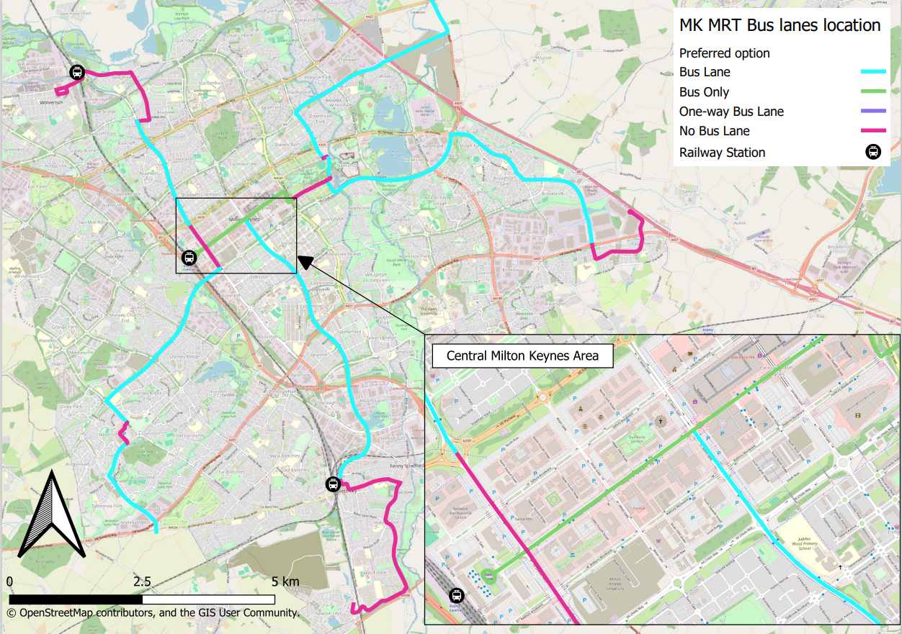

Small brownfield sites and regeneration
3.10 Alongside allocated strategic growth locations and sites, it is typically the case that much smaller sites come forward within urban areas during the course of a plan period. These are traditionally known as small brownfield sites or windfall sites and come forward through planning applications. Under Plan:MK we made an allowance of 95 homes per year to come forward in this way. Since Plan:MK was adopted, we have seen a higher number of homes from small brownfield and windfall sites come forward than anticipated. These sites and homes have been suitable and sustainable locations and have been given permission by the Council accordingly. Given past trends, we have made a reasonable estimate that 115 homes per year could come forward over the period 2024-2050 in this way, providing 3,000 homes in total.
3.11 We have also sought to investigate small to medium parcels of vacant land within the estates across Milton Keynes that could potentially be developed for housing or other uses. Whilst many sites have been identified, these are in most cases currently designated as open space within estates that may be subject to local conversations about regeneration of their neighbourhoods. As explained further below, we do not consider regeneration of estates in the city to have the required level of certainty around them to rely upon them within the Proposed Submission MK City Plan 2050 to provide a significant number of additional homes.

The Strategic Housing Land Availability Assessment
3.12 The Strategic Housing Land Availability Assessment (SHLAA), alongside the Sustainability Appraisal, is our main method for assessing and defining growth options from the various sources outlined above. A SHLAA report has been published separately as part of our evidence base, providing more detail on the methodology and outputs, but a summary is given here.
3.13 Using our digital platform to assess sites through the SHLAA, we have consistently mapped and assessed sites across rural and urban areas identified through the Call for Sites and our own review of opportunities, including Central Milton Keynes and Metro corridors.
3.14 The SHLAA assesses sites in two distinct stages. Stage 1 sifts out sites which are entirely unsuitable for housing based on fundamental constraints (e.g. flood plain and SSSIs). Due to Milton Keynes’ geographic location and characteristics, there are very few fundamental or overriding constraints that would cause a site to be excluded outright. After sieving sites through stage 1 and also discounting sites that already had planning permission and/or were under construction, stage 2 of the SHLAA uses a range of information provided by our evidence base and expert advice from colleagues to determine whether:
- the site is available (i.e. there is a willing landowner);
- the site is suitable or not for housing or employment use, and what it’s development potential is (i.e. number of homes, or employment floorspace); and
- the site is achievable (i.e. is it broadly viable).
3.15 When assessing the suitability and development potential of a site we consider the matters below and remove parts of a site that are patently unsuitable for development, and/or score the remaining parts of the site down if necessary due to other constraints or issues within or close to the site.
Figure 2. Matters considered in Stage 2 of the Strategic Housing Land Availability Assessment when assessing suitability for housing
Remaining river, surface & ground flood risk | Listed buildings and Schedule Monuments | Registered Parks and Gardens | Quality of farmland
Ancient woodland | Biological Notification Sites | Priority Habitats | Local Wildlife Sites
SSSI | Wildlife Corridors | Churchyards, cemeteries, village greens,  common land | Natural and semi-natural green space
Allotments | District and Linear Park | Paddocks | Pocket Parks

Potential number of homes
3.16 Our SHLAA has identified suitable and deliverable or developable options for housing which altogether could provide significant growth (some of which would be beyond the plan period), as shown below.
Figure 3. Potential site options and windfall allowance identified in the SHLAA (*includes a minimum of 3,329 dwellings which are already committed)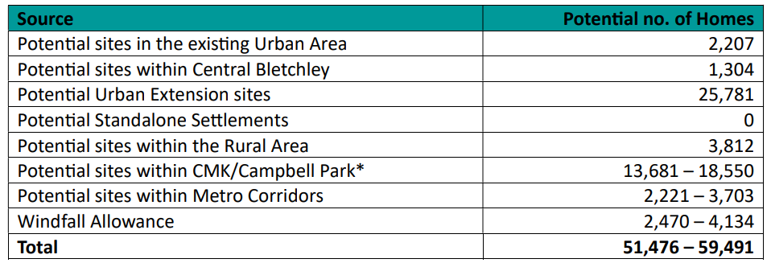

3.17 At this time, it is not possible to determine with any certainty whether and how much growth could come from potential regeneration of estates in the city. This is an ongoing conversation with local communities, and it is not felt appropriate to ascribe any housing numbers to regeneration efforts in such estates within the MK City Plan 2050.

Opportunities for commercial development
3.18 In terms of commercial development, we have identified opportunities for around 300,000 square metres of office floorspace within the ‘Downtown Quarter’ around the railway station. This location aligns with both occupier and policy requirements for directing office development to town centres, and the area around the railway station is an accessible and well-connected location for business and workers. Outside of Central Milton Keynes, our established employment sites (some of which are still vacant) and certain Strategic City Extensions do provide opportunities for new employment land to support the creation of high-quality jobs in different sectors. This is explained in greater within the Employment Land Availability Assessment. What we do not have are any new options to accommodate large-scale warehousing and logistics. This is most likely because land in the most preferred locations (close to junctions on the strategic road network) has already been exhausted for warehousing and logistics or other development. Land or sites further afield from junctions on the strategic road network are not seemingly attractive enough to the market for landowners to promote their land for these uses.
3.19 Central Milton Keynes is already a regional centre for retail and leisure with the Shopping Centre and Xscape areas providing a wide offer of comparison retail and leisure. Our Call for Sites and other work has not identified any significant new sites for retail and leisure that could be allocated in the MK City Plan 2050. However, we expect that, subject to market demand, additional floorspace could come forward within our Primary Shopping Areas and town centres in accordance with supportive planning policy that seeks to protect and enhance the role of Central Milton Keynes as a regionally importance centre.

Sustainability Appraisal and Reasonable Alternatives
3.20 Having identified a range of options through the SHLAA using a bottom-up approach, we then consider how these options map to our ambition and objectives and other strategic considerations using a ‘top-down’ approach. This process is carried out within the Sustainability Appraisal, which is an ongoing process, to identify a proportionate range of different growth strategies – referred to as Reasonable Alternatives in planning legislation. These Reasonable Alternatives are then tested to see whether they are likely to perform positively or negatively against the Sustainability Appraisal Framework Objectives (SA Framework) and associated plan objectives. The SA Framework has been established based on our overall Ambition and Objectives for the MK City Plan 2050, as well as other strategies of the council and national planning policy. It was consulted upon in early 2023 and as part of the Regulation 18 consultation in late 2024, and the finalised SA Framework Objectives are shown below.
Figure 4. MK City Plan 2050 Sustainability Appraisal Framework Objectives
No. | MK City Plan 2050 Theme | Objective
1 | High Quality Homes and Neighbourhoods; Healthy Places; Climate and Environmental Action | Support establishment of walkable neighbourhoods in existing and new areas by 2050, by improving access to health, community and leisure facilities for all people in MK.
2 | Healthy Places; High Quality Homes and Neighbourhoods | Support improvements to physical and mental health through well designed places and by improving availability of and access to health facilities and good quality green and blue infrastructure for all people in MK by 2050.
3 | Climate and Environmental Action | Provide and improve accessibility for communities in line with our modal shift targets, promote active travel, and minimise car dependent communities.
4 | High Quality Homes and Neighbourhoods; Healthy Places | Over the plan period provide a supply and mix of market and affordable good quality housing, that meets our calculated needs and aspirations.
5 | Climate and Environmental Action; Healthy Places | Over the plan period, new development supports reduction of greenhouse gas emissions from the built environment and supports communities that can 'bounce-back' from environmental challenges, helps protect human and environmental health, and supports reductions in fuel poverty.
6 | Economic and Cultural Prosperity | Designated and non-designated archaeological, built heritage, natural and biodiversity, and cultural assets are protected and enhanced over the plan period.
7 | Climate and Environmental Action | Support creation of a zero-waste economy in MK by 2050.
8 | Climate and Environmental Action | Increased water efficiency, including through water reuse and recycling measures, and contributes to improved water quality by 2050.
9 | Economic and Cultural Prosperity | By 2050 Milton Keynes has a prosperous, diverse, inclusive, and resilient economy enabled by a high skilled workforce.

3.21 It is important to acknowledge that Reasonable Alternatives are different growth strategies consisting of different combinations of sites or options, rather than individual sites in isolation. Sustainability Appraisal is not concerned with assessing and comparing every individual site in detail in the style of a ‘beauty parade’. Assessing individual sites or options against the SA Framework is helpful in dismissing clearly poor performing sites and identifying positive aspects of others in relation to our objectives. However, it is important to evolve this further and compare combinations of sites as different possible growth strategies and understand how they perform overall in fulfilling our plan objectives.
3.22 The background to this is the amount of growth we are planning for. We are proposing that our housing requirement for the MK City Plan 2050 is set at our Local Housing Need of 50,372 homes (1,799 homes per annum), however there is a need to consider whether the plan should make provision for more homes than this.
3.23 Our starting point has been the Recommended Growth Option set out within the Strategy for 2050 (RGO), which is shown below. We have then evolved this through the SA process by considering growth locations or sites that have been identified through the ‘bottom-up’ and ‘top-down’ processes explained earlier. Certain growth locations or sites clearly perform very well in supporting our plan objectives and conforming with national planning policy. These are Central Milton Keynes and Campbell Park, Central Bletchley, Strategic Brownfield Sites and Transport Hubs. These growth options are considered to form the heart of our growth strategy, complemented by housing from suitable small and brownfield sites which traditionally come forward for development over time. Different combinations of strategic greenfield sites can then complement these. This has resulted in six Reasonable Alternatives being identified which are summarised below. The full appraisal of them can be found within the Sustainability Appraisal Report.
Figure 5 Recommended Growth Option from the Strategy for 2050
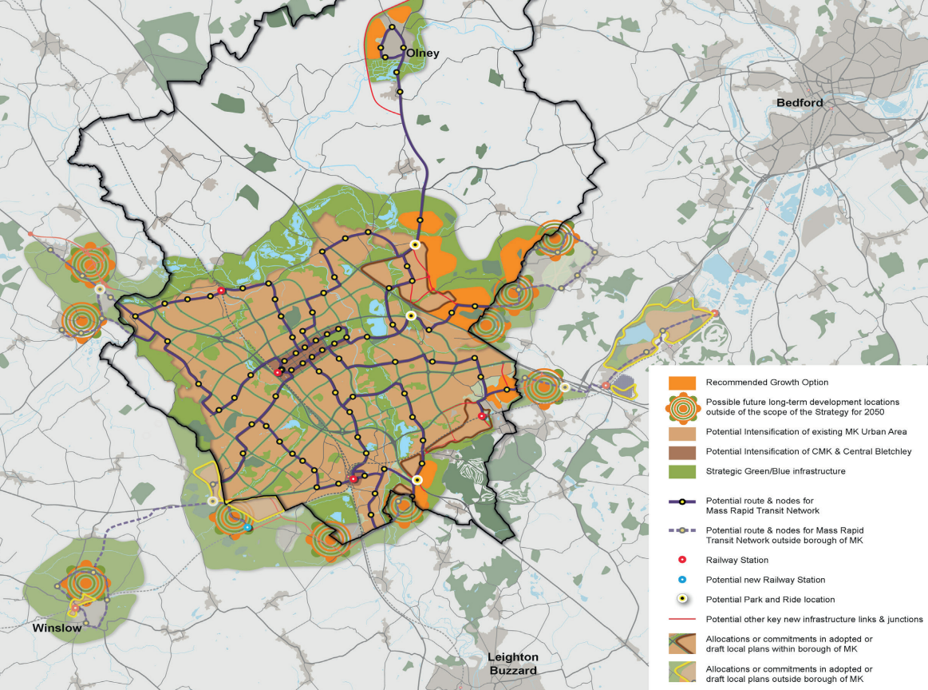

Figure 5 Summary of Reasonable Alternative Growth Strategies focussed on housing
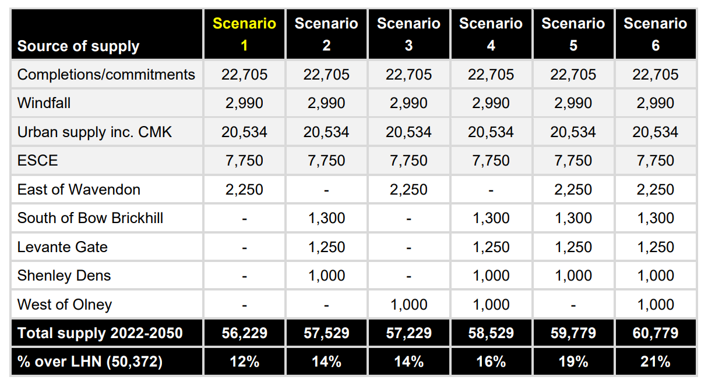

Our proposed growth strategy

Housing and infrastructure
  - Based on our evidence and assessment, Reasonable Alternative growth scenario 5 best aligns with our plan objectives and performs best against the SA Framework, is an appropriate strategy to follow, and is therefore our proposed growth strategy.

  - The proposed growth strategy can deliver 59,779 homes which matches our ambition for growth and ensures an ample buffer is provided so that we will deliver against our Local Housing Need of 50,372 homes by 2050.

  - The proposed growth strategy has a mix of very large to relatively smaller scale strategic sites and a small but not insignificant allowance for smaller brownfield and windfall sites. Together, these are eminently deliverable and do not face significant infrastructure uncertainties, unlike other Reasonable Alternatives (particularly those involving West of Olney). Coupled with the comprehensive development of our city centre, Bletchley and brownfield sites, it would avoid piecemeal development in the rural area and growth in locations that have significant infrastructure or site constraints that question the deliverability of infrastructure. The proposed growth strategy would enable an ‘infrastructure first’ approach to be taken so that key community amenities and other infrastructure can be provided viably and in a timely way.

  - The proposed growth strategy contains a very large growth location (Eastern Strategic City Extension at around 16,000 homes in total, 7,750 by 2050) which is of a scale that would dwarf almost all others in England. Ordinarily, an allocation like this would be seen as a new settlement separate from existing built development and infrastructure that would take many years to masterplan and commence. However, the Eastern Strategic City Extension would be an extension to the current city, as a continuation of the infrastructure-led growth occurring in Milton Keynes East. It can tap into and complement new infrastructure coming forward through Milton Keynes East in its early phases, allowing growth here to come forward quicker than might ordinarily be the case for such a large-scale site. Meanwhile, the proposed growth strategy contains smaller and more readily developable strategic sites (including sites within Central Milton Keynes and Bletchley) that can boost housing supply in the short to medium term of the plan period as current growth under Plan:MK begins to tail off. Towards the end of the plan period, the East of Wavendon Strategic City Extension would then begin to add further housing supply in the latter part of the plan period. Overall, this approach should enable a consistent level of housing supply and delivery over the plan period.

  - The proposed growth strategy contains around 13,550 homes coming forward on strategic greenfield sites. Our evidence tells us these sites can provide up to 40% of homes as affordable and are likely to provide a greater share of family homes than our urban growth locations are likely to. Coupled with affordable housing coming forward through existing commitments and new urban sites in the city, our proposed growth strategy is capable of providing around 14,500 affordable homes.

  - A key objective of the plan is reducing cumulative carbon emissions from growth and creating new communities that are resilient to a changing climate. Our Carbon and Climate Study shows that concentrating growth in the city is the best option for reducing cumulative carbon emissions, principally due to reduced emissions from transport. This is particularly the case in Milton Keynes where we are seeking to establish a new Mass Rapid Transit system across the city to encourage more people to choose public transport and active travel, over the car, to move around the city. In contrast, growth dispersed across the rural area tend to result in much higher cumulative carbon emissions over the long term due to reliance on the car to get around. Meanwhile, new growth in the city (or urban areas more generally) is potentially less resilient to climate change than other options, namely due to urban heat island effects.

  - Our proposed growth strategy would result in at least 20,534 additional homes located in the city. This represents around 55% of the additional growth under the proposed growth strategy being in locations that would mutually benefit from Metro and greater public transport services and are the most carbon efficient. Most of the remaining growth in the proposed growth strategy would be within Strategic City Extensions. Whilst these are not as carbon efficient as growth in the city, they are more carbon efficient than growth in the rural area. They also provide greater opportunities for creating climate resilient communities than growth in the city, given the greater opportunity to provide large scale green and blue open spaces. Overall, the proposed growth strategy strikes the most optimal balance between reducing cumulative carbon emissions from growth whilst ensuring growth overall is as resilient to a changing climate as it can be.

Commercial development and high-quality jobs

  - Whilst there is a much smaller range of options available for providing land for employment, retail and leisure, nonetheless the proposed growth strategy does provide good opportunities for creating high-quality jobs. It would do so through 300,000 square metres of office floor space in Central Milton Keynes (centred around the railway station) with a focus on jobs within technology and innovation in Block B4. It would also provide around 40 hectares of land for research and development, industry and smaller scale warehousing and distribution within the Eastern Strategic City Extension. This site sits between the city and Cranfield which both offer existing knowledge and innovation networks to tap into, linked by Metro routes and good transport infrastructure throughout the Eastern Strategic City Extension. Whilst another large-scale option, MK North, may in theory be capable of providing land for high quality jobs, the wider infrastructure and site constraints they face make this undeliverable.

  - As noted earlier in this paper, we do not have any suitable and deliverable options for strategic-scale warehousing and logistics development to address projected market demand in this sector. This is something we will reconsider through a review of the MK City Plan 2050 when landowner interest in promoting their land for this use may be stronger.

Our infrastructure first approach
5.1 Milton Keynes’ upfront commitment to long-term, well-planned growth at scale is unique. We welcome the opportunities that development can create, and this drives our ambition and growth strategy. The continued growth of the city requires an equally deliberate and positive approach to infrastructure planning.
“We must plan to strengthen what works well and make sure every resident in every part of Milton Keynes can benefit from our prosperity. This includes making available the infrastructure and services such as transport, health, social care, schools, shops, leisure, sports and cultural facilities that are essential for our existing and new communities. By planning this upfront we can make the case for investments that will serve us well into the future, rather than reacting as pressures arise.”
Milton Keynes Strategy for 2050

5.2 Therefore, to support the MK City Plan we have produced Infrastructure Study and Strategy that breaks the mould to turn our vision and ambition into tangible and deliverable plans through a related Investment Strategy.

5.3 The Milton Keynes Infrastructure Study and Strategy (MKISS):

- Provides a baseline of current infrastructure capacity and known risks, issues and opportunities, in the context of growth planned to 2031 in Plan:MK
- Provides a single and complete picture of infrastructure requirements to 2050 based on the Strategy for 2050 principles and the MK City Plan, and potential future proofing for growth beyond this point
- Outlines the impact of growth in neighbouring authorities on the provision of infrastructure within Milton Keynes
- Identifies the suitable expansion of existing infrastructure, not just new requirements
- Identifies ‘place-based’ infrastructure requirements, and those of Central Milton Keynes specifically
- Identifies different scales of infrastructure (e.g., sub-regional through to local)
- Presents the requirements in time horizons (to 2031, to 2040, to 2050, and potentially beyond)
- Develops an approach to infrastructure prioritisation
- Evidences the cost of the infrastructure required, likely funding sources (including developer funding), and funding gaps
- Provides a strategy for Milton Keynes City Council to specifically to use around the funding and delivery of infrastructure
- Underpins all the above with strong engagement of key people and organisations.

5.4 The MKISS has delivered these outputs to support the policies in the Regulation 19 Plan:
- A Baseline report, that includes snapshot of the provision of infrastructure in Milton Keynes, its issues and opportunities, at the time of writing (in late 2023 and early 2024)
- Initial and Further Assessment Reports, which set out projected infrastructure requirements to support planned growth to 2050 (and beyond), over and above the existing baseline of infrastructure and known projects to support Plan:MK
- An Investment Strategy, setting out the costs associated with projects in the Infrastructure Delivery Plan, funding plans and gaps, funding and delivery options, and an approach to project prioritisation.
- An Infrastructure Delivery Plan (including digital versions), for both Regulation 18 and 19 stages.

5.5 The MKISS work has included four principal rounds of engagement with infrastructure providers, prior to Regulation 18, during and post Regulation 18, and to inform the outputs that support the Regulation 19 Plan.

5.6 The main comments on infrastructure planning and provision made during the Regulation 18 consultation were:

- High degree of support for Infrastructure First principle but scepticism about delivery of this.
- Strong focus on the need for, and delivery of, social and environmental infrastructure, notably an additional hospital, additional GP surgeries, dentists, schools, SEND provision, and open and green spaces.
- Concerns from developers that the range of infrastructure and policy requirements will hinder delivery of the growth objectives (due to viability, feasibility, and/or time needed to deliver).
- Infrastructure first approach is supported but there is scepticism that it will be achieved, with some concerns about how this will interact with the viability and delivery of development.
- Concerns that an infrastructure deficit has incrementally grown over the last 20 years and will not be addressed with the focus on infrastructure supporting new communities only.
- Cross boundary discussions to consider and plan for infrastructure in a wider coordinated approach is proposed and supported.
- Proposal and support for regular updates to IDP to recognise changes in cost, funding, capacities, feasibility and viability of projects.
- Also concern about site specific infrastructure requirements, access and capacity, relating principally to our Strategic Allocations.

5.7 The Regulation 18 Plan included one specific policy on infrastructure – Policy GS9. To strengthen the ‘infrastructure first’ approach and provide more detail and clarity on how this will be delivered, the Regulation 19 Plan includes a new chapter specifically addressing infrastructure planning and delivery.

5.8 We have embedded our ongoing support for our proven MK ‘Tariff’ approach into new policies and spelt out what infrastructure standards developments will be assessed against, for our strategic allocations, Central Milton Keynes and the Central Bletchley area through our Regulation 19 IDP. We believe this approach addresses the Government’s expectations of what should be built into the MK City Plan at the outset.

Conclusions and next steps
6.1 Our reasoning behind the proposed growth strategy for the MK City Plan 2050 has been set out above. In summary, this has emerged from the Strategy for 2050, a wide and deep range of evidence, stakeholder engagement from early 2023 and the Regulation 18 consultation in 2024. We believe the proposed growth strategy best aligns with our plan objectives and SA Framework and would help us achieve our overall ambition and objectives for growth.
6.2 As a Regulation 19 plan, this stage of public consultation is concerned with whether the plan is legally compliant and meets the tests of soundness set out in national planning policy. We have published a range of supporting information that we believe demonstrates and substantiates this comprehensively.

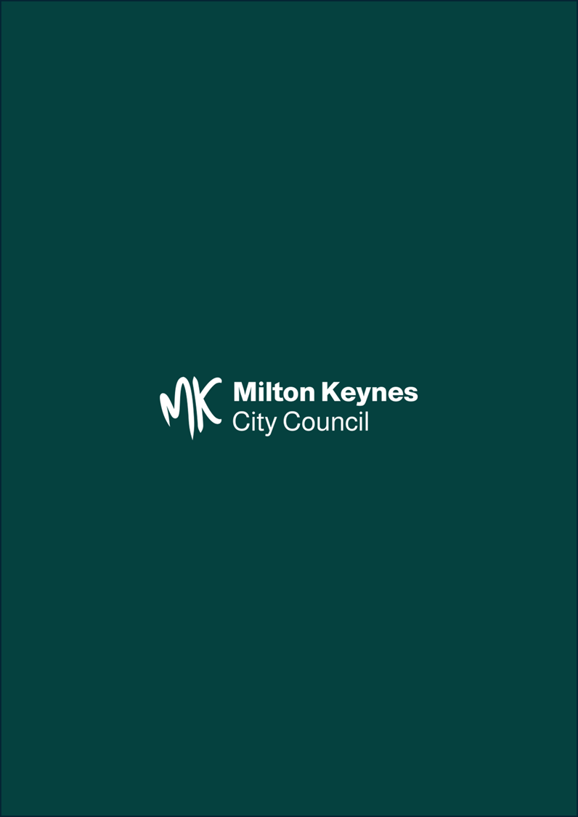

MK Futures 2050 | Milton Keynes City Council (milton-keynes.gov.uk)
The Town and Country Planning (Local Planning) (England) Regulations 2012 (legislation.gov.uk)
To be found sound by an independent inspector appointed by the Secretary of State, all local plans must meet the four tests of soundness: positively prepared; justified; effective; and consistent with national policy. See paragraph 35 of the National Planning Policy Framework for further see National Planning Policy Framework (publishing.service.gov.uk)

