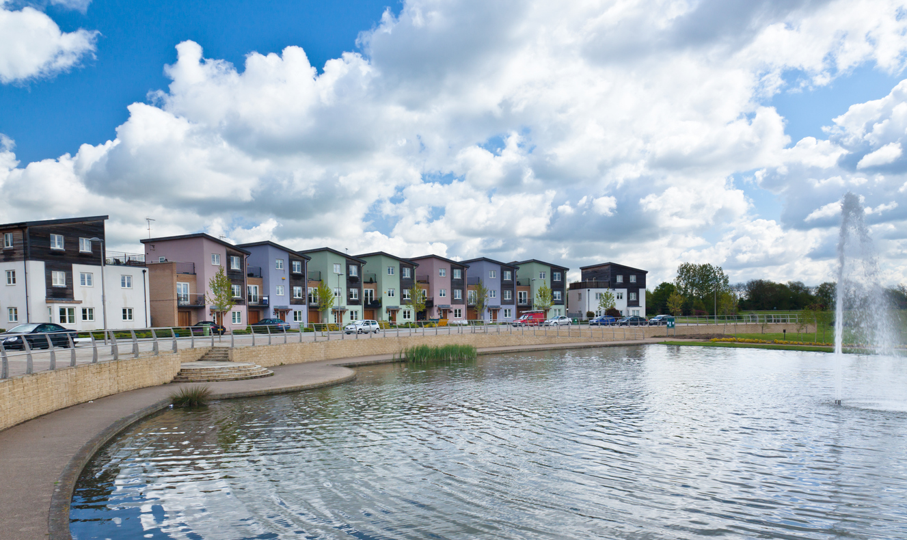
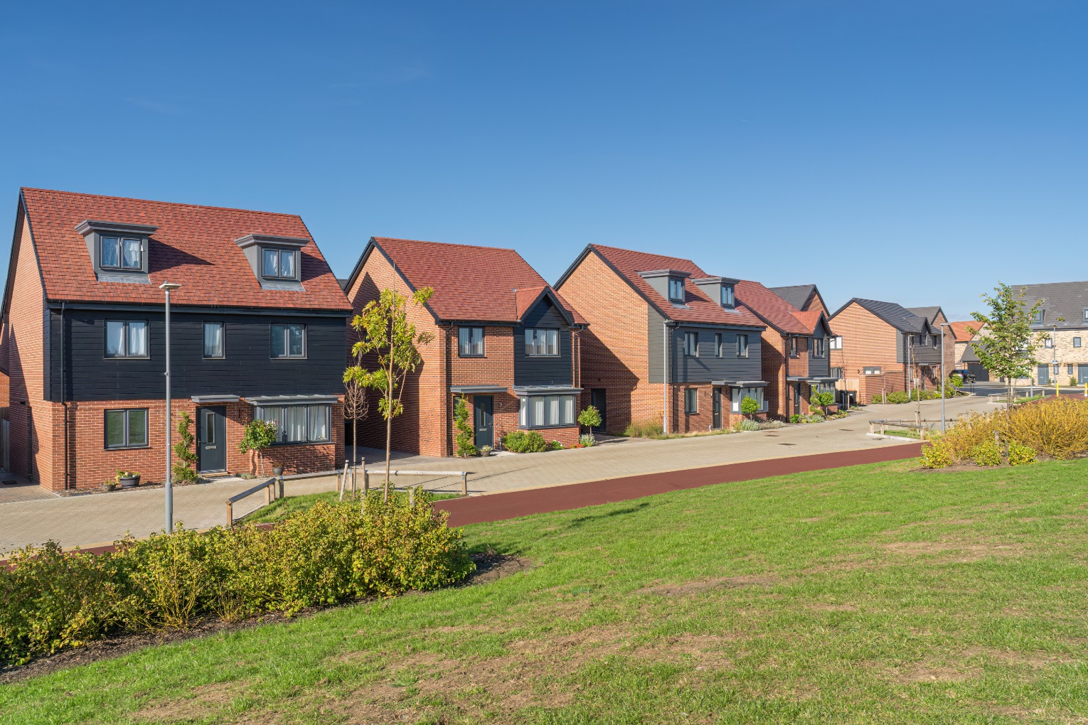

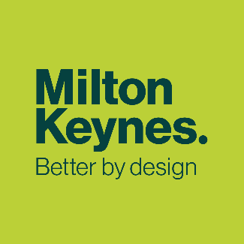


High Quality Homes

MK City Plan 2050
Topic Paper

November 2025
Regulation 19 Version

Contents
Purpose of this Topic Paper 1
Background 1
Objectives for The MK City Plan 2050 2
Challenges and Drivers for Change 3
Our Need for Homes 3
Population Changes and New Households Forming 3
What Kind of Homes do we Need? 3
Affordability of Homes in Milton Keynes 4
Planning for Affordable Homes 5
Affordable Home Ownership 6
Self and Custom Build Homes 7
Homes for different groups 7
Supported Housing Strategy 7
Homes for Older People 8
Homes for People with Disabilities 9
Accessible and adaptable homes 9
Homes for Wheelchair Users 9
Other Specialist and Supported Homes 10
Role of the Private Rented Sector 11
Second Homes, Holiday Lets and Buy to Leave 11
Homes for Single Adults and Young People 12
Purpose-Built Student Accommodation 13
Service Families 13
Essential Local Workers 14
Refugees 14
Moorings for Boat Dwellers 14
Pitches for Gypsies, Travellers and Travelling Showpeople 14
Our Policy Approach 16
Healthy Homes (HQH1) 16
Affordable Homes (HQH2) 16
Supported and Specialist Homes (HQH3) 17
Homes for Co-Living (HQH4) 17
Houses in Multiple Occupation (HQH5) 18
Pitches for Gypsies and Travellers (HQH6) 18
Accommodation for Boat Dwellers (HQH7) 18
Exception Sites (HQH8) 19
Children’s Homes (HQH9) 19
Appendix A: Glossary 20
Appendix B: Policy Context 24
Appendix C: MK City Plan 2050 Evidence Base 26

Purpose of this Topic Paper
- The MK City Plan 2050 will be our new Local Plan and will replace Plan:MK once adopted. This topic paper has been prepared to accompany the Regulation 19 MK City Plan 2050 and explains the approach we are proposing to take in the Plan and why. While the individual topic papers can be read as standalone documents, there are many linkages between them and the issues and opportunities they cover.

- The suite of topic papers has evolved through the plan-making process as we gathered further evidence and receive feedback through engagement and consultation. The topic papers set out the more detailed justification for policies in the MK City Plan 2050, allowing the Plan itself to be a shorter, user-friendly document.

- In this paper, our focus is upon explaining our approach to meet our needs and aspirations for homes at this stage in preparing the MK City Plan 2050, and how we think this helps us achieve our Ambition and Objectives.

Background

- One of the overarching objectives of the national planning system is to ensure that a sufficient number and range of homes can be provided to meet the needs of present and future generations. The MK City Plan 2050 must deliver this objective for Milton Keynes, based on a comprehensive understanding of the City’s current and future housing need for different types of homes for different groups of people. The MK City Plan 2050 must also foster well-designed, beautiful and safe places, with accessible services and open spaces that reflect current and future needs and support communities’ health, social and cultural well-being. We need to understand what this means for Milton Keynes.

- Milton Keynes is unique. We are committed to making sure we protect and enhance what makes Milton Keynes special. We will maintain our grid roads and protect community green spaces. We will ensure a proper long-term plan for development that communicates clearly that growth done in the right way is essential and beneficial to our city, and brings forward renewal and improvements to our existing estates.

- Since Plan:MK was adopted in 2019, the long-term ambitions for growth in Milton Keynes have been further clarified in the Strategy for 2050 which was adopted, as an Annex to the Council Plan, in January 2021. The Strategy for 2050 sets out a long-term approach to spatial development. It aims for a steady population increase to around 410,000 people in the administrative area by 2050, as the best means of achieving Seven Big Ambitions

- Particularly relevant for this topic are the following ambitions:

- Ensure everyone has their own decent home to rent or buy.
- Build safe communities that support health and wellbeing.
- Make it easier for everyone to travel on foot, by bike and with better public transport.
- The Strategy for 2050 is not a statutory planning document but it does set out our objectives and aspirations for growth in Milton Keynes, building upon the growth already set out within Plan:MK. It was informed by a suite of evidence studies and extensive stakeholder engagement and provides a strong foundation for developing the MK City Plan 2050.

- The Strategy for 2050 recognises that rents and house prices are far less affordable, relative to incomes, than in the past. It also recognises that many of the estates built in the 1970s are now in need of substantial investment to ensure that the homes meet modern standards. It acknowledges the importance of making available the infrastructure and services such as transport, health care, social care, schools, shops, leisure, sports and cultural facilities that are essential for communities.

- Further national and local policy context is set out in Appendix A.

Objectives for The MK City Plan 2050

- The MK City Plan 2050 contains a positive ambition and set of objectives to provide a focus to the plan and shape the spatial strategy and policies that will guide the growth of the city to 2050.

- It provides a framework for addressing housing needs and other economic, social, and environmental priorities and a platform for local people to shape their surroundings. The objectives for the ‘high-quality homes’ theme are as follows:

- Provide a range of homes for those most in need including affordable homes, and to meet wider market demand for housing.
- Support renewal and regeneration within neighbourhoods and communities that would benefit from it.
- Support delivery of social infrastructure to enable people to prosper and have a high quality of life.

- The Plan will achieve these objectives through the following policy areas:
- Creating people-friendly and healthy places (this is covered in the Healthy Places Topic Paper)
- Healthy homes
- Affordable homes
- Supported and specialist homes
- Homes for co-living and Houses in Multiple Occupation
- Accommodation for Gypsies and Travellers and Show Persons
- Accommodation for Boat Dwellers
- Exception sites
- Children's Homes

Challenges and Drivers for Change

- The objectives relating to high quality homes and neighbourhoods will be met in various ways in the MK City Plan 2050, informed by the evidence and guided by the overall strategies and national policy. This section explores the key challenges and drivers for change.

Our Need for Homes
- The Housing and Economic Development Needs Assessment (HEDNA) identifies the minimum annual local housing need figure for Milton Keynes of 1,799 homes per year, or a total of 50,372 for the MK City Plan 2050 period (2022-2050). This has been produced using the government’s standard method calculation set out in national planning practice guidance for Housing Need Assessments. The HEDNA also considers a higher aspirational growth target, based on reaching a population of 410,000 by 2050. This would require housing delivery to average 2,204 homes per year.

Population Changes and New Households Forming
- The makeup of the population of Milton Keynes is predicted to change between now and 2050. According to local housing need scenario A in the HEDNA, the overall population is projected to increase 31% from around 292,200 people in 2022 to at least 382,300 people by 2050. The older age groups account for a significant proportion of this growth which is particularly important when establishing the types of homes required and the need for homes specifically for older people. The number of people aged 65 to 74 is projected to increase by 15,100, with an increase of 25,100 people aged 75 or over (including 9,900 aged 85+), which collectively represent 45% of the overall growth.

- As set out in the HEDNA, whilst the increase in overall households is largely within the groups aged 65 or over, reflecting an increasingly ageing population, most of the new households seeking homes will be in their twenties and thirties at the time that they form. Many new households will buy or rent existing housing, and not all new homes will be occupied by new households.

- The type of homes the MK City Plan 2050 will provide for is also informed by the HEDNA’s consideration of the need for homes reflecting the projected population changes. Households of different ages are likely to have different needs for homes. Similarly, households of different types (singles, couples and families) within each age group will also have different needs for homes.

What Kind of Homes do we Need?
- The HEDNA’s Housing Mix Model considers the need for market and affordable homes on a longer-term basis that is consistent with household projections and Local Housing Need (LHN). The Model uses a range of secondary data sources to build on existing household projections and profile how the stock of homes will need to change to accommodate the projected future population. The Model provides robust and credible evidence about the required mix of homes over the full planning period and recognises how key housing market trends and drivers will impact on the appropriate mix of homes.

- The overall need for market and affordable homes as identified in the HEDNA is as follows:

 | Affordable homes to rent |  | Affordable homes to own | Total affordable housing | Total market housing | Total housing
 | Social Rent | Affordable Rent | Shared Ownership
1 bed | 2,651 | 383 | 590 | 3,624 | 1,550 | 5,175
2 bed | 3,695 | 1,200 | 1,028 | 5,923 | 4,541 | 10,464
3 bed | 4,251 | 1,589 | 717 | 6,557 | 16,393 | 22,950
4+ bed | 1,490 | 466 | 0 | 1956 | 8,954 | 10,910
All homes | 12,087 | 3,638 | 2,336 | 18,055 | 31,438 | 49,499
% of all homes | 24% | 7% | 5% | 36% | 64% | 100%
Allowance for C2 provision |  |  |  |  | 843
Total need | 12,087 | 3,638 | 2,336 | 18,061 | 32,281 | 50,372

Affordability of Homes in Milton Keynes
- The high cost of homes in Milton Keynes is a key challenge. The HEDNA concludes that that real house prices in Milton Keynes increased substantially in the period 2001-2008. Values reduced during the economic downturn and continued to decline over the period to 2014. Values then increased in the period to 2021 but are now showing a decline. For most of the time since 2021, movement in Milton Keynes house prices has broadly mirrored, although been higher, than changes in England as a whole.

- The HEDNA states that, in general, new build homes in Milton Keynes are much more expensive than existing homes, ranging in lower quartile properties from new build 4+ bed homes being 19% more expensive, to new build 1-bed homes being 68% more expensive than existing homes. It concludes that, to buy a 2-bedroom newly built home in Milton Keynes, the annual income required is £93,000 (based on a 10% deposit and 3.5 times income mortgage). An existing 2-bedroom dwelling would require an annual income of £60,300. It concludes that the median private rent for a 2-bedroom home in Milton Keynes would require an annual income of £32,571 (based on 35% of household income being allocated to housing costs). Affordable rent for a 2-bedroom home would require an annual income of £23,403 and social rent £14,200. According to the latest Office for National Statistics (ONS) information, the average annual pay in Milton Keynes is £38,029 per annum.

- The HEDNA also concludes that Build to Rent housing is usually more expensive than median rents and is typically more comparable to upper quartile rents. Occupants tend to be those that can afford these higher rents, but are not currently seeking to own a property, since the income required to service such rents is typically more than that required to get onto the housing ladder through affordable home ownership options. First Homes are typically more affordable on a weekly cost basis than shared ownership in Milton Keynes.

- Overall, open market ownership for each property size is the most expensive in terms of weekly costs, followed by Build to Rent then median private rent and shared ownership at 50% and 40%, depending on the size of property. There has been a steady increase in the overall number of owner occupiers since 1981, though the proportion in owner occupation fell back to 1981 levels between 1991 to 2011. The number and proportion of private renters has increased since 1981, from 4% to 18%.

- Milton Keynes has a relatively high rate of households in temporary accommodation (9 people per 1000, compared to 3 per 1000 in the South East and 4 per 1000 in England). Depending upon the circumstances, being in temporary accommodation often has a negative impact on people’s physical and mental wellbeing and their life chances. The current pressure for temporary accommodation and the need for supported accommodation are having a significant impact on councils across the country. There are currently 1,094 households in temporary accommodation in Milton Keynes, and the total cost to the council has been £66.89m over the last five years.

Planning for Affordable Homes
- As set out above, the affordability of homes is a key challenge, so providing for affordable housing will be a key objective of the MK City Plan 2050. There is a notable difference between ‘truly affordable homes’, which are defined in the MK Strategy for 2050 as ‘homes for rent at Local Housing Allowance Levels or lower’, and how affordable housing is defined in national planning policy and the HEDNA, meaning that we need to consider if additional interventions will be necessary to ensure delivery of the right amount of affordable housing throughout the Plan period.

- National planning policy defines affordable housing as ‘housing for sale or rent, for those whose needs are not met by the market (including housing that provides a subsidised route to home ownership and/or is for essential local workers)’ (NPPF, 2024). The need for affordable homes is calculated taking account of current unmet need for affordable homes, as well as projected future need.

- The HEDNA identifies an overall need of 18,061 affordable homes over the 28-year period 2022-50, which is equivalent to an average of 645 per annum if the need is divided equally throughout the Plan period. This is comparable to past completions of affordable housing, which average 500 per year, as shown in the table below:

Year | Affordable Homes completions | Total homes completions | % of AH delivery
2018/19 | 387 | 1,781 | 22%
2019/20 | 407 | 2,076 | 20%
2020/21 | 410 | 1,993 | 21%
2021/22 | 619 | 2,003 | 31%
2022/23 | 676 | 2,895 | 23%

- This identified need includes the needs from all households unable to afford to rent or own market housing, as well as for households who aspire to home ownership but who cannot afford to buy, where there is a realistic prospect of those households being able to access the affordable homeownership products likely to be available. This figure does not provide for all households who aspire to homeownership.

- The HEDNA identifies a backlog of affordable homes need and considers how this backlog could be addressed – either equally over the plan period, or earlier in the plan period to address the backlog more quickly.

- As well as considering the need for new affordable homes, we must also consider what is reasonable and viable to require as part of new development proposals. The Whole Plan Viability Study has considered the viability of different levels of affordable homes in different locations. It concludes that a variable approach to providing affordable homes is appropriate, with different levels of affordable homes being required in different areas known as ‘housing viability sub areas’. These areas are based on the viability of the local housing market and are shown on the Policies Map. Broadly, these range from the newer parts of the city and rural areas where a requirement for 40% of affordable housing can be achieved (which is where most of the growth is proposed to happen) to the city centre and older areas where it is more challenging to provide affordable homes, so lower targets have been proposed. In terms of the tenure split, the Viability Study concludes that Social Rent has a greater impact on viability than Affordable Rent, although the impact varies considerably across different development typologies.

Affordable Home Ownership
- The HEDNA has assessed the need for affordable home ownership in Milton Keynes, and has identified that the affordable home ownership is only 13% of the total affordable homes need.

- The HEDNA identifies a variety of different available homeownership products, and in particular First Homes and Shared-Ownership. The day to day running costs of a First Home may also be lower, due to the rental and service charge element of shared ownership First Homes are typically more affordable on a weekly cost basis, but shared-ownership does often require a lower-deposit.

- National planning policy also sets out that should evidence suggest that a higher minimum discount is needed, this should be fixed at either 40% or 50% below market value. The minimum discount should apply to the entire local plan area (except if Neighbourhood Plans are in place in certain areas) and should not be changed on a site-by-site basis.

- As of December 2024, First Homes are no longer required to make up 25% of affordable housing provision, however delivery can continue where planning authorities judge that they meet a local need.

Self and Custom Build Homes
- On 31 October 2016, new legislation came into place which amended the Self-build and Custom Housebuilding Act 2015 and implemented Chapter 2 of the Housing and Planning Act 2016. This places a duty on MKC to give suitable development permission in respect of enough serviced plots of land to meet the demand (as recorded on the authority's self-build register) for self and custom build plots within the local authority area over a set base period of time. National planning policy requires us to seek opportunities, through policies and decisions, to support small sites to come forward for community-led development for housing and self-build and custom build housing.

- Calculating the number of individuals added to the register since March 2016, and comparing to the number of permissions for Self or Custom Build plots in that period, there is a shortfall of 444 plots.

- To calculated future demand for the plan period, an average of additional groups, minus plots permitted as windfall, was calculated. From October 2016, 739 individuals and groups have been added to the self-build register, and with 362 added over the last 5 years. Taking into account the figure for the 5 year period (2019-2024), this equates to an average of 72 individuals and groups a year. Over the last 5 years, an average of 13 permissions are granted for plots which are self or custom build. This leaves an average need of 59 plots a year not provided through windfall development. In total, a need for 1652 plots is required across the plan period. A requirement has been set that 5% of plots on sites involving 100 dwellings or more should be set aside for Self and Custom Build.

Homes for different groups
- As well as planning for the right number of homes, we must also plan for different housing needs of a range of groups within the population. The HEDNA contains information about the type of housing needed for different groups in the community.

Supported Housing Strategy
- The Milton Keynes Supported Housing Strategy 2023-2026 is based on the vision of good quality housing for all, helping people to live well and helping people to live independently. It is based on a needs assessment and concludes that more specialist and supported housing will be needed in Milton Keynes in the short and medium term. It considers the needs by 2025/26 and again by 2030/31 for each of the following groups:

- Older People
- People with physical disabilities
- People with learning disabilities
- People with mental health related needs
- Single people at risk of homelessness
- Vulnerable young people aged 16 to 25
- People experiencing domestic abuse

- This strategy should be considered complementary to the needs assessment of different groups of the population in the HEDNA.

Homes for Older People
- The UK population is ageing and, as stated previously, the population projections show a substantial increase in the older population of Milton Keynes. People can expect to live longer, healthier lives than previous generations. It will be important for the MK City Plan 2050 to plan for housing which is suitable for this increase, including the type of housing. The HEDNA assesses the need for owned and rented sheltered and extra care homes and recognises the importance of these in the overall mix of homes. The HEDNA concludes that some types of specialist homes are already experiencing lower demand whilst other newer types of provision may appear to better meet changing aspirations in the future. Supporting people at home for longer along with assistive technology could also reduce or alter demand. In practice, the level of delivery identified as being required is likely to represent a significant challenge.

- Specialist and supported homes are provided in a range of ways, including:

- Age restricted general market homes – typically for people aged over 55, and may include some shared amenities such as communal gardens. Does not include support or care.
- Retirement living or sheltered homes – usually purpose-built flats or bungalows with limited communal facilities. They do not usually provide care services, but do provide some support to enable people to live independently. This could include a warden or house manager and an alarm system.
- Extra care homes or homes-with-care – usually purpose-built or adapted flats or bungalows with a medium to high level of care available if required. Residents can live independently with 24 hour access to support and staff, and meals are available. There are often extensive communal areas. May be known as retirement communities or villages.
- Residential care and nursing homes – have individual rooms within a residential building and provide a high level of care meeting all activities of daily living. They do not usually include support services for independent living. Can also include dementia care homes.

- The modelled demand for housing for older people in Milton Keynes is as follows:

 |  | Rate per 1,000 persons aged 75+ | Gross need 2022 | Existing supply | Unmet need in 2022 | Additional need 2022-2050 | Overall need
Sheltered Housing | Owned | 120 | 2,013 | 506 | +1,597 | +2,944 | +4,541
Sheltered Housing | Rented | 60 | 1,052 | 1,231 | -179 | +1,472 | +1,292
Extra Care | Owned | 40 | 701 | 101 | +600 | +981 | +1,581
Extra Care | Rented | 31 | 543 | 738 | -195 | +760 | +566
TOTAL |  | 251 | 4,399 | 2,576 | +1,823 | +6,157 | +7,980

Homes for People with Disabilities
- New homes will need to incorporate accessible and adaptable design features to help people remain at home for as long as possible. Building Regulations Approved Document Part M: Access to and use of buildings covers the following standards:

- M4(1) Category 1: Visitable dwellings – Mandatory, broadly about accessibility to ALL properties
- M4(2) Category 2: Accessible and adaptable dwellings – Optional, similar to Lifetime Homes
- M4(3) Category 3: Wheelchair user dwellings – Optional, equivalent to wheelchair accessible standard.

Accessible and adaptable homes
- The MK City Plan 2050 should identify the proportion of dwellings in new developments that should meet the requirements of M4(2) and M4(3), based on the likely future need for housing for older and disabled people (including wheelchair user dwellings), considering the overall impact on viability. The HEDNA assesses this likely future need. It concludes that 854 households need to move to a more suitable home now​, and that there will be 13,447 households either needing adaptions to their existing housing or requiring suitable new housing by the end of the plan period . The maximum need for adaptable housing between 2022 and 2050 will be 14,302. ​. It concludes that there is a range of need for adapted housing of between 6,317 and 14,302 households, based on the national English Housing Survey, together with data about relative levels of limiting long-term illness and disability in Milton Keynes.

Homes for Wheelchair Users
- The need for accessible and adaptable homes set out above includes the need for wheelchair user dwellings, although this is also calculated as a separate figure in the HEDNA. By combining the local information and national data, the HEDNA identifies the need for wheelchair adapted homes by 2050 will increase by 3,130,, which equates to 5.5% of the total minimum housing requirement. 1,330of these are needed as market housing (4.2% of the total market housing need) and 1,810 are needed as affordable housing (10% of the total affordable housing need).

- Two thirds of the wheelchair adapted homes are required for people aged 75 or over. This means that there are likely to be some people who are identified in both categories – wheelchair adapted housing and specialist older person housing. It may therefore be appropriate to plan for higher targets of specialist homes for older people that are also wheelchair accessible, which could reduce the proportion of general needs housing that would be required to meet the M4(3) requirements.

Other Specialist and Supported Homes
Mental Health

- Accommodation needs for people with mental health problems also needs to be considered, and the assessment of need estimates the number of adults with a mental health problem that is potentially serious enough to cause them to be at risk of needing supported or independent accommodation, with or without support. The HEDNA concludes that there are likely to be around 30,000 people in Milton Keynes with a mental health problem that is serious enough to consider in assessing the need for supported housing or independent housing with support. However, most of these will not be serious enough to lead to an actual need for supported housing or housing with support.

- The most likely people to require supported housing or housing with support are those who have a severe mental health problem and are in insecure or inappropriate accommodation. The HEDNA concludes that there are around 500 adults with severe mental illness at risk of requiring supported housing or housing with support. Many of these are likely to be single person households.

Learning Disabilities and Autism Spectrum

- Accommodation needs for people with learning disabilities or autism also needs to be considered. The HEDNA concludes that there are around 700 people with a learning disability who are at risk of falling into housing need in Milton Keynes and who may require supported accommodation or accommodation with support. Many of those who are in stable and appropriate accommodation will be living independently, but many will live with family. However, they could fall into need in the future.

Young People Leaving Care

- The HEDNA concludes that around 50 to 55 places are required for young people leaving care each year, which is a total of around 1,450 by 2050. However, what counts as suitable accommodation will depend on individual circumstances. Therefore, on top of this broad estimate of annual need, detailed planning with children and young people’s social care is required to ensure that young people leaving care are suitably housed.

Role of the Private Rented Sector
- As set out in the HEDNA, the Private Rented Sector (PRS) is an important tenure that has grown since 1991 to house a significant proportion of households in the area. At the same time, young households have been less likely to meet their housing need in affordable homes given the various constraints in accessing local authority and housing association rented housing. Recent changes to letting polices and the reality of pressures on the stock of homes make it less likely that single persons aged under 35 years will be allocated to a 1 bedroom social rented or affordable rented property.

- The HEDNA identifies that there are many households living in the private rented sector in Milton Keynes who aspire to home ownership. If affordable homes to buy could be provided for this group, it would help to reduce the size of the private rented sector. However, if the new supply of affordable homes changes to include a large proportion of affordable homes to buy, and if existing affordable supply in net terms reduces (i.e. if new affordable supply does not exceed stock sold under right to buy), then demand for PRS stock may continue or increase further. This means that much of the increased demand for PRS property is likely to continue, driven by young households with few other options should they wish to establish their own household.

- It will therefore be important for the Council to understand the full extent of the need of affordable homes and consider our policy responses accordingly.

- We recognise the important role that Build to Rent homes can play in local housing delivery and support a positive approach to enabling this sector to contribute to increasing the supply of homes. For Build to Rent schemes, affordable homes for rent are expected to be the normal form of affordable homes provision, as set out in the NPPF. In this context, it is known as affordable private rent.

- To be considered a ‘Build to Rent’ scheme, proposals must meet the following definition:

A development, or block/ phase within a development, of at least 30 units;
- The homes to be held as Build to Rent under a covenant for at least 10 years;
- All units to be self-contained and let separately;
- Unified ownership and unified management of the development;
- Professional and on-site management;
- Longer tenancies offered (ideally three years or more) with defined in-tenancy rent reviews; and
- Property manager to be part of an accredited Ombudsman Scheme and a member of a recognised professional body.

Second Homes, Holiday Lets and Buy to Leave
- The HEDNA states that in April 2023, at total of 871 properties were listed as vacant or holiday/short-term lets in Milton Keynes, which represents less than 1% of the housing stock. In total, 548 properties are listed on Airbnb. Data from the Census shows that the vacancy rate for Milton Keynes rose from 3.4% in 2011 to 3.8% in 2021, so short-term lets and second homes do not appear to be having an excessive impact. However, for two Census lower super output areas (LSOAs) near the city centre, the vacancy rate is around 12.3%, with 267 properties being vacant out of 2,189. Airbnb contains 146 listings in these same two areas, so there does appear to be a strong overlap between the vacancy rate at the time of the 2021 Census and short-term lets.

Homes for Single Adults and Young People
- The HEDNA concludes that the number of single people living alone is projected to increase from 27,800 to 32,100 households over the 28-year period 2022 to 2050. However, whilst the number of single people aged 65 or over is projected to increase from 11,800 to 19,400 households (an additional 7,600 households equivalent to a growth of 64%), the number aged 45-64 reduces by 7% over the period (from 8,400 to 7,800) and the number aged under 45 reduces by 35% (from 7,700 to 5,000) based on past trends.

- While the number of people aged 25-34 years is projected to rise by nearly 8,100, single person households aged 25-34 years are projected to fall by 1,230 in the period to 2050. At the same time, the number of ‘Other’ households headed by someone aged 25-34 years is projected to rise by 2,210 households in the same timeframe. Therefore, there is going to be a significant decline in headship rates for single persons aged 25-34 years in Milton Keynes. Many recent graduates will not form their own household immediately but will instead share properties with other young adults. The increasing pressures for social housing and rising private rents have seen fewer young households living on their own and more living in Houses in Multiple Occupation (HMOs). As at March 2023, Milton Keynes City Council reported there to be 447 licensed HMOs under the mandatory scheme (having 5 or more tenants) and 308 known HMOs that are not subject to the mandatory scheme (having 3 or 4 tenants). The Housing and Economic Development Needs Assessment indicates that single person households represent only a small proportion of the overall household growth (8%), and this includes 7,600 extra single persons aged 65+ years, with 1,700 fewer aged under 65. The HEDNA also indicates that the increase in ‘other’ households represents 23% of the projected growth (an increase of 11,700). Other households include multi-generation living, student households and homes in multiple occupation.

- One type of home which could help to address this issue are large-scale purpose-built shared living homes, which are a comparatively new type of home. They are non-self-contained homes, usually made up of at least 50 private individual rooms, communal spaces, and facilities. Large-scale purpose-built shared living homes usually provide accommodation for single-person households who cannot, or choose not to, live in self-contained homes or HMOs.

- At the same time, the PRS is an important tenure that has grown since 1991 to house a significant proportion of other households. It may be that dwellings are currently being built as family housing but are being occupied by sharing young households. In the future these properties could be re-used as family housing if high quality housing for single people or couples could be built.

- Given that Milton Keynes is projected to see a decline in single young person households, then the household projections would envisage little role for this type of home, and this is reflected in the HEDNA’s modelled size and tenure mix. However, as a policy led response to the increasing lack of housing for younger people in the area, large-scale purpose-built shared living homes could have a role in short term housing for groups such as recent graduates looking to establish themselves in Milton Keynes as an alternative to living in HMOs. Large-scale purpose-built shared living homes could meet the needs of some single people and couples as a lifestyle choice and allow them to save to move to permanent accommodation of one form or another, while freeing up family housing that is being used for HMOs.

- It is difficult to project a need for studio apartments or large-scale purpose-built shared living homes, because it may be that many young people prefer to share and save for their own property rather than have their own more expensive separate unit. The growth in the private rented sector and sharing households suggests that there may be a market for self-contained units which could run in to hundreds of units and that this is likely in turn to reduce the need for larger market properties to be converted to HMOs. Large-scale purpose-built shared living homes provide short term rather than permanent homes, but it may help some households move on to more permanent homes. Therefore, as with any active policy, there is a risk of an over-supply of large-scale purpose-built shared living homes.

Purpose-Built Student Accommodation
- The HEDNA also considers future need for purpose-built student accommodation. To date there has been no major higher education establishment with a significant student body in Milton Keynes. This was to change with the development of the new MK:U through a partnership led by Cranfield University, but currently, this is not expected to proceed due to lack of funding to deliver the scheme in the city centre. The Open University are now considering opening a campus on the same city centre site, but this has not yet progressed to a full business case.

- In terms of population numbers, any future growth in student numbers would be additional to demographic trend-based growth; but the standard method local housing need calculation already provides for a considerable uplift to the population and household projections.

- Existing HMOs are known to the City Council through registration. The HEDNA concludes that if a new city centre campus is developed, the City Council should consider issuing an Article 4 Direction to require planning applications to be submitted for proposals to convert family houses (C3 use class) to small Houses in Multiple Occupation (HMOs) accommodating between 3 and 6 people (C4 use class).

Service Families
- The HEDNA concludes that there is not a significant number of service personnel deployed in Milton Keynes, and so there is no specifically identifiable housing need for service families in Milton Keynes.

Essential Local Workers
- Essential local workers, as defined in the NPPF, are public sector employees who provide frontline services in areas including health, education and community safety – such as NHS staff, teachers, police, firefighters and military personnel, social care and childcare workers. The HEDNA concludes that these households will already be counted in the need for affordable homes because they cannot afford market rents, or because they wish to own their own property but cannot afford to do so. Because of this, the needs from this group will not add to the total need for affordable homes, but they are likely to require separate consideration on the housing register and it may be appropriate to consider whether some affordable properties should be set aside solely for essential local workers in need.

Refugees
- The HEDNA sets out that while there is an undoubted need for housing for refugees, information on specific housing need for refugees is not yet readily available. Some recent academic studies suggest that the need is simply general needs housing in a mix of social/affordable rented, private rented and, to a lesser extent for recent refugees, home ownership. Where these studies identify that a change is required, it is in policy and support such as advice and challenging discrimination rather than developing homes specifically for refugees.

Moorings for Boat Dwellers
- Boat dwellers are not classed as an ethnic minority under the Equality Act (2010), but the Housing and Planning Act (2016) sets out a requirement to consider the needs of people residing in or resorting to places on inland waterways where houseboats can be moored. In line with draft government guidance published in 2016, our Boat Dweller Accommodation Assessment (BDAA) focuses on boat dweller accommodation need for the period 2023-2040.
- Within the MK borough, we currently have a supply of 258 registered moorings. Of these, 187 are leisure moorings and 71 are permanent residential. The BDAA study recommends that a further 139 permanent moorings are needed for the period 2023-2040. Some of this need could be met through the conversion of temporary leisure mooring licences to permanent residential licences. However, this would not be within the remit of Planning to influence.

Pitches for Gypsies, Travellers and Travelling Showpeople

- The Planning Policy for Travellers Sites (PPTS) requires that Local Planning Authorities demonstrate an up-to-date, 5 year supply of deliverable Gypsy and Traveller sites. Gypsies and Travellers are protected as distinct ethnic minorities under the Equality Act (2010) and therefore have the right to culturally appropriate accommodation. Additionally, the Housing and Planning Act (2016) requires consideration of the need to provide sites on which caravans can be stationed or places on inland waterways where houseboats can be moored.

Permanent Sites

- Our Gypsy and Traveller Accommodation Assessment (GTAA) (2025) identified a need for a further 75 permanent pitches across the period up to 2050. This figure includes households which meet the planning definition of Gypsies and Travellers, as defined by the recent update to the PPTS. The PPTS definition was updated following an appeal decision in 2023, and now includes Gypsies and Travellers who have ceased to travel permanently or temporarily due to factors like education, health or old age.

- Our current supply of permanent pitches for Gypsies & Travellers consists of 18 pitches, located at our two public sites: Calverton Lane (12 pitches) and Willen Road (6 pitches). These sites are at capacity with no current plans to extend them. It is generally accepted amongst the Travelling community that private sites of up to 6-10 pitches are appropriate. Public sites tend to be larger and have policies and procedures in place to ensure the effective management of sites. Plan:MK Policy HN11 sets out our current policy approach towards Gypsy and Traveller accommodation.

Transit Sites

- As part of our GTAA, an update looking into transit site provision for Gypsies and Travellers, in response to an increase in the numbers of unauthorised encampments. This study identified that a large proportion of transit accommodation need is generated from groups travelling to MK for work, but they have permanent pitches elsewhere. The remaining transit need is from groups in need of permanent provision but are unable to find this due to permanent sites in MK being at capacity. The study recommends putting in place a policy of Negotiated Stopping, in which the council identifies land to accommodate encampments of up to 5 caravans, encampments of between 6 and 10 caravans and encampments of more than 10 caravans.

Our Policy Approach
  - Informed by the evidence summarised above and considered alongside the vision set out in the Strategy for 2050, the policies relating to high quality homes in Plan:MK have been reviewed. A number of new or amended policies are proposed in the MK City Plan 2050, and this section describes these policies.

Healthy Homes (HQH1)
  - To ensure that housing proposals meet the HEDNA requirements for the right mix of housing, to be provided based on demographic and market trends and the wider needs of the community, the MK City Plan 2050 proposes a policy that requires major developments to provide a mix of housing reflecting this needs assessment. It also requires other developments to seek to provide a mix of homes to reflect the Council’s latest assessment of need.

  - In addition, new homes should meet the potentially changing needs of people over time. New homes will therefore need to incorporate accessible and adaptable design features from the outset to allow people to remain independent in their own homes and enjoy a good quality of life. The Housing and Economic Development Needs Assessment provides evidence of need for 75% of all new homes to meet Category M4(2) (accessible and adaptable dwellings) requirements, 5% of new market homes to meet Category M4(3) (wheelchair user dwellings) requirements, and 10% of new affordable homes to meet category M4(3) requirements. The proposed policy therefore contains a requirement for all major developments to meet the above requirements.

  - In respect of provisions for self and custom build plots, a requirement has been set that 5% of plots on sites involving 100 dwellings or more should be set aside.

Affordable Homes (HQH2)
  - Ensuring that we maximise delivery of affordable homes is a critical part of creating people friendly and healthy places and creating mixed and balanced communities. The high cost of homes in Milton Keynes is a key challenge and we will work with key partners to prioritise the delivery of affordable homes.

  - To help address the affordability of homes as set out above, the draft MK City Plan 2050 proposes a policy requiring proposals for major developments to provide an appropriate percentage of affordable homes to meet the need identified in the HEDNA. The amount and tenure of affordable homes required is informed by the Whole Plan Viability Study, which concludes that different amounts and tenure mixes of affordable homes are viable in different areas of the City. The emerging affordable homes policy sets out the expected tenure split and requirements relating to the siting, design, clustering and phasing of affordable homes. It sets out our requirements for viability evidence, should circumstances indicate that the Whole Plan Viability Study assumptions do not apply to a given proposal, and clarifies how viability will be considered when determining planning applications.

  - National planning policy no longer requires 25% of affordable housing provision to be in the form of First Homes. The HEDNA calculated a need for 16% of all affordable housing need to be affordable home ownership.

  - We recognise the important role that Build to Rent homes can play in local housing delivery. However, we also recognise that the traditional viability model for development makes Build to Rent challenging in terms of securing affordable homes and wider planning obligations. As a reflection of this, the proposed policy sets out that a financial contribution in lieu of providing affordable homes on-site will be accepted, subject to viability. However, whilst we continue to work on evidence for the MK City Plan 2050, we will be exploring alternative ways in which the value generated by Build to Rent developments can be captured to help deliver more affordable homes and supporting infrastructure in the future.

  - We will not accept piecemeal housing development that it considers are being split to fall under the threshold for providing affordable homes, and therefore, the proposed policy sets out what information will be required should we consider whether two or more adjacent sites should be treated as a comprehensive site that would trigger the requirement to provide affordable homes.

  - The proposed policy also outlines how we will consider proposals that include a percentage of affordable housing above the minimum percentage requirements including up to 100% affordable schemes.

Supported and Specialist Homes (HQH3)
  - To help meet the identified needs for specialist and supported housing identified in the HEDNA, the MK City Plan 2050 contains policies to enable the delivery of different types of specialist and supported housing.

  - The identified needs will be met through a combination of a criteria-based policy against which proposals for new specialist and supported homes will be assessed, resisting the loss of existing facilities and the provision of new supported and specialist homes in strategic developments. The criteria for assessing proposals include requirements relating to location (that it is in a sustainable location close to local services and facilities, and public transport), that it is well related to the existing pattern of development, evidence that the proposal is meeting identified need, and that it will maintain a mixed and sustainable community within the wider neighbourhood. Supported and specialist homes will be sought as part of strategic housing allocations outlined in the Growth Strategy chapter.

Homes for Co-Living (HQH4)
  - Recognising the role of the MK City Plan 2050 to provide a range of homes to meet peoples’ different needs, the draft Plan contains a policy setting out the criteria for assessing proposals for co-living. For the purposes of this Plan, the term ‘homes for co-living’ encompasses both large-scale purpose-built shared living and purpose-built student accommodation. Recognising the emerging proposals to bring forward in-person university education to CMK, there is likely to be a need to provide purpose-built student accommodation in CMK to support the new higher education provision.

  - The proposed policy sets out that proposals for homes for co-living will be permitted where they: are in highly accessible locations and are within an existing settlement boundary, make a positive contribution to the character of the area, create or maintain a mixed and sustainable community and would not result in significant adverse impact on the amenity of residents and/or local communities.

Houses in Multiple Occupation (HQH5)
  - Houses in multiple occupation (HMOs) form an important part of the housing stock, providing a valuable supply of privately rented accommodation for a variety of households. Rents are generally cheaper than those charged for self-contained dwellings and are therefore usually one of the more affordable forms of accommodation within the private rented market.

  - The draft Plan contains a criteria-based policy setting out the requirements against which proposals for conversions to or new HMOs will be assessed. The proposed policy sets out that proposals for houses in multiple occupation or sub-division of existing dwellings into flats will be permitted where they fall within an existing settlement boundary, contribute positively to the character and amenity of the surrounding area, and create or maintain a mixed and sustainable community within the wider neighbourhood and not result in an over-concentration of that type of homes in that location.

Pitches for Gypsies and Travellers (HQH6)
  - The Planning Policy for Travellers Sites (PPTS) requires that Local Planning Authorities demonstrate an up to date, 5-year supply of deliverable Gypsy and Traveller sites. Gypsies and Travellers are protected as distinct ethnic minorities under the Equality Act (2010) and therefore have the right to culturally appropriate accommodation. Additionally, the Housing and Planning Act (2016) requires consideration of the need to provide sites on which caravans can be stationed.

  - Our proposed policy approach for permanent accommodation need for Gypsy and Traveller households is to continue with allocations for permanent pitches in the MK City Plan 2050. A mix of standalone permanent site, sites on strategic allocations, and regulation of unauthorised extensions to existing sites, has been identified.

Accommodation for Boat Dwellers (HQH7)
  - The Housing and Planning Act (2016) sets out a requirement to consider the needs of people residing in or resorting to places on inland waterways where houseboats can be moored.

  - Our proposed policy approach is a criteria-based policy to manage proposals for new permanent residential moorings. The policy approach would include criteria to ensure all new moorings have access to facilities and services and do not have adverse impacts on the area.

Exception Sites (HQH8)
  - A significant part of Milton Keynes is rural in nature with many smaller settlements and communities which, in accordance with the proposed spatial strategy, would not be appropriate for the allocation of strategic scale developments, which would normally be expected to deliver a proportion of affordable homes. Nevertheless, it is likely that there will continue to be a need for affordable homes in those communities.

  - The proposed policy sets out the criteria against which proposals for rural exception sites and First Homes exception sites will be considered. These criteria include factors such as site size, location requirements and a requirement to ensure that the homes are reserved for local needs in perpetuity. The policy also sets out the circumstances where an amount of market housing to assist with viability would be supported where appropriate viability evidence is provided.

Children’s Homes (HQH9)
  - In recent years Milton Keynes has seen an increase in planning applications for the conversion of dwelling houses to children’s care homes. It is therefore considered appropriate for the MK City Plan 2050 to include policies that will help to manage the growth and development of this type of development.

  - The proposed policy sets out the criteria on which ensures that homes are located in a suitable area close to existing facilities, and on demonstrating an appropriate risk assessment has been carried out as evidence in any application. The policy also requires the submission of evidence demonstrating registration of appropriate bodies, ensuring there are restrictions on the provider, as well as confirming prioritising occupancy towards children from Milton Keynes.

Appendix A: Glossary

Term | Meaning
Affordable Homes | Housing for sale or rent, for those whose needs are not met by the market (including housing that provides a subsidised route to home ownership and/or is for essential local workers); and which complies with one or more of the following definitions:  a) Social Rent: meets all of the following conditions: (a) the rent is set in accordance with the Government’s rent policy for Social Rent; (b) the landlord is a registered provider; and (c) it includes provisions to remain at an affordable price for future eligible households, or for the subsidy to be recycled for alternative affordable housing provision.  b) Other affordable housing for rent: meets all of the following conditions: (a) the rent is set in accordance with the Government’s rent policy for Affordable Rent, or is at least 20% below local market rents (including service charges where applicable); b) the landlord is a registered provider, except where it is included as part of a Build to Rent scheme (in which case the landlord need not be a registered provider); and (c) it includes provisions to remain at an affordable price for future eligible households, or for the subsidy to be recycled for alternative affordable housing provision. For Build to Rent schemes affordable housing for rent is expected to be the normal form of affordable housing provision (and, in this context, is known as Affordable Private Rent).  c) Discounted market sales housing: is that sold at a discount of at least 20% below local market value. Eligibility is determined with regard to local incomes and local house prices. Provisions should be in place to ensure housing remains at a discount for future eligible households.  d) Other affordable routes to home ownership: is housing provided for sale that provides a route to ownership for those who could not achieve home ownership through the market. It includes shared ownership, relevant equity loans, other low cost homes for sale (at a price equivalent to at least 20% below local market value) and rent to buy (which includes a period of intermediate rent). Where public grant funding is provided, there should be provisions for the homes to remain at an affordable price for future eligible households, or for any receipts to be recycled for alternative affordable housing provision, or refunded to Government or the relevant authority specified in the funding agreement.
Boat Dweller | A person who lives aboard a vessel (which may or may not be capable of navigation), that the vessel is used as the main or only residence and where that vessel is either (i) moored in one location for more than 28 days in a year (but may occasionally or periodically leave its mooring); or (ii) has no permanent mooring and navigates in accordance with the statutes appropriate to the navigation.
Build to Rent/Private Rental Sector (BtR/PRS) | Purpose built housing that is typically 100% rented out. It can form part of a wider multi-tenure development comprising either flats or houses, but should be on the same site and/or contiguous with the main development. Schemes will usually offer longer tenancy agreements of three years or more, and will typically be professionally managed stock in single ownership and management control.
Co-Living | Collective term for purpose-built student accommodation and large-scale purpose-built shared living
Development Plan | Includes adopted local plans and made neighbourhood plans
First Homes | First Homes are a specific kind of discounted market sale housing and should be considered to meet the definition of ‘affordable housing’ for planning purposes. Specifically, First Homes are discounted market sale units which:  a) must be discounted by a minimum of 30% against the market value;  b) are sold to a person or persons meeting the First Homes eligibility criteria;  c) on their first sale, will have a restriction registered on the title at HM Land Registry to ensure this discount (as a percentage of current market value) and certain other restrictions are passed on at each subsequent title transfer; and,  d) after the discount has been applied, the first sale must be at a price no higher than £250,000 (or £420,000 in Greater London).
First Homes Exception Site | A First Homes exception site is an exception site (that is, a housing development that comes forward outside of local or neighbourhood plan allocations to deliver affordable housing) that delivers primarily First Homes as set out in the First Homes Written Ministerial Statement.
Gypsies and Travellers | Defined in the Planning Policy for Travellers Sites (PPTS) (2023) as “Persons of nomadic habit of life whatever their race or origin, including such persons who on grounds only of their own or their family’s or dependants’ educational or health needs or old age have ceased to travel temporarily or permanently, but excluding members of an organised group of travelling showpeople or circus people travelling together as such.”
Houses in Multiple Occupation | Homes occupied by separate households (usually single people or couples) who share facilities or living space such as kitchens, bathrooms and sitting rooms.
Housing Viability Area | Milton Keynes is split into three housing viability areas which are based on the viability of the local housing market
Large-Scale Purpose-Built Shared Living | Non-self-contained homes, usually made up of at least 50 private individual rooms, communal spaces, and facilities
Local Plan | The main planning policy document for the Borough, containing strategic and site-specific policies and detailed policies to guide the location and nature of development.
Nationally Described Space Standard (NDSS) | This standard deals with internal space within new dwellings and is suitable for application across all tenures. It sets out requirements for the Gross Internal (floor) Area of new dwellings at a defined level of occupancy as well as floor areas and dimensions for key parts of the home, notably bedrooms, storage and floor to ceiling height.
Purpose-Built Student Accommodation (PBSA) | Accommodation for students, usually simple self-contained units with a range of shared spaces and facilities including communal kitchen(s) and social areas
Rural Exception Site | Small sites used for affordable housing in perpetuity where sites would not normally be used for housing. Rural exception sites seek to address the needs of the local community by accommodating households who are either current residents or have an existing family or employment connection. A proportion of market homes may be allowed on the site at the local planning authority’s discretion, for example where essential to enable the delivery of affordable units without grant funding.
Social Rent | Homes for rent at a level that is usually significantly below market rent levels
Supported and Specialist Homes | Collective term for homes for people with specific requirements. It includes: age restricted general market homes, retirement living or sheltered homes, extra care homes or homes with care, residential care and nursing homes, and supported homes or homes with support.
Tenure | The status describing how people occupy their homes. The most common forms are owning and renting.

Appendix B: Policy Context

One of the overarching objectives of the planning system is to support strong, vibrant and healthy communities, by ensuring that a sufficient number and range of homes can be provided to meet the needs of present and future generations; and by fostering well-designed, beautiful and safe places, with accessible services and open spaces that reflect current and future needs and support communities’ health, social and cultural well-being. The National Planning Policy Framework (NPPF, 2024) and national Planning Practice Guidance (PPG) set out further policy and guidance about these issues including how housing needs should be assessed (including the need for affordable homes) and which types of infrastructure should be planned for and when.

The National Design Guide sets out the characteristics of well-designed places and demonstrates what good design means in practice. It sets out ten characteristics of good design:
- Context – enhances the surroundings
- Identity – attractive and distinctive
- Built form – a coherent pattern of design
- Movement – accessible and easy to move around
- Nature – enhanced and optimised
- Public spaces – safe, social and inclusive
- Uses – mixed and integrated
- Homes and buildings – functional, healthy and sustainable
- Resources – efficient and resilient
- Lifespan – made to last

First Homes are a specific type of discounted market sale housing and should be considered to meet the definition of affordable housing for planning purposes. PPG (which came into force on 28 June 2021) sets out the criteria for First Homes, including eligibility criteria, along with guidance on section 106 (s106) agreements which should secure the necessary restrictions on the use and sale of the property. As of December 2024, First homes are no longer required as a percentage of affordable housing mix.

The Milton Keynes City Council Plan (2022-2026) recognises that Milton Keynes was established as an ambitious project to meet the urgent housing crisis at the time, but that this foundation is under threat from increasing unaffordability, national planning regulations and underinvestment. It contains several priorities and outcomes to help overcome this, including seeking to increase the supply of genuinely affordable housing, improving the mix of housing available to rent and buy, and improving and investing in existing communities and housing through renewal and regeneration.

The Council’s Community-Led Regeneration and Estate Renewal Strategy (2020) aims to improve our estates and build healthy, safe, and sustainable communities. This will be done by bringing together local residents and community leaders such as town and parish councils, to identify where we can invest in our communities by improving facilities and opportunities for local people, repurposing existing buildings and building new council homes.

The Milton Keynes Housing Strategy 2020-2025 provides a vision of how we can, with the public and other stakeholders, achieve our shared aspiration of providing housing that meets the needs of Milton Keynes. It sets out the strategic direction for housing activity in Milton Keynes and contains the following priorities for action:
- High quality placemaking, creating great places to live
- Increase the delivery of new homes, including secure truly affordable housing, along with the infrastructure to meet housing and living needs
- Ensure that everyone has access to appropriate, safe and secure housing that meets their needs
- Ensure a comprehensive range of supported and specialist housing for older and vulnerable people
- Ensure high quality homes and landlord services

The Milton Keynes Supported Housing Strategy 2023-2026 contributes to our overall Housing Strategy and together with other Council strategies and plans, is the framework through which out supported and specialist housing and housing related priorities for people with care and support needs are set out. The Supported Housing Strategy vision is:
- Good quality housing for everyone
- Helping people to live well
- Helping people to live independently

Appendix C: MK City Plan 2050 Evidence Base

Policies in the MK City Plan 2050 must be based on relevant and up to date evidence related to the local and ‘larger than local’ context of Milton Keynes. This includes information that predicts future needs (including for homes, jobs, and retail), and information that gives an assessment of the current or future predicted situation and impacts (for example landscape character and flooding). The studies particularly relevant for high-quality homes and neighbourhoods are:

Document | Purpose/Scope
Gypsies and Travellers Accommodation Assessment (GTAA) and Boat Dwellers Accommodation Assessment | To consider the housing needs of Gypsies and Travellers and transit and boat dwellers.
MK Infrastructure Study and Strategy (MKISS) | Identifies the various forms of infrastructure that are required to meet growth that may come forward through the Local Plan and through to 2050.
Land Availability Assessment (LAA) | Identifies a future supply of land which is suitable, available and achievable for housing and economic development uses over the plan period. The assessment is an important source of evidence to inform plan-making and decision-taking, and the identification of a 5-year supply of housing land.
Housing and Economic Development Needs Assessment (HEDNA)  (Logistics study commissioned separately by SEMLEP) | The HEDNA will assess the housing and economic development needs for the Borough of Milton Keynes for the period 2022-2050. It will include data on population change, market signals, the economy and labour market, employment forecasts, a commercial market assessment and future employment land requirements for different types of employment floorspace.
Carbon and Climate Study | To assess how the Local Plan can deliver low- or zero-carbon and climate-adaptable growth. This will incorporate the air quality & air pollution study.
Whole Plan Viability Study | Addresses overall deliverability of the plan to determine whether the policy requirements can be viably delivered.
Equality Impact Assessment | A systematic and evidence-based tool, which enables us to consider the likely impact of work on different groups of people. Completion of equality impact assessments is a legal requirement under race, disability and gender equality legislation.
Sustainability Appraisal | An assessment of the social, economic and environmental effects of the plan’s policies, alongside consideration of any significant adverse effects on protected biodiversity sites.

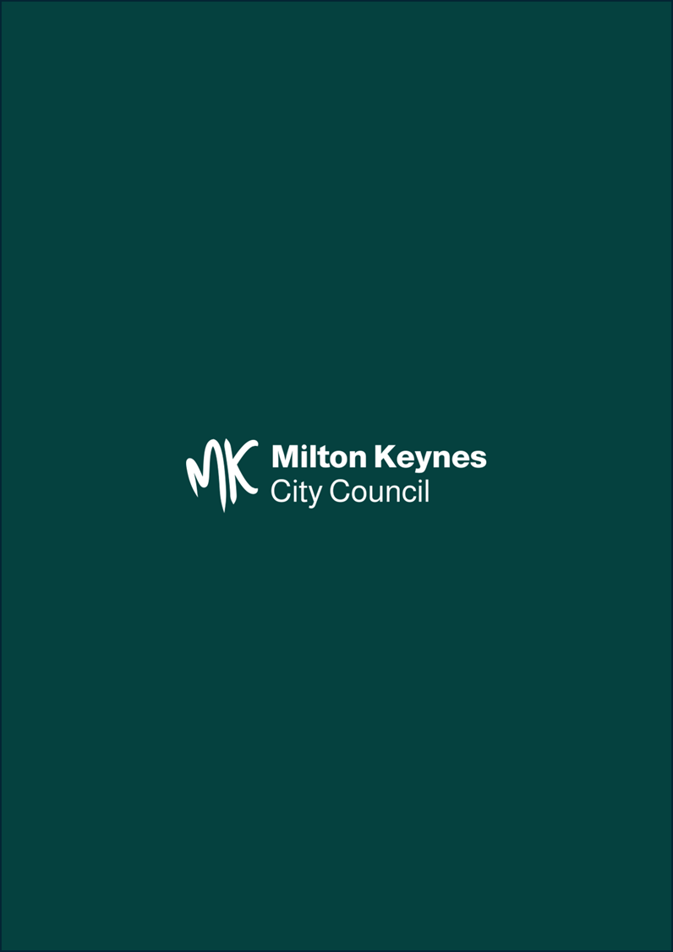

Earnings and hours worked, place of residence by local authority: ASHE Table 8 - Office for National Statistics (ons.gov.uk)
Public Health Outcomes Framework - Data - OHID (phe.org.uk)
MKCC Commissioning Strategy 2023 (milton-keynes.gov.uk)
National Planning Policy Framework (2024) paragraph 8 b)
National design guide - GOV.UK (www.gov.uk)

