


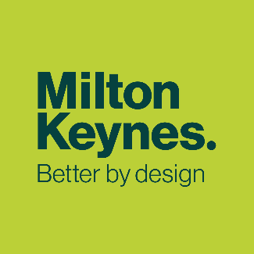


People Friendly and Healthy Places

MK City Plan 2050
Topic Paper

November 2025
Regulation 19 Version

Contents
Purpose of This Topic Paper 1
Background 1
Objectives for The MK City Plan 2050 3
Results from Engagement 3
Challenges and Drivers for Change 5
What Makes Us Healthy? 5
Health in Milton Keynes 8
Physical Activity and Obesity 10
Food Environment 11
Tobacco Consumption 19
Mental Health and Wellbeing 21
Wider Links to Health 24
Our Emerging Policy Approach 26
Delivering Healthier Places (PFHP1) 26
Provision and Protection of Community Facilities and Local Centres (PFHP2 and PFHP3) 26
Delivering a Healthier Food Environment (PFHP4) 27
Designing People-Friendly Places (PFHP5) 28
Designing Healthy Streets (PFHP6) 28
Well-Designed Buildings and Spaces (PFHP7) 29
Tall buildings outside Central Milton Keynes (PFHP8) 29
Amenity for healthy buildings and spaces (PFHP9) 30
Next Steps 31
Appendix A: Milton Keynes City Council Plan Outcomes 32
Appendix B: Policy Context 33
Appendix C: MK City Plan 2050 Evidence Base 36

Purpose of this Topic Paper
- The MK City Plan 2050 will be our new Local Plan and will replace Plan:MK once adopted. This topic paper has been prepared to accompany the Regulation 19 MK City Plan 2050 (also known as the Proposed Submission Plan) and explains the approach we are proposing to take in the Plan and why. While the individual topic papers can be read as standalone documents, there are many linkages between them and the issues and opportunities they cover.

- A suite of topic papers have evolved through the plan-making process as we have gathered further evidence and received feedback through engagement and consultation. They set out the more detailed justification for policies in the MK City Plan 2050, allowing the Plan itself to be a shorter, user-friendly document.

- This paper focuses on explaining the opportunities for improving people’s health and tackling health inequalities through the MK City Plan 2050, and how this will help us achieve our Ambition and Objectives.

Background
- One of the objectives of the national planning system is to promote healthy and safe communities. The MK City Plan 2050 must deliver this objective for Milton Keynes, based on a comprehensive understanding of the city’s identified health and well-being needs. The Plan must also deliver homes for our residents; foster well-designed, beautiful and safe places; ensure that services and open spaces are accessible; reflect both current and future needs; and support communities’ health, social and cultural well-being. We need to understand what this means for Milton Keynes.

- We have set our own priorities in terms of creating healthier places. The Council Plan (2022-2026) includes the following principles relating to people friendly and healthy places:

Opportunity for all
Everyone deserves a fair and equal opportunity to fulfil their potential, no matter their background. We want to increase aspiration levels and level-up the chances people have in life to succeed, proper, and thrive.

Prevention is better than cure
We believe in tackling the root cause of problems and issues. We will maintain our focus on investment in actions and services that mitigate rising costs, improve lives over the longer-term and improve overall quality of life.

Well planned growth and renewal
Milton Keynes is unique. We are committed to making sure we protect and enhance what makes Milton Keynes special. We will maintain our grid roads and protect community green spaces. We will ensure a proper long-term plan for development that communicates clearly that growth delivered in the right way is essential and beneficial to our city, and brings forward renewal and improvements to our existing estates.

- These priorities are underpinned by a set of outcomes which are monitored against an annual delivery plan.

- The Council has statutory duties under the Health and Social Care Act 2012 to take steps to improve the health of the people in its area, and when exercising its functions, the Council must take account of public health assessments and strategies.

- Since Plan:MK was adopted in 2019, the long-term ambitions for growth in Milton Keynes have been further clarified in the Strategy for 2050 which was adopted, as an annex to the Council Plan, in January 2021. The Strategy for 2050 sets out a long-term approach to spatial development. It aims for a steady population increase to around 410,000 people in the administrative area by 2050, as the best means of achieving seven big ambitions. Particularly relevant for this topic are the following ambitions:
- Make Milton Keynes a leading green and cultural city – by global standards.
- Build safe communities that support health and wellbeing.
- Make it easier for everyone to travel on foot, by bike and with better public transport.

- The Strategy for 2050 is not a statutory planning document but it does set out our objectives and aspirations for growth in Milton Keynes, building upon the growth already set out within Plan:MK. It was informed by a suite of evidence studies and extensive stakeholder engagement and provides a strong foundation for developing the MK City Plan 2050.

- The Strategy for 2050 recognises that the health of residents has always been important for the city. In the early days, this focused more on NHS services in our network of local health centres and the Milton Keynes University Hospital. Now, we understand that the structure of a city itself can help people to stay healthy. This includes avoiding obesity-related illness and supporting our mental health. The key is an active lifestyle – more walking and cycling and more active leisure and sport – and continuing to provide beautiful landscaped open space and parks. This proved especially important during the COVID-19 pandemic. The Strategy for 2050 also acknowledges the importance of making available the infrastructure and services such as transport, health care, social care, schools, shops, leisure, sports and cultural facilities that are essential for communities.

- Further national and local policy context is set out in Appendix B.

Objectives for the MK City Plan 2050
- The MK City Plan 2050 contains a positive ambition and set of objectives to provide a focus to the plan and shape the spatial strategy and policies that will guide the growth of the city to 2050. It provides a framework for addressing housing needs and other economic, social, and environmental priorities and a platform for local people to shape their surroundings. The objectives for the ‘people-friendly and healthy places’ theme are as follows:

- Create inclusive and safe places that encourage greater physical activity, social interaction, and healthier lifestyles.
- Create streets and neighbourhoods that prioritise walking, cycling and wheeling for access to shops, services, community facilities, and parks and open space.
- Provide a suitable range of facilities and infrastructure in the right places at the right time to promote walkable neighbourhoods and good physical and mental health.

- The Plan will achieve these objectives through the following policy areas:
- Delivering healthier places.
- Community amenities for people friendly and healthy places.
- Supporting healthier food choices.
- Urban design principles for people friendly and healthy places.
- Healthy streets.
- Well-designed buildings and spaces
- Tall buildings
- Design and amenity.
- A new MK design code.

Results from engagement
- The MK City Plan 2050 Ambition and Objectives and Sustainability Appraisal Scoping Report were published for public consultation between 31 January and 16 March 2023. The main issues raised in relation to movement were:
- Some support in relation to ‘walkable’ neighbourhoods but some not in support.
- Some in support of the Metro and shifting away from car uses but some not in support.
- Specific suggestions regarding improvement of connectivity across MK, sustainable transport options and concerns around current traffic issues and capacity of the road network.
- Concerns in relation to use of infrastructure funding for development of transport networks.

- Specifically related to the healthy places theme, we received the following comments:
- Support for prioritising health.
- Support for active travel to help health outcomes.
- Local services and facilities are important for health.

- We carried out our Regulation 18 MKCP public consultation during July-October 2024. The Regulation 18 MKCP was a comprehensive plan and we posed 67 questions within the consultation. In response, we received over 600 representations from organisations and individuals amounting to around 7,000 individual comments/answers. The main issues raised in relation to People Friendly Healthy Places policies were:

Creating people friendly and healthy places
- Support for the draft policy.
- The policy aligns with active design principles but suggested strengthening the strategy by clearly referencing active design.
- Suggested requiring a complete active design checklist for planning applications.
- Suggested adoption of the 3-30-300 plan to be mandatory.
- The policy should emphasise strong two-way legibility of active travel routes and design guidance should emphasise directness.
- Concerns with increasing density by increasing height and reducing room sizes.
- Some concerns that the policy’s wording is overly restrictive.
- Noted that the focus is only on "strategic development" proposals to promote good physical and mental health and suggested to expand the policy to include existing communities.
- Suggested incorporation of the Natural England Green Infrastructure Framework and evaluation process within planning guidance.
- Considered it vital that that social infrastructure, including community centres/ meeting places, are delivered at an early stage of a new development to support social sustainability.
- Concerns regarding feasibility of delivering dedicated food growing facilities within dwellings to achieve objectives, given freedom of residents to use space as desired.
- Question on the requirements expected within Policy PFHP1 regarding Health Impact Assessments (i.e. explain what this assessment should include and justify the requirement).
- All 12 of the Town and Country Planning Association’s Healthy Homes Principles should be included in the policy.

Delivering healthier places
- Suggested that a Health Impact Assessment for large residential developments and care institutions should acknowledge the health benefits of older persons’ housing and ensure better implementation of Active Design Principles.
- Support for the ambition of creating healthier places.
- Lack of measurable and specific targets is concerning.
- Suggested that development principles should include better connections between the historic environment and wellbeing.
- Developer disagrees on the need for Health Impact Assessments on residential dwellings of 50+ homes, explanation of why this is the case is requested. However, others endorse this requirement.
- Questions around reasoning for paragraph F and G, developments within 400 metres of education facilities. Provision of community amenities
- Support for the draft policy, but comments that the current policy approach ineffective as it lacks clarity on the information required.
- Concern that the policy does not align with the NPPF paragraph 103.
- Concern that the 800m distance in Table 3 is too large compared to the 500m in the MK Planning Manual.
- The infrastructure policy based on distance is not viable in some cases, should be based on the number of homes and existing local infrastructure.

Design code
- Design Code needs to be flexible to changing design styles over time.
- Concerns regarding the lack of detail for the design code.
- Concerns regarding the proposed area typologies for the design code, which are that set out in the National Model Design Code – rather than being set according to the unique context of MK.
- Questions on approach to design coding for strategic extensions.

Challenges and drivers for change
- The objectives relating to people friendly and healthy places will be met in various ways in the MK City Plan 2050, informed by the evidence and guided by the overall strategies and national policy. This section explores the key challenges and drivers for change.

What makes us healthy?
- The World Health Organisation defines health and wellbeing as:

Health: a state of complete physical, mental, and social wellbeing and not merely the absence of disease or infirmity.

Wellbeing: a state in which every individual realises their own potential, can cope with the normal stresses of life, can work productively and fruitfully, and is able to contribute to their community.

- Many factors affect our health: our genes, the healthcare we receive and our behaviours, the food we eat, whether we smoke, how physically active we are, and how we respond to stress.

- People tend to see behaviours, like being active or eating well, as individualistic. However, these behaviours are shaped and constrained by the world around us. Many aspects of our lives affect our health and how long we live such as our jobs, homes and neighbourhoods, access to education, green spaces, and public transport.

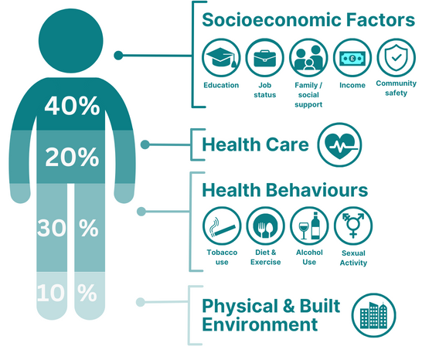
Figure 1: Health factors that impact an individual.
.
Adapted from: Canadian Institute of Advanced Research (2002).

- For example, access to public transport gives people the opportunities to attend education and work, both of which can improve people’s health in many ways, like helping people develop social networks, which in turn help people deal with stress and prevent illnesses, like depression.

- Access to public transport also helps our residents to lead active lives. Users of public transport tend to walk at one or both ends of the journey. This sort of regular physical activity, built into people’s lives, helps prevent heart disease, diabetes, dementia, and some cancers as well supporting good mental health. Public transport tends to be a cleaner and greener form of travel, helping to keep the air clean which is important for protecting against lung disease, heart disease and some cancers.
Many aspects of our lives affect our health and how long we live such as– our jobs, homes and neighbourhoods, access to education, green spaces, and public transport.

- These social, cultural, economic, and environmental influences on health, are sometimes called the Building Blocks of Health or traditionally the Wider Determinants of Health. These have a very important role in keeping people healthy. They also explain some of the large differences we see in life expectancy and years lived in good health between people living in the most and least deprived areas.

- Planning can shape many of these factors (see Figure 2). Planning is one of the more powerful levers that a Council holds to manage how its area changes and develops. Much of this stems from what is set out in a Council’s local plan. The policies the Council sets out in its local plan matters for the health of its people.

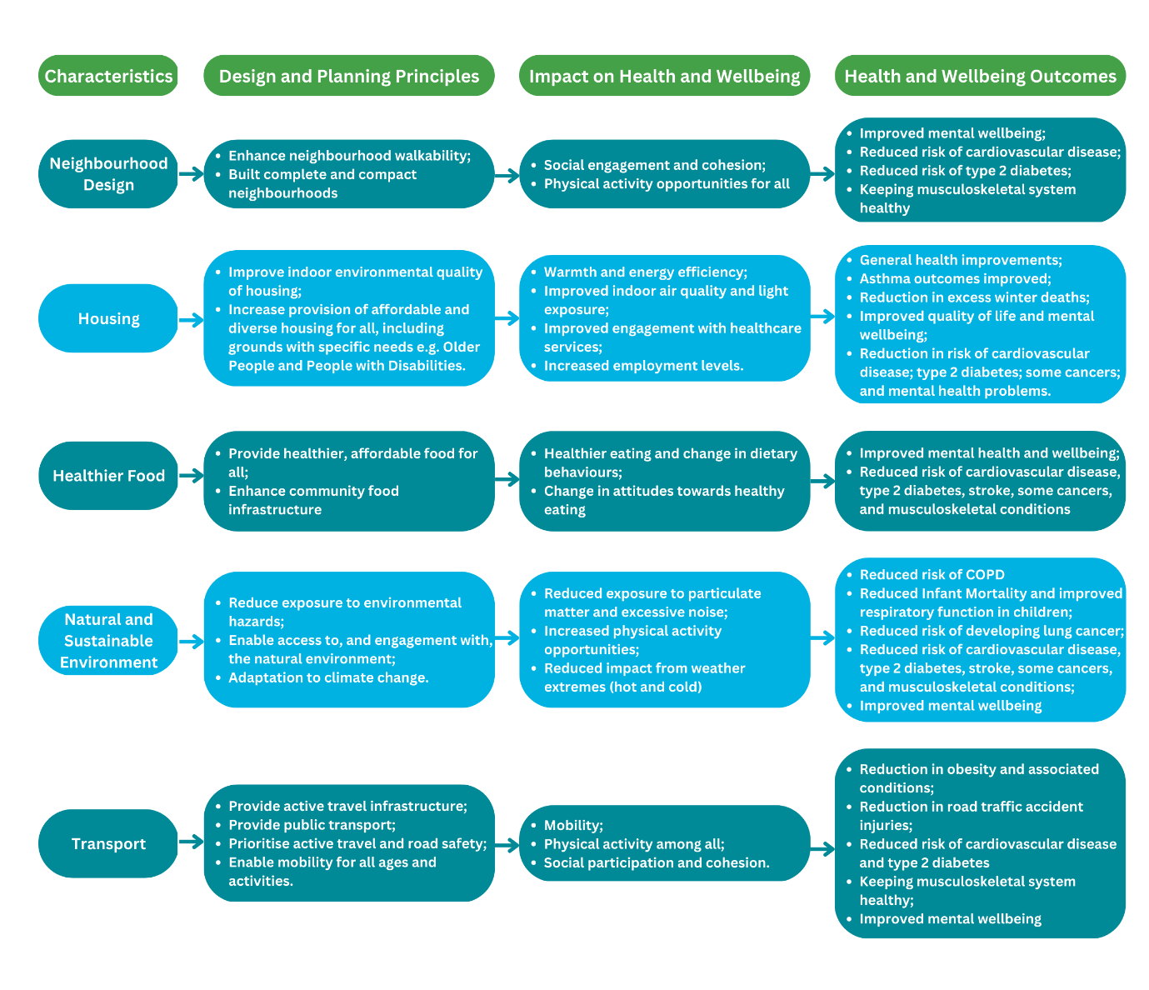
Figure 2: Links between design and planning principles with health and wellbeing
Adapted from: British Medical Journal, McKinnon et al, 2020.

Health in Milton Keynes
- Overall health in MK is broadly like England as a whole. Average life expectancy and healthy life expectancy in MK are the same as the English averages However, there are marked difference in health, or health inequalities, within MK. For example, women living in Woughton live for 18 fewer years in good health than women living in Olney.

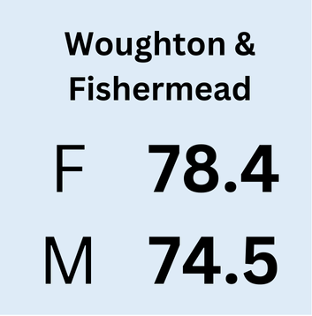
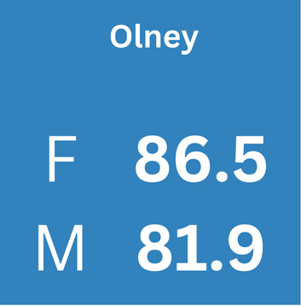
Figure 3: Life expectancy at birth for females and males in Woughton & Fishermead and Olney Wards (Source: OHID Fingertips, 2022).

- There are marked differences in the rates of childhood obesity between the most and least deprived parts of MK (Figures 4, 5, & 6). There are also differences in mental health: admissions to hospital for self-harm are twice as high in the most deprived areas of MK, relative to the least deprived. Tackling health inequalities is a priority, both for the City Council and the NHS. Besides health inequalities, there are also some other key health challenges in MK that planning can make an important contribution to addressing.

Figure 4: Prevalence of obesity amongst primary school children by deprivation quintile in Milton Keynes (2018-24)
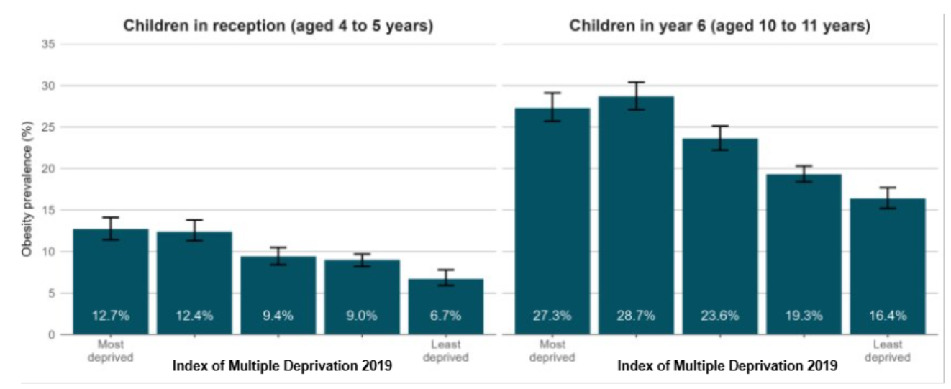

Figure 5: Prevalence of obesity in MK wards by age (Source: NCMP 2021-24)
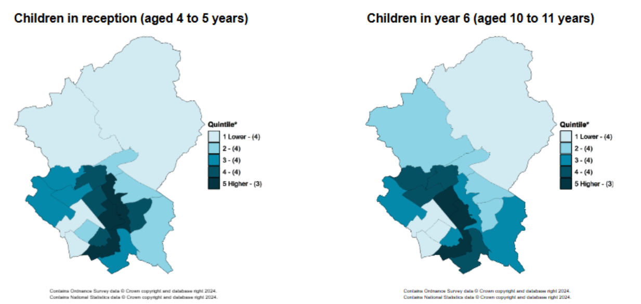
Number of wards in each quartile is shown in brackets in the map legends

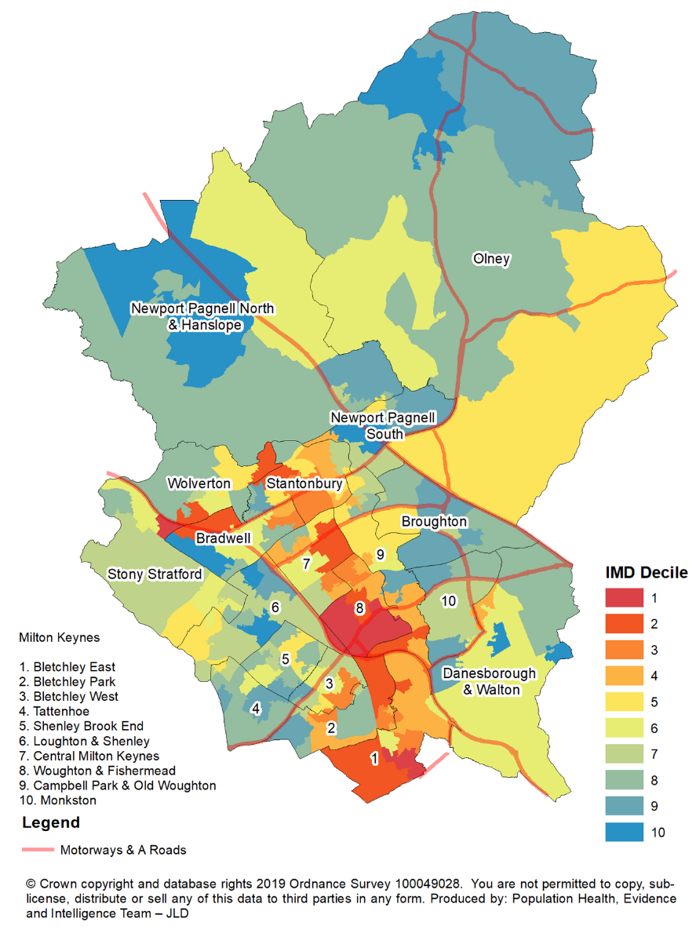
Figure 6: Index of Multiple Deprivation in MK 2019 (Source: Bedford Borough Council, 2019).

Physical activity and obesity
- Obesity is much more prevalent today than it was 40 years ago. It is a particular problem in MK. Around two in every three adults (66.7%) are living with excess weight or obesity, which is higher than the England average (64.5%). This equates to over 150,000 adults that are living with overweight or obesity in MK. For our children, 21.1% of reception-aged and 36.2% of Year 6-aged children in the city are living with excess weight or obesity.

Figure 7: Prevalence of children living with excess weight or obesity in MK.

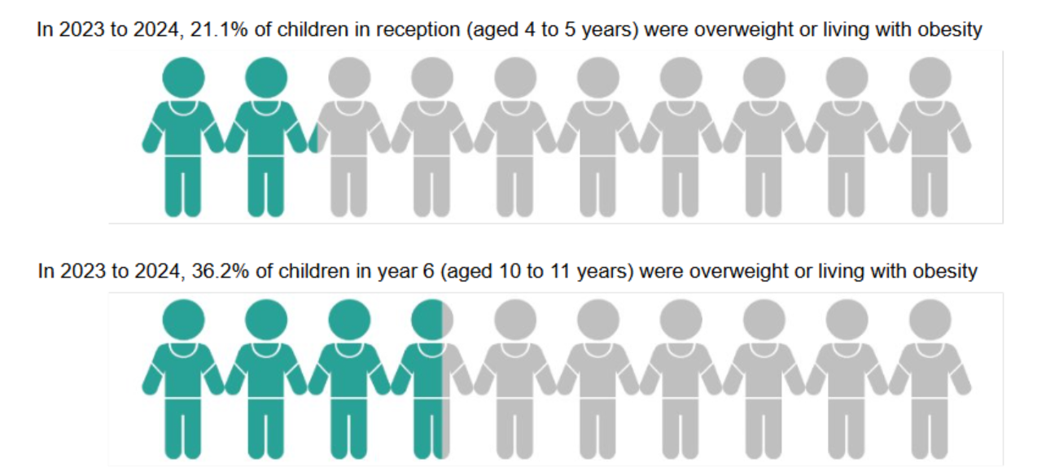 (Source: Office for Health Improvement and Disparities, 2024).

- Obesity increases the risk of type 2 diabetes, stroke, heart disease, depression, dementia, arthritis, and some cancers. It costs the NHS around £6.3 billion each year in additional treatment costs, and the costs to wider society are estimated to be £98 billion each year in the UK which is equivalent to 4% of GDP. For MK, this may be equivalent to around £25 million in NHS costs and £416 million in costs to wider society each year. Obesity is an important contributor to the differences in health seen between people living in the poorest and most affluent neighbourhoods.

- Tackling obesity is a local priority, as set out in the ‘MK Deal’, and the focus of the Director of Public Health’s Annual Report 2023. Regular physical activity and healthy eating not only help to prevent obesity, but also help to prevent many other diseases. In MK if everyone did an additional ten minutes of walking every day, over 10 years it could help to prevent around 140 cases of type 2 diabetes, 330 cases of heart disease, 120 strokes, 60 cases of cancer, 570 cases of dementia and 500 cases of depression. This could save the NHS £35 million. Preventing obesity needs to focus on making it easier for people to be active and to eat well. We will set out some of the ways in which the MK City Plan 2050 can help do this. This not only helps prevent obesity but also helps to improve our resident’s health in many other ways.

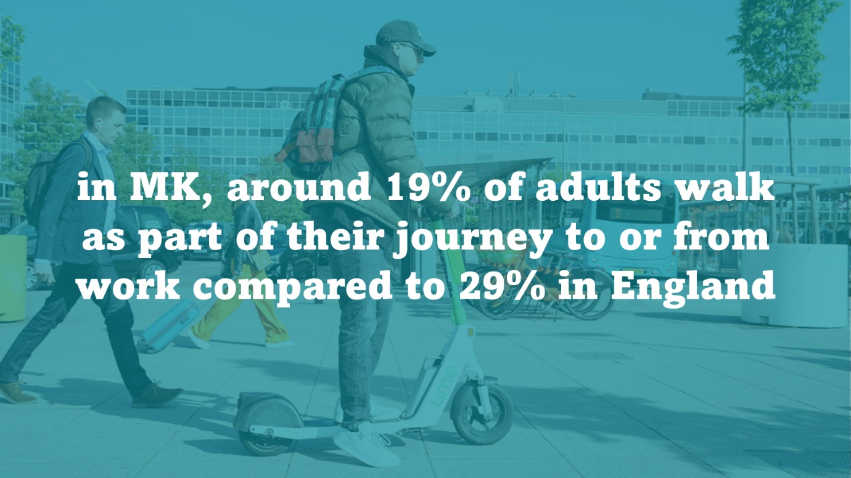

Food environment
- Many people find it challenging to eat healthily, as less healthy food options are the normal option, making it harder to maintain healthier diets. Meals eaten outside of the home tend to be associated with higher intakes of sugar, fat and salt, and portion sizes tend to be bigger. The increasing consumption of out-of-home meals has been identified as an important factor contributing to rising levels of obesity.

- The food environment is important to us, and it should help drive our health, not work against it. As such, improving the nutrient content of the food and drink we buy, cook, and eat is a priority – at both a national and local community level. Addressing health inequalities requires that organisations work together to create healthier food environments for everyone, particularly when some of our most deprived areas have 5 times more fast-food outlets compared to the most affluent areas.

- The presence or absence of Hot Food Takeaways does not tell the whole Food Environment story, although they are an important part. Healthy eating is also affected by ‘Food Deserts’ which are defined as areas which are poorly served by supermarkets and where residents struggle to access healthy food at a good price. Food deserts are not just about the availability of food, but also about the quality and affordability of food.

- Lastly, Community Food Infrastructure such as allotments and urban food growing is a key component of the Food Environment.

Figure 8: Healthier Foods planning and health outcomes
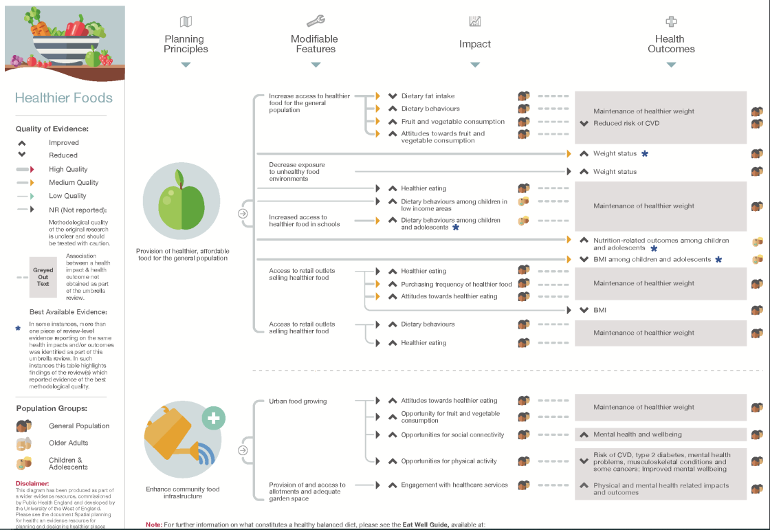
(Source: OHID/PHE 2017)

Hot Food Takeaways
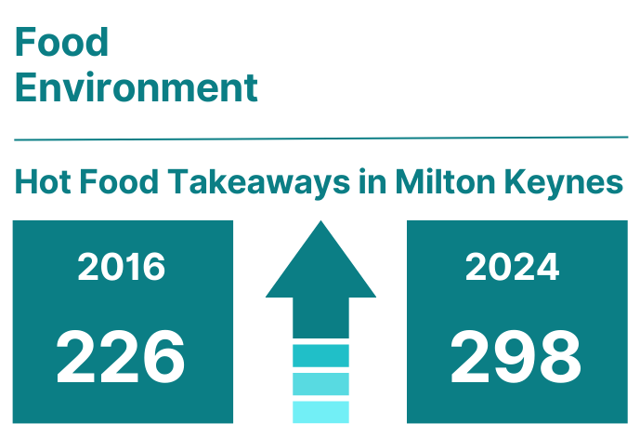
(Source: Milton Keynes City Council (2016) and FEAT (2024).
- Hot Food Takeaway locations in Milton Keynes tend to be concentrated in CMK and town centres including Bletchley and Wolverton. This also is where some of our highest levels of deprivation and childhood obesity are found.
Figure 9: Map of takeaway density in MK.
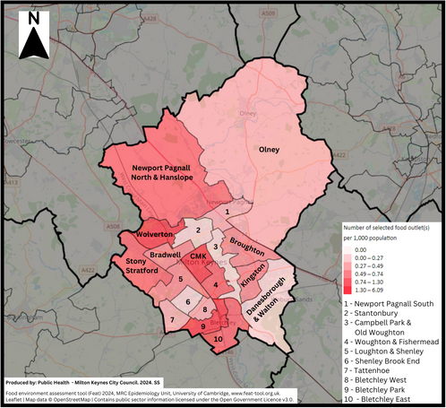
Source: MRC Epidemiology Unit, University of Cambridge and MKCC Public Health (2024).

Figure 10: Table showing wards with childhood obesity rates, IMD Rank, and takeaway density.
 | Milton Keynes Wards | Prevalence of obesity (including severe obesity) Year 6 (%) (rounded 3 yr ave)  (2021/24) | IMD Rank (2019) | Number of takeaways per 1000/population (rank)  (2025)
1 | Central Milton Keynes | 31 | 3 | 3.35 (1)
2 | Woughton & Fishermead | 31 | 1 | 1.2 (7)
3 | Wolverton | 26 | 6 | 2.06 (3)
4 | Stantonbury | 27 | 7 | 0.5 (16)
5 | Bletchley Park | 29 | 4 | 2.67 (2)
6 | Bradwell | 29 | 5 | 0.78 (10*)
7 | Bletchley East | 27 | 2 | 1.41 (5)
8 | Bletchley West | 26 | 10 | 0.55 (15)
9 | Campbell Park & Old Woughton | 26 | 8 | 0.23 (19)
10 | Stony Stratford | 22 | 9 | 1.27 (6)
11 | Monkston | 21 | 12 | 0.98 (8)
12 | Broughton | 20 | 18 | 0.7 (13)
13 | Danesborough & Walton | 22 | 14 | 0.32 (17)
14 | Shenley Brook End | 18 | 13 | 0.3 (18)
15 | Newport Pagnell North & Hanslope | 18 | 17 | 1.72 (4)
16 | Loughton & Shenley | 17 | 11 | 0.78 (10*)
17 | Newport Pagnell South | 19 | 16 | 0.63 (12)
18 | Tattenhoe | 17 | 15 | 0.57 (14)
19 | Olney | 16 | 19 | 0.87 (9)
- Some hot food takeaways offer ‘energy-dense’ or ‘fast food’ with high levels of fat, sugar and salt which are linked to obesity and related health conditions including cardiovascular disease, type 2 diabetes, stroke, and some cancers. Regular consumption of such takeaway food is linked to excess weight gain. Living in an area with higher levels of takeaway food outlets is linked to higher consumption of takeaway food. The UK Office for Health Improvement and Disparities now tracks fast food outlet density. Current data (2024) shows that the density in Milton Keynes as 125 fast food outlets per 100,000 people which is higher than the England average of 116. Of particular concern is the effect of fast-food consumption on children’s diets and eating behaviour as significant health problems related to obesity start to develop at primary school age; behaviour established in early life has been shown to track into adulthood. Food availability and accessibility are both key features of an ‘obesogenic’ environment where the widespread availability of fast food and an environment that promotes sedentary behaviour is of concern.

- The NICE Public Health Guideline on Cardiovascular disease prevention recommends action to encourage local planning authorities to restrict planning permission for takeaways and other food retail outlets in specific areas (for example, within walking distance of schools). Recent changes to the National Planning Policy Framework (NPPF 2024) further support this and steer local authorities to refuse applications for hot food takeaways and fast-food outlets within walking distance of schools and other places young people congregate.

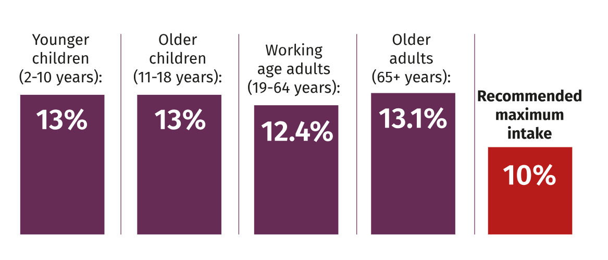
Figure 11: Average daily saturated fat consumption as a proportion of daily total energy (2020)

Source: Food Standards Agency (2022) and Public Health England (2021)

Food deserts
- Food Deserts are neighbourhoods without any local shops or supermarkets selling groceries. Food deserts are not just about the availability of food, but also about the quality and affordability of food. We’ve heard from residents through the Bletchley Pathfinder that many residents struggle to access affordable and healthy food for their families. This occurs because of residents not having access to a private car, or poor walking/wheeling routes to existing supermarkets, and the cost and availability of public transport. Whilst most of the major supermarkets do offer online delivery services across Milton Keynes it is feasible that this is not an option for all households.

- A 2024 systemic review of the food environment and obesity found that Food outlets which sell mostly unhealthy and ultra-processed foods were associated with higher levels of obesity, while fruit and vegetable availability and supermarket accessibility, which enable healthier food access, were related to lower levels of obesity.

- The Accessibility Study has identified several areas in Milton Keynes which are located outside of an 800m radius of a supermarket or convenience shop selling fresh food. The map below shows the 800m radius marked in green circles, with a pink overlay also showing areas of deprivation. Within the main urban parts of Milton Keynes these areas are disproportionately concomitant with the 25% most deprived areas.

Figure 12: Map showing food deserts and 25% most deprived areas in Milton Keynes.
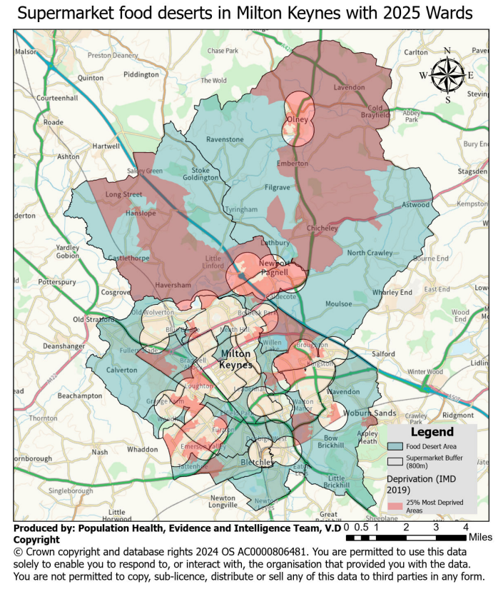

Community food growing
- Access to allotments and food growing spaces in Milton Keynes is not equal. The map below shows the percentage of households located within 800m walking distance of an allotment There are notable absences in the rural north of the borough where population density is lower, but also in central parts of the city such as CMK, Woughton & Fishermead, and parts of Bletchley, which are also areas containing some of our most deprived neighbourhoods.

Figure 13: Map showing percentage of households within 800m walking distance of an allotment.
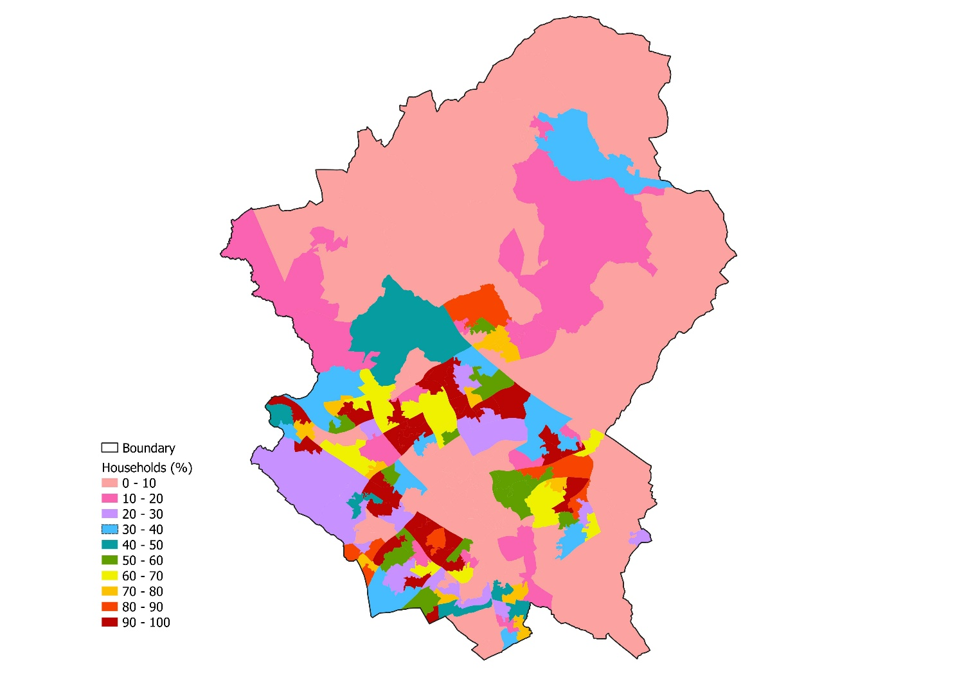

- Most allotments in Milton Keynes are managed by parish councils and those councils with allotments report waiting lists for access to their existing allotment sites. The Office for Health Improvements & Disparities (OHID) have identified that access to urban food growing can improve attitudes towards healthier eating, improve opportunities for fruit and vegetable consumption, as well as improvements in social connectivity and physical activity.

- The MK Sustainability Strategy (2019-2050) states that by 2050 we will encourage more local food and materials production. Food growing areas, such as allotments and community orchards, are a key component in helping communities to access food as well as enabling physical activity and social interaction. The Milton Keynes Nature, Green and Blue Infrastructure Strategy has recommended policy for food growing areas within new development. The strategy also recommends accessibility thresholds to greenspaces and a standard for the provision of allotment space within new developments.

Tobacco consumption
- In Milton Keynes smoking rates and smoking attributable hospital admissions are higher than both regional and national averages. MK adults working in routine and manual occupations are almost twice as likely to smoke as the wider adult population.
Figure 14: Table showing smoking profile indicators for MK with SE and England comparison.
Indicator | Milton Keynes | South East | England
Smoking prevalence in Adults (18+)  (2023) | 7.6% | 10.6% | 11.6%
Smoking prevalence in Adults in routine and manual occupations (18-64)  (2023) | 14.6% | 18.4% | 19.5%
Smoking attributable hospital admissions (2019/20).  (per 100,000) | 1,530 | 1,012 | 1,398
Smoking attributable mortality (2017-19)  (per 100,000) | 201.5 | 170.9 | 202.2
Source: Office for Health Improvement and Disparities (2025).
- Tobacco use is likely to be the major preventable contributor to ill health and health inequalities in most if not all local authority areas. Although smoking cigarettes will make up the bulk of this, it is important to address other forms of tobacco use which are more common in certain communities. Tobacco smoking remains then single biggest cause of preventable illness and death in England.

- Waterpipe smoking (shisha) is one such use. The populations where this is most used are the same communities which are at higher risk of diseases such as heart attacks and stroke from other causes, such as genetic predisposition or diet. Waterpipe smoking (shisha) is a way of inhaling smoke – usually tobacco smoke – which has existed for several hundred years and is a traditional practice in the Middle East and Southern Asia. In recent decades it has become more popular in western countries, particularly in young people. Waterpipe smoking creates smoke containing harmful chemicals, and the practice has been identified as a potential public health concern in the UK and elsewhere.

- A 2016 NHS analysis of several studies suggests that, during a one hour session on a waterpipe, a person can take in:
- the same amount of tar as if they had smoked 25 cigarettes.
- the same amount of carbon monoxide as if they had smoked 11 cigarettes.
- the same amount of nicotine as if they had smoked two cigarettes.

- Premises which sell shisha are required to comply with the full range of both tobacco and health and safety regulations, and the recent proliferation of shisha premises in the UK therefore also introduces regulatory challenges. Between 2007-2012, shisha smoking rose by 210 per cent and there was a 510 per cent increase in shisha cafes between 2010-2018. The Khan Review commissioned by the Government in 2022 has found that some shisha premises have devised 'smoking shelters' so extreme, that while technically within the law, they offer staff and customers next to no protection from the toxic smoke.

- In Milton Keynes there are understood to be seven shisha premises operating:
Premise | Ward | Ward IMD ranking
1 | Wolverton | 6
2 | Newport Pagnell South | 16
3 | Central Milton Keynes | 3
4 | Central Milton Keynes | 3
5 | Bletchley Park | 4
6 | Bletchley Park | 4
7 | Bletchley East | 2

- There is a broad geographical spread of the premises, however a particular concentration is found in and around Bletchley.

- In addition to direct health impacts, the Local Government Association identify that premises can contribute to various amenity and quality of life issues, which in turn can impact the health and wellbeing of the wider community. These include:
- illegal indoor smoking.
- outdoor smoking in structures that are unlawful or dangerous.
- dangerous equipment (with the risk of carbon monoxide poisoning).
- dangerous swinging of charcoal burners.
- enclosures, tables & chairs/seating, or equipment blocking the highway.
- excessive noise and smell, particularly late at night.
- second-hand smoke affecting passers-by, staff, neighbouring premises or homes above/near premises.
- unauthorised changes of use.
- the visibility and promotion of shisha, which may influence children and young people.
- The LGA also advise that fire safety is also a significant concern regarding shisha premises and that carbon monoxide emissions from shisha premises can contribute to poor air quality, particularly in urban centres.

- Shisha premises have been found to fall within ‘Sui Generis’ use therefore allowing local planning authorities to exercise control.

Mental health and wellbeing
- Mental wellbeing and mental health are much bigger concerns today, both for children and adults. Depression and anxiety have increased over the last 30 years. Today, around one in seven adults in England have depression or anxiety, equivalent to around 27,000 adults in MK. The pandemic was associated with worsening mental health, on average, for both children and adults.

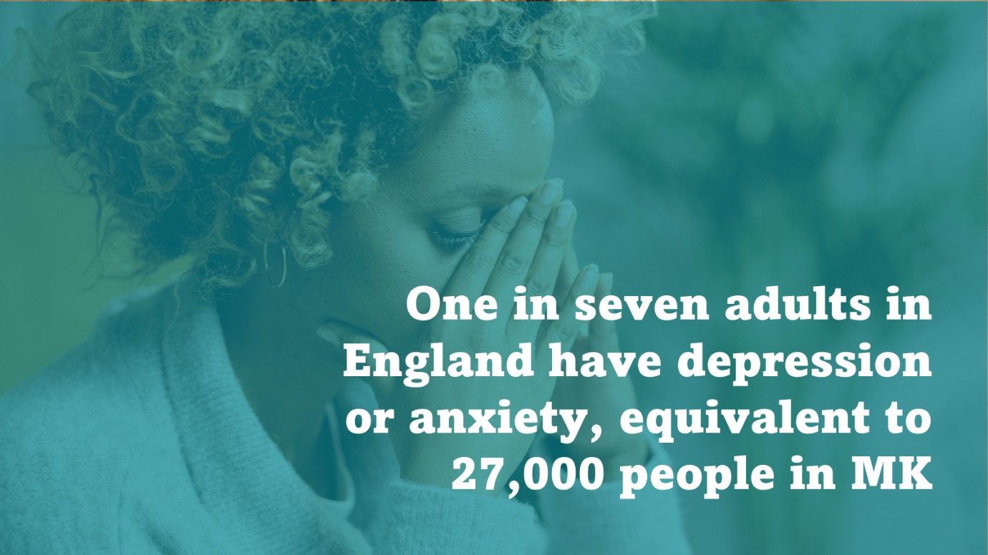

- Enabling residents of all ages to achieve good mental health and mental wellbeing is also a priority in MK and we need to focus on prevention not just treatment. Children and young people’s mental health is one of the priority areas in the ‘MK Deal’. It is also a priority for local suicide prevention work, with the National Suicide Prevention Strategy (2023) recognises the role that building design has in this area. Tall buildings and structures are a recognised means of suicide. Locally deaths by suicide from tall structures are a rare occurrence but incidents that have occurred have tended to be from tall buildings or bridges. The National Suicide prevention strategy for England: 2023 to 2028 encourages those with a role in the planning system to consider the risks of suicide associated with buildings and public spaces and to consult the practice resource: Preventing suicides in public places when creating local design policies.

- There are a variety of factors (e.g., biological, social, and psychological) that can influence people’s mental health. Increasingly it is also recognised that the physical environment can shape people’s mental health and wellbeing. We will later set out some of the ways that the MK City Plan 2050 can help provide the opportunities for all people to enjoy good mental health. MK aspires to be a dementia friendly city and to make it easier for people with dementia to live well, has adopted guidance to implement design that delivers familiarity, legibility, distinctiveness, accessibility, comfort, and safety for people living with dementia.

Pay Day Loans
- Research by the Royal Society for Public Health (RSPH) has identified that ‘debt’ is a determinant of ill-health and there is a bi-directional relationship between debt and health – debt resulting in poorer health outcomes and individuals with poorer health being more likely to use credit and find themselves in debt. The research found that payday lenders had the most negative impact on mental well-being. 43% of those who had used a payday loan stated that their housing situation had been negatively affected by their debts.

- In Milton Keynes there are understood to be four pay day loan shops:

Shop | Ward | Ward IMD ranking
1 | Stony Stratford | 9
2 | Bletchley Park | 4
3 | Bletchley Park | 4
4 | Bletchley Park | 4

- Most are concentrated in Bletchley Town Centre, with Bletchley Park and the neighbouring Bletchley East ward being ranking as 4th and 2nd most deprived respectively (IMD 2019).

- Analysis by the Financial Conduct Authority in 2022 found that payday loans were more likely to be held by people living in the most deprived areas and those with greatest vulnerability including poor health and low resilience.

Gambling and problem gambling
- Public Health have produced the Gambling and Problem Gambling in Milton Keynes Health Needs Assessment, which estimates 95,000 residents gamble and approximately 1,500 residents have a problem with gambling. A further 7,300 are at low or moderate risk of gambling-related harm.

- The review also found that gambling premises and gambling machines are disproportionately located in the more deprived areas of Milton Keynes, which increases access for those already at heightened risk of problem gambling. These are individuals who have mental health issues, are unemployed or employed in routine/manual jobs, are homeless or have substance misuse issues. The report has made several recommendations on prevention, early intervention and treatment.

- Betting shops, casinos, and payday loan shops fall within a ‘Sui Generis’ use as defined by the Town and Country Planning (use classes) Order 1987 (as amended), which allows the local planning authority to exercise control through the need for planning permission to be obtained for changes of use to or from these uses.

Figure 15: Table showing the number of gabling licenses and machines per ward (2020).
Ward | Machines | Machine Licenses | Premises Licenses | IMD rank (201(  (1 most–  19 least)
Central Milton Keynes | 173* | 14 | 7 | 3
Bletchley Park | 101 | 10 | 8 | 4
Wolverton | 60 | 12 | 4 | 6
Newport Pagnell North & Hanslope | 53 | 9 | 2 | 17
Newport Pagnell South | 33 | 11 | 1 | 16
Stony Stratford | 23 | 9 | 1 | 9
Bletchley East | 23 | 8 | 1 | 2
Broughton | 22 | 6 | 1 | 18
Stantonbury | 17 | 4 | 1 | 7
Bletchley West | 16 | 3 | 1 | 10
Monkston | 16 | 4 | 1 | 12
Loughton & Shenley | 15 | 3 | 1 | 11
Campbell Park & Old Woughton | 14 | 6 | 0 | 8
Olney | 13 | 6 | 0 | 19
Bradwell | 11 | 5 | 0 | 5
Woughton & Fishermead | 10 | 2 | 1 | 1
Shenley Brook End | 9 | 4 | 0 | 13
Tattenhoe | 9 | 2 | 1 | 15
Danesborough & Walton | 7 | 3 | 0 | 14
TOTAL | 625 | 121 | 31 | -

Wider links to health
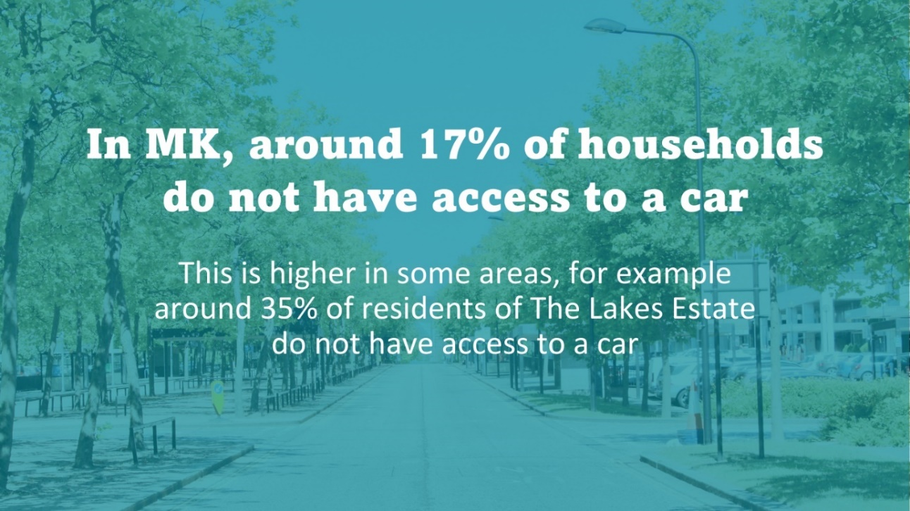
- Man-made (e.g. roads, railways) or natural barriers (e.g. rivers) can present a physical and/or mental barrier to moving across a city, particularly when they inhibit people moving by foot. This is known as severance. Whilst the grid roads can provide good ability for people with cars to get around MK, the grid roads in MK as well as other major roads or rail corridors may also be a barrier to movement for some people. Severance discourages physical activity, and it may reduce access to opportunities for social engagement or employment. Whilst bridges or underpasses are put in place to address these issues, they take people out of their way or often leave people feeling unsafe – so do not fully overcome severance. These effects will be experienced differently by different people, for example people who don’t have access to or cannot afford a car, children and young people, and older adults. The MK City Plan 2050 is an opportunity to consider how the effects of severance can be minimised as MK develops.

- Air pollution can cause heart disease, strokes, lung disease and some cancers. Air pollution is one of the largest environmental risks to people’s health in the UK and can affect us all throughout our lives. Children and older adults are particularly vulnerable. In MK, it is estimated there are 89 deaths each year attributable to air pollution Professor Chris Whitty, the Chief Medical Officer for England, focused his 2022 annual report on air pollution. He highlighted the role of planning in reducing the concentration of pollutants locally and promoting health.

- The MK City Plan 2050 will play an important role in housing design and delivery. Sustainably designed and heated homes can help protect people from cold and damp, which can contribute to heart disease and lung disease. Increasingly, homes also need to be resilient to the effects of climate change, such as flooding and heatwaves. Flooding is a major risk factor for depression and the release of sewage in floods can cause infectious diseases. Last summer’s heatwaves led to excess deaths in the UK. Good housing and neighbourhood design that prevents excessive heating indoors and provides natural ventilation and cooling from shade and green spaces can help people cope better with future heatwaves. Affordable and secure housing can also help boost peoples’ sense of wellbeing and find a job.

Our emerging policy approach
  - Informed by the evidence summarised above and considered alongside the vision set out in the Strategy for 2050, the policies relating to people friendly and healthy places in Plan:MK have been reviewed. Several new or amended policies are proposed in the Regulation 19 MK City Plan 2050, and this section describes these policies. The approach to creating healthier places is supported at the national planning policy level. The NPPF paragraph 96 says planning policies and decisions should aim to achieve places which enable and support healthy lives, through both promoting good health and preventing ill-health, especially where this would address identified local health and well-being needs and reduce health inequalities between the most and least deprived communities.

Delivering Healthier Places (PFHP1)
  - To deliver healthier places, the Council will be supportive of proposals where they accord with the Milton Keynes Healthy Place Principles, reduce health inequalities, and address local health impacts. The policy establishes the healthy place principles, recognising that there are many determinants of health that cut across the range of policies set out in the plan.

  - To facilitate this, Health Impact Assessments (HIA) will be required for certain development proposals. This was a requirement in Plan:MK, however the eligible development proposals have been amended to incorporate more residential typologies anticipated in the plan, and to cover other uses that can have an impact on population health. The criteria around care homes have been revised to increase the threshold for triggering a HIA, as Plan:MK was triggering HIAs for low-occupancy care homes where HIA preparation was disproportionate to population health impacts.

  - Certain uses falling within ‘Sui Generis’ as defined in the Use Class Order will be subject to additional assessment criteria, recognising that these uses can potentially exacerbate existing and cause health inequalities within the city to increase.

  - This policy aims to support Council Plan objectives for addressing health inequalities especially for those in ethnic minority communities and for those on low incomes, reducing smoking, and delivering well planned growth.

Provision and Protection of Community Facilities and Local Centres (PFHP2 and PFHP3)
  - An important part of creating people friendly and healthy places is providing a suitable range of facilities in the right places to promote walkable neighbourhoods and good physical and mental health. Community facilities make a fundamental contribution to quality of life and creating successful communities and neighbourhoods where most people can meet their everyday needs within a short walk, wheel, cycle, or scoot of their home.

  - To ensure that existing community facilities are protected, and that new community facilities are provided in suitable locations, the Plan proposes a policy setting out the requirements for where they should be located and how the loss of community facilities will be assessed.

  - Many of the important community facilities are found in Local Centres across Milton Keynes. The Plan proposes policy that supports the creation of new Local Centres, and convenience stores in particular, where they are currently lacking at the moment. This supportive policy framework will assist in addressing the identified food deserts across parts of Milton Keynes. The Plan also proposed general criteria on the scale of residential development that should trigger the provision of additional convenience retail floorspace, and the residential catchment area for new convenience stores.

Delivering a Healthier Food Environment (PFHP4)
  - The Council will support proposals that increase healthier food choices for our residents across the city. To achieve this the policy seeks to provide additional food growing opportunities, through the requirement for residential development proposals to provide food growing facilities and where appropriate, new allotment space. Development proposals would need to protect existing allotments and urban food growing spaces except in certain circumstances. Proposals would also need to avoid negatively impacting on any adjacent allotments or urban food growing land.

  - The policy also seeks to address food deserts in the city, which are existing places which have poor access to fresh food available for sale from retail premises. Significant weight will be placed on proposals which deliver new, expanded or upgraded facilities that deliver affordable healthy food and drink, such as through new community growing areas, allotments, orchards, shops and cafes.

  - MK City Plan 2050 will also seek to locate development proposals for new hot food takeaways away from places where young people congregate, including schools, areas with high levels of children living with obesity, and locations where clustering of uses would occur. The approach builds on that from Plan:MK but recognises that the number of adults and children living with obesity, and takeaways in the city, have continued to increase in recent years. Tackling obesity is a key priority for the council and the wider healthcare system, recognising the significant health impacts this can have on our residents and the subsequent costs to the NHS and public services. The thresholds set for childhood obesity reflect Milton Keynes’ baseline position from when the National Child Measurement Programme was first introduced in 2006.

  - Promoting a healthier food environment is a key component of a whole-systems approach to tackling obesity, which the Council and the NHS seek to facilitate. Our policies set out a way of managing the prevalence of hot food takeaways where there are known health and obesity issues in the city, an approach supported by the National Planning Policy Framework (NPPF) and the National Institute for Health and Care Research (NIHR). Places where unhealthy food is readily available and highly promoted make it harder for people to make healthy choices. The policy requires current childhood obesity levels to be taken into account in decision making. Obese children are more likely to become obese adults.

  - The policy aims to support Council Plan objectives for addressing health inequalities especially for those in ethnic minority communities and for those on low incomes, reducing obesity, and delivering well planned growth. It would also support the MK Together Health and Care Partnership’s aims to tackle obesity through shaping a healthier city and reducing barriers to accessing healthy food. The policy would also support the MK Sustainability Strategy which states that by 2050 we will encourage more local food and materials production.

Designing People-Friendly Places (PFHP5)
  - The Levelling Up and Regeneration Act 2023 requires local planning authorities to prepare an authority-wide design code. However, the December 2024 update to the National Planning Policy Framework moved authorities away from authority wide codes to more localised coding. Our revised approach to creating design codes will be focused on area-based codes for strategic expansion areas and regeneration areas which will experience significant growth. The approach is outlined in the submission Plan. In addition, developers will be required to prepare design codes for large development sites, and neighbourhood planning groups can also prepare design codes as part of their neighbourhood plans.

  - The proposed policy requires that development proposals must accord with any Design Code that has been approved for the site or wider area. It also sets out design criteria against which development proposals will be assessed including considerations such as character, ease of movement, overlooking, integration with surrounding environments, soft and hard landscaping, adaptability and promoting walkable neighbourhoods.

  - The aim of this policy is to ensure that the built form and layout responds appropriately to the context and delivers high quality form of urban design with a connected public realm that helps creates places with identity. The NPPF promotes Building for a Healthy Life as a tool for assessing and improving the design of new residential development. We will look to use Building for a Healthy Life or other suitable assessment tools and methods to assess major residential development proposals. High profile major planning applications will also use a Design Review process to improve the quality of design.

Designing Healthy Streets (PFHP6)
  - The Manual for Streets defines a street as “a highway that has important public realm functions beyond the movement of traffic.” Streets are typically lined with buildings and are places for people as well as for movement. It is this place function that distinguishes a street from a road, whose main function is accommodating the movement of motor traffic.

  - Healthy Streets is an evidence-based approach to improve health and reduce health inequalities through active travel. It uses 10 indicators that reflect the experience of being on streets, but they are relevant to most of the spaces we move through as well. These indicators are based on evidence of what is needed to create a healthy, inclusive environment in which people are more likely to choose to walk, cycle and use public transport.

  - The proposed policy sets out the principles for designing healthy streets against which development proposals will be assessed. The policy reflects the Healthy Streets principles but is not based exclusively on the 10 indicators.

Well-Designed Buildings and Spaces (PFHP7)
  - The objective of this policy is to ensure that all new buildings and spaces are well designed, relate well to the surrounding area and contribute to the character of the development. The design of new buildings is important irrespective of whether it lies within one of the older settlements, located within the existing city, or on a greenfield site on the edge of the city.

  - The proposed policy sets out the criteria which should govern the design of new buildings (and extensions to existing buildings) to ensure that they make a positive contribution to the area within which they are located. Criteria for the delivery of age-friendly development is also incorporated, recognising the Council’s commitment to make Milton Keynes a dementia-friendly city.

  - Milton Keynes has a rich history of being at the forefront of new approaches to housing design and architecture, delivering innovative buildings within the context of a holistically designed city. Progressive, forward-thinking, and distinctive architecture creates buildings that allow for innovation while being reflective of their place and the time they were built. This is reflected in the building design policies in the Milton Keynes City Plan.

  - Buildings are among the most visible parts of a development and therefore are a key influencing factor in the creation of a character for a development. The appearance of buildings also helps with legibility and the generation of varying character across large developments in particular.

Tall buildings outside Central Milton Keynes (PFHP8)
  - The objective of this policy is to ensure that tall buildings are developed in the right locations and of a high quality to support our wider placemaking aims for people friendly and healthy places.

  - Milton Keynes has a history of lower rise-built form. However, the city is at a point of change with taller buildings emerging within areas of our city centre. In the right location taller buildings support the principles of people friendly and healthy places by providing a more compact urban form in sustainable locations, enabling more people to access facilities, including in our town and city centres, whilst also providing more people with better access to public transport.

  - Tall buildings will predominantly be located within Central Milton Keynes, and there will be a limited number of opportunities for taller buildings on urban infill sites in sustainable locations elsewhere in the city. Sustainable locations will be where increased density supports the viability of the Metro routes or existing town or local centres, that have good access to facilities and public transport.

  - Tall buildings will usually require a landscape/townscape visual impact assessment. This is particularly important if the site has not been identified as a location for taller buildings in supporting guidance.

  - Tall buildings and/or visually prominent buildings will be expected to undertake an independent design review. This is intended to ensure that the design quality of the development is acceptable. Tall buildings within Central Milton Keynes particularly those that are over the height suggested in the Central Milton Keynes Framework Plan will require a positive response from the independent design review panel and the planning authority that provides evidence that the scheme is of a quality that is appropriate for its visual prominence. This process may also be used to help justify any deviation for the building heights guidance.

Amenity for healthy buildings and spaces (PFHP9)
  - The amenity afforded by new development and the protection of amenity within existing developments is critical to ensuring the creation of people friendly and healthy places. Buildings must be carefully designed to ensure adequate privacy, sun lighting, and daylighting has been achieved.

Next steps
- This topic paper accompanies the Regulation 19 consultation version of the Milton Keynes City Plan 2050 and sets out the detailed justification for the proposed policies relating to high quality homes in the submission Plan. As we progress through the plan-making process to, submission and examination stages, we will continue to update the topic papers and relevant policies as we consider new evidence. The topic papers are ‘living’ documents that will be updated through the preparation of the Local Plan.

Appendix A: Milton Keynes City Council Plan Outcomes

Well planned growth
- Appropriate infrastructure to meet the increased demands through growth and holding developers to account for timely delivery.
- Protected and enhanced grid roads and community green spaces.

Improved health and wellbeing
- Increase integration of health and social care services with our partners on the MK Health and Care Partnership (‘MK Deal’) and the BLMK Integrated Care Board.
- Improved access to GP and mental health services.
- Reduced health inequalities, especially in ethnic minorities and for those on low incomes.
- Reduced obesity and levels of smoking and increased early diagnosis of diabetes and HIV

Sustainable public transport and mobility
- Increase journeys made by walking and cycling and investment in improving our Redways to reduce car usage.

Appendix B: Policy Context
One of the overarching objectives of the planning system is to promote healthy and safe communities through enabling and supporting healthy lifestyles, especially where this would address identified local health and well-being needs - for example through the provision of safe and accessible green infrastructure, sports facilities, local shops, access to healthier food, allotments and layouts that encourage walking and cycling.. The National Planning Policy Framework (NPPF, 2024) and national Planning Practice Guidance (PPG) set out further policy and guidance about these issues including how positive planning can contribute to healthier communities by promoting both good health and preventing ill-health, and reducing health inequalities between the most and least deprived communities. Further it references how planning can create a healthier food environment and states local planning authorities should refuse applications for hot food takeaways and fast-food outlets in certain circumstances.

The National Design Guide sets out the characteristics of well-designed places and demonstrates what good design means in practice. It sets out ten characteristics of good design:
- Context – enhances the surroundings.
- Identity – attractive and distinctive.
- Built form – a coherent pattern of design.
- Movement – accessible and easy to move around.
- Nature – enhanced and optimised.
- Public spaces – safe, social and inclusive.
- Uses – mixed and integrated.
- Homes and buildings – functional, healthy and sustainable.
- Resources – efficient and resilient.
- Lifespan – made to last.

The Milton Keynes City Council Plan (2022-2026) recognises that Milton Keynes was established as an ambitious project to meet the urgent housing crisis at the time, but that this foundation is under threat from increasing unaffordability, national planning regulations and underinvestment. It contains several priorities and outcomes to help overcome this, including seeking to increase the supply of genuinely affordable housing, improving the mix of housing available to rent and buy, and improving and investing in existing communities and housing through renewal and regeneration.

The Council’s Health and Wellbeing Strategy (2018-2028) seeks to enable people to lead fulfilling lives, and to be actively involved in families and communities. The strategy has been informed based on detailed analysis of data contained within the Joint Strategic Needs Assessment. The HWBS has three themes, each with supporting priorities: Start Well, Live Well, and Age Well.

The MK Together Health and Care Partnership’s Ambition for Health and Social Care outlines that in 2022, the Milton Keynes Health and Care Partnership and the Integrated Care Board agreed on the ‘MK Deal’ to improve health in the city, focusing on four priorities: tackling obesity, improving system flow, mental health for children and young people, and supporting people with complex needs.

For tacking obesity our approach by 2028 will be:

  - Strongly focused on preventing unhealthy weight gain, with an emphasis on healthy lives and shaping a healthier city. We will have made some breakthroughs, but everyone will recognise that our work will take longer to have a population-level impact.
  - Supported by most residents, who will have better access to information to help them make healthier choices, with fewer barriers to accessing social activities, physical activity and healthy food.
  - Bolder and underpinned by a widespread agreement that some of the things we need to do might make life slightly less convenient for some, helping everyone understand why it needs to be like this.
  - Characterised by joined up and well-co-ordinated action across the public sector, voluntary sector and businesses. We will have collaborated around a shared single goal, such as making free drinking water accessible right across the city.
  - Enhanced by a step change in the availability of effective and accessible support and treatments to help people lose weight. We will be more data driven, capitalising on opportunities to segment data to engage more proactively with residents living with, or at risk of, excess weight.
  - Nationally recognised for our innovation in tackling obesity and as a place where new approaches can be tested to help build the ‘what works’ evidence-base further.

The MK Sustainability Strategy (2019-2050) states that by 2050 we will encourage more local food and materials production.

The Director of Public Health’s Annual Report (2023) identifies that two out of three adults and two out of five 11-year-olds living in Milton Keynes are overweight or obese. Excess weight is a major cause of ill health and death locally and disproportionately affects some of our poorest communities. Tackling excess weight is not simply a matter of educating individuals to make healthier choices. The people who are most likely to become overweight or obese are those whose lives are shaped by work, school and social environments that promote overeating and inactivity. It is easy to feel overwhelmed by the scale and complexity of the challenge, but there are effective actions we can take locally. The report this year focuses on the important roles that partner organisations and businesses in Milton Keynes play in shaping our environment and keeping our population healthy. If we are serious about working preventatively to improve health in Milton Keynes, there is more we can do together to stop people developing excess weight and support more people to lose weight.

The Joint Strategic Needs Assessment (JSNA) contains insight and intelligence on the current picture of the needs and utilisation of services by the local population and highlights where there might be unmet need. This allows for general or targeted interventions ensuring the efficient use of public funds and resources to improve health, care and wellbeing and reduce inequity in access and inequality of outcomes. Among the key strategies that the JSNA currently informs are Milton Keynes City’s Joint Health and Wellbeing Strategy (JHWS) and the Milton Keynes City Plan.

The JSNA is a live entity not a static document. It is a library where “books” or blocks of information are added as they are developed, each adding to the overall knowledge base. Therefore, the information will be added to over time.

The JSNA is supported by a range of supporting evidence and intelligence which are regularly refreshed and updated. These are all hosted at: https://bmkjsna.org/milton-keynes/

Appendix C: MK City Plan 2050 Evidence Base
Policies in the MK City Plan 2050 must be based on relevant and up to date evidence related to the local and ‘larger than local’ context of Milton Keynes. This includes information that predicts future needs (including for homes, jobs, and retail), and information that gives an assessment of the current or future predicted situation and impacts (for example landscape character and flooding). The studies particularly relevant for high-quality homes and neighbourhoods are:

Document | Purpose/Scope
Gypsies and Travellers Accommodation Assessment (GTAA) and Boat Dwellers Accommodation Assessment | To consider the housing needs of Gypsies and Travellers and transit and boat dwellers.
MK Infrastructure Study and Strategy (MKISS) | Identifies the various forms of infrastructure that are required to meet growth that may come forward through the Local Plan and through to 2050.
Land Availability Assessment (LAA) | Identifies a future supply of land which is suitable, available and achievable for housing and economic development uses over the plan period. The assessment is an important source of evidence to inform plan-making and decision-taking, and the identification of a 5-year supply of housing land.
Housing and Economic Development Needs Assessment (HEDNA)  (Logistics study commissioned separately by SEMLEP) | The HEDNA will assess the housing and economic development needs for the Borough of Milton Keynes for the period 2022-2050. It will include data on population change, market signals, the economy and labour market, employment forecasts, a commercial market assessment and future employment land requirements for different types of employment floorspace.
Carbon and Climate Study | To assess how the Local Plan can deliver low- or zero-carbon and climate-adaptable growth. This will incorporate the air quality & air pollution study.
Whole Plan Viability Study | Addresses overall deliverability of the plan to determine whether the policy requirements can be viably delivered.
Equality Impact Assessment | A systematic and evidence-based tool, which enables us to consider the likely impact of work on different groups of people. Completion of equality impact assessments is a legal requirement under race, disability and gender equality legislation.
Sustainability Appraisal | An assessment of the social, economic and environmental effects of the plan’s policies, alongside consideration of any significant adverse effects on protected biodiversity sites.
Health Impact Assessment of the draft Local Plan (Regulation 18 and Regulation 19 versions) | The Health Impact Assessment supports policy development that encourages positive impacts on the health and well-being of our residents. By addressing potential challenges and working to tackle health inequalities, Milton Keynes can become an exemplar for health focussed Local Plan development. The HIA takes a systematic approach to ensure a comprehensive assessment and understanding of the plan’s impact on health and wellbeing.

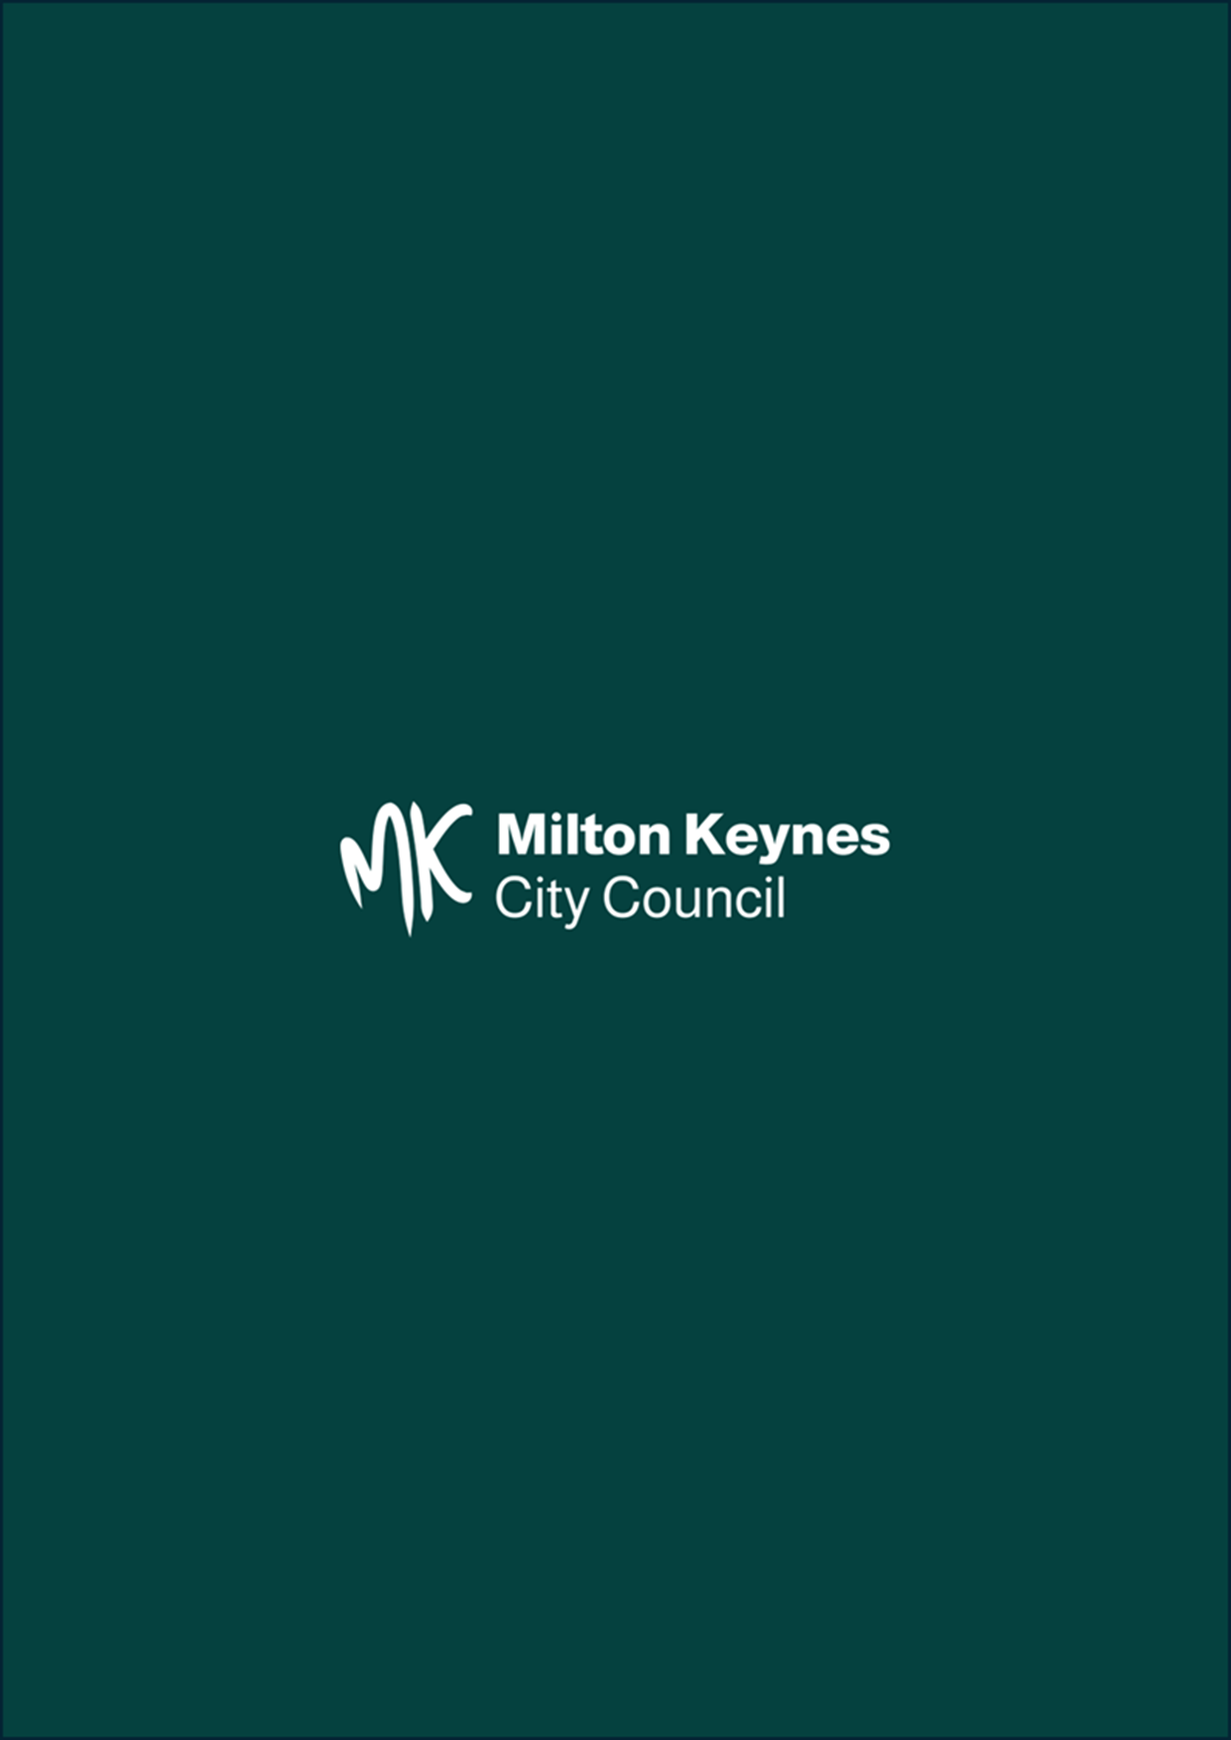

See Appendix A
Cited in Kuznetsova, D. (2012) 'Healthy places: Councils leading on public health'.
National Institute for Clinical Excellence NICE (2014) Physical activity: public health guideline
Office for Health Improvement and Disparities. Local authority health profiles. 2023 https://fingertips.phe.org.uk
ONS ward level data on life expectancy: Life expectancy by census ward (ons.gov.uk); for females Woughton healthy life expectancy, 54.5 years; Olney, 72.5 years; the equivalent figure for men is 16 years (55.1 years for Woughton vs 71.2 for Sherington)
Office for Health Improvement and Disparities. Local authority health profiles. 2023 https://fingertips.phe.org.uk
Source: Enhanced NCMP datasets Data combined 5-years, (2018 to 2019, 2019 to 2020, 2021 to 2022, 2022 to 2023, and 2023 to 2024)
Office for Health Improvement and Disparities. Public health profiles. 2023/2024 https://fingertips.phe.org.uk
Department of Health and Social Care (2024) Government plans to tackle obesity.
Tony Blair Institute (2023) Unhealthy numbers: the rising cost of obesity in the UK.
This figure is based on extrapolating the per capita costs for the UK to the MK population, based on 2021 Census
Milton Keynes City Council (2024) Our Ambition for Health and Social Care.
Milton Keynes City Council (2022) Taking Action to Address Excess Weight in Milton Keynes.
UK Health Security Agency (2019) Addressing the food environment as part of local whole system approaches to obesity.
van Erpecum, CP.L., van Zon, S.K., Bültmann, U. et al., 2022. The association between the presence of fast-food outlets and BMI: the role of neighbourhood socio-economic status, healthy food outlets, and dietary factors. BMC Public Health 22, 1432 (2022). https://doi.org/10.1186/s12889-022- 13826-1
Keeble, M., Adams, J., White, M. et al., 2019. Correlates of English local government use of the planning system to regulate hot food takeaway outlets: a cross-sectional analysis. Int J Behav Nutr Phys Act 16, 127 (2019)
Office for Health Improvement & Disparities. Official Statistics. 2025 [cited 2025 Jul 10]. Wider Determinants of Health: statistical commentary on the location of fast food outlets, February 2025. Available from: https://www.gov.uk/government/statistics/wider-determinants-of-health-february-2025-update/wider-determinants-of-health-statistical-commentary-february-2025
NHS Healthy Urban Development (2013) Using the planning system to control hot food takeaways.
NICE, Cardiovascular disease prevention, Public Health Guideline [PH25]. June 2010
NPPF, paragraph 97. December 2024.
Food Standards Agency (2022) The nation’s plate, our diet and food choices today.
Public Health England (2021) National Diet and Nutrition survey.
https://www.milton-keynes.gov.uk/health-and-wellbeing/bletchley-pathfinder
Pineda E, Stockton J, Scholes S, et al. Food environment and obesity: a systematic review and meta-analysis. BMJ Nutrition, Prevention & Health 2024;0:e000663. doi:10.1136/ bmjnph-2023-000663
Milton Keynes City Council (2019) Sustainability Strategy 2019-2050.
Milton Keynes City Council & Lepus Consulting MK NG&BI Strategy (2023)
Association of Directors of Public Health (2017) Shisha in England: The Public Health Challenge.
Khan, J. (2022) The Khan Review: Making Smoking Obsolete
LGA (2024) Reducing the harm of shisha and the need for better regulation.
Department of Health and Social Care, 2023, Suicide prevention strategy for England: 2023 to 2028.
RSPH (2018) Life on Debt Row
Financial Conduct Authority (2023) Financial Lives Survey 2022.
Milton Keynes City Council (2020) Gambling and Problem Gambling in Milton Keynes
Public Health England (2014) Estimating Local Mortality Burdens associated with Particulate Air Pollution
Chief Medical Officer’s annual report 2022: air pollution
National Planning Policy Framework (2023) paragraph 96c)
National design guide - GOV.UK (www.gov.uk)

