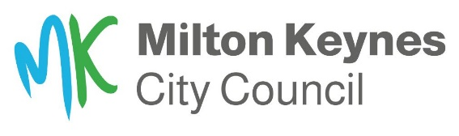
Highways and Transportation
Bridges and Highways Structures

H4 Canal Footbridge (86414A)
Footbridge Maintenance – Resurfacing and Sealants Works

14 January 2026

Milton Keynes City Council (MKC) will be carrying out maintenance work to the redway footbridge over the Grand Union Canal between Pennyland and Bolbeck Park.

The works will be delivered by MKCC’s Highways service provider Ringway.
Site works will start on 12 January 2026 and finish on 13 February 2026 and will include:
- Footbridge deck resurfacing
- Footbridge approaches resurfacing
- Joints Sealants replacement
- Install solid white lining on the Redway

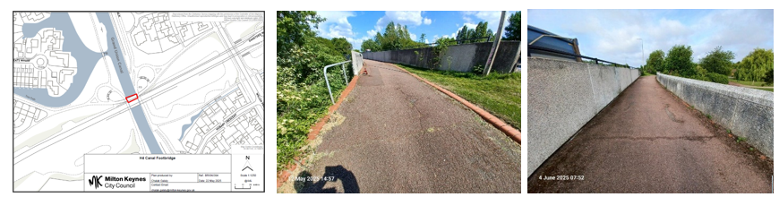

How will this affect you?
The footbridge will be closed for the duration of site works and a clearly signed diversion route for the closure will be installed.

Working hours will be Monday to Friday 07:30 to 17:30 hours.

There may be a degree of noise experienced during the works and we will endeavour to keep
noise levels to a minimum. We apologise in advance for any inconvenience experienced
because of these works and thank you for your patience whilst we improve your bridge stock.

Should there be any changes to the proposed start date, duration or working hours, the users of the footbridge will be notified on the information boards situated at both ends of the bridge.

Should you have any questions about this project, please use the Contact Us form on our website or call 01908 252353.

Yours sincerely,
Bridges and Structures Team
Highways and Transportation
MK City Council

