February 2026

The Workplace Health Team work in partnership with others to offer FREE health and wellbeing services and training, to all workplaces in Milton Keynes, Bedford Borough and Central Bedfordshire.

Our regular bulletin provides updates on different health and wellbeing topics, a service offer spotlight and information about forthcoming campaigns to support health and wellbeing in your workplace.

The Workplace Health webpages provide a range of free resources and information.

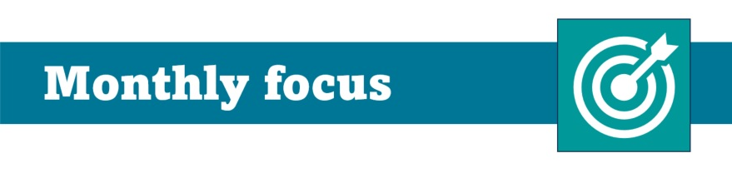

Why invest in workplace health?

Poor workplace health costs UK employers £85 billion a year. Investing in workplace health can reduce sickness absence, boost productivity & build a culture that attracts and retains talent & drives business growth. Who are we and how can we help? As part of Public Health, our Workplace Health team helps organisations improve health and wellbeing at work. We offer training, tools, guidance, and access to health programmes and services to support workplace health, enhance employee wellbeing and help businesses thrive.

Who are we and how can we help?

As part of Public Health, our Workplace Health team helps organisations improve health and wellbeing at work. We offer training, tools, guidance, and access to health programmes and services to support workplace health, enhance employee wellbeing and help businesses thrive.

Are you a business owner or senior leader?

Or do you lead on people and culture or health and wellbeing within your organisation?

Please help us shape our service.

Your input matters! Take part in a short survey and tell us about your organisation, your workplace health priorities, and what support you need. Together, we’ll co-create solutions for maximum impact.

Service offer Spotlight:

Connect to Work: is a Free employment support service supporting Your Workforce, Strengthening Your Business Looking to recruit, retain, and support staff more effectively?

Whether you’re filling vacancies, supporting someone who is returning to work, or helping an employee stay in their role, the service works alongside you to find solutions that fit your business. For your staff, Connect to Work provides tailored 1:1 support, to help overcome a range of challenges such as health conditions, disabilities, caring responsibilities, confidence issues, or changes in circumstances. This can mean better attendance, improved wellbeing, and increased productivity.

Get involved: Employers based in Central Bedfordshire can contact the team directly at: BESA.careersadvice@centralbedfordshire.gov.uk.

For businesses and employees in Milton Keynes, access support by completing the online expression of interest form

For businesses and employees in Bedford contact connect2jobs@bedford.gov.uk

Training for workplaces

The Workplace Health Team work in partnership with local and national organisations to offer FREE workplace health and wellbeing training sessions and webinars.

Up and coming training and webinars:

FREE suicide prevention training, delivered by Mind BLMK and funded by the Workplace Health team.

This training is open to any employee working in Bedford Borough, Central Bedfordshire or Milton Keynes and is designed to build basic suicide prevention awareness within the workplace. See the Signs, Save a Life Suicide Prevention Training Free: See the Signs, Save a Life Suicide Prevention Training - Mind BLMK.

Book your place by visiting Workplace Health Training Calendar

Visit our webpage regularly for updates. Our training calendar will be expanding soon.



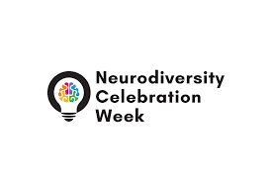
Neurodiversity Celebration Week 2026

This year, during Celebrating Neurodiversity Week it is shifting from awareness and focusing on action at an organisational level and sharing best practice to have greater impact.

For the full calendar of events Schedule March 16th to 20th go to https://www.neurodiversityweek.com/

