Map of the West Bletchley Resident Permit Parking Scheme Proposed Parking Zones

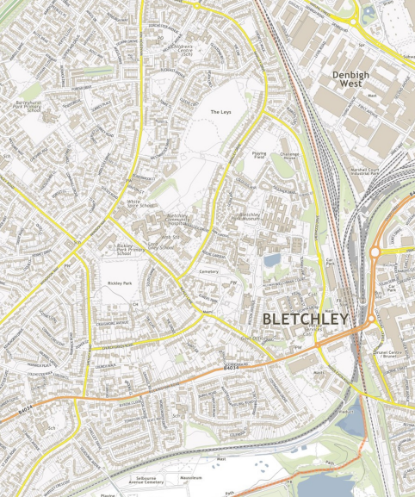
Zone A
Zone C
Zone B
Zone A | Proposed area for new parking restrictions
Zone B | Proposed area for new parking restrictions
Zone C | Proposed area for new parking restrictions

