West Bletchley Resident Parking Scheme Survey

Background
Prior to Covid lockdown in 2020, residents living in the residential streets near to Bletchley railway station had reported increasing levels of nuisance parking in their streets. It was thought that this was related to long term parking by vehicles from outside the area, avoiding the charge in the station car park, or looking to park close to their place of work/education.
When lockdown happened, the problem went away, but as things have returned to normal, and people have returned to their place of work/education and commuting a few days a week, the problem has gradually started to appear again.
A West Bletchley On-Street Parking Study was undertaken by the City Council at the request of West Bletchley Council in 2025, which confirmed that there are an identified number of external vehicles coming into the residential streets around the station and parking there for extended (all day) periods, reducing opportunities for residents to park near their homes.
Now that a problem has been identified, it is time for local residents to decide how this problem should be addressed – as there are a few different possible solutions, each offering a different level of improvement.
These are four available options labelled Option 1, Option 2, Option 3 and Option 4 and these are described in turn in the following sections.
There are also three distinct areas where measures could be introduced, which are shown on the map below marked A, B and C.

Map of the West Bletchley Resident Permit Parking Scheme Proposed Parking Zones

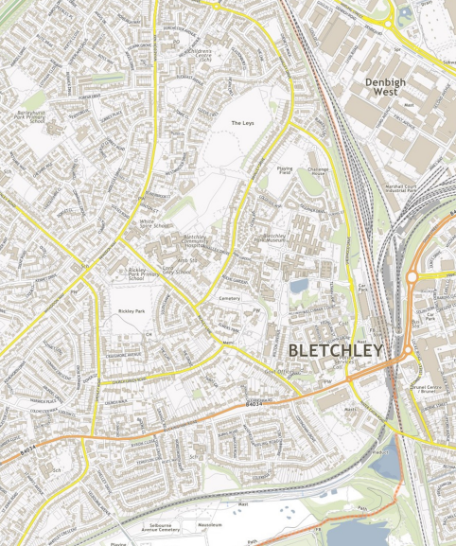
Zone A
Zone C
Zone B
Zone A | Proposed area for new parking restrictions
Zone B | Proposed area for new parking restrictions
Zone C | Proposed area for new parking restrictions

--------------------------------------------------------------------------------------------------------------------------------------
Option 1 – Resident Parking Zone
A resident parking zone is the only option that allows for protected parking for residents only. In order for our City Council parking enforcement officers to be able to tell if a vehicle belongs to a resident or not, we would need to introduce a resident permit scheme.
This would allow parking to be exclusively allocated to residents only, with any external vehicles subject to a penalty charge notice (a parking ticket). This would prevent any external vehicles parking in the area and reserve the on-street parking within the resident zone to just residents and their visitors only.
The ‘resident permit holder only’ restrictions would apply at certain times of the day, devised to prevent longer stay parking. The longer the restrictions apply, the longer the streets will be reserved for residents and their visitors only. In some cases, these resident only restrictions can also apply at the weekend, although it is quite unlikely that would be needed here.
This option would also implement new short sections of double yellow lines to prevent parking in unsafe locations, such as near to junctions or crossings, or where width or visibility is restricted, to make sure access for refuse vehicles and emergency vehicles is maintained.
In a resident permit scheme, the permit itself wouldn’t have to be a physical one that you have to attach to your windscreen – it would be digital, with residents’ vehicle registration numbers added to a permit database which is checked by parking officers on hand-held devices.
If a resident has a visitor coming, there would be a simple visitor permit process to add their vehicle registration number to the database to ensure that they are authorised to park and are not ticketed.
To cover the administration costs of a permit system, and to maintain an updated database of registration numbers, there is an annual charge of £25 per resident’s vehicle. You’ll need to tell us if you change your vehicle, so that we can add your registration number to our permit database, and remove your old one.
An annual transferable visitor permit also costs £25, or 24 hour visitor permits can be purchased for £1.
Annual visitor permits are the most cost effective, but if you don’t need many, a number of single 24 hour permits through the year could be cheaper.
If you have a private driveway, garage or other off-street parking, you won’t need a permit for the vehicle(s) that park there, but if your car is parked on the street when the permit only restrictions apply, even for a short time, and you don’t have a permit for that vehicle, you could be issued with a ticket.
The City Council has produced a handy guide to West Bletchley Resident Parking Scheme that you can be downloaded from the informal public consultation webpage.
This is likely to be the option favoured by those residents who are extremely inconvenienced by nuisance external parking at the moment, as it will eradicate the problem of external parked vehicles in the area completely.
Remember – this is the only way we can differentiate between residents’ vehicles and external vehicles coming into the area to park.

--------------------------------------------------------------------------------------------------------------------------------------
Option 2 – Daytime Parking Restrictions
An effective way of preventing all day and commuter parking is to introduce parking restrictions during part of the day. These would be in the form of yellow lines, with associated signs indicating the time that the restriction applies. Often these restrictions apply in the middle of the day on weekdays……12.00 – 2.00pm for example, to be most effective at tackling long stay or commuter parking.
However, there is one major disadvantage with daytime parking restrictions when compared to a resident permit zone – residents will also be subject to the same parking restrictions when they apply. Because our parking enforcement officers cannot tell which vehicles belong to residents, the parking restrictions would apply to all vehicles in the area. This would mean that if a resident were at home all day, they would need to move their car and park it elsewhere during the time that the parking restrictions apply. Residents who are unable to move their car, or forget to do so, could be ticketed along with any other vehicles parked during the restricted times.
As with Option 1, this option would also implement new short sections of double yellow lines to prevent parking in unsafe locations, such as near to junctions or crossings, or where width or visibility is restricted, to make sure access for refuse vehicles and emergency vehicles is maintained.
While this solution may tackle the external parking problem for those parking for longer periods, it is likely to be inconvenient to some local residents who park on the street and who will be subject to the same restrictions.
However, this solution may suit some residents who drive out of the area during the day, when the restrictions would apply, such as someone who drives to work every day, and it would have a positive effect on preventing external long-term parking in the area.
--------------------------------------------------------------------------------------------------------------------------------------
Option 3 – Junction and Access Restrictions Only
There is a third, ‘light touch’ option – and this is to simply add short sections of parking restrictions (double yellow lines) at junctions and other key locations across the residential streets near to the station, to ensure safety and visibility. This is also included with Option 1 and Option 2, but this option includes only these new restrictions and no other parking controls.
This would only make sure that parking takes place safely within the area, and that parking close to junctions and in other places where it poses a safety or visibility problem is prohibited. It would allow vehicles parked on the double yellow lines to be ticketed, and should ensure that access is maintained for refuse and emergency vehicles.
However, there would be no other restrictions, and external vehicles could still park in the remaining areas of on-street parking, along with residents.
This is therefore a ‘do-minimum’ solution which only addresses unsafe parking around junctions and where visibility or width is restricted on streets in the area and introduces no other restrictions.
As a result, this is unlikely to improve the current situation very much, although it should make the external vehicle parking happen a bit safer – and the City Council can issue tickets to vehicles parked on the double yellows to act as a deterrent.
This might be an appropriate solution for residents who don’t think there is a major problem, but think that some unsafe parking occurs in the area and are concerned about maintaining access for larger vehicles, such as refuse lorries and fire appliances.
--------------------------------------------------------------------------------------------------------------------------------------
Option 4 – Do Nothing
A final option is to do nothing at all, and to introduce no new restrictions or yellow lines (either single or double) anywhere in the area.
This will be the option favoured by residents who do not think there is a problem that needs to be solved at all.
--------------------------------------------------------------------------------------------------------------------------------------

Summary
It is therefore for residents to decide how big a problem it is currently, and what sort of solution would work best for them.
- Is the problem sufficiently irritating for residents to make it worth £25 a year per vehicle, (or 50p a week, or 10p per weekday) to solve completely, or is it not worth that much?
- Is the problem not big enough to require permits, and for residents to instead endure day-time restrictions that would also apply to them, in order to remove the external parking, or is that too much hassle for residents?
- Is the problem not too bad, and just some protections against parking close to junctions and to ensure larger vehicles can get through will be enough?
- Is there no real problem at all, and nothing needs to be done?
For all the options that involve new restrictions (i.e. Option 1, Option 2 and Option 3), there is also the question of over what area these new restrictions would apply.
There are three distinct areas where new measures could be introduced – a main area to the west of Sherwood Drive extending down to Buckingham Road (Area A – where the parking survey was undertaken), the area south of Buckingham Road enclosed by Cottingham Drive (Area B), and the Poet’s Estate, also south of Buckingham Road but also including an area north of Buckingham Road enclosed by Church Green Road and Shenley Road (Area C).
We recognise that the impacts of nuisance parking may not extend across the whole area, so we are giving residents in Area B and Area C the option of being included or not.
The City Council will do whatever residents choose – including if some areas don’t want to be included, or the choice is to do nothing whatsoever.

Map of the West Bletchley Resident Permit Parking Scheme Proposed Parking Zones
Zone A
Zone C
Zone B
Zone A | Proposed area for new parking restrictions
Zone B | Proposed area for new parking restrictions
Zone C | Proposed area for new parking restrictions

