Best Start in Life: Milton Keynes City Council (MKCC) Local Plan (2026)
March 2026

Introduction
I am pleased to introduce our Best Start in Life Plan, which sets out Milton Keynes City Council’s shared ambition to ensure that every child grows up healthy, confident and ready to learn. This plan represents our collective commitment to delivering a high‑quality, integrated early years system—one that brings together health, education, early help, and community partners to support families from pregnancy through to age five.
Our approach is rooted in local need and built on the strong foundations already in place across Milton Keynes. Recent assessments highlight both our strengths and the areas where improvement is essential to achieving better outcomes for children, particularly in the early years. By prioritising early intervention, strengthening family support, improving access to high‑quality early education and childcare, and embedding inclusive, evidence‑based practice, we are taking the action required to meet our statutory responsibilities and achieve our 2028 target for a Good Level of Development.
Delivering this plan will require continued leadership, collaboration and accountability across all partners. Best Start Family Hubs will be central to this work, offering integrated, accessible services that support all families, while ensuring additional help is available to those who need it most. Our workforce will be supported to deliver high‑quality, relational practice, and families will continue to be active partners in shaping and improving our services.
This plan is both ambitious and achievable. It provides a clear roadmap for how we will meet national expectations, respond to local priorities and most importantly improve the lives and life chances of our youngest children. By working together, we can create the conditions that enable every child in Milton Keynes to thrive, from their earliest days and throughout their childhood.
Mac Heath
Director of Children’s Services
As the first five years of life are so crucial to a child’s development, we welcome the Government’s focus on giving children the Best Start in Life. The City of Milton Keynes has a relatively young and increasingly diverse population. We are proud that nearly three quarters of Milton Keynes children were assessed as achieving a Good Level of Development at the end of the school Reception year in 2024/25. However, for those who experience financial disadvantage, just over half achieve this level of development. We also know that factors such as where children live and the presence of specific vulnerabilities such as having special educational needs, impact on a child’s chances to reach certain milestones. So, there is more we can and should be doing to give more children the best possible start in life.
In preparation for our local Best Start plan, we have carried out an assessment of needs to ensure we have a detailed understand of the experiences of our residents in the early years. This looked at a wide range of factors from physical and emotional wellbeing, to wider ‘building blocks’ of health, including the impact of the home environment and access to early childhood education and care. This has helped to shape our Plan, building on opportunities to identify needs at an early stage, and where we need to target more support, or different support, depending on needs of young people and families.
We look forward to working partners to deliver the changes needed to enable every children to achieve and thrive.

Marimba Carr
Deputy Director of Public Health

Contents

Best Start in Life: Milton Keynes City Council (MKCC) Local Plan (2026) 0
Introduction 0
Contents 2
I. Vision and Targets 3
Key Targets: Good Level of Development (GLD) Targets 3
II. Case for Action 3
Local Context 3
Placeholder DATA 5
Our Strengths 7
Sustaining and Strengthening Effective Services 7
What We Need to Improve 10
III. Core Best Start in Life Service Aims 10
Better Support for Families 10
More accessible early education and childcare 12
Improved quality in early years including reception 12
IV. System Enablers 14
Service Integration & Family Hubs: 14
Workforce capacity and capabilities: 14
Family Involvement: 15
Monitoring, Evaluation & Learning: 16
Accountability and governance 16
Funding 17
Key Strategies 17
Appendices (Available upon request): 17

Vision and Targets

Milton Keynes City Council and our partners are united in our commitment to giving every child the Best Start in Life. By 2028, we will achieve a Good Level of Development (GLD) target of 77.4% (59.7% for children accessing Free School Meals). We will do this by working collaboratively across services and with partner agencies, empowering families and creating nurturing environments where children can thrive. Our vision is for all children to be healthy, confident, and ready to learn, supported by strong relationships, inclusive communities, and timely, accessible early help. Through evidence‑informed practice, partnership working, and a relentless focus on early intervention, we will ensure that every child has the opportunity to reach their full potential.

Key Targets: Good Level of Development (GLD) Targets
77.4% reach GLD by 2028 (2024/25: 73%, +4.4% to meet target)
Free School Meal GLD: 59.7% by 2028 (2024/25: 54%, +5.7% to meet target)
SEND Support GLD: 29% by 2028 (2024/25: 24.2%, 4.8% to meet target)
EHCP GLD: 4.29% by 2028 (2024/25: 3.3%, 0.99% to meet target)
SEND: Special Education Needs & Disabilities
EHCP: Education, Health & Care Plan.

Case for Action

Local Context
Milton Keynes is a largely urban area located in the South East of England. Milton Keynes is a rapidly growing city with an estimated population of approximately 305,884 residents as of 2024, reflecting a decade of sustained growth, with 6% of residents aged under five
The number of children in Milton Keynes aged under 5 is forecast to rise to over 20,000 by 2033.
17,863 under 5s living in Milton Keynes - around 6.0% of the total population.
The highest number are located in Danesborough & Walton (1,642), Bletchley East (1,530), Broughton (1,503) and Stony Stratford (1,425).
The Income Deprivation Affecting Children Index (IDACI) highlights areas of relative child poverty across LSOAs in England. In Milton Keynes, two wards are located in the 1st IDACI Decile (the most deprived) – Bletchley East and Woughton & Fishermead.
Overall, 2,553 (1 in 7) under-fives are estimated to be living in areas with the highest levels of child income deprivation
(Source: 2024 Mid-Year Estimates)

IDACI Deciles by Ward
Number of under 5s by ward

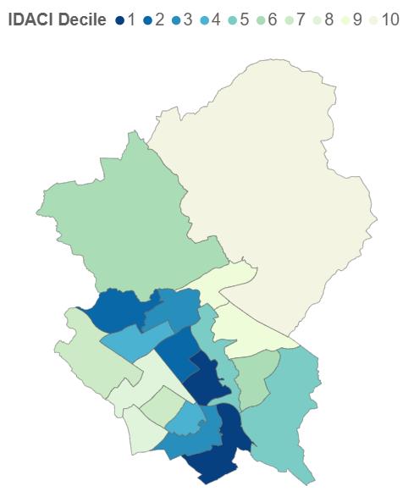
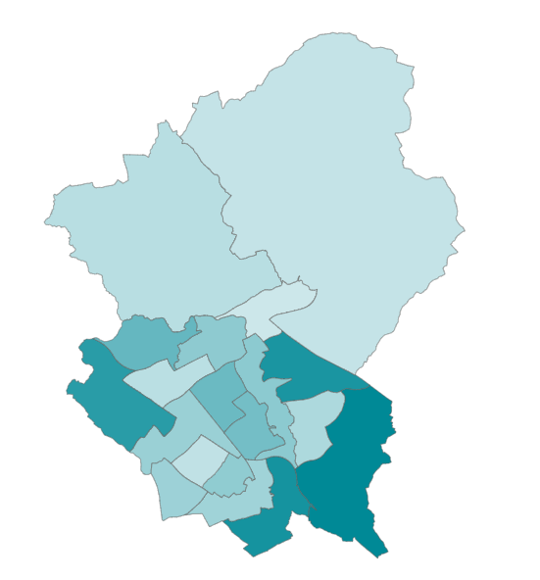
WoWout

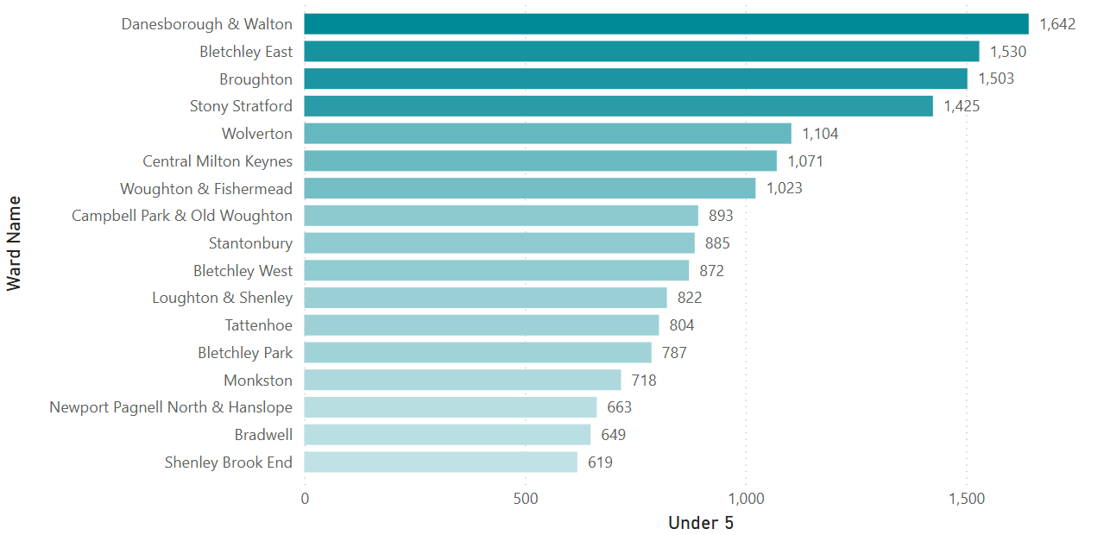
Figure 1 – Ward graphs

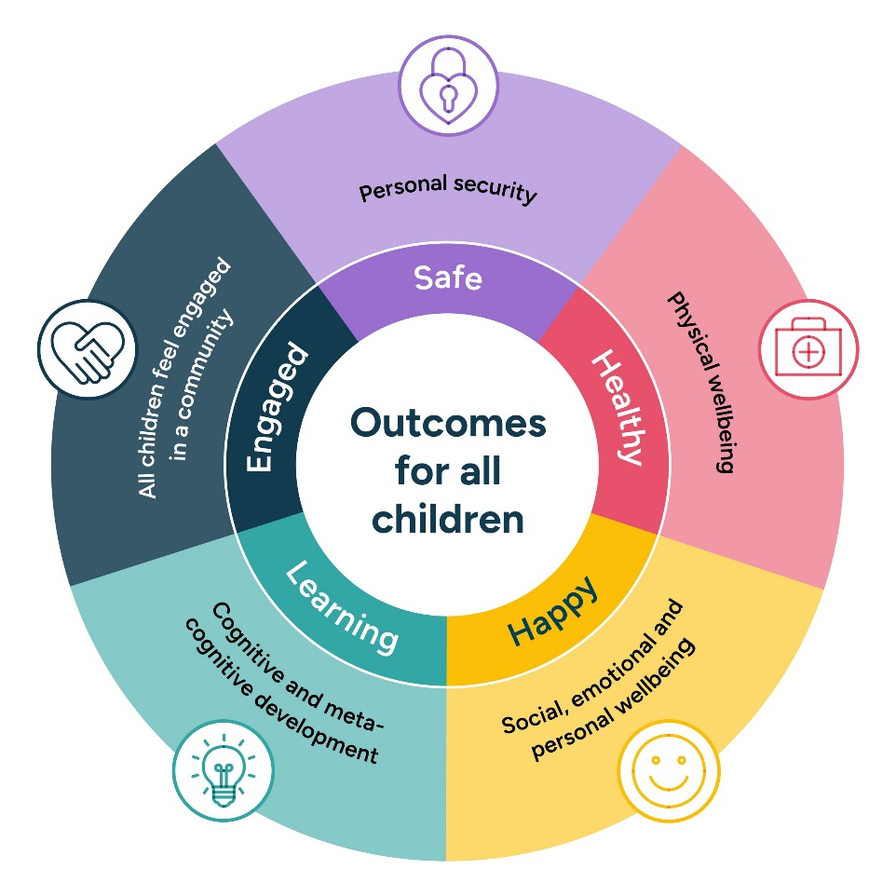
The Common Outcomes Framework, shown below, offers a holistic approach of measuring many key milestones in child development, the wider factors influencing these, and what ‘good’ outcomes are for children at the population level.

Figure 2 - Common Outcomes Framework (Summary) from https://www.commonoutcomes.org.uk/the-framework

Our Strengths
- Our 2024/25 Good Level of Development (73%) is 4.7% higher than the 2024/25 national average (68.3%).
- Our 2024/25 Good Level of Development for children in receipt of Free School Meals (54%) is 2.7% higher than the 2024/25 national average (51.3%)
- Our 2024/25 Good Level of Development for children with English as an additional language (EAL) (74.8%) is 10.1% higher than the 2024/25 national average (64.7%)
- Our take-up of early learning for 2 year olds entitlement (79%) is 14% higher than national average (Spring 2025 census).
- Robust Family Centre engagement (184,000+ total footfall in 2024/25, with 21,600 under 5s attending 3216 Early Years Foundation Stage [EYFS]/development sessions in 2024/25)
- Family Centres have high positive impact. Family Centres help under-5s build core EYFS-aligned developmental skills, improve speech and language, and stay safe through integrated family support and cost-of-living assistance.

Sustaining and Strengthening Effective Services
We will continue to offer, or enhance, the following which have been proven to have positive impact:
The MK Education Toolkit - Outlines the ways in which different parts of the education sector come together to share practice and work cohesively across the city. This includes how schools and settings can access traded support and guidance from MKCC and wider sector partners.
The MK School Improvement Framework - Sets out how Milton Keynes City Council (MKCC) dispenses statutory duties for maintained schools. This includes consideration of Strong Foundations in Early Years and work with school-based nurseries (including the two locally authority-maintained nursery schools). It defines how MKCC works in partnership with schools across all parts of the education system – maintained and academy.
The Local Area SEND Strategy - The strategy sets out a joint vision for children and young people with SEND. With an ambition to ensure that they thrive, belong and are at the heart of our plans.
Two-Year Old Participation Project - Focussed on the take up of places of eligible children whose parents get extra support (early learning for 2-year-old entitlement).
Early Years Childcare Sufficiency - Mapping current and projected future supply and demand for early education and childcare provision across the city with information published annually.
National Wraparound and Childcare Programme & National Free Breakfast Club - Targeting gaps in provision, continue to work with schools to roll out free breakfast clubs across the city.
Rattlebox Initiative - Targeting providers in receipt of Deprivation Funding and/or in areas near schools with historically low GLD outcomes. Rattlebox aims to improve executive function and support strong foundational knowledge and skills – through focussing on early communication, language, literacy and maths using stories, songs and rhymes.
Support for Early Years providers who have Ofsted outcomes of less than ‘Good/ the Expected Standard.’ - Action planning meetings, follow up support, and visits are provided so that settings can make a swift return to ‘Expected Standards’. This is so that MK children receive high quality provision and experiences.
Support for EYS providers who are due their Ofsted inspection or expecting their first one - Support meetings and visits are offered to newly set up providers so that their practice complies with the statutory Early Years Foundation Stage (EYFS) requirements.
Early Years Foundation Stage (EYFS) training and continued professional development (CPD) - Providers are signposted to CPD and training through the regular publication of the ‘Early Years Essential’ (EYE) and ‘Heads Up’ newsletters. Opportunities include: Access to training, webinars, blogs and meetings through DfE’s funded ‘Early Years Stronger Practice Hubs’. Milton Keynes belongs to the Thames Valley Hub.
Healthy Baby Initiatives delivered via Best Start Family Hubs - Part of the Healthy Child Programme, in partnership with the 0-19 team, including immunisation and screening, breastfeeding checks and healthy weight (baby clinics)
UNICEF Baby Level 2 - Working towards UNICEF Baby Level 3. Key elements include:
- Supporting pregnant women to understand breastfeeding and early bonding
- Helping mothers and babies establish feeding and close relationships from birth
- Ensuring parents receive consistent, evidence‑based support in maternity, neonatal, and community services
Interviews with parents to confirm the standards are being met in real‑world practice.
Fit for Pregnancy - Delivered by midwives based on site at Family Centres throughout the week and weekends.
Aligning workstreams with Public Health and joint working with the CYP Alliance. - Specific Health improvement and Health protection, funded and monitored by Public Health. For example: Immunisations, Obesity, Oral Health, Weight Management. Signposting to key services including Substance Misuse and Mental Health.
Cost of Living Offer - This covers a wide range of services, including food bank services, community larders, hygiene bank services, baby items for collection, baby milk, budgeting sessions, Christmas hampers, emergency utility vouchers, clothing, condoms, daily cafes, family holidays, help hub, referrals to other services, washing machine use.
Mental Health Support - CAHMS appointments, CHUMS, Relate, Five to Thrive, referrals to Mental Health School Team, Ride High, wellbeing sessions, therapeutic sessions.
1:1 Sessions with Children and Adults - Practitioners provide early help support, online safety sessions, health and safety campaign.
0-19 Health Child Programme (HCP) Health Visiting and School Nursing Service - Provides a range of touchpoints and support, including:
- antenatal / perinatal mental health support,
- virtual and face to face breast feeding and infant feeding groups
- baby clinics
- development checks
- growth development
- toilet training
- bed wetting
- fussy eating
- speech & language (see below)
- dietary advice
- sleep
- behaviour
- parenting advice
- support for young parents
- sexual health advice for young people.

The 0-19 HCP staff consist of Health Visitors, School Nurses, Registered Nurses, Nursery Nurses, Healthcare Assistants and Administrators. Health Visitors and School Nurses are all qualified nurses or midwives with specialist training in Public Health.
Choose You - Healthy eating programme for Under 5s.
Speech & Language - Joint offer between Family Centres & 0-19 HCP. Speech & Language Champions in the Family Centres.
EYFS sessions in Family Centres - These are run daily, throughout the day, across all the Family Centres, focused on child development.
Nurture Programme - Funded by Public Health and run via Family Centres.
Teenage Pregnancy Prevention and Support Work - Two-yearly multi-agency Teenage Pregnancy Prevention and Support Self-Assessment conducted by Public Health.
Parenting support packages - Geared towards parents of 2-year olds, these packages will roll out from September 2026.
Family Centre outreach in areas of need - We will provide additional outreach in areas of need, such as Wolverton.

What We Need to Improve
Following a comprehensive needs assessment conducted by Public Health, and workshops with parents/carers of children with SEND, the following have been identified as areas of focus:
- Early identification of needs across maternal health, SEND, developmental milestones and mental health, with a focus on enabling access to perinatal mental health support.
- Children in receipt of free school meals, especially those living in identified areas of deprivation.
- Ethnicity and language groups in which the GLD outcome of boys or girls falls disproportionately below national averages.
- Fine motor and relationship skills where local figures are lower than national averages.
- Early identification of need from 2 – 2 ½ year reviews and support for children in the early years.
- Maintain high take up of early learning places for disadvantaged 2-year-olds.
- Data quality and local analysis to understand variation across wards and population groups.
- Early practical SEND advice and guidance, via the Family Centres and the Local Offer, to assist families before crisis hits.
- Provide more free support for new parents on caring for newborns and understanding milestones.

Core Best Start in Life Service Aims

Better Support for Families
We will enhance family support through strengthened Home Learning Environment and Parenting interventions, delivered via Best Start Family Hubs/Family Centres. Core services will include:
- Home Learning Environment programmes
- Parenting programmes
- Perinatal mental health support
- Parent–infant relationship support
- Infant-feeding support
- Support for children with additional needs

Priority actions:
- Strengthen early identification and support pathways
Early identification of needs across maternal health, SEND, developmental milestones, and mental health, with a particular focus on improving access to perinatal mental health support through Health Visitors and Best Start Family Hubs/Family Centres; strengthen SENCO development; and ensure clear, consistent referral routes to specialist and community health, education and wellbeing services.

- Enhance Parenting and Home Learning Environment support
Commission and deliver evidence based parenting programmes, Speech and Language interventions, and Home Learning Environment initiatives including a Screen Time programme.

- Improve outreach and tailored support for children with SEND and/or additional needs
Prioritise proactive outreach among families who do not attend Family Centres, recruit specialist SEND practitioners within Family Hubs, and ensure families can access timely, high-quality SEND advice and support. We will consider how the Setting and School Inclusion Team can support work in Best Start Family Hubs.

- Expand multilingual and digital family support
Develop a Community Help digital offer that includes improved multilingual support to ensure all families can access guidance, services, and early education opportunities.

- Strengthen partnership pathways from pregnancy onwards
Establish formal referral pathways with 0–19 teams and midwives to ensure every contact leads to early support; promote takeup of Healthy Start; and offer targeted support around smoking, alcohol, mental health, and wider health concerns in pregnancy.

- Increase engagement with key health and wellbeing services
Improve uptake of immunisations, key Health Visitor reviews, supervised tooth brushing, nutrition support, and healthy lifestyle initiatives, particularly for priority families and underserved communities.

Measures of progress:
- Improved child development outcomes in targeted areas
- Stronger School Readiness indicators.
- Increased engagement and access for priority families
- Higher participation in parenting programmes, SEND support, and digital/multilingual services.
- Positive feedback from children, parents (especially priority families), and settings.
- Stronger health outcomes for young children and families
- Increased uptake of immunisations, Healthy Start, and key Health Visitor contacts.
- Improved maternal wellbeing and reduction of health risks in pregnancy (e.g., smoking/alcohol concerns).

More accessible early education and childcare
We will increase the availability of early education and childcare provision in areas of highest need, ensuring that all children—particularly those who are disadvantaged or underrepresented—can access high-quality, inclusive early years settings.

Priority actions:
- Maintaining high levels of take up for those accessing the early learning for 2-year-olds entitlement (previously known as FRAS). Our most recent DfE termly scorecard take up was 89%.
- Work with the sector to identify potential gaps and opportunities across the borough for additional early years provision where there is potential unmet demand.
- Local delivery of the national free breakfast club programme in line with national phasing.

Measures of progress:
- Take-up of early learning for 2 year olds entitlement.
- ‘Childcare Sufficiency Assessment’ publication.
- Number of schools on free breakfast club programme delivered in line with national phasing.
- All children, including those with SEND and/or EAL, can access a high-quality early education place in Milton Keynes.

Improved quality in early years including reception

We will collaborate closely with early years education, childcare providers and wider sector partners, locally and regionally, to raise the quality of provision across the city. By offering targeted support, guidance, and partnership working in areas of highest need, we aim to ensure that children benefit from consistent, inclusive, and high‑quality early years experiences.

Priority actions:
- Attainment of disadvantaged (Free School Meal) children: Support and challenge setting and school leaders towards securing increasingly high quality, inclusive provision for children. Focus on wider vulnerabilities identified by data analysis at specific setting level as well as at Local Authority level.

- Strong Foundations/ attainment of disadvantaged (Free School Meal) children: Continued use and roll out of the Rattlebox initiative, with emphasis on provisions in areas of disadvantage and /or surrounding schools with historically low GLD outcomes.

- Attainment of children with SEND: Challenge providers in relation to places for children with SEND, if needed. Empower and enable schools and settings to use the Identification of Need, Ordinarily Available Provision documentation and approaches. Ensure that robust SEND Support Plans and transition plans are in place.

- Attainment of children from Black backgrounds: Provide targeted support and training for early years providers (and schools) to strengthen understanding of children’s learning needs and create effective environments that support strong outcomes.

- Transition to school: Help schools, settings and families to engage with the Starting Reception strategy.

- Consistent and cohesive local approach: Cross team working between parts of the Education Outcomes Service (School Improvement, Early Years Quality, Governor Services, Virtual School, Ethnic Minority Achievement Network, MK Music Service, and Setting and School Inclusion).

- Regional improvement teams: Make use of the support on offer to help bolster provision, practice and outcomes in underperforming schools.

- Support swift access to high quality places where providers are found to be less than ‘Good/Expected Standard’ by Ofsted.

Measures of progress:
- Proportion of funded early years providers that are graded at least ‘Good/Expected Standard’ by Ofsted.
- Proportion of schools in which Early Years provision is graded at least ‘Good/Expected Standard’ by Ofsted.
- Targeted schools and settings show qualitative improvements in relation to executive function, communication and language, early literacy, and early maths (evidenced through evaluations and professional feedback).
- GLD outcomes - overall, for children eligible for FSM, for children with SEND and from Black backgrounds.

IV. System Enablers

Service Integration & Family Hubs:
Milton Keynes City Council will enhance and transform existing Family Centres into fully integrated Best Start Family Hubs, bringing together SEND, Public Health, Early Help and wider partners to provide joined up support. These Best Start Family Hubs will operate as accessible ‘one stop shops’, offering families a wide range of universal services within their local community.

Priority actions:
- Transform four Family Centres into Best Start Family Hubs, one for each Children’s Social Care quadrants (North, South, East, West).
- Prioritise outreach and engagement for children who speak English as an additional language; children with SEND/emerging SEND; children in most deprived areas such as Woughton & Fishermead and Bletchley East (focusing on Communication & Language and Literacy); boys from Black African/Mixed backgrounds and Bangladeshi girls; and families who do not attend Family Centres.
- Co-locate specialists, including SEND practitioners, within the Best Start Family Hubs
- Improve attendance data collection for Best Start Family Hubs/Family Centres.

Measures of progress:
- Percentage of families in target group accessing Best Start Family Hubs/Family Centres.
- Family feedback on join-up between services
- Monitoring data about referrals and waiting times for key services.

Workforce capacity and capabilities:

We will focus on:
- Ensuring sufficient capacity in universal and targeted Best Start services.
- Building a workforce with the right skills to support families in the early years.
- Empowering and having SEND practitioners from across services based in Best Start Family Hubs.
- Promoting consistency, continuity and high-quality practice across services.
- Supporting workforce wellbeing and resilience.

Priority actions:
- Work with partners to strengthen recruitment and retention in key services.
- Deliver a coordinated programme of professional development that promotes shared understanding of Best Start priorities and ways of working; strengthens skills in [e.g. trauma-informed practice] and supports leadership development.
- Supporting integrated working through shared learning opportunities, clarifying roles and responsibilities across services, and embedding a strengths-based, family centred approach across the workforce.
- Regularly review workforce capacity, skills and wellbeing through Best Start governance arrangements. Data on recruitment, retention, training uptake and staff feedback will inform continuous improvement and future workforce planning.

Measures of progress:
- Vacancy rates, turnover, caseloads, sickness absence, number of new starters.
- Time to recruit for priority roles.
- Proportion of workforce completing core multi-agency training.
- Leadership training uptake.
- Staff reported confidence in joint working.
- Staff satisfaction and engagement.

Family Involvement:
We will strengthen and diversify our approach to family involvement, expanding opportunities for parents and carers to share their views through panels, feedback mechanisms and community led engagement. We will develop a network of parent champions and work closely with voluntary and community partners to ensure that insights shared with trusted organisations meaningfully inform our local authority decision making.

Priority actions:
- Expand our current parent groups with a focus on underserved communities, and ensure that parent views are present in decision-making forums (e.g. PACA)
- Establish regular feedback sessions with voluntary and community sector organisations to share knowledge about family needs and priorities

Measures of progress:
- Number of parent members recruited to groups.
- Retention rates over 12 months.
- Diversity of parent champions compared to local demographics.
- Evidence of service changes in response to parental feedback.
- Parental engagement with services, increased parental awareness of available services and support.

Monitoring, Evaluation & Learning:
We will use robust monitoring, evaluation and learning to drive meaningful improvements for children and families, ensuring our approach continually adapts and strengthens in response to emerging evidence and the lived experience of our communities.

Priority actions:
- Establish a shared outcomes framework across services (Best Start Delivery Plan 2026-28).
- Standardise information sharing across health visiting, family hubs, early education settings and schools.
- Embed ways to collect parent and practitioner feedback regularly.
- Develop a unified data dashboard, and associated routines

Measures of progress:
- Outcomes framework signed off by partners
- Priority actions with defined success measures
- Routine collection of parent and practitioner feedback.

Accountability and governance
We will strengthen our governance and accountability arrangements to ensure the effective, high-quality delivery of our Best Start in Life Local Plan. We will reinforce clear multi-agency ownership, coordination and shared responsibility across the system, ensuring partners work collectively to drive continuous improvement for children and families.

Priority actions:
- Establish a Best Start delivery group with overall responsibility for delivery of the Plan. This group will report to the Child First, Family Led Programme Board and with dotted-line reporting to the Education Performance Board.
- Establish parent/carer voice within governance.

Measures of progress:
- Defined roles and responsibilities for all partners.
- Meetings held as planned and summaries shared quickly.
- Evidence of multi-agency involvement in governance (attendance, contributions), parent/carer voice formally embedded in governance.

Funding
We will ensure that funding and resources are strategically aligned with our GLD priorities, exploring opportunities for pooled and partnership-based investment, and securing the long-term sustainability of the interventions that have the greatest impact on children and families.

Priority actions:
- Develop a clear, evidence‑led funding narrative that aligns resources with Milton Keynes’ Best Start priorities and secures the long‑term sustainability of service delivery.
- Review all commissioned services for alignment with Best Start priorities and establish a forward plan for future commissioning and recommissioning to ensure consistency, impact and value for money.
- Explore opportunities for pooled funding and joint commissioning across partners, supported through strengthened MKCC governance and partnership boards.

Measures of progress:
- Monitoring of core service unit costs against both service engagement and target child outcomes
- Availability of pooled funding streams
- Number and type of jointly commissioned services

Key Strategies

Early Help Strategy 2024-2027
SEND Strategy 2025-2028
Healthy Child Programme
Local Offer

Appendices (Available upon request):
MK GLD Needs Assessment 2026

Population estimates for England and Wales - Office for National Statistics
Demographics Dashboard | Milton Keynes JSNA
Population Forecasts 2023–2043 | Milton Keynes JSNA
About us — Common Outcomes for Children and Young People Collaborative — Common Outcomes for Children and Young People Collaborative

