ANNEX A
Anti-social Behaviour, Crime and Policing Act 2014,
Part 4, Section 59
Public Space Protection Order
This Order is made by Milton Keynes City Council (the “Council”) and
shall be known as the Milton Keynes Public Space Protection Order (Dog Fouling)
No.1 2026
PRELIMINARY
- The Council, in making this Order, is satisfied on reasonable grounds that:
The activity identified below has been carried out in public places within the Council’s area and have had a detrimental effect on the life of those in the locality,
and that:
the effect, or likely effect of the activity:
is, or is likely to be, of a persistent or continuing nature,
is, or is likely to be, such as to make the activity unreasonable, and
justifies the restrictions imposed by this Order.
- The Council is satisfied that the prohibition imposed by this Order is reasonable to impose in order to prevent the detrimental effect of the activity from continuing, occurring or recurring, or to reduce that detrimental effect of to reduce the risk of its continuance, occurrence or recurrence.
- The Council has had particular regard to the rights and freedoms set out in Article 10 (right of freedom of expression) and Article 11 (right of freedom of assembly) of the European Convention on Human Rights and has concluded that the restrictions on such rights and freedoms imposed by this Order are lawful, necessary and proportionate.

THE PROHIBITION
- The Activity prohibited by this Order is as follows:
- Failing to remove dog faeces, forthwith, from land to which the public or any section of the public has access (on payment or otherwise as a right or by virtue of express or implied consent).

- This Order applies to any person in charge of a dog. For the purposes of this order –
- A person who habitually has a dog in his possession shall be taken to be in charge of the dog at any time unless at that time some other person is in charge of the dogs.
- Placing the faeces in a receptacle on the land which is provided for the purpose, or for the disposal of waste, shall be sufficient removal from the land.
- Being unaware of the defecation (whether by reason of not being in the vicinity or otherwise), or not having a device for or other suitable means of removing the faeces shall not be a reasonable excuse for failing to remove the faeces;
THE RESTRICTED AREA
- The activity prohibited by this Order applies to the Restricted Area illustrated on the attached plan in Schedule 1.
THE EXCEPTION
- The Prohibition does not apply to a person who –
- Is registered as a blind person in a register complied under Section 29 of the National Assistance Act 1948.

PERIOD FOR WHICH THIS ORDER HAS EFFECT
- This Order will come into force at 00.00hrs on 5 March 2026 and will expire at 23.59hr on 4 March 2029.
- At any point before the expiry of this three year period the Council can extend the Order by up to three years if they are satisfied on reasonable grounds that this is necessary to prevent the activity identified in Order from occurring or recurring or to prevent an increase in the frequency or seriousness of those activities after that time.
WHAT HAPPENS IN YOU FAIL TO COMPLY WITH THIS ORDER?
- Section 67 of the Anti-Social Behaviour, Crime and Policing Act 2014 states that it is a criminal offence for a person without reasonable excuse –
- To do anything that the person is prohibited from doing by a Public Space Protection Order; or

- To fail to comply with a requirement to which the person is subject under a Public Space Protection Order.
- A person guilty of an offence under Section 67 of the Anti-Social Behaviour, Crime and Policing Act 2014 is liable on conviction in the Magistrates’ Court to a fine not exceeding level 3 on the standard scale.
FIXED PENALTY NOTICES
- A constable, police community support officer or an authorised officer of the Council may issue a Fixed Penalty Notice to anyone he/she believes has committed an offence under Section 67 of the Anti-Social Behaviour, Crime and Policing Act 2014. You will have 21 days to pay the fixed penalty of £100. If you pay the fixed penalty within 14 days, the amount payable is reduced to £75.
- For the purposes of this Order –
- An “authorised officer of the Council” means an employee, partnership agency or contractor of the Council who is authorised in writing by Milton Keynes Council for the purposes of giving directions under the Order.

APPEALS
- Any challenge to this Order must be made in the High Court by an interested person within six weeks of it being made. An interested person is someone who lives in, regularly works in, or visits the restricted area. This means that only those who are directly affected by the restrictions imposed by this Oder have the power to challenge it. The right to challenge also exists where an Order is varied by the Council.
- Interested persons can challenge the validity of this Order on two grounds –
- That the Council did not have the power to make the Order, or to include particular prohibitions or requirements; or

- That one of the requirements of the legislation has not been complied with.

- Where an application is made, the High Court can decide to suspend the operation of the Order pending the Court’s decision, in part or totally. The High Court has the ability to uphold, quash or vary the Order.
INTERPRETATION
- For the purpose of this Order:
- “Council” means Milton Keynes City Council.
- “A person in charge of a dog” means a person who habitually has a dog in his possession shall be taken to be in charge of the dog at any time unless at that time some other person is in charge of the dogs.
- “Restrict Area” means any public place within Milton Keynes as illustrated on the attached plan in Schedule 1.
Dated.....................................
The Common Seal of Milton Keynes City Council
was affixed in the presence of
……………………………..
Authorised Signatory

SCHEDULE 1 – Plan of the Borough of Milton Keynes where the specified activity is prohibited under this Order
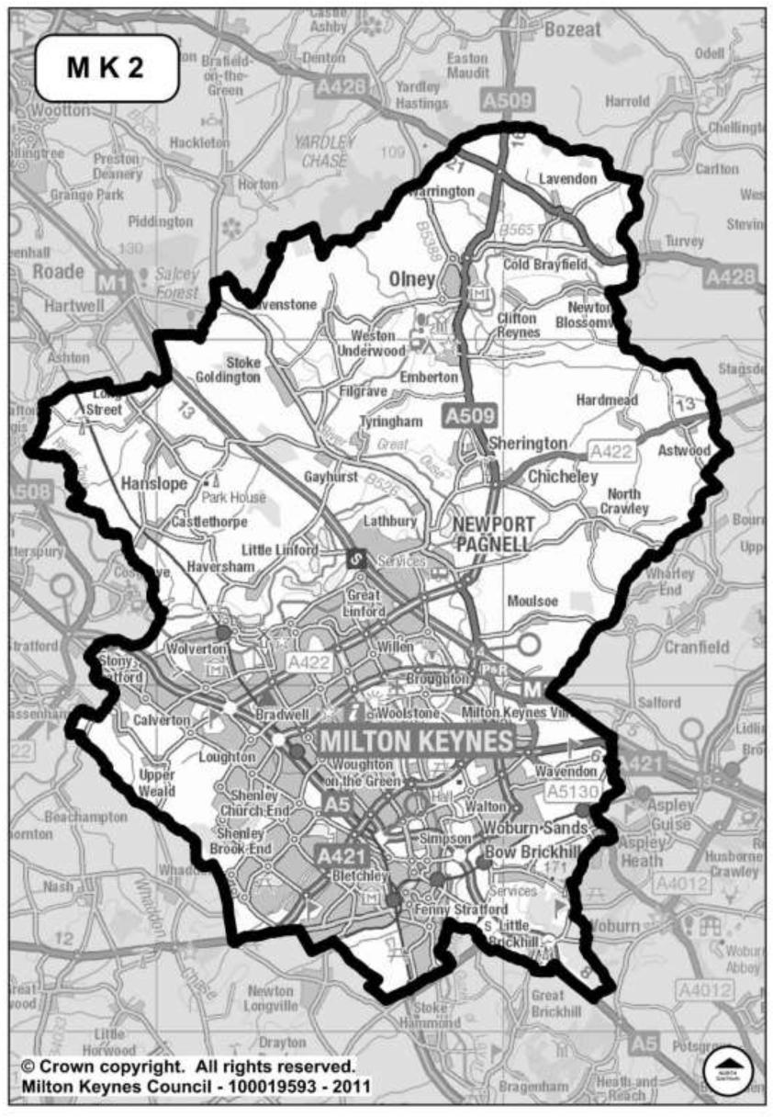
This Order applies to any public place within Milton Keynes as shown outlined in black in the plan

