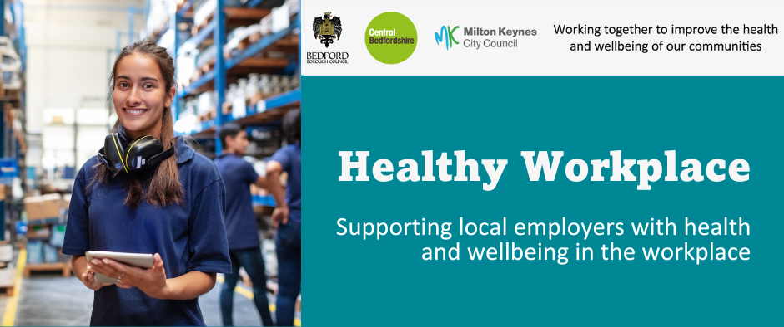

April 2026

The Workplace Health Team work in partnership with others to offer FREE health and wellbeing services and training, to all workplaces in Milton Keynes, Bedford Borough and Central Bedfordshire.

Our regular bulletin provides updates on different health and wellbeing topics, a service offer spotlight and information about forthcoming campaigns to support health and wellbeing in your workplace.

The Workplace Health webpages provide a range of free resources and information.

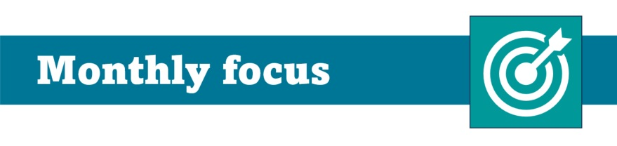

FREE Workplace Health and Wellbeing Event

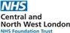
Are you committed to inclusive employment and supporting health and wellbeing at work?

Join employers from across Bedfordshire, Luton and Milton Keynes (BLMK) for a free Health and Wellbeing event, hosted by Central and North West London NHS Foundation Trust in partnership with Public Health (a shared service across Milton Keynes, Bedford Borough and Central Bedfordshire).

This event is designed for employers who want to build supportive, inclusive workplaces while strengthening their approach to workplace health and wellbeing, Equality, Diversity and Inclusion (EDI) and social value.

Increase your awareness of drug and alcohol support across BLMK and the role of workplaces in recovery, gain CPD through an interactive session delivered by Mind BLMK on stress and burnout, connect with local wellbeing services to strengthen your health and wellbeing offer, and join the conversation on inclusive employment at our employer Q&A.

To book your place register https://www.eventbrite.co.uk/e/workplace-health-inclusion-an-event-for-employers-in-beds-luton-mk-tickets-1985578826721?aff=oddtdtcreator



Roll and stroll is a new fun, free and friendly active challenge campaign for workplaces across Milton Keynes running from 1st May - 31st May.

It supports increased physical activity alongside sustainable travel choices offering great benefits:
🫀 Better physical and mental health
🌍 Lower carbon emissions
💷 Reduced travel costs
🏆 Fun challenges with rewards and incentives

Cycle, walk, run or wheel your way to more active days this May. Compete with other departments or workplaces and make daily movement a habit.

Roll and Stroll will be giving away virtual trophies to the top 3 workplace winners in each size category by topping the leaderboards.

Register your workplace with a named champion, this will help your workplace climb the leaderboard while building healthy habits.

Workplace eligibility: Your organisation must have a base in Milton Keynes (you don’t need to live in MK) but when registering you will need to assign your name against your organisation. All points from activity and encouragement contribute to your workplace’s score. For more information visit: Current Challenge : Love to Ride

To support staff engagement with the campaign and embed walking, wheeling and cycling into everyday working life, we have created an implementation guide with simple, practical tips to help you bring your campaign to life and create lasting change in your organisation. Please share widely to boost impact. It is available to download and print via our webpage under the 'plan your campaign tab'.

Be Active: Street Tag

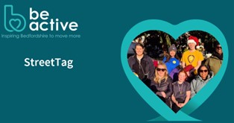
Street Tag is for workplaces including schools in Bedford Borough who would like to ensure movement, sport and physical activity is an integral part of everyday life for all. Using a free smartphone app that rewards moving; running, walking or cycling and collect virtual tags through the app, giving Street Tag points.

For more information visit: https://www.beactivebeds.co.uk/street-tag

Training for workplaces

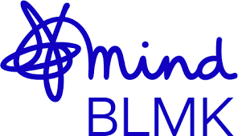
The Workplace Health Team work in partnership with local and national organisations to offer FREE workplace health and wellbeing training sessions and webinars.

Training is open to employees working in Bedford Borough, Central Bedfordshire or Milton Keynes.

Up and coming training and webinars delivered by Mind BLMK:
- Suicide prevention training in the workplace, to book your place visit: Workplace Health Training Calendar
New one-hour, bite-size webinars that fit into your working day and support health and wellbeing at work available for all employees:
- Burnout in the workplace on 10th June
- Stress management and work life balance on 17th June
- Supporting wellbeing in your team on 7th July
Training dedicated for Managers:
- Supporting return to work on 22nd September
To book a place email training@mind-blmk.org.uk

Visit our workplace health webpage regularly for updates. Our training calendar will be expanding soon.



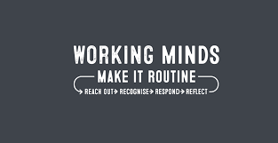
April 2026 is Stress Awareness Month

Stress Awareness Month provides employers the opportunity to action one of the challenges workplaces face around absenteeism.

Work related stress can impact all areas of an organisation. Absenteeism from work-related stress is one of the leading causes of ill health at work, 50% of all work-related ill health is attributed by stress.

Spotting the early signs is crucial to prevent more serious health issues although recognising stress can be difficult because people experience and show it in very different ways.

As part of the Health Safety Executive (HSE) Working Minds campaign, helps prevent work-related stress and promotes good mental health at work. Visit for resources and toolkits.

The Stress Management Society offer free resources, an individual stress test and more.

