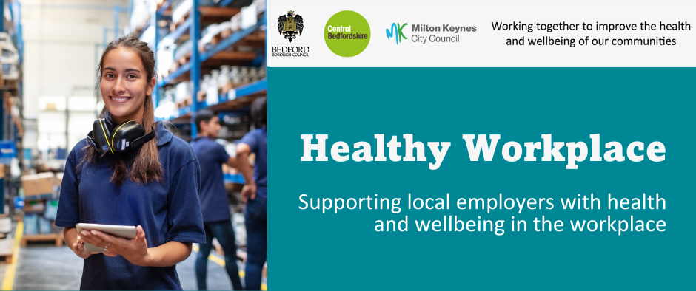

June 2026

The Workplace Health Team work in partnership with others to offer FREE health and wellbeing services and training, to all workplaces in Milton Keynes, Bedford Borough and Central Bedfordshire.

Our regular bulletin provides updates on different health and wellbeing topics, a service offer spotlight and information about forthcoming campaigns to support health and wellbeing in your workplace.

The Workplace Health webpages provide a range of free resources and information.

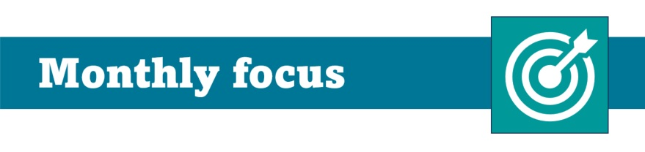

Employment Support for recruiting young people:
Youth Guarantee

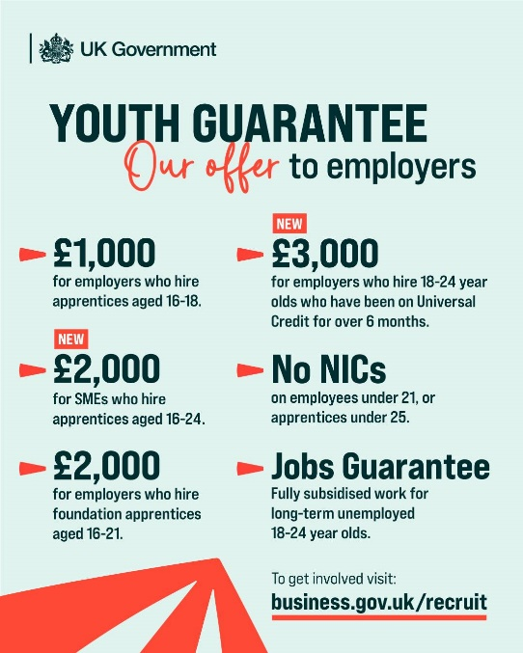
What is the Youth Guarantee?

The Youth Guarantee is a government commitment to ensure all 16–24-year-olds receive support to enter work or education.

Over the next three years, an additional £2.5 billion will be invested in the Youth Guarantee and Growth and Skills Levy, supporting nearly one million young people and creating up to 500,000 jobs, training, and learning opportunities.

What's in it for your business?

Employers are key to the success of the Youth Guarantee and building the future workforce, with the government expanding the support available to businesses. Whether you're looking to fill entry-level roles, grow your apprenticeship programme, or invest in the next generation of your workforce, the Youth Guarantee is designed to make that easier.

In addition to the financial incentives summarised above, you can access:
- Bespoke training support to help you design sector-specific work academy programmes and work experience opportunities that suit your business
- Access to local Youth Hubs to match you with job-ready candidates in your area
- Administrative support onboarding Universal Credit customers to help you take on new starters smoothly
For more information go to Recruit the right people with Jobcentre Plus

Employment Support for recruiting young people: Apprenticeships

Looking to grow your workforce and develop new skills?

Hiring an apprentice could be a cost-effective and impactful solution. Apprenticeships enable employers to recruit new talent or upskill existing staff through structured, on-the-job training, with government funding and support available to help manage costs.

Employers can choose from a wide range of training programmes, access guidance on recruiting and supporting apprentices, and tailor learning to meet business needs.

Whether you’re filling skills gaps or investing in future talent, apprenticeships offer a flexible route to strengthen your workforce and improve retention.

👉 Find out more and get started: https://www.gov.uk/employing-an-apprentice
👉 To find out training providers who deliver apprenticeships: https://findapprenticeshiptraining.apprenticeships.education.gov.uk/courses?Keyword=&location=&Distance=10

📢 Upcoming event for Milton Keynes Businesses

Are you offering apprenticeships, volunteering, work experience or entry-level opportunities for young people in Milton Keynes?

We’re inviting local employers to join our Children and Young People Prevention and Wellbeing Alliance event, bringing together businesses, education and training providers and support services to strengthen pathways for young people into education, employment or training.

📅 15 October 2026
🕑2:00pm – 4:00pm
📍Rowans Family Centre

Please join us to showcase your organisation, build connections, and help shape local pathways into work

👉 Register your interest by emailing: liz.wilson@milton-keynes.gov.uk

Together, we can support more young people into positive futures and strengthen the local workforce.

FREE Mental Health Training for workplaces

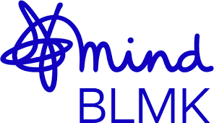
The Workplace Health Team work in partnership with local and national organisations to offer FREE workplace health and wellbeing training sessions and webinars.

Open to all employees with tailored sessions for managers, HR teams, occupational health professionals and health and wellbeing leads.

Key themes for 2026/2027:
🧠 Mental Health
👥 Social Wellbeing and Workplace Culture
🌍 Inclusive Employment

Upcoming sessions include:
• Supporting wellbeing in your team on 7th July (for managers)
• Supporting employees return to work on 22nd September (open to all)
• Mental health awareness on 8th October (open to all)


To sign up to our one hour, bite size webinars delivered by Mind BLMK and view all available training, please use the QR code or visit our training page. Workplace Health Training | Milton Keynes City Council

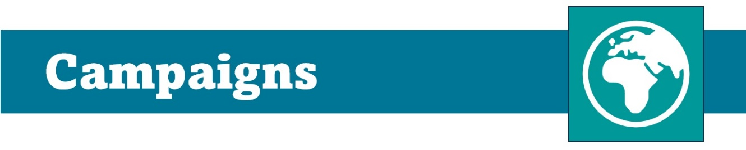

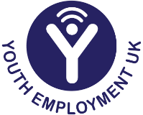
Youth Employment Week

Youth Employment Week is 6th to 10th July 2026 and is an opportunity to recognise the employers who are opening doors, creating inclusive pathways, and setting the standard for supportive and empowering workplaces.

Ongoing commitment to Youth Employment Week and to expand opportunities for everyone is helping to shape a workforce that reflects the richness and strength of our diverse region.

Youth Employment UK have developed lots of virtual activities and numerous ways for employers to get involved to embed Youth Employment Week within a workplace.

Take the Talent Tap quiz. Takes less than 5-minutes and will provide a tailored guidebook based on your answers, complete with timed activities you can do, no matter whether you have 15 minutes or a few hours to spare.

Visit their webpage to download:
https://www.youthemployment.org.uk/youth-employment-week/

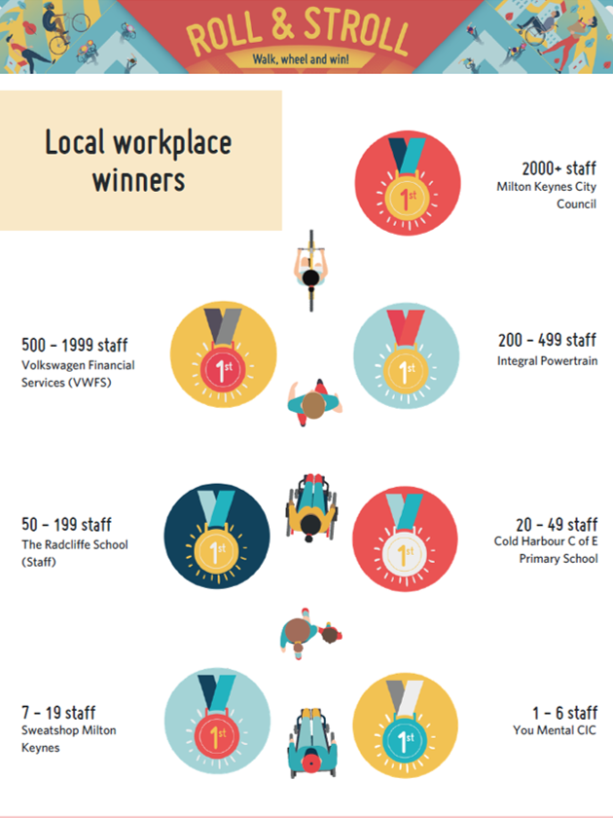

A huge thank you and well done to all the Milton Keynes businesses and their workforce who engaged with our Roll and Stroll campaign during May.

Outcomes include:
🌍 Carbon reduction; Switching some car journeys for walking or wheeling helped save nearly 7 tonnes of CO₂, this is equivalent to 27,000 miles driven by an average petrol car

🌱 Increased physical activity; 87,923 miles of walking/wheeling were completed, contributing towards improved mental wellbeing and physical health

✅ Modal shift toward active travel; 7,424 “transport trips” were made, suggesting staff are replacing car journeys, not just adding leisure walking, which can reduce congestion and air pollution.

If you are keen to continue to promote active sustainable travel and physical activity in your workforce, please keep your eyes peeled for the next ‘Love to Ride’ active travel campaign ‘Cycle September’ and encourage your team to explore the range of activities available during MK Festival of Cycling, running from 21st-28th June MK Festival of Cycling - Milton Keynes

