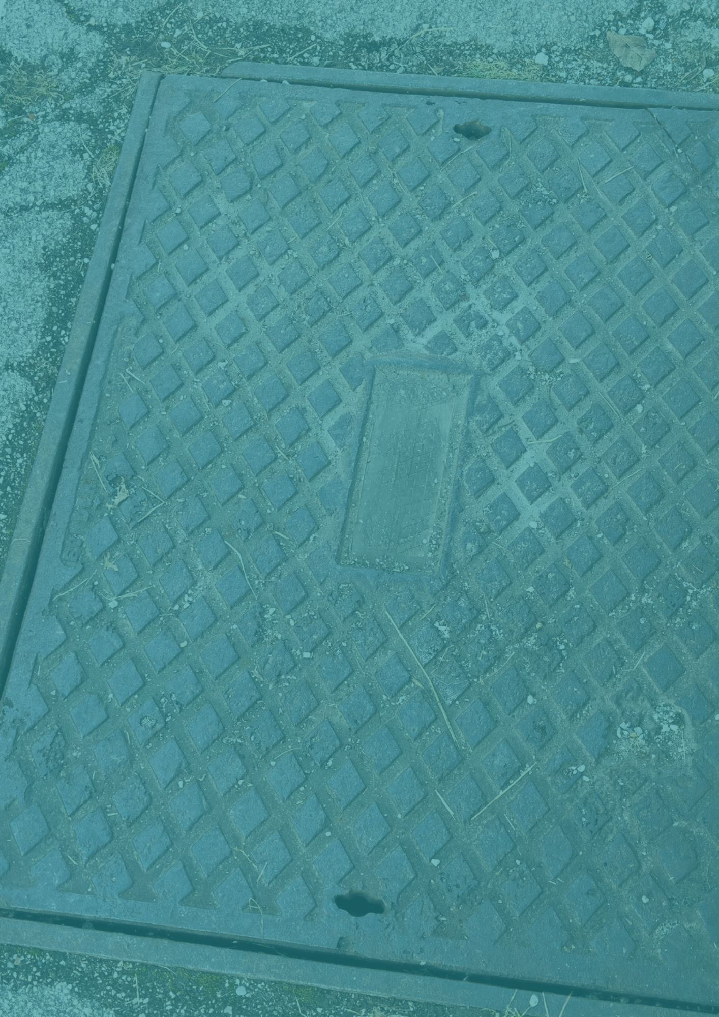


Utility Covers

How to report damaged or loose utility covers.
June 2026
Contents

Section | Title | Page
1.0 | Background | 2
2.0 | Who owns utility covers? | 2
3.0 | Why Report to the Utility Owner Instead of the Council? | 3
4.0 | How to Identify the Owner | 3
5.0 | How to Report a Damaged Cover | 4
6.0 | When to Contact the Council | 4

Background
There are many utility covers on the public highway, also known as a manhole, inspection chambers, or access covers.

A damaged cover can pose a safety risk to pedestrians or vehicles, and a loose one can be equally as dangerous whilst also potentially being a noise nuisance to those living nearby.

Many people assume that the local council is responsible for fixing these covers, but in practice, most utility covers are owned and maintained by utility companies, not the council.

Understanding how to identify the owner and report issues directly can lead to faster repairs especially if there is a safety risk.

2.0 Who owns utility covers?
Utility covers are typically owned by the organisation whose infrastructure lies beneath them. Mostly this will include:
- Water companies (e.g., for sewers and water mains)
- Telecommunications providers (e.g., broadband and phone networks)
- Electricity network operators
- Gas distribution companies
- Highways authorities (for drainage and some road infrastructure)

Each cover will usually have a marking, logo, or abbreviation that indicates the owner—for example:
Abbreviation | Type | Utility Owner
FW | Foul Water* | Anglian Water (for MK)
SW | Storm Water Drainage
GAS | Gas supply | Gas utility like SGN or British Gas
ELEC OR E | Electrical cables or equipment
BT, a T or GPO | Telecoms | BT Openreach
AV | Air valve
FO | Fibre Optic
SL | Streetlighting | Usually, the council unless it is on private land
LV | Low voltage electrical cables
HV | High voltage electrical cables
TEL or TELE | Telephone lines

*Please note that the council’s highways team does not deal with foul water (sewage). Our systems only carry rainwater and are fully separate to domestic systems.

3.0 Why Report to the Utility Owner Instead of the Council?
As the Highways Authority for Milton Keynes, the council is responsible for managing the roads and footways, but we do not have responsibility for utility apparatus installed by third-party companies. The Council can notify a utility company to carry out repairs to their assets under a Section 81 Notice, but this adds a delay in notifying the owner.
By reporting directly to the owner, the reports go straight to the responsible repair team, and most utility companies have an established process to report issues to them. It also means that the council is not processing enquiries that need to go to a third party anyway. The relevant organisation is notified immediately and can act.

4.0 How to Identify the Owner
Before reporting, take a moment to:
- Look at the cover itself
Check for embossed markings or logos.
- Note the location carefully
Include the road name, nearby house number, or a What3Words reference if possible.
- Take a photo
This can help both you and the utility company confirm ownership and assess severity.

- How to Report a Damaged Cover
Once you’ve identified (or reasonably guessed) the owner, you can report the issue using their official channels:
1. Utility Company Websites
Most major utility providers have online reporting forms for defective covers or street equipment.
Examples include:
- Water companies: “Report a problem” sections.
- Telecoms providers (e.g., Openreach): dedicated hazard reporting pages
- Electricity and gas networks: emergency or defect reporting portals
2. Customer Service Lines
If the damage is severe or poses immediate danger (e.g., a missing cover), call the company’s emergency number.

What Information to Provide
To help ensure a swift repair, include:
- Exact location (postcode, landmarks, or What3Words)
- Description of the issue (loose, rocking, broken, missing, sunken)
- Level of risk (e.g., hazard to cyclists, deep hole)
- Photos (if safe to take them)

6.0 When to Contact the Council
There are still cases where the council is the correct contact:
- If the cover has no visible marking and appears to be part of road drainage
- If the issue relates to surrounding road surface rather than the cover itself
- If you’re unsure and cannot identify the owner at all

In these situations, the council can help identify the responsible party.



