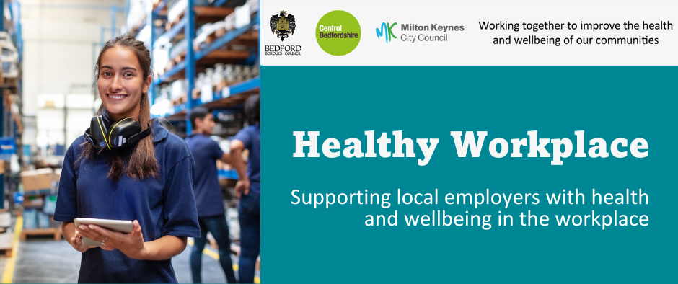

August 2026

The Workplace Health Team work in partnership with others to offer FREE health and wellbeing services and training, to all workplaces in Milton Keynes, Bedford Borough and Central Bedfordshire.

Our regular bulletin provides updates on different health and wellbeing topics, a service offer spotlight and information about forthcoming campaigns to support health and wellbeing in your workplace.

The Workplace Health webpages provide a range of free resources and information.

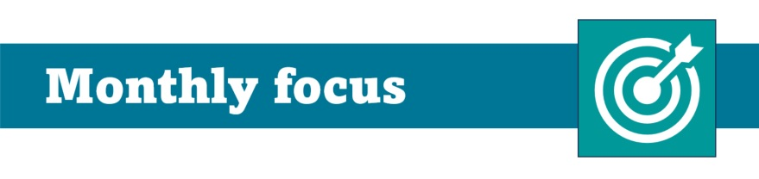

Women's Health at Work: Supporting menopause and pregnancy loss

October 2026 is Menopause Awareness Month, providing a valuable opportunity to support employees, increase understanding and create a more inclusive workplace.

It aims to raise awareness of menopause, encourage open conversations and improve access to information and support.

What can an employer do?

A supportive working environment can enable employees experiencing menopause symptoms to remain engaged, productive and confident at work.
An employer can provide practical support by promoting the support available, including menopause related policies, reasonable workplace adjustments, occupational health services and employee wellbeing resources.

In addition employers can consider:
- awareness campaigns to help employees feel more comfortable discussing menopause and seeking support from managers, colleagues or HR
- have open conversations through employee discussion groups or peer support networks
- educational webinars or lunch-and-learn sessions. See below for free training
For more information on menopause go to https://thebms.org.uk/ for further resources including factsheets and videos go to https://www.womens-health-concern.org/help-and-advice/menopause-in-the-workplace/

📢 FREE Menopause training for workplaces

📍The Manager Workshop: Putting Menopause Support into Practice (online 2 hours)​

Who is this for?
Designed for managers and HR at all levels. As the first point of contact for many employees, line managers and HR play a crucial role in supporting colleagues who may be experiencing menopause-related challenges. ​ ​

This interactive workshop helps attendees feel confident supporting employees affected by menopause. Through practical advice and tools, learn how to start supportive conversations and respond effectively to individual needs.​ ​ ​

📅 6th October 2026 🕑 1pm - 3pm

📍Employer Awareness: Breaking the taboo into Practice (online 1 hour)​

Who is this for?
For any employee wishing to broaden or deepen their knowledge and understanding. ​

Explore why menopause is often not discussed in the workplace and how we can change that. Gain practical and honest insights into menopause including hormones affected, potential symptoms, personal solutions and workplace solutions and how to support your colleagues and partners ​​ ​

​ 📅 12th October 2026 🕑 1pm - 2pm

📍Masterclass – Hormone Replacement Therapy (HRT) what you need to know (online 1 hour)​

Who is this for?
For any employee wishing to broaden or deepen knowledge and understanding. ​ ​

Perimenopause and menopause can affect physical, emotional and mental wellbeing. Join GP and menopause specialist Dr Ferhat Uddin for a live one-hour HRT masterclass, including a Q&A session and expert guidance to separate the facts from the myths.

📅 19th October 2026 🕑 1pm-2pm

👉 To book a place please complete the booking form link: form https://forms.cloud.microsoft/e/NPkSw7rkwL?origin=lprLink

Pregnancy Loss

Most workplaces will have employees who have been affected by the heartbreak of pregnancy loss.

The recent Miscarriage in the UK report revealed that 80% of respondents were working when they experienced their most recent pregnancy loss.

Because not everyone feels able to speak openly about their loss, the need for support may go unrecognised. Creating a supportive workplace culture, backed by clear policies and compassionate managers, can have a significant impact on how individuals navigate their loss and return to work.

What can employers do?

Sign up to The Pregnancy Loss Pledge and demonstrate:
❤️Your commitment to supporting colleagues affected by pregnancy loss
🌻Create appropriate policies
🍃Equip managers with the right knowledge
👥Foster an inclusive workplace culture where every loss matters

For more information and to sign up to the pledge please visit: https://www.miscarriageuk.org/pregnancy-loss-pledge/

World Mental Health Day

World Mental health Day is 10th October 2026 and the international theme for 2026 is "Lived Experiences Heard: Real Voices, Real Change." ​ ​

This provides a great opportunity for employers to focus on employee voice, psychological safety, and reducing stigma around mental health. ​ ​

What can employers do?

A supportive working environment can help employees maintain good mental health, remain engaged, productive and feel valued at work.​ ​Employers can support mental wellbeing by promoting a positive workplace culture by:

💜Encouraging open conversations about mental health
🫂Ensuring employees are aware of the support available including employee assistance programmes and other wellbeing resources
🌱Develop mental health and wellbeing policies
☀️Offer reasonable workplace adjustments and occupational health services

For more information and resources visit Mental Health Foundation's webpage: https://www.mentalhealth.org.uk/our-work/campaigns/world-mental-health-day

See below for free training

FREE Mental Health Training for workplaces

The Workplace Health Team work in partnership with local and national organisations to offer FREE workplace health and wellbeing training sessions and webinars.

Open to all employees with tailored sessions for managers, HR teams, occupational health professionals and health and wellbeing leads.

Key themes for 2026/2027:
🧠 Mental Health
👥 Social Wellbeing and Workplace Culture
🌍 Inclusive Employment

Upcoming sessions include:

🌍Inclusive employment: Supporting employees returning to the workplace from leave on 22nd September (for managers)

🧠Mental health awareness on 8th October (open to all)

👥Influence and participation: how to build positive relationships and embedding
colleague voice on 9th November (for managers)


To sign up to our one hour, bite size webinars delivered by Mind BLMK and view all available training, please use the QR code or visit our training page. Workplace Health Training | Milton Keynes City Council



Cycle September is a fun, free and friendly active challenge campaign for workplaces across Milton Keynes running from 1st September - 30th September.

It supports increased physical activity alongside sustainable travel choices offering great benefits:
🫀 Better physical and mental health
🌍 Lower carbon emissions
💷 Reduced travel costs
🏆 Fun challenges with rewards and incentives cycle your way to more active days this September.

Compete with other departments or workplaces and make cycling a habit.

Cycle September will be giving away virtual trophies to the top 3 workplace winners in each size category by topping the leaderboards.

Register your workplace with a named champion, this will help your workplace climb the leaderboard while building healthy habits.

An Implementation Guide has been developed to support workplaces promote Cycle September please visit https://www.milton-keynes.gov.uk/health-and-wellbeing/workplace-health-and-wellbeing-across-milton-keynes-bedford-borough-and-3

Please do not reply to this email
Send all queries to workplacehealth@milton-keynes.gov.uk



Manage details | Unsubscribe all | Add to safe senders

