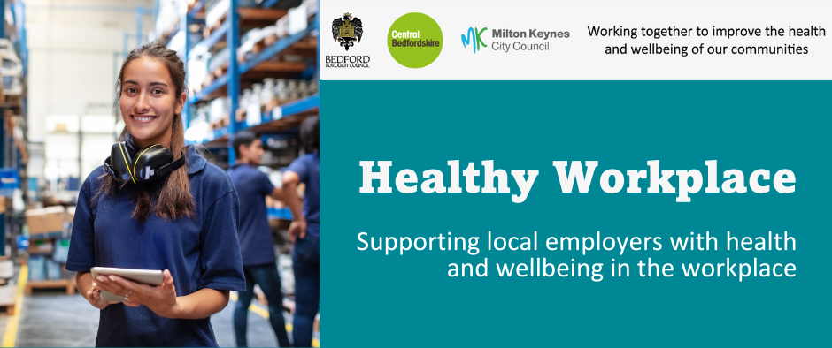

October 2026

The Workplace Health Team work in partnership with others to offer FREE health and wellbeing services and training, to all workplaces in Milton Keynes, Bedford Borough and Central Bedfordshire.

Our regular bulletin provides updates on different health and wellbeing topics, a service offer spotlight and information about forthcoming campaigns to support health and wellbeing in your workplace.

The Workplace Health webpages provide a range of free resources and information.

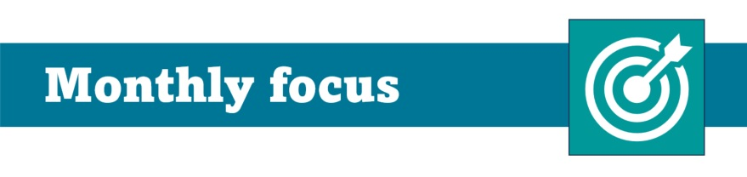

FREE Health Checks direct to your workforce

Building a heart-healthy workplace
Heart and circulatory diseases are one of the leading causes of ill health in the UK and can have a significant impact on the workforce.
Supporting heart health is not just good for employees, it makes good business sense too. Why it matters to employers:

💼 Reduce sickness absence by helping prevent long-term health conditions that can lead to time away from work
🚀 Improve productivity and performance by supporting a healthier, more energised workforce
💚 Boost employee wellbeing and demonstrate a commitment to staff health and welfare
🩺 Encourage early detection through health checks and awareness, helping people take action before problems become more serious
🤝 Support workforce retention by helping employees stay healthy and remain in work for longer
📉 Reduce long-term costs associated with ill health, absence and presenteeism

Workplace NHS Health Checks

Many employees want to look after their health but face practical barriers that can make it difficult to access health checks and preventative support.

Public Health are working in collaboration with employers to offer free NHS Health Checks, delivered onsite at your workplace for staff aged 40 and over.

What is an NHS Health Check?

The NHS Health Check is a preventive public health programme aimed at identifying early signs of cardiovascular disease, available to adults aged 40–74.

Health checks:
• Measure cholesterol, blood pressure, pulse, weight, BMI and other key health indicators
• Provide an opportunity to access healthy lifestyle guidance and signposting to local support services
• Take approximately 30 minutes

For more information on the national NHS Health Checks go to: https://www.nhs.uk/tests-and-treatments/nhs-health-check/

To register your employer for the workplace Health Checks, please use the expression of interest form link below.

Could your workplace benefit?

This opportunity is for:

• Employers across Bedford Borough, Central Bedfordshire and Milton Keynes (BMK)
• Organisations with a large proportion of staff aged 40 and over
• Organisations with a large proportion of employees living within the BMK area or registered with a local GP.

Don't meet all of the above criteria?
We'd still love to hear from you. We welcome expressions of interest from all employers who are committed to supporting the health and wellbeing of their workforce.

👉 To register your interest, please complete our expression of interest form: https://www.milton-keynes.gov.uk/health-and-wellbeing/workplace-health-and-wellbeing-across-milton-keynes-bedford-borough-and-4

What else can employers do to build a Heart-Healthy Workplace?

🚶 Encourage staff to move more with regular breaks, walking meetings and active travel
🥗 Offer healthier food, drink and hydration options where possible
🩺 Support employees to attend health checks and medical appointments
💚 Promote wellbeing initiatives that help staff manage stress and maintain a healthy work-life balance
📢 Raise awareness of heart health risk factors and where to access support

Choose You is free local service, available to anyone who lives or works in our region, supporting people to build healthy habits, like quitting smoking or reaching a healthy weight https://chooseyou.co.uk/

For more information on creating a heart healthy workplace please access free Health at work resources from The British Heart Foundation https://www.bhf.org.uk/how-you-can-help/health-at-work/resources or contact us workplacehealth@milton-keynes.gov.uk.

UK evidence shows that proactive wellbeing initiatives with early detection of conditions such as high blood pressure, diabetes, and cardiovascular risk helps prevent more serious long-term- illness and reduces sickness absence.

FREE Mental Health Training for workplaces

The Workplace Health Team work in partnership with local and national organisations to offer FREE workplace health and wellbeing training sessions and webinars.

Open to all employees with tailored sessions for managers, HR teams, occupational health professionals and health and wellbeing leads.

Key themes for 2026/2027:
🧠 Mental Health
👥 Social Wellbeing and Workplace Culture
🌍 Inclusive Employment

Upcoming sessions include:

🧠Burnout in the workplace: how to identify the 3 core dimensions of burnout and implement strategies to reduce workplace burnout on 4th November (open to all)

👥Influence and participation: how to build positive relationships and embedding
colleague voice on 9th November (for managers)

🌍Approaches in creating psychological safe environments at work: Supporting managers to create a workplace where people feel safe to speak up, share ideas and ask for help on 9th December (for managers)

👥 Managing Difficult Conversations: identify personal strengths and resilience and understand healthy boundaries to manage challenging conversations effectively on 12th January 2027 (for managers)

🧠 Resilience and positive mindset: understanding the stages of change, develop positive self-talk, and building resilience skills to support wellbeing and personal growth on 13th January 2027 (open to all)

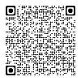
To sign up to our one hour, bite size webinars delivered by Mind BLMK and view all available training, please use the QR code or visit our training page. Workplace Health Training | Milton Keynes City Council

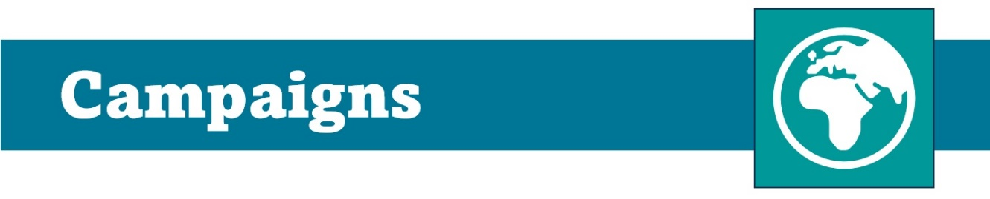

Movember 2026

Movember dedicates health and wellbeing to men's health and wellbeing throughout October, this is because men die five times earlier than women often from preventable causes.
Make a commitment at work to change men's health and have conversations around prevention-focused topics:
- prostate cancer
- mental health and suicide prevention
- testicular cancer
🏆 Suggestions from Movember to increase engagement and promotion are:

💙Grow a moustache, challenge a friend or grow mustaches together
💙Have a physical activity event
💙Host an event promoting conversations and support

For more information and access to free resources on Movember please visit: https://uk.movember.com/support-us

🏃‍♂️ Take on the Milton Keynes MoRun

Join the Milton Keynes MoRun on 29 November 2026 and support Movember, raising awareness of men's mental and physical health. Choose from a 5k, 10k, Half Marathon or family-friendly Mini MoRun and get active for a great cause.

Why not make it a team challenge with colleagues, or get friends and family involved and take part together? It's a great way to boost physical activity, wellbeing and team spirit while supporting an important cause.

👉 Find out more and sign up via the Milton Keynes MoRun event page
www.mo-running.com/milton-keynes

International Men's day is 19th November 2026.

The UK theme for the Day is “Supporting Men and Boys” with three focus points which are used every year:

💙Making a positive difference to the wellbeing and lives of men and boys
💙Raising awareness and/or funds for charities supporting men and boys’ wellbeing
💙Promoting a positive conversation about men, manhood and masculinity

This is an opportunity for employers and organisations to hold wellbeing events and activities for male members of staff in all their diversity, as well as encouraging women to take part.

For more information and resources please visit: https://ukmensday.org.uk/

Please do not reply to this email
Send all queries to workplacehealth@milton-keynes.gov.uk



Manage details | Unsubscribe all | Add to safe senders

